YESHIVAT HAR ETZION

ISRAEL KOSCHITZKY VIRTUAL BEIT MIDRASH (VBM)

*********************************************************

GEOGRAPHY IN THE PARASHA

***************************************************************

In memory of Pinhas ben Shalom (Paul) Cymbalista z”l

Niftar 20 Nissan 5752. Dedicated by his family.

***************************************************************

These Pesach Shiurim are dedicated in memory of Sidney Gontownik z"l,

brother of Jerry Gontownik, on the occasion of Sidney's upcoming eleventh Yahrzeit, on the 24th of Nissan. May his memory be for a blessing.

The Gontownik Family

***************************************************************

Dedicated in memory of HaRav HaGaon R. Chaim Heller zt"l,

whose yahrzeit falls on the 14th of Nissan, by Vivian S. Singer.

***************************************************************

***PARASHAT SHEMOT***

**Ramesses and the Question of Dating the Exodus**

**By Prof. Yoel Elitzur**

**Identifying Pithom and Ramesses[1]**

“And they built garrison cities for Pharaoh; Pithom and Ramesses” (Exodus 1:11).

Many have attempted to identify these two cities, and many identifications have been suggested in the Nile Delta region in Egypt. It is fair to say that this question cannot be answered with certainty.

Part of the difficulty in answering this question lies in a fundamental difference between the land of Israel and Egypt. In the land of Israel, we encounter a phenomenon that might seem miraculous: A large percentage of the ancient place names in the land of Israel have been preserved by its residents until the modern era. When we returned to the land of Israel, we found that Lod was called al-Ludd, Jaffa was called Yāfa, Bethlehem was called Bēt Laḥm, Haifa was called Ḥayfā and Acre was called cAkkā. Thus, we were able to easily identify these locations, and many others as well, with a great degree of certainty.

This phenomenon did not occur in the lands of other ancient kingdoms or empires, like Egypt, Babylonia and Turkey, where the ancient Hittite empire was located. In these lands, very few of the ancient names were preserved, and in general, the modern names are not reliable indicators for identification of ancient locations. In Egypt, place names have been constantly changing throughout history, even into the modern era. Indeed, maps of Egypt from eighty years ago, forty years ago and today feature significantly different sets of names.

Targum Yerushalmi identified Ramesses as Pelusium, a famous city during the Hellenistic, Roman and Byzantine periods. Pelusium was located on the eastern branch of the Nile, which dried up toward the end of the ancient period, and was a source of fine linen fabrics.[2] Today, Pelusium can be found east of the Suez Canal at a site known as Tell el-Farama, in a region that was called Baluza – this time actually preserving its ancient Greek name. However, this placement seems too far northeast to be an accurate identification for Ramesses. According to the Torah, Ramesses was located within the land of Goshen:

Settle your father and your brothers in the best part of the land; let them stay in the region of Goshen… So Joseph settled his father and his brothers… in the choicest part of the land of Egypt, in the region of Ramesses, as Pharaoh had commanded. (Genesis 47:6-11)

We also learn that Ramesses was near the royal city: “Where you will be near me” (45:10); “He summoned Moses and Aaron in the night” (Exodus 12:31). Pelusium, in contrast, was situated outside the heart of Egypt. Additionally, the path between Pelusium and the land of Canaan does not pass anywhere near the Red Sea. Finally, nowhere in the vicinity of Pelusium have significant remnants been found from Biblical times. Thus, it seems highly doubtful that Pelusium can be an accurate identification for Ramesses.

Most scholars identify Pithom and Ramesses as Tell el-Maskhūṭa and Tell er-Reṭabe, respectively, tells located west of Ismaïlia on the eastern side of the Delta. Other sites that have been suggested as identifications for Pithom or Ramesses were further north, near Qantir, and some even considered Tanis even further to the north. One scholar strayed to the southwest, identifying Pithom as Heliopolis, a suburb of Cairo. Some of the sites suggested had already been identified as a different ancient location, and it would have to be assumed that the location possessed multiple names, either simultaneously or in different eras. At the end of the day, it seems that the common denominator between all of these identifications is that they are all doubtful, and they all rely upon secondary considerations.[3]

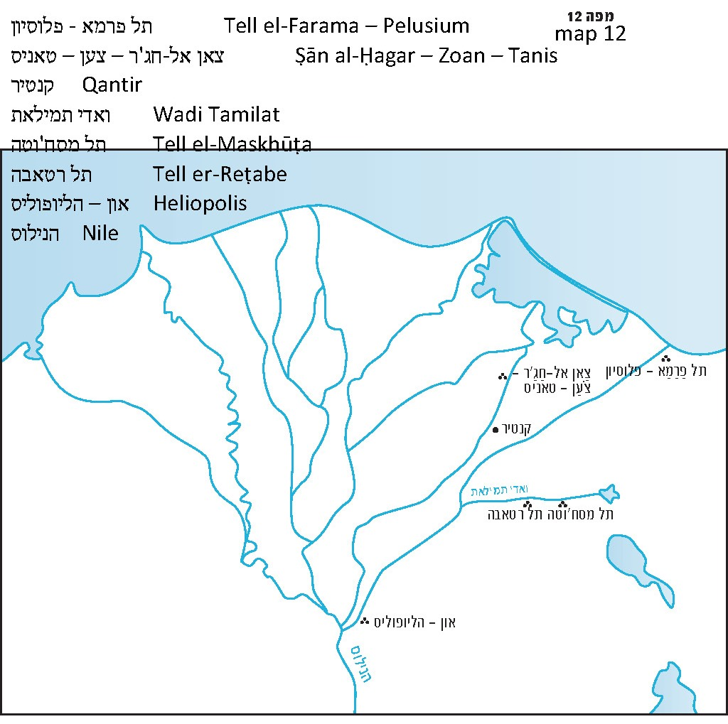

**The Name “Ramesses”**

The name Ramesses has critical implications for formulating the entire chronology of the Biblical period. We know that there were several pharaohs that were called Ramesses. The name first appeared at around 1300 BCE, at the start of the Nineteenth Dynasty of Egypt. No pharaohs used the name Ramesses before this point, and from then on pharaohs began using the name in intermittent spurts. Ramesses I was a monarch who did not manage to accomplish great things in his lifetime. He began his reign at an advanced age and only rule for a year or two before appointing his son and heir Seti I (who was himself around thirty years old at the time) to rule alongside him. The reign of Seti I saw the renewal of a long period of conquests and Egyptian rule in the land of Canaan. This was not the first instance of Egyptian rule in the land of Israel and its neighboring lands, but this was the start of a new period of Egyptian hegemony in the land of Israel and Syria following a period of decline. Seti I, who ruled for sixteen years, achieved great things on behalf of Egypt in the land of Israel.

The most interesting man of all the pharaohs who took the name Ramesses was Ramesses II, who followed Seti I. Known as Ramesses the Great, Ramesses II is likely the most celebrated pharaoh in Egyptian history. First, he ruled for sixty-seven years – longer than any other pharaoh. Such a lengthy reign may have been difficult for us to believe, if not for the existence of similarly long-reigning monarchs in modern times, such as Queen Victoria of the United Kingdom and Emperor Hirohito of Japan. There are even a few currently-reigning monarchs, such as Queen Elizabeth II, who have reigned for over sixty years.

Ramesses II began his reign at a young age, and ruled until he was an elderly man. He was a strong and forceful ruler, waging great wars and building extensively throughout the region. The first half of his reign was marked by great military conquests. Ramesses recorded on the walls of temples and palaces more conquest lists in the land of Canaan and its surroundings than any other monarch. He also undertook numerous building projects, primarily in the second half of his reign. Among Ramesses’ many building achievements, one stands out in several Egyptian records: the construction of a city in his honor called Per-Ramesses, or “the House of Ramesses”.[4]

Following Ramesses II, many other pharaohs took on the name Ramesses. The most important of these pharaohs was Ramesses III of the Twentieth Dynasty. Ramesses III was followed by a list of additional Ramesseses who were not particularly historically significant, and during whose reigns Egypt no longer ruled over foreign lands. The last of these pharaohs was Ramesses XI, who ruled in the early eleventh century BCE. In all, Egypt was ruled by a pharaoh named Ramesses for a total of 230 years. Ramesses II was not only the greatest Ramesses who ruled Egypt, but also the greatest pharaoh in all of Egyptian history. He reigned for most of the thirteenth century BCE. There is some disagreement among scholars regarding the precise years of his reign, but it is clear that it began around 1300-1290 BCE and ended around 1230-1220 BCE, an extremely long period of rule for the strongest and most powerful pharaoh of all time. Furthermore, the reign of Ramesses II is considered a kind of watershed moment in Egyptian history: There is the Classical period and there is the Ramesside period. His reign even had an impact on the Egyptian language; there is a Ramesside dialect that has its own unique facets and nuances.

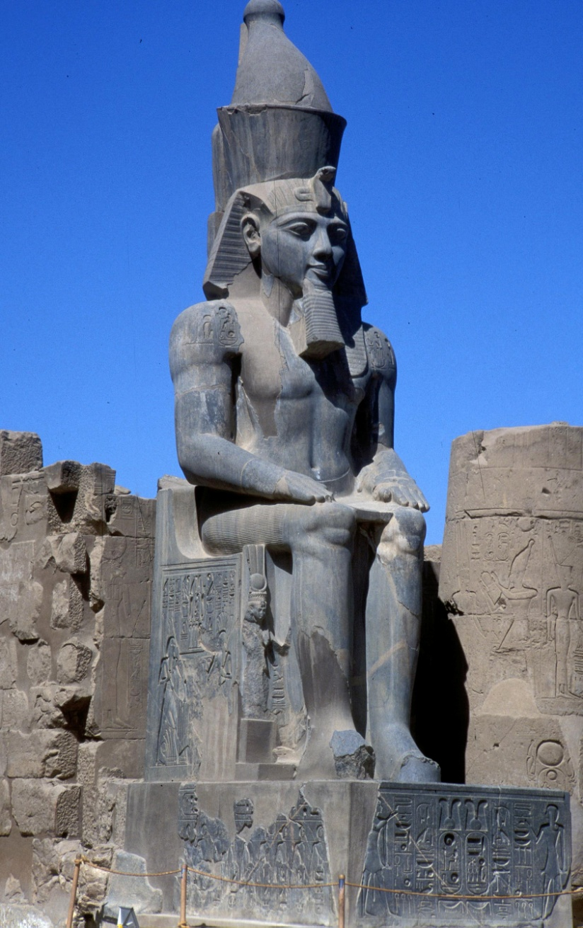

Ramesses II – the pharaoh of the enslavement and the Exodus according to the most common approach (Z. Radovan)

The parallel between the Ramesses who appears in Egyptian sources and the Ramesses who appears in *Tanakh* drew the attention of scholars. Many scholars assumed that if Ramesses II reported that he built a city in his honor called “the House of Ramesses,” this certainly fits the Torah’s description in the verse, “And they built garrison cities for Pharaoh; Pithom and Ramesses.”[5] Thus, this notion has become very accepted, including in many historical atlases and encyclopedias, which state unequivocally that Ramesses II was the pharaoh who enslaved the people of Israel and during whose reign the Exodus occurred.

**The *Tanakh*’sChronology**

The historical debate on this topic is beyond the scope of this discussion, so I will suffice in saying briefly that this notion simply does not fit with the chronology that the *Tanakh* presents. According to the *Tanakh*, 480 years passed from the Exodus to the construction of the First Temple (I Kings 6:1), and there are other verses that indicate that about four hundred years passed between the conquest of Canaan and the time of David.[6] David and Solomon reigned in the tenth century BCE, meaning that the Exodus took place around 1450 BCE and the conquest of Canaan occurred around 1400 BCE. The identification of the pharaoh of the Exodus with Ramesses II would effectively cut the period between the Exodus and the conquest of Canaan in two.

Since we cannot accept this modified chronology in light of the *Tanakh*’s account, we should resist the temptation to identify the pharaoh of the Exodus with Ramesses II. The Torah refers to “the region of Ramesses” (Genesis 47:11) in the narrative of Joseph and his brothers, long before the enslavement. It seems that “the region of Ramesses” and the city of Ramesses preceded the rulers who took on this name – and this should not surprise us. There is no linguistic evidence that suggests that the use of the name Ramesses only began later. Apparently, the connection between the names is coincidental; according to the *Tanakh*’s chronology,the great accomplishments of Ramesses II all took place during the period of the Judges, from the perspective of the people of Israel. The lists of cities conquered by Seti I and his son Ramesses II in the land of Israel generally include towns along the coast and in the Jordan Rift Valley, in particular the towns that were situated along the “Via Maris.” In other words, they conquered distinctly Canaanite regions whose inhabitants the people of Israel never dispossessed throughout the period of the Judges. Apparently, the tribes of Israel, who lived irregularly in unwalled localities throughout the hilly and semi-arid regions of the land, were not an appropriate target for the Egyptian conquerors, who were eager to seize only valuable plunder. Because of this, the people of Israel were not mentioned in the Egyptian military records and in the lists of their conquests. Rameses II’s heir Merneptah mentions Israel in his victory stele, which he had carved in the fifth year of his reign (circa 1220 BCE), along with Canaan and the Canaanite cities of Ashkelon, Gezer and Yenoam; this is the first extra-biblical source that mentions Israel.

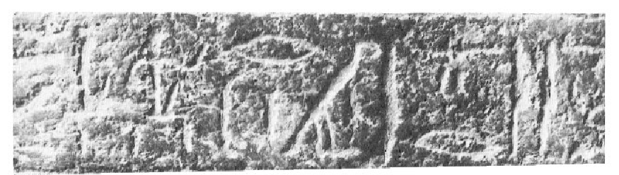

y-s-r-3-r “Israel” with the determinatives “nation” and “foreigners” in Merneptah’s stele (c. 1220 BCE) – source and decipherment. In this stele, Israel is mentioned together with Gezer and Ashkelon, both with the determinative “place in foreign land” (P. Lacau, 1909).

**Responding to the Accepted Chronology**

The later dating of the settlement of the land of Israel was accepted by most scholars for most of the twentieth century, and it was based primarily on three pillars. a) The connection to Ramesses, presented above. b) Archaeological evidence: The archaeology of the land of Israel features an abrupt transition from the Bronze Age to the Iron Age. Fortified cities built atop tells were conquered and destroyed, often by intense fire. In their place, small villages sprouted up, meager in comparison to their predecessors and generally unwalled. Scholars dated this transition to around 1200 BCE, speculating that the people who destroyed the fortified cities and built simple towns for themselves were none other than the Israelites. According to the *Tanakh*’s account, the people of Israel conquered the land by storm but quickly entered the period of the Judges, when there was no central leadership and the tribes of Israel were weak in relation to their neighbors. c) Egypt’s absence from the books of Joshua and Judges. According to Egyptian sources, Egypt ruled over Canaan for centuries,[7] their power in Canaan only abating after the reign of Ramesses III. Thus, if Israel entered the Land during those centuries, they would have had to deal with Egypt, rather than with the thirty-one Canaanite kings. If there had been some kind of agreement with Egypt allowing them to enter, it would mean that from a political perspective they had essentially never left Egypt.

However, the *Tanakh*’s chronology obviously does not fit all of this. What, then, is the solution?

Let us first point out that the whole framework that the scholars established in developing their chronology was somewhat phony to begin with. The truth is that even the scholars’ chronology is riddled with problems. With respect to the “third pillar” mentioned above, the people of Israel would have had to enter the land only after Ramesses III, who reigned for thirty-two years and left a legacy of seven lists of conquests in the land of Canaan. The problem is that Merneptah, who died about twenty years before Ramesses III’s reign began, already mentioned the presence of Israel in the land. Furthermore, if the pharaoh who enslaved the people of Israel was Ramesses II, how could they have managed to be already entrenched in the land of Israel by the start of the reign of Merneptah, his heir? These problems forced the scholars to employ a technique that my father *z”l* called “contracting and stretching”: On the one hand, they shortened the length of the enslavement, the Exodus and the period of wandering in the wilderness so that these events could fit within the reign of Ramesses II (writing off the “forty years” in the wilderness as a “typological number”); on the other hand, they stretched out the period of entry into the land of Israel over the course of several decades, viewing it as a slow process that began before Merneptah and ended after Ramesses III. They also went on to minimize the significance of Ramesses III’s conquests, painting a picture of a monarch who struggled to defend his own land from the invasion of the Sea Peoples.

The solution to the archaeological question (the “second pillar”) was developed by several archaeologists who refused to accept the conventional scholarship. I will attempt to explain this solution here in brief. Scholars of this period noticed an interesting phenomenon: Settlement in the land of Israel in the Late Bronze Age is most prominent in the cities of the Shephelah, the coast and the valleys, and even there settlement was, by and large, diminished compared to the Middle Bronze Age that preceded it. In contrast, in most mountainous areas, settlement in the Late Bronze Age is completely nonexistent. In light of this, members of the archaeological mainstream concluded that there was a settlement gap during that period (fifteenth-thirteenth centuries BCE) in the mountainous regions. The few scholars who stuck with the straightforward understanding of the *Tanakh*’s chronology explained this archaeological phenomenon differently. According to these archaeologists, there was no settlement gap in the mountain cities during that period. Rather, the Iron Age – the Israelite period – began here earlier. The Canaanites continued to reside in the Shephelah, the coast and the valleys; the people of Israel did not dispossess them “for they had iron chariots” (Judges 1:19). It was there that the “Late Bronze” culture began to develop, while the mountain regions saw the beginning of the material “Iron” culture, ushering in the Israelite period in the land.[8]

As for the “third pillar”: According to the accounting of the *Tanakh*, the people of Israel entered Canaan and established themselves in the land over the course of the last hundred years of the Eighteenth Dynasty. This was a period of great decline for the Egyptian empire, during which Egypt lacked practical control outside of its own borders. When Egypt regained its power and increased it further during the time of Seti and Ramesses II – who, according to our chronology, reigned during the period of the Judges – the people of Israel consisted of a collection of meager mountainous tribes, of no interest to the marauding Egyptians. At that time, the pharaohs concentrated their efforts on international roads and the fortified Canaanite cities situated along these roads.

In terms of positive Egyptian evidence supporting our proposed chronology, I will briefly summarize the two most important historical points. First, according to our chronology, the kings of the **Hyksos** dynasty (who were Semitic in origin) were the ones who accepted Joseph and, later on, Jacob and his family. Their violent expulsion from Egypt may be hinted at in the verse, “A new king arose over Egypt” (Exodus 1:8). Second, the **Amarna letters** (written during the time of Amenhotep III and his son Amenhotep IV, better known as Akhenaten) contain a possible eyewitness account of the Israelite conquest of the land of Canaan and the dread that gripped the Canaanites at the time.[9]



Tuthmose III Temple gate in Upper Egypt (depiction from the nineteenth century CE) Tuthmose III (Eighteenth Dynasty, fifteenth century BCE) was one of the strongest kings of Egypt; he reigned 54 years. According to the Biblical chronology, he was probably the pharaoh of the enslavement.

Finally, I feel the need to add that this entire discussion has become somewhat dated in recent years. Over the last two or three decades, a new fad has begun to dominate in academic settings: the complete denial of the historicity of the *Tanakh* as a whole. According to this approach, there was no enslavement and there was no Exodus; we did not conquer Canaan and we never set up judges and leaders; if David and Solomon did exist, they were marginal local leaders. The history of the nation of Israel began sometime in the middle of the period of the two separate kingdoms of Israel and Judah. When faced with such extreme positions, the distance between the two sides of the playing field in the age-old debate on the chronology of the Exodus and the conquest of Canaan becomes largely negligible.

|  |  |  |  |  |
| --- | --- | --- | --- | --- |
| **Year (BCE)** | **Archaeological period** | **Dynasty** | **Important pharaohs** | **Israel** |
| ~2000 | Middle Bronze I |  |  |  |
| ~1700 | Middle Bronze II B | **Hyksos** |  |  |
| ~1550 | Late Bronze | **18** | Ahmose I – expulsion of the Hyksos  Tuthmose III |  |
| ~1450 |  |  | Amenhotep II | Exodus according to *Tanakh* |
| ~1400 |  |  | Amenhotep III – Amarna letters  Amenhotep IV = Akhenaten | Conquest of Canaan according to *Tanakh* |
| ~1320 |  | **19** | Seti I |  |
| ~1290 |  |  | Ramesses II | Exodus (accepted) |
| ~1230 |  |  | Merneptah – “Israel Stele” | Conquest of Canaan (accepted) |
| ~1200 | Iron I | **20** | Ramesses III |  |
| ~1100 | Iron II |  | Ramesses XI |  |
| ~1070 |  | **21** |  |  |
| ~1010 |  |  |  | David |
| ~970 |  |  |  | Solomon – construction of First Temple |

**For further study:**

S. Ahituv, “*Le-zeihuyah shel Pitom*,” in B. Oppenheimer (ed.), Bible and Jewish History: Studies in Bible and Jewish History Dedicated to the Memory of Jacob Liver, Tel Aviv 1971, 157-160 [Hebrew].

J. H. Breasted, *A History of Egypt*, II, Tel Aviv 1963.

J. J. Bimson, *Redating the Exodus and Conquest*, Sheffield 1981.

J. Garstang, “Chronology and Dates,” *Joshua Judges*, London 1931, 51-66.

J. Garstang, “The Hornet,” *Joshua Judges*, London 1931, 112-115.

Yehudah Elitzur, “*Yetzi’at Mitzrayim Le-or Ha-historiya*,” *Israel and the Bible*, Ramat Gan 2000, 51-53 [Hebrew].

Yoel Elitzur, “*Al Ofnot Be-cheker Toldot Yisrael*,” *Al Atar* 7 (2000), 23-41 [Hebrew].

I. Meitlis, *Excavating the Bible*, Baltimore 2012.

Translated by Daniel Landman

1. Prof. Elitzur’s series is now available as a book: [*Places in the Parasha: Biblical Geography and Its Meaning*](https://korenpub.com/products/places-in-the-parasha-1) (Maggid, 2020).
2. See *Mishna Yoma* 3:7: “In the morning he put on Pelusium linen worth twelve minas.”
3. See map below.
4. *Per* is the Egyptian word for “house.”
5. It should be noted that, according to Egyptian sources, there were several locations called “Ramesses.”
6. See the list of years of the Judges, as well as the “three hundred years” (Judges 11:26) that Jephthah mentions. Also see the list of generations of High Priests and Levite singers in I Chronicles 5-6.
7. The Torah hints at this as well: “Both the land of Egypt and the land of Canaan languished because of the famine” (Genesis 47:13); “Chariots, too, and horsemen went up with him” (50:9).
8. This discussion is connected to another secondary discussion regarding the question of dating the transition from the Middle Bronze Age to the Late Bronze Age. Those interested in reading a more comprehensive analysis are encouraged to consult the bibliography.
9. See the sources listed in the bibliography for more on the Amarna letters.