YESHIVAT HAR ETZION
ISRAEL KOSCHITZKY VIRTUAL BEIT MIDRASH (VBM)
*********************************************************

The Path of the Piaseczner Rebbe
By Dr. Ron Wacks

Shiur #03: Biography (part 2)

With the outbreak of the Second World War and the Nazi occupation of Poland, R. Kalonymus decided to remain in Warsaw, although his chassidim in Eretz Yisrael had urged him on several occasions to leave Poland and make his way to there. Special emissaries were dispatched to persuade him, but he refused, declaring it unthinkable that he would save himself while leaving his brethren to suffer.

On Monday, 12 Tishrei 5700 (the eve of Sukkot, September 1939), the Nazis stormed Warsaw. R. Kalonymus’s son, R. Elimelekh, was severely wounded in the German bombardment, and he died on the second day of the festival. His daughter-in-law Gittel, daughter of the Rebbe of Balichov, was also killed in a bombardment, along with her aunt Channa, daughter of R. Yerachmiel Moshe of Kozhnitz, as they tended to R. Elimelekh in the hospital.

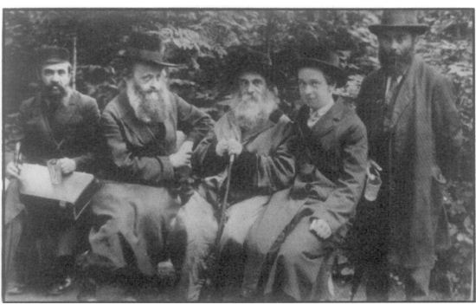
R. Kalonymus and his son’s father-in-law, R. Shlomo Chaim – the Rebbe of Balichov

Before the Rebbe had time to recover from these losses, his mother, the Rebbetzin of Grodzisk, passed away on 7 Marcheshvan 5700 (1939). His daughter, Rekhil-Yehudit, was taken by the Nazis at the beginning of Elul 5702 (1942), during the deportations. Those close to him reported him saying, “I have already been defeated; may God held the Jewish People to prevail in this war.”

Even under these difficult circumstances, R. Kalonymus devoted himself day and night to the chassidim who continued to flock to him. He worked at the Schultz German shoe factory, headed by Avraham Handel – an establishment that came to be known as the “Workshop of the Admorim” owing to the chassidic leaders and Roshei Yeshivot who worked there. R. Kalonymus’s home was at 5 Dolno Street in the Warsaw Ghetto. He established a soup kitchen there for the 1,500 Jews of Piaseczno who clung to him. In these darkest of days, he continued to provide for their spiritual needs, exerting efforts to create the appropriate atmosphere for the festivals, circumcising newborn boys, and helping establish clandestine mikvaot. He would get up in the middle of the night to recite Tikkun Chatzot; on Shabbat he would hold a traditional tisch, and he continued to inspire hope in his followers. Although R. Kalonymus’s chassidim attempted to arrange for him to be smuggled out of Poland and sent him to Eretz Yisrael, he was adamant in his refusal to leave.

A collection of his sermons, later published under the title Esh Kodesh, written between the years 5700-5702 (1940-1942), in the midst of the annihilation of Polish Jewry, is a unique work, documenting his attempt to imbue the Holocaust with religious meaning and to deal with the existential questions that it raised. R. Kalonymus’s writings were hidden underneath the ghetto in milk canisters belonging to Dr. Emanuel Ringelblum’s “Oneg Shabbat” archives. After the war, parts of his work were discovered and later printed in Israel.
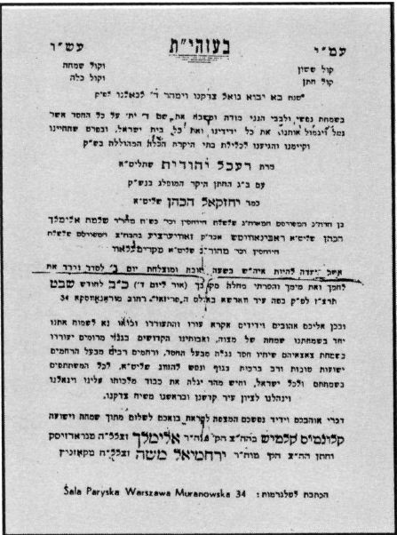
Invitation to R. Kalonymus’s daughter’s wedding

After January 1943, R. Kalonymus was taken to the labor camp in Bodzin, near Lublin, where he was murdered, apparently on 4 Cheshvan 5704 (November 2, 1943).

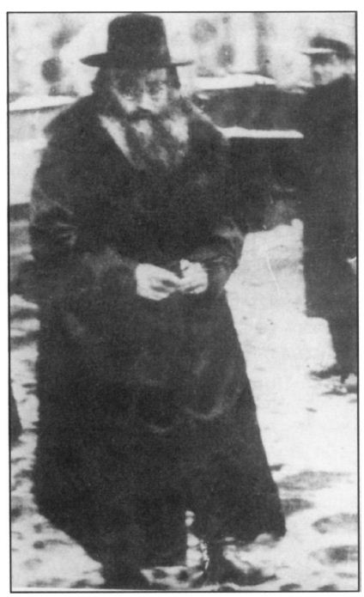
R. Kalonymus on a street in Warsaw

The following brief, heartfelt appraisal of R. Kalonymus’s stature was written by an acquaintance, Leibl Bein:

I knew the Rebbe from his earliest youth as a perfect individual divinely blessed with precious qualities. Later, I accompanied him over the course of thirty-two years, from his appointment up until the end of 1939, when he ordered me to leave Poland with my family and to flee to Russia. I could write entire books about his multi-faceted greatness, without covering it all.

I knew more than three hundred Admorim in Poland, Galicia, Hungary, and Bukovina; I studied them and gathered valuable biographical material about them. I witnessed each of them in his greatness and unique qualities, but all of their virtues were to be found together in this spiritual giant, the Rebbe of Piaseczno, may his memory be blessed…

The Rebbe of Piaseczno, R. Kalonymus Kalmish Shapiro, ztz”l, was a man of perfection.

(To be continued)

Translated by Kaeren Fish

See Bein, “Mi-Pinkaso shel Itonai-Chasid,” p. 34. Bein himself asked the Rebbe to move with him to the Land of Israel. Bein was active in the Mizrachi movement and also served as editor of Hatzofeh newspaper; see E. Farbstein, Be-Seter Ra’am, p. 431, n. 9.
Reiser, Derashot MiShenot HaZa’am, 1, p. 21.
According to a letter he wrote on 26 Tevet 5703 to his brother and to two of his friends, printed at the beginning of Esh Kodesh.
Bein, “Mi-Pinkaso shel Itonai-Chasid,” p. 34.
Farbstein, Be-Seter Ra’am, p. 433.
Ibid., p. 434.
Most studies about R. Kalonymus have focused on this book. See N. Polen, The Holy Fire; M. Piekarz, Ha-Te’uda Ha-Chassidit Ha-Sifrutit Ha-Achrona al Admat Polin: Divrei Ha-Rav Mi-Piaseczno Be-Geto Varsha (Jerusalem, 5739); M. Piekarz, Chassidut Polin: Megamot Ra’ayoniyot bein Shetei Ha-Milchamot U-Ve-Gezerot 5700-5705 (“Ha-Shoah”) (Jerusalem, 5750), pp. 373-244; Zilberschlag and Frankel, Zikhron Kodesh; Farbstein, Be-Seter Ra’am, pp. 429-454; E. Schweid, Bein Churban Le-Yeshu’a – Teguvot shel Hagut Charedit Le-Shoa Be-Zemanah (Tel Aviv, 1994), pp. 105-154; A. Schiff, “Dachaf Meshichi U-Mimusho Bi-Derashotav shel Ha-Admor Mi-Piaseczno Be-Tekufat Ha-Shoa,” M.A. dissertation (Tel Aviv 5747).
See the forthcoming shiur, “R. Kalonymus’s Writings.”
Farbstein, Be-Seter Ra’am, p. 435. According to Nehemia Polen, he was murdered in a labor camp near Treblinka. See N. Polen, The Holy Fire, pp. 155-156. Piekarz (Chassidut Polin, p. 375) writes that he was murdered in one of the camps near Lublin.
Bein, “Mi-Pinkaso shel Itonai-Chasid,” p. 273.

