YESHIVAT HAR ETZION
ISRAEL KOSCHITZKY VIRTUAL BEIT MIDRASH (VBM)
*********************************************************

GEOGRAPHY IN THE PARASHA

For easy printing, see
http://vbm-torah.org/archive/geography/03lekhlekha.htm

PARASHAT LEKH LEKHA

“Between Bethel and Ai” – Identifying Ai

By Prof. Yoel Elitzur
Translated by Daniel Landman

The Linkage

There are five places in Tanakh where Bethel and Ai are linked.

- Abraham’s tent: “Between Bethel and Ai” is mentioned as the location of Abraham’s tent and the place in which he first “invoked the Lord by name.” This phrase appears twice in Parashat Lekh Lekha, the first instance of which occurs shortly after Abraham enters the land of Canaan:

Go forth from your native land … Abram passed through the land as far as the site of Shechem, at Elon Moreh… From there he moved on to the hill east of Bethel and pitched his tent, with Bethel on the west and Ai on the east; and he built there an altar to the Lord and invoked the Lord by name. (12:1-8)

The second instance occurs upon Abraham’s return from Egypt:

And he proceeded by stages from the Negeb as far as Bethel, to the place where his tent had been formerly, between Bethel and Ai, the site of the altar that he had built there at first; and there Abram invoked the Lord by name. (13:3-4)

- The conquest of Ai: Ai is described in the book of Joshua at the start of the story of land’s conquest: “Joshua sent men from Jericho to Ai, which lies close to Beth-aven – east of Bethel” (7:2). Joshua set an ambush of thirty thousand warriors, followed by a second ambush of five thousand, strategically placed “between Bethel and Ai – west of Ai.” When Joshua and his men feigned retreat, the armies of both cities emptied out in pursuit of their fleeing Israelite foes, leaving the cities defenseless against the hidden ambush: “Not a man was left in Ai or in Bethel who did not go out after Israel; they left the city open while they pursued Israel” (8:17).

- The 31 Canaanite kings: One of the kings listed is “the king of Ai, near Bethel” (Joshua 12:8).

- The returnees from exile in Zerubbabel’s time: In the second half of the list of those “who returned to Jerusalem and Judah, each to his own city” (Ezra 2:1; repeated in Nehemiah 7:6), the returnees are organized by point of origin. There we find: “The men of Bethel and Ai – 223” (Ezra 2:28; in Nehemiah 7:32 the number is given as 123).

- The final geo-demographic listing of the people of Israel in Tanakh: “The Benjaminites: from Geba, Michmash, Aija [Ai] and Bethel and its outlying towns” (Nehemiah 11:31).

Bethel is mentioned numerous times on its own throughout Tanakh, but Ai is only once mentioned alone, without connection to Bethel. Isaiah describes the route that the Assyrians took in their march on Jerusalem, a roughly diagonal eastern path, presumably from the fords of the Jordan, that did not pass through Bethel: “He advanced upon Aiath [Ai], he proceeded to Migron, at Michmas he deposited his baggage” (Isaiah 10:28).

Identifying Bethel

Most scholars agree that ancient Bethel was located in what is now the village of Beitin (a rough preservation of the ancient name), just southeast of modern-day Beit El; Bethel was a well-known village even as late as the Roman-Byzantine period. The site fits the Biblical description, for the most part. First, it is the point of intersection between the Benjamin-Ephraim border (a line running east-west) and the Way of the Patriarchs (a line running north-south). Second, according to Chazal, Bethel was unique in that its fruits would ripen later than in any other place in the Benjamin region. This observation fits Beitin, as it is the highest town in the region (approximately 3,000 feet above sea level). Third, early Christian sources note that Bethel lay 12 Roman miles from Jerusalem and 28 Roman miles from Shechem, numbers that are consistent with the distance of Beitin from those two cities.

Archaeological excavations in Beitin have revealed a walled city sitting near a spring and containing an ancient ritual site. The city’s origins date back to approximately 2000 BCE, shortly before the Patriarchal age, and it continued to be inhabited until the end of the Byzantine era.

Identifying Ai – The Story of Et-Tell

According to the Biblical account, Ai should be located just east of Bethel. Sure enough, just over one mile east of Beitin, a large tell was discovered atop a tall rise. It is the largest of its kind in the Benjamin region, and the Arabs there call it “Khirbet et-Tell,” or “the ruins of the tell.” In addition, there exists a tall peak located between the site and Beitin, which fits the description of “the hill east of Bethel” (12:8). The excellent view provided by this hill makes it the perfect lookout point for Lot in the narrative of the following chapter: “Lot looked about him and saw how well watered was the whole plain of the Jordan” (13:10).

In 1928, British archaeologist and Bible scholar John Garstang visited the site and, upon preliminary inspection, determined that the architectural style was characteristic of the Middle Bronze Age. He also found pottery shards from the Early, Middle and Late Bronze Age, dating up to 1400 BCE. The findings spanned from before the Patriarchal age through to the conquest of Canaan.

These findings, which seemed to positively identify the ancient city of Ai – famously featured in connection with both Abraham and Joshua – generated a great deal of excitement worldwide. Baron Edmond de Rothschild sponsored further, more intensive investigations of et-Tell, culminating in a new, systematic excavation of the site in 1933. The lead excavator was a young archaeologist by the name of Judith Marquet-Krause, the daughter of agronomist Eliyahu Krause, the longtime headmaster of the famed Mikveh Israel agricultural school and close friend of Rothschild.

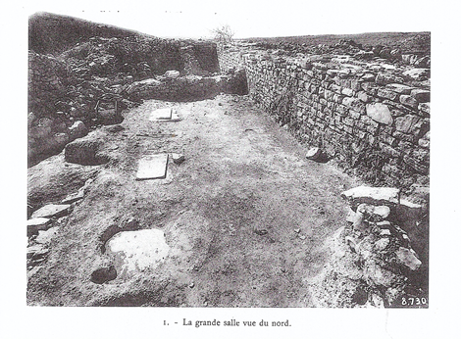
From Judith Marquet-Krause’s findings at et-Tell: The floor of the central chamber of the fortified palace from the Bronze Age found at the top of the tell. On the floor, one can make out the bases of the pillars that supported the ceiling. (Syria, 1935)

What happened next shocked the world of Biblical archaeology. Marquet-Krause’s findings, published in 1935, were dramatically different from what most had anticipated. As it turned out, et-Tell was a highly fortified city in the Early Bronze Age, long before our forefathers entered the scene. The site contained a fortified temple-palace compound, a municipal reservoir and a double line of walls and gates. The city was destroyed by fire in approximately 2100 BCE and since then only ruins remain. On top of these ruins, in one section of the tell, an unfortified village was established at some point during the Iron Age I (pre-monarchic Israelite period). The village was inhabited for 150-200 years until it was abandoned. No evidence of activity from other periods of history was found.

What this meant, as people immediately realized, was that the large, fortified city had already been destroyed before Abraham arrived in the land of Canaan, and the small, unfortified village was not built until long after Joshua’s conquest of Ai. Instead of helping to solve some of the Bible’s mysteries, Marquet-Krause’s archaeological findings only generated more of them.

It may be difficult to appreciate today the extent of the uproar that these findings caused, particularly in the scientific community of pre-state Israel. Much of this community was dedicated wholeheartedly to the cause of unearthing Biblical and national roots in the land of Israel, in the hopes of reinforcing the Zionist claims on the land.

A fascinating correspondence demonstrating this acute sentiment has come into my possession, and I am publicizing it here for the first time in a non-Hebrew publication. My late uncle Prof. Samuel Klein was then the head of the Land of Israel Studies department at the Hebrew University and of the Israel Exploration Society and editor of the prestigious Hebrew journal Yedi’ot Ha-chevra La-chakirat Eretz Yisrael Ve-atikoteha. Judith Marquet-Krause sent a report of the findings from her excavation for publication in Yedi’ot, along with an attached request that the journal refrain from changing any details from the report. When Marquet-Krause was informed that her article was not in the hands of an anonymous editorial board, but rather was being overseen by the eminent Prof. Klein himself, she immediately retracted her request. In a letter to Prof. Klein dated Sunday, December 1, 1935, Marquet-Krause writes:

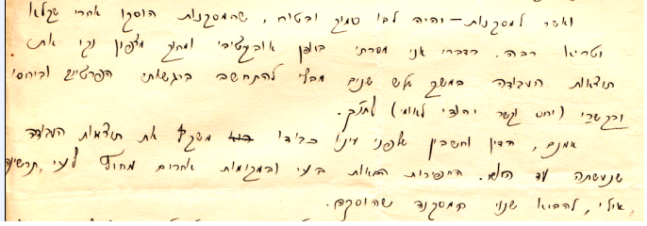
“Rest assured that the conclusions were reached only after extensive debate… without the involvement of my personal emotions…”
From Judith Marquet-Krause’s letter to Samuel Klein

…As to the findings – rest assured that the conclusions were reached only after extensive debate. I have submitted, objectively and with a clear conscience, the results of my work over the course of three years, without the involvement of my personal emotions or of my attitudes or connections (Jewish national attitudes and connections) to the Tanakh.

Indeed, the report that sits before your honor's eyes represents the findings of the work that has been done until today. Future excavations in Ai and in other locations outside of Ai may allow us to arrive at different conclusions from those that were reached.

In a few days, an exhibition will take place at Mikveh Israel at which all of the findings of the Ai excavation will be displayed (you are invited in advance to this exhibition, the opening date of which I will inform you of personally), and I am certain that in light of what will be presented there you will undoubtedly come to the same conclusion as I have, or to a similar one. But for the time being I hope that you will allow me to present before you in writing the reasons that caused me to express the position that I took in my article.

Over the course of three years in Ai, we excavated several locations within the tell, and we were unable to find any remains of settlement during the period between 2000 BCE and 1450 BCE, as the Early Bronze Age city was completely destroyed by 2000 BCE. You will certainly agree that in order to prove the existence of a small kingdom at the time of Joshua’s conquest, it would have been necessary to produce some remains of settlement from around 1450 BCE. Some remains of this kingdom, however negligible, should have been discovered at one of the excavation points. But we only found remains from two periods: the Early Bronze Age (3000-2000) and the Iron Age (1200-1000). This indicates that the city was destroyed long before Joshua arrived and remained abandoned for approximately 800 years.

In light of this, we may propose several hypotheses: a) though the tell fits the general topographical description in the book of Joshua, it is not, in fact, Ai (no one supports this hypothesis); b) a different city was conquered, whose name was switched with the name of the city of Ai (in which case we should not be using the Biblical descriptions to identify the location of Ai); and c) the great importance that Ai possessed until its destruction in 2000 BCE (and its ruins were important as well, as the name “Ai” [literally, heap of ruins] testifies) gave rise to the story of its conquest as recorded in the book of Joshua.

It can also be assumed that the upcoming excavations will lead to a change in our conclusions: In due time we may find, in some corner of the tell, remains of settlement from the Middle and Late Bronze Age (remains from these periods, as you know, have been found in many tells throughout the land: Gezer, Jericho, Bethel, etc.).

These conclusions, which I have detailed in my article, are drawn from the results of the excavations conducted to date. As God is my witness, I hope to find evidence that corroborates the Biblical narrative in the upcoming excavations.

I would be delighted to learn that I have succeeded, even slightly, in explaining to you the reasons that led me to the conclusion that is expressed in my article. When you visit Mikveh Israel you will find corroboration for my position in light of the findings. However, if you decide that this position should not be publicized for religious or national reasons, I will take your view into consideration and will not object to concluding my article with a broad summary of the findings.

It would be my pleasure to read your opinion regarding this matter.

With great respect and with great admiration,
Judith Krause

Prof. Klein responded briefly, writing:

…As to the heart of the matter, I am certain that your intentions are good, and I too hope that, in the upcoming period you will find the proofs – and I am almost certain you will – that this is truly Ai and that there was settlement there before the period of the conquest, in a location that has not been excavated to date.

Due to my heavy workload, I must be brief, but I would like to express my thanks for the invitation to the exhibition at Mikveh Israel. Of course, I will make an effort to attend.

With great respect and endearment,
S. K.

Klein’s hopes were dashed twofold: Judith Marquet-Krause died suddenly a few months after their correspondence, and the archaeologists who followed her in excavating the tell found remains from neither the Patriarchal age (Middle Bronze Age) nor the period of the conquest (Late Bronze Age). In a letter of condolence sent by Klein to the Krause family on July 7, 1936, he mentioned Judith’s letter, calling it “a letter full of both scientific and Jewish insight.”

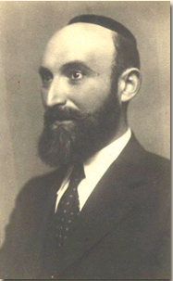
Prof. Samuel Klein (1886-1940)

How Can We Reconcile the Torah and the Archaeological Findings?

In light of the findings, a variety of critical views on the story of Joshua’s conquest of Ai have been accepted by historians. The renowned scholar William F. Albright posited that the Biblical narrative originally described the conquest of Bethel, rather than Ai, but over the course of time the details of the story changed. Other scholars, such as Martin Noth, took a more extreme position, seeing the story of Ai’s conquest as part of an Israelite corpus of fictional, etiological myths. In other words, these are legendary stories that serve to explain the origins and characteristics of significant geographic locations.

According to Noth, “Ai” did not refer to any particular location – it was a common noun, simply meaning “ruins,” similar to the later Arabic name “Khirbet et-Tell,” which was named for the ruins of the ancient city that lay abandoned 1,000 years before the Israelites arrived. When they did arrive, Israelite children from a neighboring village would ask their fathers how this formerly great city became the ruins that they now beheld. Not knowing the true history, the fathers would respond by connecting the destruction of the ruin with Joshua, the legendary Israelite warrior. Other scholars claimed that the identification with Joshua’s Ai stems from a kind of “transference” from the story of the battle between the Israelites and the Benjaminites at Gibeah, found in Judges 20.

Other writers, particularly those who took a more traditional approach, began to search for Ai in various other unlikely locations. One scholar placed Ai in the vicinity of Jericho, one declared that the ancient city could be found further south, near Michmas, while another placed it further north, in the vicinity of ‘Ain Samiya, north of Kochav HaShahar. Unfortunately, none of these theories fits the description of the Biblical text, which states plainly: “Ai, near Bethel” and “Not a man was left in Ai or in Bethel who did not go out after Israel.” Recently, Bryant G. Wood raised the possibility that throughout history, the name “Ai” was never associated with one distinct location. Rather, the name bounced about from place to place, and each of these places was known as “Ai” at one period of time.

Grintz’s Analysis

At this juncture, I will present the brilliant analysis of Prof. Yehoshua Meir Grintz, z”l. Grintz was a Bible scholar and Jewish historian who possessed broad knowledge in the areas of both Ancient Near Eastern languages and culture and the Classical World. His innovative interpretations demonstrated a keen eye for detail and a tendency to accept the Biblical narrative as it is, rejecting both historical and literary Biblical criticism. I quoted Grintz approvingly in the previous chapter, and here too I find his position very compelling.

One of the guiding principles in Grintz’s methodology is his insistence on separating the respective roles of the archaeologist and the historian. The archaeologist’s role is to uncover and present new information, while the role of the historian is to analyze that information in light of the existing sources. With this in mind, let us return our attention to the question of Ai: What geographical information can be gleaned from Tanakh?

The opening verse of the Ai narrative in the book of Joshua mentions three adjacent locations: “Joshua sent men from Jericho to Ai, which lies close to Beth-aven – east of Bethel” (7:2). What does Tanakh tell us about each of these three places?

- Bethel: Bethel is mentioned during the time of Abraham and Jacob, several times in the books of Joshua and Judges, and through the time of Samuel and Saul. From the time of the post-Solomonic schism until the reign of Josiah, Bethel was home to a bama (“high place” used for sacrifice) that served as a central location in the Kingdom of Israel. In the time of Zerubbabel, some exiles returned to their former home in Bethel: “Who returned each to his own city” (Ezra 2; Nehemiah 7). Toward the end of the Biblical period, Bethel is mentioned in the latest geographical listing in Tanakh, in Nehemiah 11.

It seems clear from this wealth of information that Bethel was a continuously inhabited city throughout the entire Biblical period, from the beginning of the Patriarchal age until the time of Nehemiah.

- Ai: Ai is mentioned during the time of Abraham and thereafter only in the book of Joshua. Following the conquest of Ai, its utter destruction is described vividly: “Then Joshua burned down Ai, and turned it into a mound of ruins for all time, a desolation to this day” (8:28). In other words, the city lay desolate for a significant period of time, at least until the final redaction of the book of Joshua. However, Ai seems to return in the time of Isaiah, its name altered slightly: “He advanced upon Aiath, he proceeded to Migron, at Michmas he deposited his baggage” (Isaiah 10:28). Finally, Ai is among the destinations of the returning exiles listed in Ezra-Nehemiah, and it is mentioned one last time in Nehemiah: “The Benjaminites: from Geba, Michmash, Aija [Ai] and Bethel and its outlying hamlets” (11:31).

This seems to indicate that Ai was an inhabited city at the beginning of the Biblical period, was destroyed by Joshua and his army and lay desolate for several generations until it was resettled at some point no later than the period of the Judean Kings.

- Beth-aven: The Torah makes no mention of Beth-aven during its account of the patriarchs. However, some of Abraham’s exploits took place at the location known as “between Bethel and Ai”: This was the second place he visited in the Promised Land, and he travels there again after his return from Egypt; the conflict between his and Lot’s shepherds took place there; it is there that he and Lot agreed to part ways; there Lot “looked about him and saw how well watered was the whole plain of the Jordan” (Genesis 13:10); and it is there that God asked Abraham to look out upon the land and know that it will all belong to him and his descendants.

Since we learn in Joshua that Ai “lies close to Beth-aven,” it is curious that Beth-aven is not mentioned in any of these stories. A similar, yet more critical question can be asked regarding the story of the Battle of Ai in the book of Joshua. The text of the narrative is extremely thorough; not even the smallest details are omitted regarding the forces involved on both sides of the battle, the two different ambushes that Joshua set up between Bethel and Ai and the staged retreat: “Not a man was left in Ai or in Bethel who did not go out after Israel” (8:17). But in the midst of all this military maneuvering, where were the people of Beth-aven? Did they participate in the battle? Did they sign a treaty with Joshua in order to avoid confrontation? We learn that Ai was conquered (Joshua 12:9) and that Bethel was conquered (Judges 1:22-26), but what happened to Beth-aven?

The most straightforward answer to these questions, writes Grintz, is that Beth-aven was uninhabited during the periods of both Abraham and Joshua. However, by the time of the book of Joshua’s final redaction, this reality must have changed, as the book uses Beth-aven as a reference point for the location of Ai – “Ai, which lies close to Beth-aven” – meaning that by then Beth-aven was inhabited, and was thus a significant place on the map. The same conclusion can be reached by reading the description of the Benjaminites’ territory in Joshua 18:12. Beth-aven is mentioned two more times in I Samuel 13-14, in the story of Saul’s war with the Philistines: “They encamped at Michmas, east of Beth-aven” (13:5); “The fighting passed beyond Beth-aven” (14:23) – indicating that Beth-aven was still inhabited at that point.

From this point on, Beth-aven is not mentioned explicitly in Tanakh, at least not in the sense of a distinct location. The name does appear in the prophecies of Hosea and Amos, but there it is used as a derogatory reference to Bethel and its history of calf worship: “For Gilgal shall go into exile, and Bethel shall become a delusion (le-aven)” (Amos 5:5); “The inhabitants of Samaria fear the calf of Beth-aven” (Hosea 10:5). Grintz explains that the name “Beth-aven” took on this new role because, since the actual town known as Beth-aven had been deserted by the time of Hosea and Amos, its name became available for use as a derogatory nickname for nearby Bethel.

It seems, therefore, that Ai and Beth-aven maintained a kind of inverse relationship throughout history, evoking Chazal’s statement on the relationship between Jerusalem and ancient Caesarea: “If one says to you that both are destroyed, do not believe him; if he says that both are flourishing, do not believe him… if this one is inhabited, that one is destroyed, and if that one is inhabited, this one is destroyed” (Megilla 6a). From the Patriarchal age to Joshua’s conquest of the land, Ai was inhabited and Beth-aven was abandoned. Then, during the time of the tribal allotments of the land and the redaction of the book of Joshua, through the time of Samuel and Saul, the converse was true: Beth-aven was inhabited and Ai was destroyed. Finally, during the time of Hosea, Amos, Isaiah and seemingly thereafter until the end of the Biblical period, Ai once again became inhabited and Beth-aven returned to its former state of desolation.

What could be the explanation for this inverse relationship between Ai and Beth-aven? As the two towns were clearly located in close proximity to each other (“Ai, which lies close to Beth-aven”) and likely supported themselves by farming the same agricultural area, it may be that there was simply not enough room for two towns to survive on one shared tract of land. Because of this, only one of the two towns was able to exist at any given point in time, creating a kind of historical rotation.

Now that we have established a working Biblical chronology for Bethel, Ai and Beth-aven, our next step is to translate this chronology from Biblical periods to archaeological periods. Without getting too entangled in the intricacies and points of debate that are inherent in this task, we can present the following basic timeline: David and Solomon reigned during the 10th century BCE, David’s reign having begun in approximately 1000 BCE. According to I Kings 6:1, Solomon built the First Temple in the 480th year following the Exodus from Egypt, meaning that the Exodus took place in approximately 1450 BCE. About 400 years passed between the time of Abraham and the Exodus, meaning that the events involving Abraham in the land of Canaan took place in 1900-1800 BCE. In the world of archaeology, the period between Joshua's conquest of the land of Canaan and the reigns of David and Solomon is known as the Israelite Period I, or alternatively, the Iron Age I. The period during which the Exodus and the conquest of Canaan took place is known as the Late Canaanite Period or the Late Bronze Age (LB). Finally, the Patriarchal age is known as the Middle Canaanite Period or the Middle Bronze Age (MB).

The following table may help illustrate how the information we collected regarding Bethel, Ai and Beth-aven fits into the archaeological timeline we just established:

 | Bethel | Ai | Beth-aven
Patriarchal age (MB: 1900-1800 BCE) | inhabited | inhabited | uninhabited
Conquest of Canaan (LB: c. 1400 BCE) | inhabited | inhabited | uninhabited
Redaction of Joshua, Judges and Samuel (Iron I to 1000 BCE) | inhabited | uninhabited | inhabited
Kingdoms of Israel (Iron II-III: 1000-586 BCE) | inhabited | inhabited | uninhabited
Return to Zion (Persian period: 5th-4th century BCE) | inhabited | inhabited | uninhabited

Now let us build a parallel table for the archaeological findings from the two relevant sites in the region – Beitin and et-Tell. Note the addition of a new first row representing the Early Bronze Age (EB).

 | Beitin | Et-Tell
Early Bronze Age until 2000 BCE | uninhabited | inhabited (large, fortified city)
Middle Bronze Age: 2000-1550 BCE | inhabited | uninhabited
Late Bronze Age: c. 1400 BCE | inhabited | uninhabited
Tribal allotments to David’s reign (Iron I to 1000 BCE) | inhabited | inhabited (small, unfortified town)
Kingdoms of Israel (Iron II-III: 1000-586 BCE) | inhabited | uninhabited
Return to Zion (Persian period: 5th-4th century BCE) | inhabited | uninhabited

The first row in this table (Early Bronze Age) is irrelevant for our purposes, as it describes the period before Abraham arrived in the land of Canaan. But contained in the remainder of the table is a startlingly clear solution to the problem of Ai. As we expected, the Beitin findings are completely in sync with the Biblical account of Bethel. The shocking revelation here is the following: Not only are the et-Tell findings the absolute converse of the Biblical account of Ai, they are in perfect accord with that of Beth-aven! Indeed, it seems clear from this analysis that et-Tell is not Ai at all, but Beth-aven, a small, unfortified Israelite town built on part of the ruins of a huge, fortified, ancient Canaanite city. This Canaanite city existed only in the pre-Abrahamic period, and thus bears no connection to the history of the people of Israel.

Now that we have successfully located Beth-Aven, we are still left with one problem: Where is Ai? According to the Biblical sources, it must be located in close enough proximity to Beth-aven that it was necessary to share farmland with its neighbor. In fact, it is likely that the ruins of Ai can simply be found in a section of et-Tell that has not yet been excavated, perhaps buried beneath part of the adjacent town of Deir Dibwan.

It is critical to stress that the mere lack of archaeological evidence for this claim is no proof of its illegitimacy. Many important sites appear completely innocuous – like unremarkable open areas – before they are excavated. Take, for instance, Tel Muqanna (Miqne) in the Shefela lowlands, which scholars today unanimously identify with the ancient Philistine city of Ekron. This tell is one of the largest in country, but before it was excavated one would have had great difficulty discerning the site from the rest of the landscape. The same is true of Tel Ashtarah in the Bashan region: Early researchers refused to identify it with the city of Ashtaroth, due to the area’s “wretched appearance.” Then archaeologists excavated the site and the findings reflected the existence of a large, fortified tell. This same phenomenon transpired even at et-Tell itself: When Edward Robinson visited in 1838, he suggested that the tell was not an ancient site at all! Whether the tell is Ai or not, it is clear that Robinson erred in this particular claim.

This kind of retrospective analysis of the attempts of scholars throughout modern history to locate Ai enables us to zero in on a fundamental failing on the part of many of them. Scholars recognized Ai from its repeated mention in Abraham’s narrative and from its role in the long, dramatic battle story in the book of Joshua. When a large, impressive tell was found in the Benjamin region, these scholars rushed to find evidence of Ai therein (and many then proceeded to deny the veracity of the Biblical narrative when the expected findings did not materialize). However, if these scholars had simply analyzed the Biblical texts more closely, they could have easily rejected the possibility that Ai was located at et-Tell without the use of a single shovel or hoe. As it turns out, there is not always a correlation between how long or memorable a city’s narrative is and the city’s actual size. In the case of Ai, the book of Joshua implies that it was not a particularly large city, stating that Gibeon was a larger city than Ai (10:2). The location of ancient Gibeon is known to us, and the area of its ruins spans approximately 50 dunams, less than half the size of et-Tell.

Finally, it may not be necessary to reject Noth’s position – that “Ai” was a generic expression meaning “ruins” – in its entirety. In fact, it seems very likely that the location known as “Ai” in Abraham’s time was named for the ruins of the large Canaanite city that had been destroyed years earlier. Whether Ai was built directly atop these ruins or in their general vicinity, they were undoubtedly one of the defining geographical landmarks of the region, providing a compelling explanation for the choice of the name “Ai.”

For further study:

Y. Bin-Nun, “‘Ba al Aiat’ – Pitaron Chadash Le-zihui Ha-Ai,” Judea and Samaria Research Studies 2, Kedumim-Ariel 1993, 43-63 [Hebrew].

J. A. Callaway, “Ai,” Anchor Bible Dictionary, 1, 125-130.

Y. Elitzur, “Madu’a I Efshar Lezahot et Ha-Ai Be-Ein Samiya? Hasagot Le-hatza’ato shel Ha-rav Yoel Bin-Nun”, Judea and Samaria Research Studies 2, Kedumim-Ariel 1993, 63-64 (also see 64, “Teshuvat Yoel Bin-Nun Le-he’arat Yoel Elitzur”) [Hebrew].

J. Garstang, Joshua Judges, London 1931, 149-161, 355-356.

Y. M. Grintz, “Ai which is beside Beth Aven,” Studies in Early Biblical Ethnology and History, Tel-Aviv 1969, 278-289 [Hebrew].

D. Livingston, “One Last Word of Bethel and Ai,” BAR 15 (1989), 18-30.

B. Z. Luria, “Mekomah shel Ha-Ai,” Iyunim Be-sefer Yehoshua: Diyunei Ha-chug Le-mikra Be-veit David Ben-Gurion, Jerusalem 1971, 12-41 (note the responses of scholars therein!) [Hebrew].

S. Riklin, “A New Proposal for the Identification of the City Ha'Ai near Ma’aleh Michmash,” Judea and Samaria Research Studies 5, Kedumim-Ariel 1996, 27-32 [Hebrew].

B. G. Wood, “The Search for Joshua’s Ai,” R. Hess, G. A. Klingbeil and P. J. Ray (eds.), Critical Issues in Early Israelite History, Winona Lake 2008, 205-240.

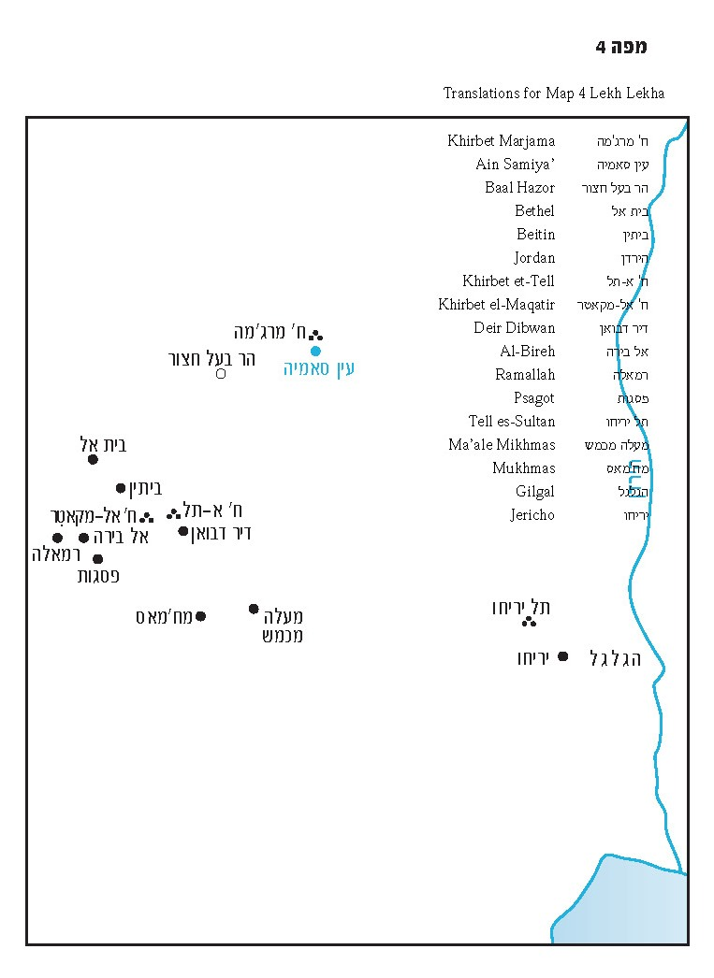

Rashi notes that this sequence can be interpreted in two ways: either that Abraham traveled to the place where he had invoked the Lord by name earlier, or that he invoked the Lord by name anew in that very same place.
That Joshua was able to hide such a vast number of troops between the two cities is a result of the uniquely wooded topography of the region, referenced in the story of Elisha and the bears (II Kings 2:23-25).
See map at end of shiur.
This reckoning follows an early chronological system that dates the Exodus circa 1450 BCE and the conquest of Canaan circa 1400 BCE. This chronology, which was accepted by Garstang and others, was rejected by most scholars. According to the common position among Bible scholars, the Exodus and Conquest actually took place nearly 200 years later than this. However, this position is inconsistent with the Biblical text. We shall discuss this when we reach Parashat Shemot.
Scholars who adopted this theory evidently overlooked the fact that the Ai narrative in Joshua is not a story of miracles and bravery. Rather, it is one of initial military failure and, following this, of a planned war featuring superior forces and advanced deceptive tactics.
Wood invokes the view of the late David Livingston, who assigned the same phenomenon to the city of Bethel as well.
Some place the beginning of David’s reign in 1010 BCE. This calculus factored into Israel’s decision to celebrate the trimillenial anniversary of the city of Jerusalem in 1997.
See above n. 4.

