YESHIVAT HAR ETZION
ISRAEL KOSCHITZKY VIRTUAL BEIT MIDRASH (VBM)
*********************************************************

The Path of the Piaseczner Rebbe
By Dr. Ron Wacks

Shiur #05: R. Kalonymus’s Written Works (Part I)

R. Kalonymus saw great value in writing, especially writing about chassidut, as we will see. His surviving works include the following.

1) Chovat Ha-Talmidim (Warsaw, 5692)

This was the only book that was published during his lifetime. The book addresses boys studying at yeshiva and instructs them in the chassidic approach to work on their Divine service.

The reader almost hears the Rebbe’s voice speaking to him: “Young Jewish man, take note of this rule: In this matter, and in all matters, if you do not exert yourself and try with all your might to remove and uproot every negative trait and folly that is still with you from your childhood, it will remain part of you and harm you.” In this book, R. Kalonymus discusses the difficulties facing an adolescent boy and offers practical advice on how to deal with his weaknesses and failures, his laziness and his desires, and how he might arouse and strengthen his inner powers.
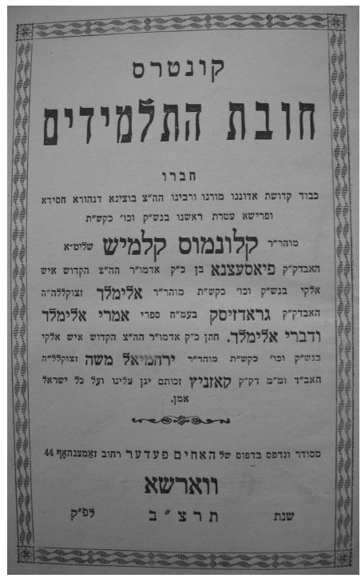
Front page of the first edition of Chovat Ha-Talmidim

The second part of the book is intended as a next step for those who have successfully implemented the first part. It consists of three essays. The first deals with the proper way to study books of chassidut; the second discusses Torah and prayer; and the third focuses on Shabbat.

The introduction to the book is meant for educators. It sets forth R. Kalonymus’s educational approach (which we will discuss at length at a later juncture).

2) Benei Machshava Tova (Tel Aviv, 5733)

This volume is intended for an organized group of exemplary individuals. R. Kalonymus seeks to revive the ancient idea of a chabura (fraternity), as manifest, for example, in the groups of “sons of the prophets” mentioned in Sefer Melakhim; the chabura of R. Shimon bar Yochai and his disciples in the Zohar; the Ari and his chabura in Tzefat; and the chabura of the Ba’al Shem Tov and his followers. This book offers practical guidance on using thought and imagination to achieve closeness to God. R. Kalonymus sent the book to his brother, R. Yeshayahu Shapiro, in Jerusalem, with the intention that he would have it printed. It was distributed only to individual students who accepted upon themselves the commitments set down in the book.

From the wording of the text, it is clear that this book was written before the more detailed Hakhsharat Ha-Avrekhim and Mevo Ha-She’arim, and a number of paragraphs from Benei Machshava Tova are in fact incorporated into those works. We shall discuss this book at greater length at a later point.

3) Hakhsharat Ha-Avrekhim (Tel Aviv, 5722)

This book is a continuation of Chovat Ha-Talmidim and a sort of introduction to a work entitled Chovat Ha-Avrekhim, which was never completed. It deals with practical guidance in Divine service, such as the way to acquire inspiration and fervor, methods of contemplation and thought, the chabura, the tzaddik, and more.

The author deposited his book with the Oneg Shabbat underground archive in the Warsaw Ghetto, headed by historian Dr. Emmanuel Ringelbaum, who documented the lives of Jews in Warsaw and in Poland under Nazi occupation. R. Kalonymus’s works were hidden, along with many other documents belonging to this archive, in milk cans that were buried in the ground of the ghetto. After the war, in December 1950, they were discovered by Polish construction workers who were digging the foundations for a building. The works reached the history committee of the Central Council of Polish Jewry, which in later years became the Jewish Historical Institute. R. Kalonymus’s other works – Esh Kodesh, Hakhsharat Ha-Avrekhim, Mevo Ha-She’arim, and Tzav Ve-Ziruz, were discovered in the same manner.

4) Mevo She’arim (Tel Aviv, 5722)

This book is the third part of the trilogy that includes Chovat Ha-Talmidim and Hakhsharat Ha-Avrekhim, and also serves as the first section of Chovat Ha-Avrekhim, which the author never completed. It deals mainly with the manner and meaning of Divine service through prophecy, as well as its connection to kabbalah and to chassidut. An extensive introduction discusses the chassidut of the Ba’al Shem Tov and its innovations in Kabbala.

5) Tzav Ve-Ziruz (Tel Aviv, 5722)

This is a collection of brief thoughts about the feelings and practices associated with Divine service, especially as relating to prayer and supplication. The author periodically shares the discourse of his inner world, exposing his own spiritual character. The following excerpt is an example:

Thank God, I am already in my fortieth year of life and in a few months it will be my fortieth birthday. After that begins the decline of life, the beginnings of my old age… So what am I missing? Simply to be a Jew… You I beseech… Help me – I want to become a simple Jew!

The book also offers guidance on various topics: improvement of one’s character, time management, achieving closeness to God, meditation, personal accounting, and more. Although it includes some personal elements, the volume was written for others and not only for R. Kalonymus’s personal use, as evidenced by the fact that he referred his students to it.

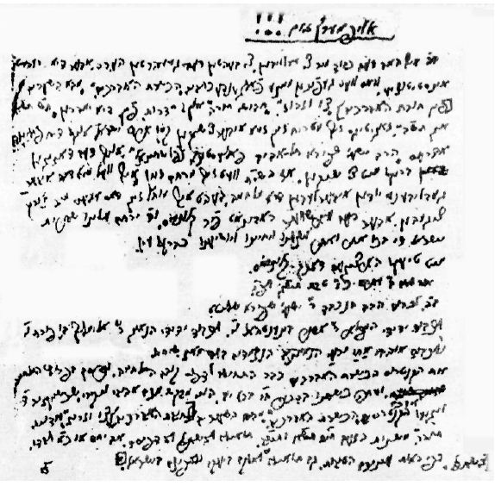
R. Kalonymus’s will, found buried in the ground of the ghetto, along with his writings

6) Esh Kodesh (Jerusalem, 5720)

This is a book of the sermons that R. Kalonymus delivered on Shabbat and festivals in the Warsaw Ghetto in the years 1940-1942. It has been researched extensively owing to its unique value as an authentic document reflecting R. Kalonymus’s grappling with the religious challenge presented by the Holocaust. An accurate edition, based on the author’s manuscript, was recently published by Daniel Reiser, entitled Derashot Mi-Shenot Ha-Za’am.

7) Derekh Ha-Melekh (Tel Avv, 5736)

A collection of sermons and Torah insights delivered on Shabbatot and festivals. Every week, the Rebbe would personally record his insights under the title Derekh Ha-Melekh. He would then give the material to one of his students for copying, since it was his hope that it would be printed at some point. Some of this material was copied by students who moved to Palestine prior to the Holocaust. The second edition of the book (Tel Aviv, 5758) features some important additions, including Torah insights from R. Kalonymus’s father, R. Elimelekh, which had not appeared in his other works; the introduction to R. Kalonymus’s book on the Zohar, which is no longer extant except for one short essay (p. 434); the Shabbat Shuva sermon of 5696 in Piaseczno (printed in Warsaw); an educational essay; a method for quieting the mind (which we will discuss further); some letters; and more. The lengthy sermons treat fundamental subjects in Divine service, most of which are also discussed in R. Kalonymus’s methodological works. Thus, even in his sermons on Shabbat and festivals, the Rebbe touched on the same subjects that occupied him constantly: prayer, emotion, enthusiasm, use of the imagination, Torah study, Shabbat, perfection of one’s character, and so on.

(To be continued)
Translated by Kaeren Fish

Some of these works have been translated into English, and we shall cite from these translations in later chapters.
Chovat Ha-Talmidim, p. 67.
R. Kalonymus mentioned the book in a discourse he delivered to the students of his yeshiva in the year 5681 and in a later discourse in 5690 (Derekh Ha-Melekh, pp. 53, 449), such that we are able to estimate when it was written. Z. Leshem (Bein Meshichiyut Le-Nevua: Ha-Chassidut al pi Ha-Admor Mi-Piaseczna, p. 6) notes correctly that the date 5681 should be viewed with some scepticism, since the yeshiva was founded only in 5683.
On the importance of the chabura, see Hakhsharat Ha-Avrekhim, p. 144.
Melakhim II 2.
For more on the printing of this book, see Reiser, Derashot Mi-Shenot Ha-Za’am, pp. 38-41.
See the author’s introduction to Hakhsharat Ha-Avrekhim.
A single essay remaining from the great work Chovat Ha-Avrekhim appears at the end of Derekh Ha-Melekh, pp. 438-440.
For more on the concealment and discovery of the writings, see Shmuel D. Kassov, Mi Yikhtov et Ha-Historia Shelanu (Jerusalem, 2014), p. 183, but cf. Reiser, Derashot Mi-Shenot Ha-Za’am, p. 31.
As recorded in the publisher’s introduction to Esh Kodesh, 5720 edition, as well as the publisher’s introduction to Hakhsharat Ha-Avrekhim, which reads: “We give thanks to the blessed God for the merit of publishing the works Hakhsharat Ha-Avrekhim, Mevo ha-She’arim, and Tzav Ve-Ziruz, the works of our holy rabbi and teacher, the Admor of Piaseczno, Hy”d, who hid them deep in the wretched ground of the Warsaw Ghetto during the Holocaust in 5703.”
To Heal the Soul (Tzav Ve-Ziruz), p. 45-46. For discussion of the concealment of the writings and their discovery, see Reiser, Derashot Mi-Shenot ha-Za’am, pp. 27-53.
See Derekh Ha-Melekh, p. 449.
For more on the students who transcribed these sermons and the printing of the book, see Reiser, Derashot Mi-Shenot Ha-Za’am, pp. 42-45.

