YESHIVAT HAR ETZION
ISRAEL KOSCHITZKY VIRTUAL BEIT MIDRASH (VBM)
*********************************************************

GEOGRAPHY IN THE PARASHA

*********************************************************
Dedicated to Liora & Ari Tuchman - In honor of the Bat Mitzvah of Danelle Sophia and in Honor of the Birth of their son, Adin Emanuel
*********************************************************

*********************************************************
This week’s shiurim are dedicated in memory of Herschey Hawk z”l
by Dr Jerry Hawk
********************************************************

PARASHAT VAYISHLACH

The Parcel of Land in Shechem
By Prof. Yoel Elitzur

“The Parcel of Land” in Genesis and Joshua

The second place in the Land of Israel, following the cave of Machpelah, to have been purchased by one of our patriarchs, and the first place where Jacob built an altar and invoked the name of God, is the “parcel of land” in Shechem:

Jacob arrived safe in the city of Shechem which is in the land of Canaan – having come thus from Paddan-aram – and he encamped before the city. The parcel of land where he pitched his tent he purchased from the children of Hamor, Shechem's father, for a hundred kesitahs. He set up an altar there, and called it El-elohe-yisrael. (Genesis 33:18-20)

Centuries later, in the time of Joshua, the parcel of land is revisited:

The bones of Joseph, which the Israelites had brought up from Egypt, were buried at Shechem, in the parcel of land which Jacob had bought for a hundred kesitahs from the children of Hamor, Shechem's father, and which had become a heritage of the Josephites. (Joshua, 24:32)

This verse is part of the book of Joshua’s epilogue. Most of the book tells the story of the conquest and apportionment of the land, but the final verses list the burial sites of three luminaries: Joshua, the nation's leader; Eleazar, the high priest; and Joseph, whose burial symbolizes the connection between the patriarchs and their descendants, who are now settling the Promised Land. Note how the text describes Joseph’s burial site: It is known, first and foremost, as the “parcel of land” that Jacob purchased, to which the people of Israel later added Joseph's remains.

Joseph's Tomb in the Last Twenty Years

It is impossible to speak today about Joseph's burial site without getting into a bit of politics. Joseph's Tomb in Shechem is the historical site that is perhaps the most apt microcosm of the sociopolitical events of the past two decades in Israel. First, the site was attacked on two separate occasions by a violent Arab mob, in September 1996 and in September 2000. In each instance, the Israeli government refused to act like a sovereign nation that protects its property and its people, turning instead to the Palestinian Authority to free our trapped soldiers. In each instance, the result of that decision was a loss of lives and severe property damage; all in all, these were degrading incidents and desecrations of God's name.

In the first attack, six Israeli soldiers were killed, seven others were injured and several military vehicles were burned. In the second attack, Madhat Yusef, a member of the Israel Border Police from the Druze village of Beit Jann, was killed. He died from loss of blood as a result of his wounds on the second day of Rosh Ha-shana, after four hours during which the Arab mob prevented his rescue. On the night of Shabbat Shuva, the IDF abandoned Joseph's Tomb, while the Arabs, despite their assurances to the contrary, shot at the vehicles making their retreat. The Arab mob then stormed the site, burning it and destroying it. Hillel Lieberman of Elon Moreh, who had rushed to the Tomb wrapped in a talit, was murdered. When his bullet-ridden body was finally found and taken for burial in the neighboring settlement of Yitzhar, the funeral was interrupted by gunfire from rioting Arabs.

Ever since then, Joseph's Tomb has not been in Israeli hands. However, many still return to the site intermittently, usually in coordinated night visits under army guard, but sometimes in unauthorized visits as well. On April 24, 2011, Palestinian Authority police officers shot at and murdered 24-year-old Ben-Yosef Livnat, who came to pray at Joseph's Tomb.

Through the 1980s and 1990s, some in Israel have voiced doubts as to the authenticity of Joseph's Tomb. Shulamit Aloni, then Israel's Minister of Education, asserted in several media interviews that, based on the research of archaeologist Meir Ben-Dov, the site is merely a late Arab grave of a certain Sheikh Yusuf, who lived only 200 years ago. In an issue of Haaretz from 1986, in connection with its coverage of the events at Joseph's Tomb, a short background piece was published – with no attribution – with the headline: “Archaeologists: Joseph's Tomb in Shechem Belongs to Muslim Sheikh.” The body of the article contained an authoritative declaration:

The site known as “Joseph's Tomb” near Shechem is a structure that was apparently erected during the Mamluk Period as a tomb for a Muslim sheikh… According to archaeologist Meir Ben-Dov, the structure of the tomb fits the distinctive style of the tombs of Muslim sheikhs that were built in the country during the Mamluk and Ottoman Periods. It was the local tradition of the small Jewish community, which existed in the Shechem region during the last century and at the start of the present century, that identified the tomb of Joseph with this site. He noted that many traditions were created in a similar manner in the Middle Ages, by identifying the burial sites of various other characters from Jewish history.

Haaretz (10/15/86): “A tomb for a Muslim sheikh”

On May 4, 1990, a Hakhnasat Sefer Torah took place at Joseph's tomb, celebrating the addition of a new Torah scroll to the yeshiva located there. Following this event, which was attended by ministers and senior members of the Likud Party, an even more extreme article on the matter appeared in Haaretz, this time penned by Ben-Dov himself. He wrote:

The Hakhnasat Sefer Torah at the yeshiva at Joseph’s Tomb that took place yesterday is based on an error. Anyone who thought that he was entering the tomb of Joseph, son of Jacob, was actually entering the opening to the tomb of a Muslim sheikh, a domed structure that was built 200 years ago. There is not even a hint of a connection between this site and the tomb of Joseph. Not one iota of information exists as to the location of Joseph’s tomb, to which, according to tradition, Joseph’s remains were brought from Egypt. The veneration of holy burial sites in Judaism is a later phenomenon that did not exist when the nation of Israel still lived in the Land.

In this vein, countless newspaper articles from that period – even, to some extent, in more right-leaning venues – gave the impression that the “scientific truth” is that the traditional location of Joseph’s Tomb is actually a marginal Muslim site; any belief in its significance to the Jewish people is rooted in religious folklore, like the countless “holy burial sites” in the Galilee and in other regions around the country. The religious journalist Michael Shashar wrote in Maariv on December 21, 1993:

Moreover, anyone who is familiar with the history of the Land of Israel and the history of burial sites in the Land of Israel knows that it is absolutely clear that what is presented today as Joseph’s tomb is not Joseph’s tomb…

Echoing Shashar, Orientalist Yehoshua Porat wrote in Maariv on October 16, 1996:

Joseph’s Tomb and Rachel’s Tomb – how little they have in common, despite the linguistic similarity… the belief that Joseph is buried there is an Islamic folk tradition. The religious folklore of the Muslims in this land consecrates many sites as, according to folk tradition, burial sites of Biblical characters who are considered prophets in Islam, or of various Islamic personalities. Until 1967, Joseph’s Tomb did not exist in the Jewish historical consciousness. No one went there on a pilgrimage, it was not customary to pray at the site, it was not listed in descriptions of Jewish travelers and pilgrims and it was not a symbol of national identity… only after 1967 came the turning point. As a result of zealots among us, who thought that we needed to seize a stronghold in the heart of Samaria, within a crowded town of hundreds of thousands of Arabs, they turned Joseph’s tomb into a Jewish place of worship and pilgrimage and established a yeshiva alongside it…

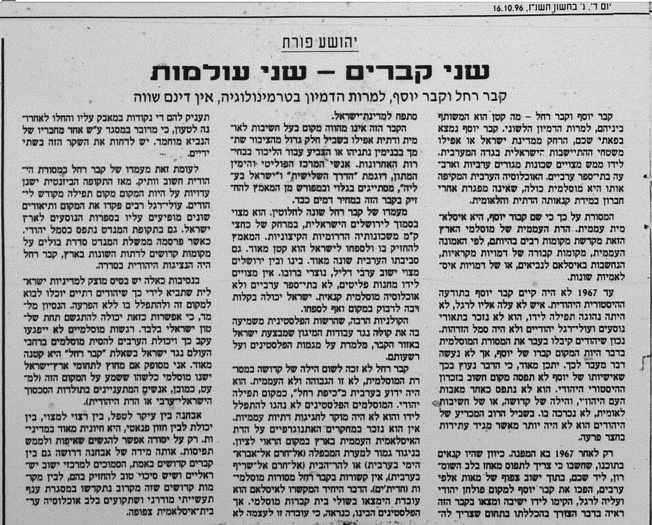
Prof. Yehoshua Porat in Maariv (10/16/96): “The belief that Joseph is buried there is an Islamic folk tradition.”

It may very well be that the Israeli government’s lack of desire to protect Joseph’s Tomb during the events leading up to the army’s humiliating abandonment of the site was significantly influenced by this version of reality depicted in the Israeli media.

In truth, anyone who is even slightly familiar with the geography and history of the Land of Israel knows that the statements presented above contradict both the facts on the ground and the historical sources, and simply represent wishful thinking on the part of their writers. It is truly regrettable that, at the time those statements were made, no clear voice of protest from the experts in the field – outside the political framework – was heard. All that would have been required to debunk the claims of inauthenticity is to present some basic information and sources regarding Joseph’s Tomb. In this shiur, I will try, albeit belatedly, to do just that – to provide a small, concentrated amount of material about the site and its origins. I will also cite early accounts from individuals who described the site, demonstrating that the site we know today as Joseph’s Tomb was known and venerated by the inhabitants of the Land of Israel for thousands of years. I will trace the connection to the site that the Muslims claim to possess, and I will close with considerations in analyzing the region in light of the Biblical text.

Selected Accounts of the Site from the Roman-Byzantine Period

- John 4:4-6: “Now, he had to go through Samaria. So he came to a town in Samaria called Sychar, near the parcel of land Jacob had given to his son Joseph. Jacob’s well was there…”

The significance of this New Testament source is, first, the indication that the “parcel of land” was a well-known place at the time the Gospel of John was written (toward the end of the first century CE or a little later), used as a point of reference to identify the location of the city of Sychar. In addition, the description of the geography here is quite rich in detail. The source does not mention Shechem, which was destroyed at the time, nor does it mention Neapolis, which was only founded in 72 CE. Sychar has been identified with great certainty with the village of Askar (based on many sources, in particular the Samaritan chronicles), whose ancient center is located about 2,000 feet northeast of the modern Joseph’s Tomb. “Jacob’s well” apparently refers to the deep (100 feet) ancient well about 1700 feet south of Joseph’s Tomb (located today within the grounds of an Eastern Orthodox monastery).

- Bereishit Rabba 79:19:

“The parcel of land… he purchased…” (Genesis 33:19). Rabbi Yuda son of Rabbi Simon [early fourth century CE] said: “This is one of the three places of which the nations of the world cannot defraud Israel, saying that we stole them from them. They are: the cave of Machpelah, the Temple and the tomb of Joseph. The cave of Machpelah – ‘Abraham paid out to Ephron’ (Genesis 23:16). The Temple – ‘So David paid Ornan’ (I Chronicles 21:25). The tomb of Joseph – ‘The parcel of land… he purchased.’”

Clearly, Rabbi Yuda’s statement is only possible if a distinct location exists, in relation to which it is possible to defend an ancient Jewish claim of ownership.

- Eusebius’s Onomasticon (early fourth century CE) 150:1: “Sychem – City of Jacob now deserted. The place is pointed out in the suburb of Neapolis. There the tomb of Joseph is pointed out nearby.”

Neapolis, or Nablus, refers to today’s “qasba” (the ancient part of Shechem), about 1.5 miles west of Joseph’s Tomb. Eusebius was still able to recognize the ancient, ruined tell of Shechem, noting its location in relation to Neapolis, and was aware of Joseph’s Tomb nearby. This description is entirely congruous with Joseph’s Tomb as we know it today, at the foot of the ancient tell to the east.

- “Theodosius” (Christian pilgrim, 518-520 CE), De Situ Terrae Sanctae (On the Topography of the Holy Land): “There [near Neapolis] is the well which Jacob made. There are the bones of Joseph the holy.”

Accounts from the Middle Ages

There exist numerous accounts of the site in the various writings of travelers in the land during this period. The accounts that are particularly important for our discussion are those that describe the gravestone itself as flanked by two short pillars, a piece of information that is not mentioned anywhere else in descriptions of other gravestones and is a trademark of Joseph’s Tomb even today.

- Menachem ben Peretz of Hebron (1215 CE): “And from there I walked to Shechem, and I saw the tomb of Joseph the Righteous, son of Jacob our Father, between two marble pillars, one at his head and one at his feet.”

- “These are the Journeys” and “Avenues in the Land of Israel” (1270-1290 CE): “And here in Shechem is the tomb of Joseph the Righteous, and on it are two marble pillars, one at his head and one at his feet, and a short stone wall surrounding the tomb.”

- Rabbi Ishtori Ha-Parchi, one of the great topographers of the Land of Israel during the Middle Ages:

Shechem can be found between two mountains, Mount Gerizim and Mount Ebal, and it is, I believe, the village known as Balata, not the city about a techum Shabbat-distance (2000 cubits, about three fifths of a mile) to the west of it, which is called Nablus. And I must say this: The gravestone of Joseph the Righteous is about 50 cubits (about 75 feet) north of Balata, in the field that Jacob purchased, as explained at the end of the book of Joshua, and it is located in front of Shechem and Nablus, at a distance from there. And it is that field where Joseph, a”h, lies, that from the day I began to study the Land of Israel, I have refrained from entering. The area of the grave is fenced with stones, due to the holiness of the site, for there was an altar there.

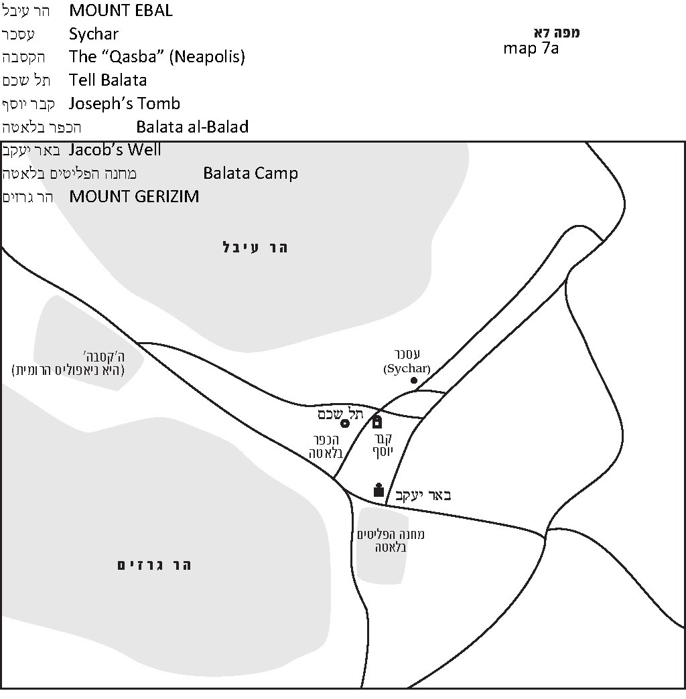

Lack of Muslim Connection to the Site

Muslims generally identify the tomb of Joseph with a site next to the cave of Machpelah in Hebron, whereas what we call Joseph’s Tomb in Shechem they occasionally mention in their literature as a marginally significant site. This Muslim tradition, which stands in contradiction to the Tanakh and to the solid evidence found in the early sources, has its roots in the apocryphal book “Testaments of the Twelve Patriarchs” 20:6 and in the itinerary of the sixth-century pilgrim Antoninus of Piacenza.

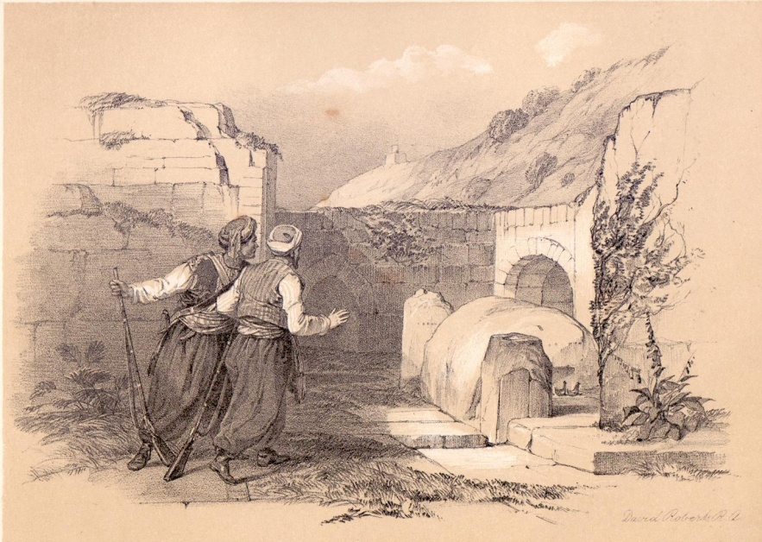
Joseph’s Tomb (David Roberts 1839); note the two pillars on either side of the gravestone.

Authentic Tradition vs. Folk Tradition

Joseph’s Tomb is located at the foot of the eastern gate of ancient Shechem, which was discovered in the twentieth century in the course of archaeological excavations. The area around the tomb is flat and lower than the area surrounding it, in contrast to the style typical of the folkloric “burial sites” of Muslim sheikhs and prophets, which are generally situated atop mountains. The tomb’s location east of the ancient Tell Balata, which was unknown throughout the Byzantine Period and the Middle Ages, and not within the later Neapolis/Nablus complex, demonstrates the antiquity of the tradition. It also proves the tradition’s congruity with the Torah’s account of Jacob’s arrival in Shechem, east of the Jordan: “And he encamped before the city. The parcel of land where he pitched his tent he purchased…” (Genesis 33:18-19); “The bones of Joseph… were buried at Shechem, in the parcel of land which Jacob had bought…” (Joshua 24:32). If someone was to have created a new, false tradition regarding the parcel of land and Joseph’s tomb later in history, he would undoubtedly have situated the tomb within Neapolis, and not in the remote Platanus-Balata. Sure enough, there developed a folk tradition among the Samaritans that places the “parcel of land” precisely where they likely imagined it would be – at the entrance to Neapolis (“the site of Jacob’s mourning”).

Joseph’s Tomb (photograph taken c. 1900); the two pillars are still a prominent feature of the site.

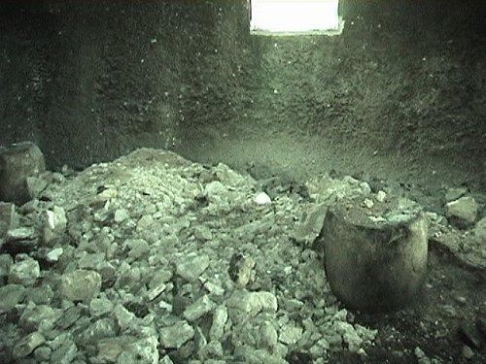
Joseph’s Tomb after its destruction by Arab rioters (March 2003); the two pillars are still visible.

For further study:

Z. Ben-Haim, Teivat Markeh: Asufat Midrashim Shomroniyim, Jerusalem 1988, 335 [Hebrew].

M. Dabbagh, Biladna Falastin II/ 2, Kefar Qara 1991, 277-279 [Arabic].

Z. H. Ehrlich, “Kever Yosef Ve-hamivneh She-alav,” Shomron U-binyamin 1, 1987, 153-162 [Hebrew].

M. Ish Shalom, Kivrei Avot, Jerusalem (1948) 2001, 79-82 [Hebrew].

G. Le Strange, Palestine under the Moslems (1890), Beirut 1965, 314, 319, 325, 512.

J. E. Tailor (ed.), The Onomasticon by Eusebius of Caesarea, Jerusalem 2003, 83.

“Theodosius,” Latin source: Itineraria et alia geographica (CCSL 175), Turnholt 1965, Par. 2 English translation: Theodosius (PPTS, trans. J. H. Bernard), London 1893, 7.

J. Wilkinson, Egeria's Travels to the Holy Land, Jerusalem-Warminster 1981, 193.

Wikipedia entries [Hebrew]: “Mehumot Minharat Ha-kotel” and “Kever Yosef”

Translated by Daniel Landman

Recent research indicates that there is no reason to dispute the authenticity of this work.
Two very similar works whose authorship is disputed, both from the second half of the thirteenth century CE
His work Kaftor Va-ferach on the Land of Israel and its unique laws was completed in 1322 CE; the quote here is taken from chapter 11, based on MS Milano.
See map.

