YESHIVAT HAR ETZION
ISRAEL KOSCHITZKY VIRTUAL BEIT MIDRASH (VBM)
*********************************************************

GEOGRAPHY IN THE PARASHA

For easy printing, see
http://vbm-torah.org/archive/geography/09vayeshev.htm

PARASHAT VAYESHEV

“He Was At Chezib When She Bore Him”
By Prof. Yoel Elitzur

Chezib/Achzib

Parashat Vayeshev states: “Judah left his brothers and camped near a certain Adullamite whose name was Hirah” (Genesis 38:1). He then married and had three sons: Er, Onan and Shelah. In its description of Shelah’s birth, the Torah says, “Once again she bore a son, and named him Shelah; he was at Chezib when she bore him” (38:5).

Before we go further, it is important to note that there are two different places known as Chezib, or Achzib, in Israel. The first is an ancient town on the northern coast, now home to a well-known national park near the city of Nahariya. The second is located in the heart of the Shephelah region in south-central Israel, and it is to this latter location that our parasha refers.

Achzib is also mentioned in the list of cities in the Shephela found in Joshua (15:44), and later in the beginning of Micah in the list of Judean cities conquered by the Assyrians (1:14). Our parasha mentions Chezib alongside places like Adullam, Enaim and Timna; in Joshua it can be found near Keilah and Maresha; and in Micah it follows Lachish and Moresheth-gath, while preceding Maresha and Adullam. Most of these locations have been identified with a great degree of certainty (see the map below). Achzib itself has not been positively identified, but the region where it was located is clear. In the fourth century CE, Eusebius (Onomasticon 172:6-7) described it as a ruin in the vicinity of Adullam, and modern researchers have suggested two locations for this ancient city. (See map below.)

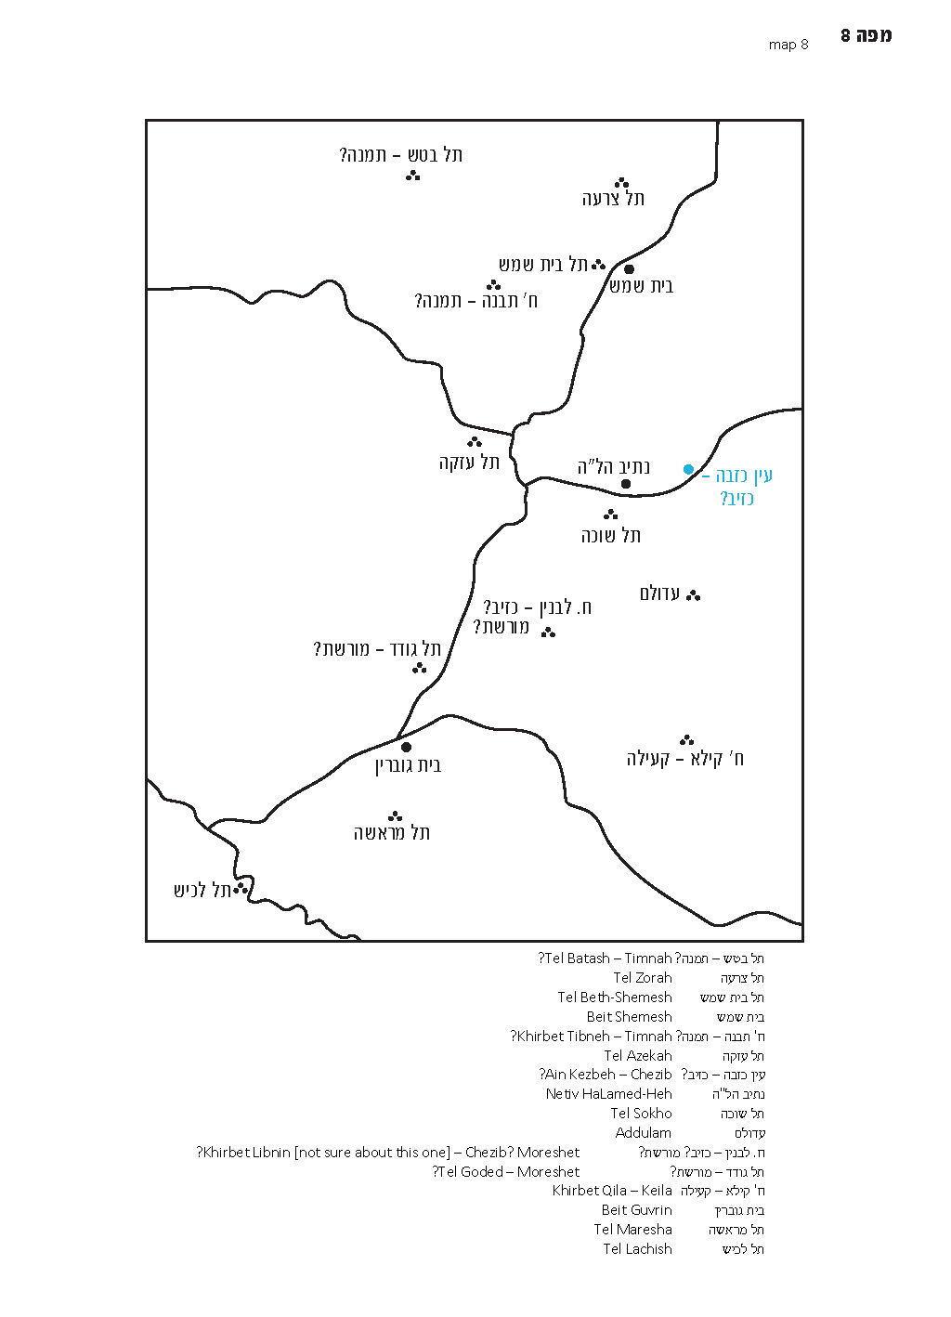

Why Was Chezib Mentioned?

The interesting question that arises upon analysis of this Biblical passage is why the verse mentions Chezib. Translators and commentators alike have debated even the simple meaning of the verse: Who was in Chezib? Some explain that the verse refers to Judah, and the verse mentions this to tell the reader that Judah was not home when Shela was born. According to the Septuagint, it was Judah’s wife, the daughter of Shua, who was in Chezib. Still others explain that the verse refers not to a person, but to the birth itself (either of Shela or of both him and his brothers) that took place in Chezib. In any case, the detail of Chezib seems superfluous; it is difficult to understand why the verse needed to include it.

According to an interpretation found in several ancient translations, the word Chezib here does not refer to an actual location at all. Instead, the verse is simply saying that after this point, Judah’s wife stopped having children. In this interpretation, the word bi-khziv is used in the sense of a ma’ayan akhzav, an intermittent spring whose flow of water is characterized by periodically stopping entirely. However, this explanation is difficult from a linguistic perspective, and also cannot be accepted since Achzib is evidently the name of a city in the Shephelah, found in the lists of cities in Joshua and Micah. In light of this, it is unlikely that this is the simple meaning of the verse.

Radak suggests that according to ancient custom, the father would name the first and third children, while the mother would name the second and fourth children. When Shela was born, Judah was not home but in Chezib, and as a result Shela was named by his mother despite being the third child. Ramban cites this explanation only to forcefully reject it. Some scholars have claimed that Chezib was, for a certain period of time, home to Shela’s descendants, and because of this the Torah mentioned the city in connection with Shela’s birth. At the end of the day, it seems that the question is better than the answers.

Hidden Interpretations of Biblical Names

As we mentioned earlier, in our discussion on Parashat Vayetze, the interpretations given throughout Tanakh of names of people and places generally do not account for how these names were first created. Instead, they serve to inject new homiletical meaning, based on the events that our ancestors experienced, into names that already existed. To add a new dimension to this concept, very often these interpretations are not found explicitly in the text, but are hidden or subtly implied.

Several examples of this phenomenon can be found in Genesis alone. In Parashat Vayetze, an explicit interpretation for the name Machanaim is found in the text: “‘This is God’s camp (machaneh).’ So he named that place Machanaim” (Genesis 32:3). But there is also a hidden interpretation for the name, hinted at multiple times throughout the narrative: “He divided the people… into two camps” (32:8); “If Esau comes to the one camp and attacks it, the other camp may yet escape” (32:9); “and now I have become two camps” (32:11).

Another similar example is the name Penuel. The Torah says, “So Jacob named the place Peniel, meaning, ‘I have seen a divine being face to face (panim el panim)’” (Genesis 32:31). But less explicitly, the word panim and its linguistic relatives appear countless times in the narrative – “Go on ahead (lefanai)” (32:17); “‘If I propitiate him (akhapera panav) with presents in advance (lefanai), and then face him (er’eh panav), perhaps he will show me favor (yisa panai).’ And so the gift went on ahead (al panav)…” (32:21-22); “For to see your face (panekha) is like seeing the face of God (penei Elohim), and you have received me favorably” (33:10).

In other instances, there exists only implicit interpretation. For example, after Jacob crosses the ford of the Jabbok, we immediately read that “a man wrestled (va-ye’avek) with him until the break of dawn” (Genesis 32:25). Tellingly, this is the only place in the Tanakh that the verb va-ye’avek (which is very similar to the name Jabbok) appears. In the course of Jacob’s exploits in Laban’s house, we read that “Jacob then got fresh shoots of poplar (livneh), and of almond and plane, and peeled white (levanot) stripes in them, laying bare the white (ha-lavan) of the shoots” (30:37). Even the shoots of almond mentioned in that verse – luz in Hebrew, another word that appears nowhere else in Tanakh in this context – is perhaps a reference to Bethel, formerly known as Luz (28:19), where Jacob visited prior to arriving in Haran. Finally, when Jacob departs from Laban’s house, we find a hint of his impending meeting with Esau in Laban’s accusation: “It was a foolish thing for you to do (aso)” (31:28).

The Importance of Names and Their Connection to Events

It is clear that the Torah considers the interpretations given for names extremely significant. In a sense, these interpretations serve to establish the true essence of the people and places that bear the corresponding names, not unlike a blessing or a curse. Names and their interpretations are not always mere ancillary elements in a story, but can often propel the plot forward, giving it the proper narrative emphases.

For example, the word tzechok – laughter – is not only the linguistic root given for Isaac’s name, but it is also a motif that runs through his entire life. Before Isaac was born, his father Abraham laughed in joy, while his mother Sarah laughed derisively, leading to her being reprimanded. When he was born, his mother said, “God has brought me laughter; everyone who hears will laugh with me” (Genesis 21:6). Sarah witnessed Isaac’s rival Ishmael “playing (metzachek)” (21:9), and years later, Abimelech witnessed Isaac “fondling (metzachek) his wife Rebekah” (26:8). The verse purposely leaves vague the exact nature of Ishmael and Isaac’s actions; the important message from the Torah’s perspective is the disproportionate use of the linguistic root that can be found within the name of the protagonist.

It is unclear if the Torah would have found it necessary to mention the exact nature of the food with which Jacob purchased the birthright from his brother in Parashat Toledot, if not for the linguistic connection to Esau: “‘Give me some of that red stuff (adom) to gulp down’… which is why he was called Edom” (Genesis 25:30). Once again, in addition to this explicit interpretation of the name Edom, we find another hidden connection: “Red (admoni), like a hairy mantle (ke-aderet sei’ar) all over” (25:25), which clearly hints at the land of Edom and Mount Seir.

Shelah and Chezib

Let us now return to Parashat Vayeshev, and the verse, “[She] named him Shela; he was at Chezib when she bore him” (Genesis 38:5). The style in which the verse is written suggests that it is an interpretation of Shela’s name, but there is seemingly no connection between Shela, son of Judah, and the place called Chezib. A solution to this problem can be found in an early commentary on the book of Chronicles ascribed by the Tosafists to “a student of Rav Saadia Gaon” (Yoma 9a). This answer is cited in the Da’at Mikra commentary on I Chronicles 2:3, and the Ramban suggests the same idea in his own commentary. The answer is that this is a case where the interpretation of the name is hidden within a synonym. This kind of interpretation can only be appreciated by individuals who possess a deep understanding of the Hebrew language.

In the book of Kings, Elisha promises the Shunammite woman that “At this season next year, you will be embracing a son.” She responds, “Please, my lord, man of God, do not delude (tekhazev) your maidservant” (II Kings 4:16). When her son dies, his mother runs back to Elisha, accusing, “Did I ask my lord for a son? Didn’t I say, ‘Don’t mislead (tashleh) me’?” (4:28). This episode teaches us that in Hebrew, the words tekhazev and tashleh are synonymous, since the Shunammite woman is actually quoting her own earlier statement in verse 28, where she substitutes tashleh for tekhazev. In light of this, the implied linguistic connection in our parasha between Shela and Chezib suddenly makes perfect sense.

There may have been an additional connection between Shela and Chezib, relating to the meaning of the word akhzav: Shela’s life was characterized by disappointment. In Tanakh, the verb lekhazev and the expression akhzav are used to describe things that disappoint, that do not realize the potential that is associated with them. Some examples include: “Like a spring whose waters do not fail (yekhazevu)” (Isaiah 58:11); “You have been to me like a spring that fails (akhzav), like waters that cannot be relied on” (Jeremiah 15:18); “See, any hope [of capturing him] must be disappointed (nikhzava)” (Job 41:1); and “All men are false (kozev)” (Psalms 115:11). In the story of Judah and Tamar, it had been expected that Tamar would marry Shela, but Judah was afraid to proceed with the match, “for he thought, ‘He too might die like his brothers’” (Genesis 38:11). Thus, Shela was indeed a disappointment, and the name Chezib hints at this disappointment that would later be the hallmark of Shela’s life. Once we accept this explanation, whether the birth took place in Chezib or whether Shela’s father was in Chezib at the time matters little – either way, the connection to Chezib and the theme of disappointment is conveyed.

Name Interpretation through Synonyms in Other Texts

The notion of interpreting the meaning of a name through the use of a synonym is found in other sources as well. Yair Zakovitch wrote on this topic, citing several examples, some of which are more convincing than others. The following is a very compelling example brought by Zakovitch in his article.

In Judges 15, we read the story of Samson at “the cave of the rock of Etam,” where the men of Judah handed him over to the Philistines:

When he reached Lehi, the Philistines came shouting to meet him. Thereupon the spirit of the Lord gripped him, and the ropes on his arms became like flax that catches fire… He came upon a fresh jawbone (lechi) of an ass and he picked it up; and with it he killed a thousand men. Then Samson said: “With the jaw of an ass, mass upon mass! With the jaw of an ass I have slain a thousand men.” As he finished speaking, he threw the jawbone away; hence that place was called Ramath-lehi. (Judges 15:14-17)

The level of detail in the final verse of this passage is curious. Why do we need to know that Samson discarded the jawbone at the conclusion of his declaration? Would we have thought otherwise that the jawbone remained in his hand until today? It is obvious that he threw the jawbone away, and to state explicitly that he did so seems superfluous.

Furthermore, the very use of the word lechi to refer to a jawbone is slightly odd. The word lechi generally refers to the cheek and not to the jaw itself, even in biblical Hebrew. It may be that if the incident with Samson and the Philistines had not taken place in Lehi, a different word may have been preferred over lechi in this context. The location may have been named Lehi because of a raised plateau (rama) whose topographical form resembled a person’s cheek. Since the incident occurred in a place called Lehi or Ramath-lehi, the author of Judges chose the word lechi specifically.

But how can we explain the verse, “he threw the jawbone away”? Zakowitz answers, convincingly, that the full name of the location was Ramath-lehi. The Hebrew word rama means “plateau” here, but taken as a verb, it can also mean “threw away,” as in the verse, “Horse and driver He has hurled (rama) into the sea” (Exodus 15:1). The word has a similar meaning in its Aramaic and Arabic cognates. For the sole purpose of interpreting the name Ramath-lehi, the book of Judges added this seemingly superfluous detail of Samson throwing away the jawbone: “As he finished speaking, he threw the jawbone away; hence that place was called Ramath-lehi” (Judges 15:17).

With this in mind, let us return to Parashat Vayeshev to analyze an additional name. The city of Dothan (or Dothain) is mentioned only twice in all of Tanakh, once in the story of Joseph and his brothers (Genesis 37) and a second time in the time of Elisha (II Kings 6). The name Dothan appears to derive from the word dut and the suffix -an or -ain. What is the meaning of the word dut? In the Hebrew of the Tannaitic period, the word dut often accompanies the word bor, in connection to different types of storage in one’s house. What is the difference between a bor and a dut? The Talmud states: “Both bor and dut are excavations in the soil, only a bor is merely dug out, whereas a dut is faced with stone” (Bava Batra 64a). The Rashbam explains: “Dug out – in hard soil… Faced with stone – they dig a well in soft dirt, and then build a stone wall within it; this is called a dut.” The word dut exists in Akkadian as well (dûtu). The Proto-Semitic form of the word was apparently *dawt, and it is likely, as we stated above, that the name Dothan was derived from this form.

It is reasonable to ask why the Torah mentioned Dothan in the story of the sale of Joseph. The detail that the brothers were in Dothan at the time is not necessary for the story, and there is no further mention of Dothan in the narrative. Considering all that we have discussed above, it may be that the Torah mentioned Dothan in this context in order to hint at the role of the location in the story – it is home to the pit (bor) into which the brothers threw Joseph.

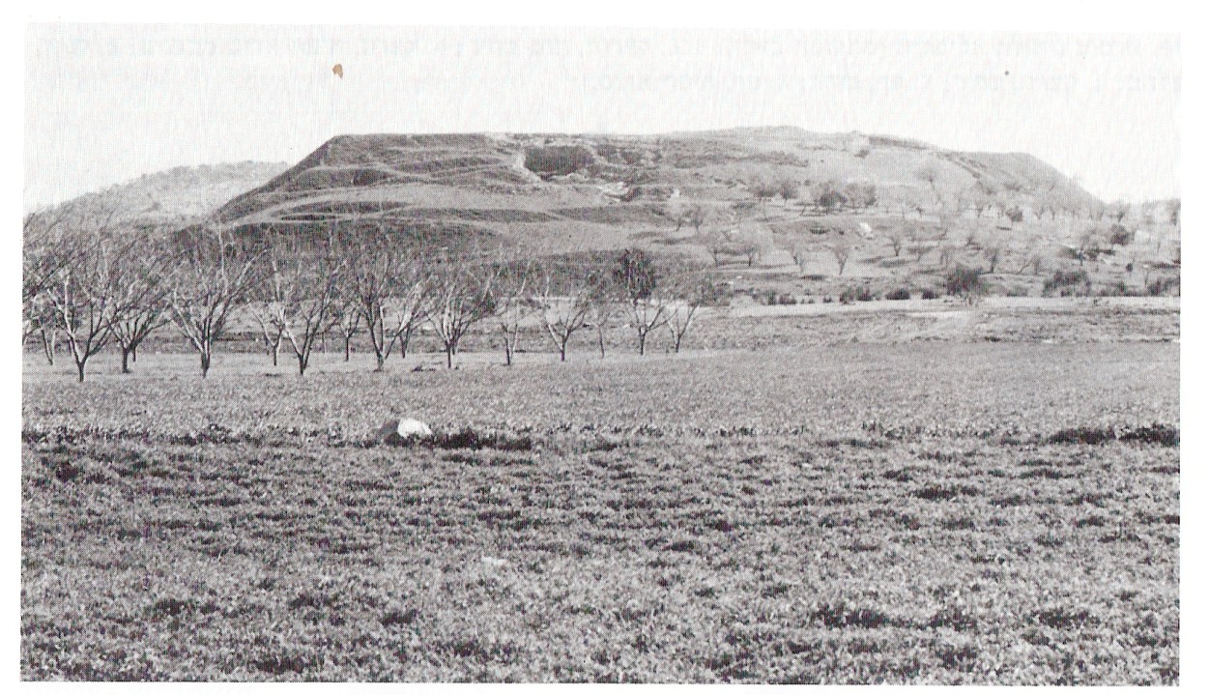
Tel Dothan (Image courtesy of Prof. Adam Zertal, Haifa University)

For further study:

A. Demsky, “The Houses of Achzib,” Israel Exploration Journal 16 (1966), 211-215.

Y. Elitzur, Ancient Place Names in the Holy Land: Preservation and History, Jerusalem-Winona Lake 2004, 283-290, 335.

Y. Elitzur, “דות and חדות,” Lešonenu 48-49 (1985), 132-141 [Hebrew].

Y. Elitzur, “Od He’ara al Dut-Dotan,” Leshonenu 50 (1986), 75-76 [Hebrew].

M. W. Prausnitz, “Achzib 1,” Anchor Bible Dictionary, 1:57.

Y. Zakovitch, “The Synonymous Word and Synonymous Name in Name-Midrashim,” Shnaton – An Annual for Biblical and Ancient Near Eastern Studies 2 (1977), 100-115 [Hebrew].

B. Zissu, “The identification of biblical Achzib at ‘Khirbet ‘En el-Kizbe’ in the Judean Shephelah, and the origins of Shimon Bar Kokhba,” Go Out and Study the Land: Studies in Honor of Hanan Eshal (ed. A. M. Maeir, J. Magness and L. W. Schiffman), Leiden 2012, 377-426.

Translated by Daniel Landman

The two names are functionally identical; the letter aleph at the beginning of “Achzib” merely eases the pronunciation of “Chezib,” which begins with a consonant cluster.
These include Aquila, the Palestinian Targumim and a translation cited in Bereishit Rabba, as well as the Peshitta and the Vulgate.
Rashi tried to connect this interpretation to the simple meaning of the verse by explaining that the city was named Chezib because it was the place where Judah’s wife stopped having children. Ramban rejected this proposal.
According to Aaron Demsky, Chezib was named for Shelah’s son Cozeba, who is mentioned in I Chronicles 4:22.
It is noteworthy that, in this case, the hidden interpretation of the name has two advantages that the explicit interpretation lacks: a) In the explicit explanation – “this is God's camp” – the word “camp” is metaphorical, while in the hidden interpretation it refers to a real camp; b) the hidden interpretation explains well not only the name itself, but also its dual ending -ayim (machanayim) – ostensibly meaning “two camps.” For more on the dual-like suffixes of place names, and in particular the case of Machanaim, see the discussion in my Ancient Place Names, referred to in the bibliography.
Also compare “But my brother Esau is a hairy man and I am smooth skinned (chalak)” (Genesis 27:11) to the description of the southern border of the land of Israel, which it shares with the land of Edom: “Mount Chalak, which ascends to Seir” (Joshua 11:17).
The word for jawbone in rabbinic and modern Hebrew is leset.
See our discussion on Parashat Bamidbar.
The phrase bor va-dut appears five times throughout the Babylonian version of the Mishna, and it appears in the Tosefta as well. Other versions of the Mishna read instead bor ve-chadut and the Yerushalmi reads harut. See my articles devoted to this topic in the bibliography at the end of this chapter.
At this point, I would like to thank my close friend Prof. Yochanan Breuer; this last idea took shape as a result of a conversation with him.

