YESHIVAT HAR ETZION
ISRAEL KOSCHITZKY VIRTUAL BEIT MIDRASH (VBM)
*********************************************************

GEOGRAPHY IN THE PARASHA

For easy printing, see
http://vbm-torah.org/archive/geography/12vayechi.htm

PARASHAT VAYECHI

**********************************************************************
Dedicated by Aaron and Tzipora Ross and family in honor of the yahrzeits of our esteemed grandparents: Neil Fredman (Shmuel Nachamu ben Shlomo Moshe HaKohen, 10 Tevet), Clara Fredman (Chaya bat Yitzchak Dovid, 15 Tevet), and Walter Rosenthal (Shimon ben Moshe, 16 Tevet).
***************************************************
Dedicated in loving memory of Richard J. Silvera A”H by his children
Hillel (’91), Albert and Michelle
***************************************************
Dedicated by the Wise and Etshalom families in memory of Rebbetzin Miriam Wise, ז״ל, Miriam bat Yitzhak and Rivkah, whose first yahrzeit is on 9 Tevet.
יהי זכרה ברוך
***************************************************

Goren Ha-atad
By Prof. Yoel Elitzur

The Problem

As we approach the end of Parashat Vayechi, we encounter a place called “Goren Ha-atad.” This place raises a serious geographical difficulty.

Accompanied by a large delegation of Egyptians, Jacob’s children depart from Egypt in order to bury their father in Hebron:

So Joseph went up to bury his father; and with him went up all the officials of Pharaoh, the senior members of his court and all of Egypt’s dignitaries, together with all of Joseph’s household, his brothers and his father’s household; only their children, their flocks and their herds were left in the region of Goshen. Chariots, too, and horsemen went up with him; it was a very large troop. When they came to Goren Ha-atad, which is beyond the Jordan, they held there a very great and solemn lamentation; and he observed a mourning period of seven days for his father. (Genesis 50:7-10)

When the mourning period was over, “his sons did for him as he had instructed them. His sons carried him to the land of Canaan, and buried him in the cave of the field of Machpelah, the field near Mamre” (50:12-13).

Thus, the mourners’ journey began in Egypt and ended in Hebron, stopping only in Goren Ha-atad to hold a “great lamentation” for Jacob. It would seem logical, then, to search for Goren Ha-atad somewhere along the way between Egypt and Hebron – perhaps even in the vicinity of Hebron.

The problem is that the Torah places Goren Ha-atad elsewhere: “Goren Ha-atad, which is beyond the Jordan (be-ever ha-Yarden)… That is why it was named Abel-mizraim, which is beyond the Jordan” (50:10-11). This is very strange: How did the mourners end up on the eastern side of the Jordan while traveling from Egypt to Hebron? It is somewhat surprising that most of the commentators, both classical and modern, seem to have been unperturbed by this difficulty. In addition, the commentators that did raise this question posited solutions that are largely inadequate.

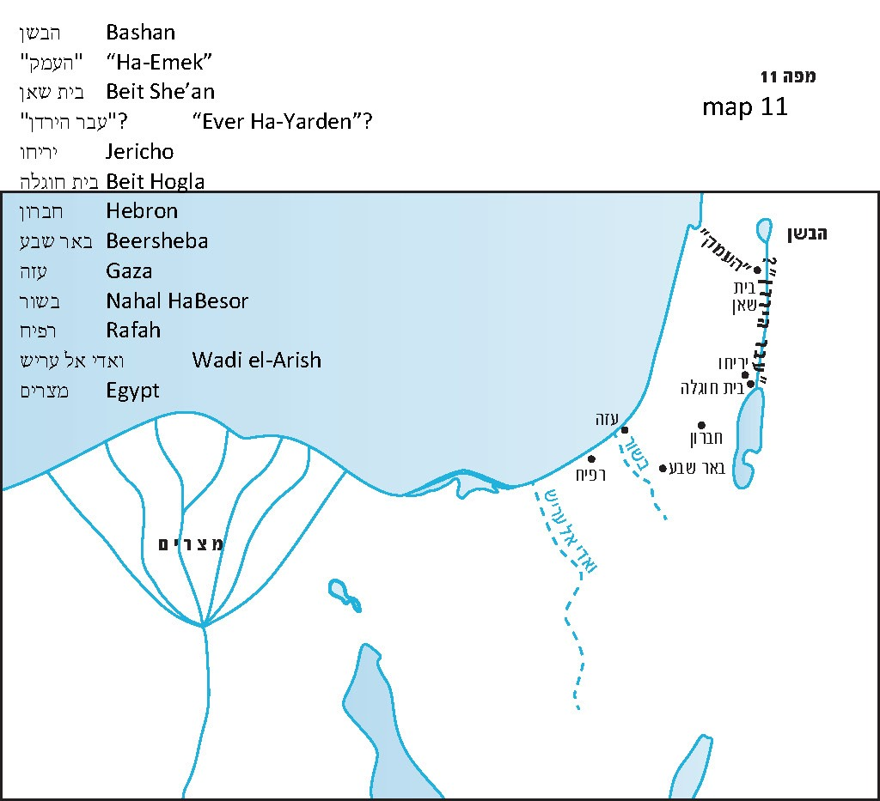

Ziv and Demsky’s Solution

In 1960, Yehuda Ziv proposed an original solution to this problem, which was suggested again more comprehensively by Prof. Aaron Demsky in a 1993 article. Demsky cites three chronologically disparate sources: the list of Shishak’s conquests in the southern portion of Judah (no. 150), Josephus’s The Jewish War (III, 3:5, 51) and a Christian chronicle written in Syriac recounting the Muslim conquest of the land in 634 CE. In each of these three sources there appears a place called “Jordan” (in Shishak's list: y-r-d-n; in Josephus: Iordan; in the Christian chronicle: yrdn) in southwest Israel. Shishak’s list places Jordan near Rafah, Josephus places it near the southern border of Judea and the Syriac chronicle places it twelve miles east of Gaza. In light of these sources, Ziv and Demsky suggest that the “Jordan” mentioned in connection with the narrative of Jacob’s burial is not the well-known Jordan River but this lesser-known Jordan in the southwest. Demsky explains that “Abel-mizraim” is actually “the wadi of Egypt,” and “be-ever ha-Yarden” refers to a crossing (ma’avar) that the mourners used to traverse this wadi, which was located in the vicinity of “Jordan.”

This is a brilliant and innovative theory, but unfortunately it is also unconvincing. Demsky himself admitted the unlikelihood of there existing in the land of Israel not only two Jordans but also two separate places known as ever ha-Yarden. To solve this difficulty, Demsky suggested that this is a case of intentional wordplay. In my opinion, it is impossible to accept the notion that “the wadi of Egypt” referred to several different wadis over the course of history, and Demsky’s interpretation of “be-ever ha-Yarden” seems dubious as well. It should be noted that Benjamin Mazar linked Josephus’s “Iordan” to three other names: “yrḏ,” which appears in the Annals of Thutmose III; “yurza,” which appears in the Amarna letters; and “Orda,” which appears on the Madaba Map. From a linguistic perspective, however, while the addition of the letter nun at the end of a word during the Second Temple period would be conceivable; dropping a nun from the end of a place name during the Biblical period is not. In addition, the linguistic interpretation of the word “Abel” to mean “wadi” is somewhat contrived. In sum, I believe that Ziv and Demsky’s theory does not solve the problem, but only emphasizes its difficulty.

My Father, z”l’s Solution

I would like to present a solution that I learned from my father, Prof. Yehuda Elitzur, z”l. He never managed to publish this idea in his lifetime, and I want to take this opportunity to do so on his behalf.

In order to understand my father’s solution properly, we must first introduce two concepts that may be unfamiliar to readers. The first relates to geographical terminology in Tanakh, and the second relates to the way in which things are described in Tanakh.

Let us begin with the second concept: Biblical descriptions. In general, when one studies Tanakh, he must be aware that the Tanakh does not describe things in the same way that historians do. There are things that are described at length and in great detail in Tanakh that a historian might deem insignificant and disregard entirely. In contrast, there are things that may seem incredibly important to the objective reader that the Tanakh simply glosses over.

For example, we read that “the other events of Ahab’s reign, and all his actions – the ivory palace that he built and all the towns that he fortified – are all recorded in the Annals of the Kings of Israel” (I Kings 22:39). The Annals of the Kings of Israel presumably dedicated many of its pages to the various wars and other exploits of Ahab, many of which the Tanakh does not deign to recount. Indeed, we only learn of the greatest war of Ahab’s reign from an Assyrian account; the war seems to have been omitted entirely from Tanakh. In addition, “the ivory palace that he built” certainly sounds like an impressive building that Ahab would likely display to his visitors, but in the book of Kings the palace is only mentioned here in passing, almost parenthetically. Instead of focusing on Ahab’s military and architectural achievements, the Tanakh prefers to dwell on the story of Naboth the Jezreelite’s vineyard, an incident that a historian would undoubtedly ignore.

In Genesis, there are several examples that fit this model. The long journey to Haran undertaken by Abraham’s servant and his ten camels was certainly an arduous trek, complicated further by the problem of finding food and water along the way. We can assume that they stopped at numerous wells in the course of their journey, but the Torah only tells us about the events surrounding one of them: the well at Haran. Clearly, this is not an objective historical account, but an account based on the narrative that the Torah intends to convey.

We are all familiar with the story of how Esau, exhausted from the hunt, sold his birthright to Jacob for a pot of lentil stew. However, this incident is surely not one to which any serious biographer or historian would devote significant attention. It may be that even the two brothers themselves related to the incident as an amusing episode from their youth. But from the Torah’s perspective, this is a highly important and symbolic exchange, and as such, it is presented in great detail.

Let us return now to the topic at hand. We read here that the delegation of mourners for Jacob consisted of chariots and horsemen, “a very large troop.” The scope of this journey seems to more closely resemble that of a military operation than that of a mourners’ procession. If we analyze the verses carefully, we will see that the delegation was actually comprised of two separate groups. One group consisted of Jacob’s family: “Joseph’s household, his brothers and his father’s household.” The second group consisted of “the officials of Pharaoh, the senior members of his court and all of Egypt’s dignitaries,” and with them, chariots and horsemen – a very large troop. In other words, it is a small group of Israelites traveling alongside a large Egyptian delegation. A close reading of the verses demonstrates that, following the mourning ceremony in Goren Ha-atad, Jacob’s sons alone proceeded on to bury their father: “His sons did for him as he had instructed them. His sons carried him to the land of Canaan, and buried him in the cave of the field of Machpelah, the field near Mamre, which Abraham had bought” (50:12-13).

What perhaps seemed like a joint procession of Egyptians and Israelites was actually two separate delegations traveling alongside each other for the first leg of the journey. The Torah lingers on the actions of Jacob’s sons, as well as on the large portion of the journey that was dedicated to mourning for Jacob. However, it seems very likely that the Egyptian delegation that set out to bury Jacob actually had an ulterior motive for its journey. While they certainly had great respect for Jacob – they “bewailed him seventy days” (50:3) and embalmed him as they would their most respected figures – the journey seems to have had a different purpose as well.

According to Egyptian sources, Egypt ruled over the land of Canaan during that period. To maintain their hold on the land, the Egyptians would set up garrisons in various locations. The most important of these garrisons were located in Beit She’an and Gaza, and each year the soldiers manning these garrisons would be replaced with fresh troops. Apparently, this yearly changing of the guard would be accompanied by a large military delegation.

In light of this, the chariots, horsemen and “very large troop” from our parasha presumably served precisely this purpose: They set out from Egypt to take the place of the Egyptian forces who were manning the garrisons in the land of Canaan. The decision to implement this changing of the guard at that particular time was likely a result of various Egyptian military factors, but what interests the Torah is that this journey was integrated with the mourning ceremony for Jacob.

Let us turn now to the topic of Biblical geographical terminology. The geographical term in question is ever ha-Yarden. In general, when we encounter this term in Tanakh, the verse specifies which side (ever) of the Jordan is being referred to. A scholar named Gemser investigated this question over sixty years ago and found twenty-four instances in which the expression ever ha-Yarden appears together with a geographical direction. Most often the reference is to the east side of the Jordan, and the word mizracha is appended to ever ha-Yarden, as in: “But we will not have a share with them in the territory beyond the Jordan, for we have received our share on the east side of the Jordan (me-ever ha-Yarden mizracha)” (Numbers 32:19); “Those two and a half tribes have received their portions across the Jordan (me-ever la-Yarden), opposite Jericho, on the east, the orient side (mizracha)” (34:15); and “Then Moses set aside three cities on the east side of the Jordan (be-ever ha-Yarden mizracha shamesh)” (Deuteronomy 4:41). Occasionally, the direction is west (yama), as in: “When all the kings of the Amorites on the western side of the Jordan (be-ever ha-Yarden yama)” (Joshua 5:1); and “And the following are the local kings whom Joshua and the Israelites defeated on the west side of the Jordan (be-ever ha-Yarden yama)” (12:7).

In light of this evidence, it is worthwhile to investigate the cases in which the phrase ever ha-Yarden appears alone, without an east-west clarification. There are only a few examples in which this stand-alone phrase refers to the Transjordan; indeed, it usually has another meaning entirely. A prime example of this can be found at the end of I Samuel:

And when the men of Israel asher be-ever ha-Emek va-asher be-ever ha-Yarden saw that the men of Israel had fled and that Saul and his sons were dead, they abandoned the towns and fled; the Philistines then came and occupied them. (31:7)

The phrase asher be-ever ha-Emek va-asher be-ever ha-Yarden is usually translated as “on the other side of the valley and on the other side of the Jordan.” However, from a geographical-historical perspective it is difficult to imagine that this verse is referring to the eastern side of the Jordan and the areas beyond the Jezreel Valley, since the Philistines never settled in those regions. Considering the geographical and historical context of the narrative in Samuel, it must be that the verse is referring to the plains of the Jezreel Valley and the Jordan Rift Valley – on the western side of the Jordan River.

An interesting example that has confounded translators and commentators can be found in the book of Joshua: “When all the kings asher be-ever ha-Yarden, in the hill country, in the Shephelah, and along the entire coast of the Mediterranean Sea up to the vicinity of Lebanon heard…” (9:1). Here, “be-ever ha-Yarden” – literally “beyond the Jordan” – certainly does not refer to Transjordan, but it cannot be referring to Cisjordan either. The events of this chapter and the following chapters occur on the western side of the Jordan and were written in the Land after the entire region had already been conquered; why, then, would the writer of this verse call his own location “beyond”? Based on the context, however, it seems that the verse is presenting a list of topographical regions of the land, similar to: “in the Arabah, the hill country, the Shephelah, the Negeb, the seacoast” (Deuteronomy 1:7); “Joshua conquered the whole of this region: the hill country, the Negeb, the whole land of Goshen, the Shephelah, the Arabah” (Joshua 11:16); and “In the hill country, in the lowlands, in the Arabah, in the slopes, in the wilderness and in the Negeb” (12:8). If we view the verse in Joshua 9 in the context of these other lists, we get the impression that the phrase “be-ever ha-Yarden” does not function as a heading for the list of regions that follow, but instead refers to a distinct region in the land of Israel. In other words, the punctuation following the phrase should be a comma (“be-ever ha-Yarden, in the hill country…”) rather than a colon (“be-ever ha-Yarden: in the hill country…”), a parsing that is corroborated by the traditional cantillation marks associated with the verse. Furthermore, this new understanding can help us determine approximately to which region ever ha-Yarden refers. The one region that can found in each of the above lists, but is missing from the list in Joshua 9, is the Arabah, the Biblical name for the Jordan Rift Valley. We can infer from this substitution of ever ha-Yarden for “Arabah” that ever ha-Yarden refers precisely to this region – the Jordan Rift Valley.

What is the linguistic background for the identification of ever ha-Yarden with the Jordan Rift Valley? It appears that it can be deduced from an interesting example of kerei u-khetiv in II Samuel. The verse reads: “Look, I shall linger in the steppes of the wilderness (be-arvot ha-midbar) until word come from you to inform me” (15:28). In the Masoretic text, however, the letters resh and bet in the word be-arvot are flipped and the word is spelled be-avrot ha-midbar. The couple arvot-avrot might be explained as metathesis (like keves-kesev and simla-salma). Thus, ever ha-Yarden can be understood to mean arvot ha-Yarden – the Arabah.

We read in Isaiah:

Nevertheless this darkness shall not be the same as the affliction that came upon her when they lightly touched the land of Zebulun and the land of Naphtali, nor afterward when they more grievously afflicted her by the way of the sea, ever ha-Yarden, in Galilee of the Gentiles. (8:23)
The historical context of this verse is complicated and well beyond the scope of our discussion. However, since the verse is dealing with regions in northern Israel, we can assume that “ever ha-Yarden” refers here to the Jordan Rift Valley, rather than the lands of Gilead and Bashan east of the Jordan River.

The most interesting verse of this type is the opening verse of Deuteronomy: “These are the words that Moses addressed to all Israel be-ever ha-Yarden” (1:1). Ibn Ezra, in an enigmatic comment here, hints at a theological problem: Deuteronomy, along with the entire Chumash, was completed on the day of Moses's death in the Plains of Moab, at which point the Levites were commanded to “take this book of teaching and place it beside the Ark of the Covenant of the Lord your God” (31:26). But if we understand “be-ever ha-Yarden” in Deuteronomy 1:1 to mean “the other side of the Jordan,” then that seems to imply that this opening verse of Deuteronomy was written after the people of Israel had crossed the Jordan. Only once the people are situated west of the Jordan do the plains of Moab become “the other side.”

According to our interpretation of be-ever ha-Yarden, however, there is no such contradiction. Since the phrase appears without a directional qualifier, the verse is essentially saying: “These are the words that Moses addressed to all Israel in the Jordan Rift Valley.” Verse 5 can be explained in the same manner: “In the plain of the Jordan (be-ever ha-Yarden), in the land of Moab,” meaning, essentially, “in the plains of Moab.”

Now let us return to Goren Ha-atad. The phrase be-ever ha-Yarden appears in our parasha as well, similarly without an accompanying direction: “When they came to Goren Ha-atad, which is be-ever ha-Yarden… that is why it was named Abel-mizraim, which is be-ever ha-Yarden” (Genesis 50:10-11). Thus, following our new understanding, we can conclude that the verse is not referring to the eastern side of the Jordan but to the Jordan Rift Valley. Goren Ha-atad, where the memorial ceremony for Jacob took place, was located somewhere in the Jordan Rift Valley, presumably on the western side of the Jordan River.

Support for placing Goren Ha-atad west of the Jordan can be found in verse 11: “The Canaanite inhabitants of the land saw the mourning.” Throughout Tanakh, there is not one mention of Canaanites east of the Jordan. Canaanites are always portrayed as living on the western side of the Jordan, in the Jordan Rift Valley in particular, as we find in the story of the spies: “And Canaanites dwell by the Sea and along the Jordan” (Numbers 13:29). In other words, the Jordan Rift Valley was the regional home of the Canaanites (one of the seven nations that lived in the land of Canaan).

To summarize, our parasha describes a large-scale Egyptian military expedition, a yearly operation that involved numerous chariots and horsemen. The purpose of this expedition was to replace the troops manning the Egyptian garrisons throughout Canaan with fresh soldiers from Egypt.

Before each group of soldiers went off to their respective garrisons, the delegation stopped at a central location – Goren Ha-atad – for seven days, to mourn the loss of Jacob, the father of the second-in-command of Egypt. After this ceremony, the Egyptian troops all traveled to their designated garrisons, and Jacob’s twelve sons departed for Hebron to bury their father.

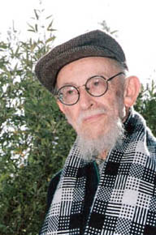
Prof. Yehuda Elitzur, z”l (1911-1997)

Where Was Goren Ha-atad?

As we established, Goren Ha-atad was located somewhere in the Jordan Rift Valley. My father, z”l, speculated that it was in the general vicinity of Beit She’an, which was a major Egyptian military center during the time the Egyptians maintained a presence in the land of Israel. At the time, Beit She’an also functioned as a kind of geographical midpoint in the land. From Beit She’an, roads branched out to the north, south, west and even east, to the Bashan region where the Egyptians held important military outposts.

On the other hand, it is worth noting the existence of an ancient tradition that places Goren Ha-atad near Beit Hogla, southeast of Jericho. This tradition is mentioned by several early Christian sources: Eusebius, in the early fourth century CE in his Onomasticon (8:17), Epiphanius of Salamis; Jerome; and the Madaba Map. There is some substance to the claim that this tradition is rooted in Jewish sources as well, as there is a clear connection to a midrash. According to Eusebius, Halōn Atad (Goren Ha-atad) is now called Bethagla, meaning “place of circling,” because “there (according to custom) they were circling in lamentation over Jacob.” E. Z. Melamed noted the similarity between Eusebius’s explanation and the following Talmudic passage: “But is there a threshing floor (goren) for brambles (atad)? Rabbi Abahu said: ‘It teaches that they surrounded Jacob’s coffin with crowns like a threshing floor that is surrounded by a hedge of brambles’” (Sota 13a). This connection is especially interesting considering that Rabbi Abahu and Eusebius lived during the same time period and in the same place: Caesaria in the early fourth century CE. Additionally, Rabbi Abahu was a well-known figure, and he was held in high regard by the non-Jewish residents of Caesaria (Ketubot 17a and Sanhedrin 14a).

Thus, it seems likely that the ancient tradition placing Goren Ha-atad in the Jordan Rift Valley, near Jericho, is actually a Jewish tradition as well. This tradition might fit with the theory presented above regarding the main purpose of the Egyptian expedition to Goren Ha-atad.

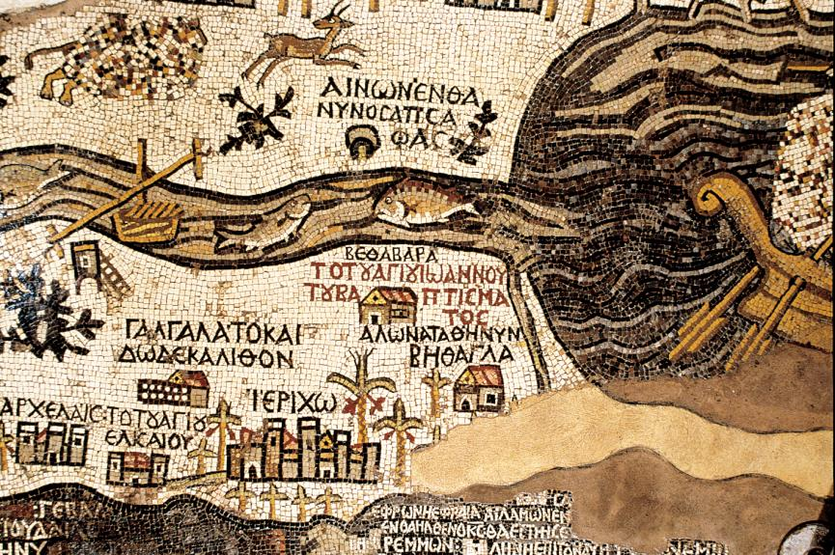
Goren Ha-atad on the Madaba Map (Z. Radovan). The map faces east. The main items are the Jordan River and the Dead Sea. Below the outlet of the Jordan into the Dead Sea, two churches are visible. The lower church bears the caption “ΑΛWN ATAΘ Η ΝΥΝ ΒΗΘΑΓΛΑ”: “Ηalon Atath, which is now Bethagla”

For further study:

A. Demsky, “The Route of Jacob’s Funeral Cortege and the Problem of Eber Hayyarden (Genesis 50:10-11),” M. Brettler and M. Fishbane (eds.), Minḥah le-Naḥum: Biblical and Other Studies Presented to Nahum M. Sarna (JSOT 154), Sheffield 1993, 55-64.

B. Gemser, “Be^{c}ēber Hajjardēn: In Jordan's Borderland,” VT 2 (1952), 349-355.

M. M. Kasher, Torah Shelema, 7, 1870-1871 [Hebrew].

B. Mazar, Cities and Districts in Eretz-Israel, Jerusalem 1976, 141-146 [Hebrew].

E. Z. Melamed, “The Onomasticon of Eusebius: An Introduction,” Tarbiz 4 (1933), 256 [Hebrew].

Y. Ziv, “Yarden Levo Mitzrayim,” Teva Va-aretz II (1960), 412-413. Reprint: Y. Ziv, Yalkut Gav: Iyyunim Bi-yedi’at Ha-aretz, Jerusalem 1991, 162-164 [Hebrew].

Translated by Daniel Landman

See map.
This location appears several times throughout Tanakh (Numbers 34:5; Joshua 15:4; Isaiah 27:12). According to Demsky, “the wadi of Egypt” did not necessarily refer to the same wadi throughout history, and in our parasha it refers to Nachal Ha-Besor.
Based on the word yuval (tributary), appearing in Daniel 8:2 in the form uval: “I was beside the Ulai River (Uval Ulai).”
This is considered a lost work.
See our discussion on the first day of Sukkot.
Where the traditional pronunciation of a word conflicts with the Masoretic text
The end of the verse then highlights one particular section of the valley – “in the Arabah, near Suph.”

