YESHIVAT HAR ETZION
ISRAEL KOSCHITZKY VIRTUAL BEIT MIDRASH (VBM)
*********************************************************

GEOGRAPHY IN THE PARASHA

For easy printing, see
http://vbm-torah.org/archive/geography/14vaera.htm

*********************************************************
In memory of our parents, Helen and Benjamin Pearlman z”l and Jack Stone z”l
and in honor of my mother, Esther Stone, Yibadel L’chayim Tovim
by Gary and Ilene Stone
*********************************************************

PARASHAT VA’ERA

People Named For Places
By Prof. Yoel Elitzur

Places Named for People and People Named for Places

“The following are the heads of their respective clans. The sons of Reuben… The sons of Simeon… The sons of Levi…” (Exodus 6:14-19).

Among the names of the sons of Levi, which are names of people, we find one prominent place name, one that, in every other context we find it, is a geographical location: “The sons of Kehath: Amram, Izhar, Hebron and Uzziel” (6:18). Hebron, which, in every other context, is the name of a city, here is the name of a person – Levi’s grandson. This phenomenon, where a person’s name and a place name are identical, is found numerous times throughout Tanakh. In these cases, either the person bears the name of the place or the place bears the name of the person. But which is it? Which came first: the person or the place?

In modern Israeli maps, we find many places named for people. In the late Second Temple period, several such place names became established, some of which remained until today. These include Caesarea (for Augustus Caesar), Tiberias (for Tiberius) and Petza’el (for Herod’s brother Phasael). Names of this type from the modern era include Herzliya (for Theodor Herzl), Netanya (for Nathan Straus), as well as dozens of other names in memory of more or less prominent people, such as Kiryat Motzkin, Kfar Vitkin, Kfar Hess and Netzer Sereni. All of these places were named for people.

Even as early as the opening chapters of the Torah, we can find a prominent example of this phenomenon. The Torah says that Cain “founded a city, and named the city after his son Enoch” (Genesis 4:17). Other people in the Torah were named Enoch as well: “Ephah, Epher, Enoch, Abida and Eldaah” (25:4). In our parasha as well, we read: “Enoch and Pallu, Hezron and Carmi” (Exodus 6:14). It is clear, then, that in this case the personal name came first, and the place was named for it.

But when it comes to Levi’s grandson Hebron, logic would dictate that the person was named for the place and not vice versa. This can be assumed from a historical perspective, since Hebron was settled by Abraham as early as Parashat Lekh Lekha: “And Abram moved his tent, and came to dwell at Elonei Mamre, which is in Hebron” (Genesis 13:18). It is thus inconceivable that the city of Hebron was named for this Egyptian-born Levite who lived years after Abraham’s journeys. From a linguistic perspective as well, the name Hebron bears a nominal pattern typical of many place names in the region, such as Eglon, Heshbon and Ashkelon. Thus, it is reasonable to conclude that, in this case, the person was named for the place.

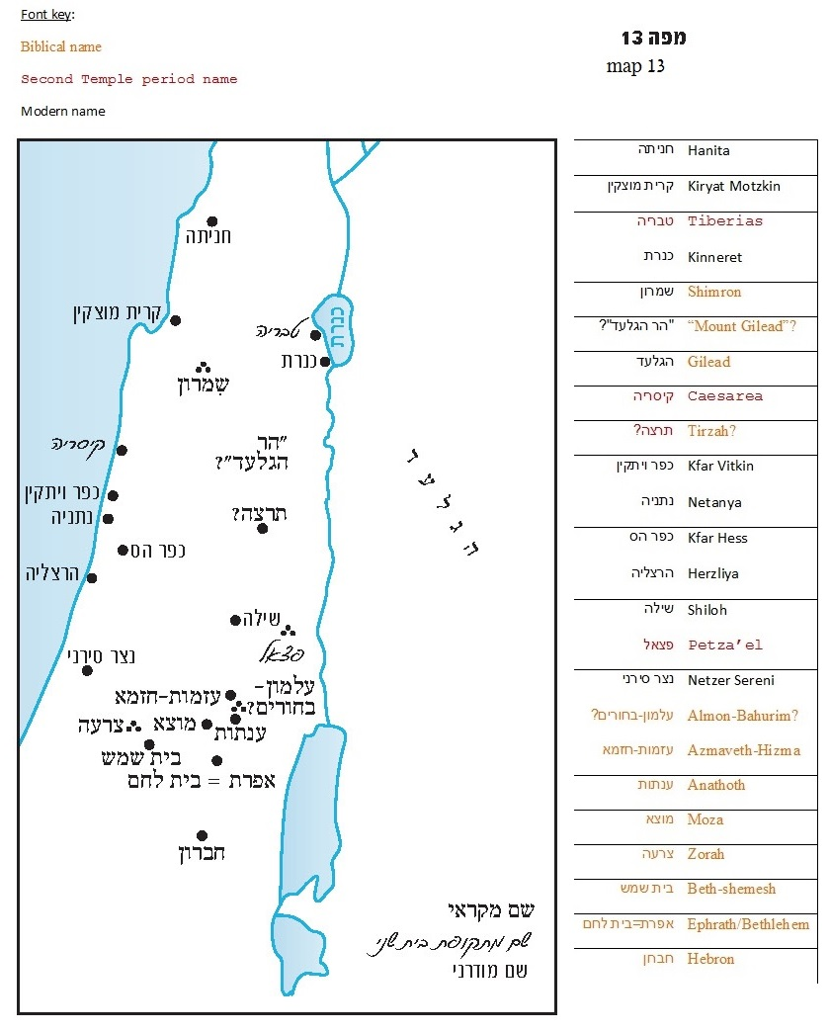

Tribal Names

Before we begin to discuss this phenomenon, let us first familiarize ourselves with the phenomenon of tribal names in Tanakh. Some names pass from generation to generation within a particular tribe, while remaining exclusive to that tribe alone. Even today we are familiar with this phenomenon; in some families, a name like “Yissakhar” or “Zevulun” is common, while in other families these names have not been used for centuries.

Take, for example, the family of nesi’im in the Tannaitic period; we find repeated alternating instances of the names Hillel, Simeon, Gamaliel and Judah. These names recur generation after generation within this particular family; each new generation is given the name of one of his recent ancestors. This phenomenon even has a scientific name: patronym – name for one’s father. The Tanakh features examples of this as well. In the list of family members in this parasha, we read of Korah’s three sons: “The sons of Korah: Assir, Elkanah and Abiasaph. Those are the families of the Korahites” (Exodus 6:24). Later, in the parallel list of Korahites in Chronicles, which includes the likes of Samuel the prophet and Heman the singer, we find the name Elkanah three more times, precisely among the descendants of Abiasaph, the brother of the original Elkanah (I Chronicles 6:7-22).

In the book of Judges, we find a judge from the tribe of Issachar named Tola son of Puah (10:1). Tola is the name of one of the families of Issachar, and Puah/Puvah is the name of a different household within the tribe of Issachar (Genesis 46:13). It is clear that this judge came from the tribe of Issachar, and that both he and his father were named for two great households within the tribe.

In the tribe of Benjamin, we encounter Ehud son of Gera and Shimei son of Gera, who lived in two separate generations. Sure enough, Gera is one of the ten households of the tribe of Benjamin: “Gera, Naaman, Ehi, Rosh” (Genesis 46:21), and apparently two people in two different periods were both named for Gera, one of the forefathers of the tribe.

In all of Tanakh, there are only two people named Mephibosheth, and they are related to each other: One was the son of Saul by his concubine (II Samuel 21:8) and the other was Mephibosheth son of Jonathan, “whose feet are crippled” (II Samuel 9:3), the nephew of the original Mephibosheth.

Jeremiah clashed with a priest named Pashhur son of Immer (Jeremiah 20:1). Pashhur is the name of one of the priestly divisions (an alternate name for the division of Jakim) and Immer is the name of a different priestly division. This priest, who was the “chief officer in the House of the Lord,” could equally have been from any other division as well.

Similarly, we read in Esther: “In the fortress Shushan lived a Jew by the name of Mordecai, son of Jair son of Shimei son of Kish, a Benjaminite” (2:5). We are familiar with the Benjaminite names Shimei and Kish from the time of Saul; in fact, Saul and the Shimei of his time were distant relatives (“a member of Saul’s clan” [II Samuel 16:5]). The book of Esther takes place in the generation following the Exile. According to the simple understanding of the text, “Kish, a Benjamite” was exiled from Jerusalem along with King Jeconiah of Judah. Now, four generations later, Mordecai is born in Shushan.

In all of these examples, and in many other instances as well, it is clear that the name in question is a tribal name that can appear in different generations, in any family within the tribe. This straightforward understanding of the text runs parallel to the reality that we find in many cultures throughout history, and it reflects a wholly understandable phenomenon. Nevertheless, it is important to stress the existence of this phenomenon, because alternate approaches to the question of repeated names abound. In midrashic sources there is a tendency to conflate different characters with the same name into one. For instance, the Talmud cites an aggada that claims that the Shimei that appears in Mordecai’s lineage is the same Shimei who cursed David as he fled from his son Absalom (Megilla 13a).

Surprisingly, many Bible scholars advocate this same aggadic approach, often formulated in critical language. For instance, Shmuel Ahituv writes: “According to Genesis 46, Numbers 26 and I Chronicles 7, Tola was Puah’s brother; but according to Judges 10 Tola was Puah’s son.” In a more extreme manifestation of this approach, Yairah Amit writes: “The details on Tola son of Puah, who lived at Shamir, seem to indicate that this was a fictitious personality, a personification of the families of Issachar: Tola, Puvah, Jashub and Shimron.” According to Jacob Liver in Encyclopedia Biblica, as well as according to Da’at Mikra on Judges and Samuel, Ehud son of Gera and Shimei son of Gera were merely members of the household of Gera. It is not that their fathers’ names were both Gera, but rather that the phrase “son of Gera” refers to their broader family heritage. This begs the question: Why should these people be any different from all the rest of their contemporaries, who were frequently and consistently mentioned with their fathers’ names – such as “Joshua son of Nun,” “Saul son of Kish” or “David son of Jesse”?

In the opening to the narrative of Jephthah, we read:

Jephthah the Gileadite was an able warrior, who was the son of a prostitute. Jephthah’s father was Gilead; but Gilead also had sons by his wife, and when the wife’s sons grew up, they drove Jephthah out. They said to him, “You shall have no share in our father’s property, for you are the son of an outsider.” (Judges 11:1-2)

The name “Gilead” is well known; it is the name of the family’s early forefather, Gilead son of Machir son of Manasseh, as well as the name of the region where Jephthah resided. The simple explanation – that in the middle of the period of the Judges, the family name Gilead was given to a certain member of the family who lived in the Gilead region – for some reason seems inconceivable to Bible scholars. German theologian Bernhard Stade took the literary-anthropological route, explaining that Gilead here refers to the tribe of Gilead, which produced Jephthah and his household. Jephthah’s household was inferior in status among the other households, as manifested in the words “the son of an outsider.” American scholar George Foot Moore proposed a more inventive solution. According to Moore, the original text read: “Jephthah the Gileadite was an able warrior, and Jephthah fled from his brothers… Jephthah replied to the elders of Gilead, ‘You are the very people who rejected me and drove me out of your midst.’” The original intent of the text was to portray Jephthah as a man of the Gilead region, and “his brothers” as the local residents and his extended family. A later editor who did not understand what he was reading thought that “the Gileadite” meant “the son of Gilead,” and “his brothers” meant his literal brothers. Therefore, he added extra verses to the original text, by way of (inaccurate) commentary.

Interestingly, just like in the other examples, here too the solutions put forward by scholars and modern Bible critics fall unexpectedly in line with positions found in early midrashim. We, on the other hand, will dispense with speculations and homiletics and follow the words of the Tanakh themselves, which demonstrate clearly that tribal names existed in the people of Israel.

Names of People and Names of Places

I will begin with two preliminary remarks. First, there are several lists of family members throughout Tanakh, particularly in descriptions of the early periods, in which names of different nations and ethnic groups are often interwoven. For example: “And Mizraim begot the Ludim, the Anamim, the Lehabim, the Naphtuhim, the Pathrusim, the Casluhim and the Caphtorim, whence the Philistines came forth” (Genesis 10:13-14); and “The descendants of Dedan were the Asshurim, the Letushim and the Leummim” (25:3). But there is no reason to broaden this genre as various scholars have done, applying its attributes to normal lists of family ties in Tanakh, where the name of a man and the name of his father are actually no more than what they appear to be. Second, the phrase “father of…” commonly found in the “family tree” chapters in the book of Chronicles, is always followed by the name of a city in which the subject of the verse established settlement. For instance, we find: “father of Bethlehem” (I Chronicles 2:51), “father of Kiriath-jearim” (2:50) and “the father of Birzaith” (7:31). This is a unique usage and not just the casual integration of a place name within a list of people’s names.

Let us now return to the topic of people who were named for geographical locations. If we understand that tribal names existed during the Biblical period, passed down through the generations in honor of the tribal forefathers or simply because these were the popular names within a particular tribe, it should not surprise us that some tribe members were named for geographical locations within their tribe’s territory. We find among the sons of Issachar the name Shimron (Genesis 46:13; Numbers 26:24; I Chronicles 7:1), which is also the name of a city on the border of territories of Issachar and Zebulun (Joshua 12:20; 19:15). We also find the name Ephrath (I Chronicles 2:19), which is more commonly known as an early name for Bethlehem, in Judea. In the same vein, it is not outside the realm of possibility that the great warrior Samson, who was born in Zorah, was named for the neighboring city of Beth-shemesh. Scholars have noted the connection between the two names, but used this connection to advance their romantic-critical claims that Samson was a kind of mythological figure representing sun (shemesh) worship.

I recall a panel discussion that was broadcast on the radio decades ago in which Yigael Yadin and my father, z”l, participated. When Yadin connected Samson with sun worship, my father challenged him in response: Does this mean that the modern last name Sonnenfeld (“field of sun” in German) is connected to sun worship as well? According to my claim, it is quite reasonable to connect Samson with Beth-shemesh, but the connection is a purely human one. It may very well be that the city of Beth-shemesh was named at the dawn of history for an ancient sun temple, but when Samson was named for the city, this was an act of pure tribal patriotism without any mythological or ritual connotations. By Samson's time, the connection to paganism had been long since forgotten.

Even today, people in Israel are still being named for places. People give their children names like Hanita, Kinneret or Shiloh to express the spiritual connection that they feel to these places. The difference between this modern phenomenon and the parallel phenomenon in the Biblical period is that today there is no geographic or familial element that limits the use of certain names to a particular tribe. In the Biblical period, tribal attitudes dominated the people’s way of life, which explains why they named their children for place names within their tribal territory.

The tribe of Benjamin was extraordinary in this regard. If we look at the Benjaminite family listing in I Chronicles, we find among the descendants of King Saul: “And Jarah begot Alemeth, Azmaveth and Zimri; Zimri begot Moza” (9:42). The people mentioned here are seven or eight generations removed from Saul. It was now the middle of the period of Israelite monarchy, by which time Israelite settlement in the land of Benjamin was already centuries old, and in such a case one would not expect new settlements to be established there. But lo and behold, we find that Alemeth is a place name in the Benjamin region, known today as Khirbet Almit; Azmaveth is a place in Benjamin as well, likely located in modern-day Hizma; the name Zimri was preserved in the name of a wadi below Pisgat Ze’ev called Wadi Zimra; and Moza is Motza, a neighborhood on the western edge of Jerusalem. Some scholars may still claim that geographical names got “mixed into” the Benjaminite family listing, but once again, the Biblical text here speaks for itself. If we take the text as it is, this is a clear example of the phenomenon of people named for places. Two particularly interesting examples are one Benjaminite named “Anathoth” (I Chronicles 7:8) and another with the unique name “Anthothiah” (8:24). Incidentally, many scholars believe that the place name Anathoth, upon which the names of these Benjaminites were based, was pagan in origin. The Benjaminites were certainly not aware of this, and were not interested in such matters in any case. From their perspective, to name someone Anathoth (or Anthothiah, by adding the theophoric ending yod-he) was an expression of pride and admiration for an esteemed location in their territory. In the variant Anthothiah in particular, its form demonstrates that we are dealing here with a person’s name that was derived from a place name and not vice versa – and surely not that the person was “representing” the place name.

Saul’s daughter Michal was given as a wife to Palti son of Laish from Gallim (I Samuel 25:44). However, it turns out that Laish and Gallim are two adjacent locations in the Benjamin region (see Isaiah 10:30). What this means is that Palti’s father lived in Gallim and was named for the neighboring town of Laish. And one more Benjaminite example: One of David’s warrior’s was named Azmaveth the Bahrumite (I Chronicles 11:33; II Samuel 21:31), who came from Bahurim but was named for a different place in the Benjaminite territory.

The tribe of Manasseh, as well, is full of people who were named for places. Gilead son of Machir son of Manasseh was obviously named for Mount Gilead on the eastern side of the Jordan. But in an entirely different generation, during the period of the Judges, one of his descendants was given this name as well – the father of Jephthah the Gileadite: “Jephthah’s father was Gilead” (Judges 11:1). The original Gilead’s sons and grandsons settled in both Gilead and Samaria (Numbers 26:30-33; Joshua 17:5-6). A mountain named Gilead on the western side of the Jordan appears once in Tanakh (Judges 7:3; 12:4 as well according to Da’at Mikra), and it may be speculated that this less-renowned Mount Gilead was named for one of the original Gilead’s descendants who bore that name.

Among the descendants of Manasseh we find the name Tirzah, which is the name of an important city mentioned in the list of Joshua’s conquests: “the king of Tirzah, one” (Joshua 12:24). Tirzah was even the capital city of Israel for a period of time. Similarly, Tirzah’s grandfather was named Hepher, which is the name of another city-kingdom conquered by Joshua: “the king of Hepher, one” (12:17).

The most interesting point is that the people mentioned here, including Gilead son of Machir son of Manasseh and including Hepher and Tirzah his granddaughter, were all born in Egypt. This observation led my father, z”l, to propose a novel suggestion: Even as the descendants of Jacob were enslaved in Egypt, they maintained a connection to locations in the land of Israel, and apparently in particular to locations that were designated to become part of their respective territories. In other words, even before Jacob’s family descended to Egypt, there was already a basic plan for dividing the land into territories, and their knowledge of this planned division motivated them to name their children for locations designated for them.

It seems that Hebron, with whom we opened this discussion, was a product of this approach as well. Here was an Egyptian-born Israelite who bore the name of the revered city of the Patriarchs – Hebron. Incidentally, Hebron the man was a Levite, and the city of Hebron was both a city of refuge and a Levite city; it functioned, essentially, as a city of priests. In light of this, Hebron, the uncle of Moses and Aaron, was apparently named in Egypt as a sign of longing for Hebron, city of the Patriarchs, to which we, their descendants, have merited to return.

For further study:

S. Ahituv, “Tola,” Encyclopaedia Biblica 8, 466 [Hebrew].

Y. Amit, Judges: Introduction and Commentary (“Bible for Israel” series), Tel-Aviv/Jerusalem 1999, 181 [Hebrew].

W. Borée, Die alten Ortsnamen Palästinas, Hildesheim 1968, 57-61.

Y. Elitzur, “Anashim Ve-nachalot Bi-Menasheh U-veshivtei Yisrael,” Al Atar 4-5 (1999), 243-249 [Hebrew].

T. Kahane, “The Priestly Courses and Their Geographical Settlements,” Tarbiz 48 (1979), 9-29 [Hebrew].

J. Liver, “Relation,” Encyclopaedia Biblica 3, 66 [Hebrew].

G. F. Moore, A Criticial and Exegetical Commentary on Judges (ICC), Edinburgh 1989, 284-285.

D. M. Pike, Israelite Theophoric Personal Names in the Bible and their Implications for Religious History, Pennsylvania 1990, 199-201.

Translated by Daniel Landman

Wilhelm Borée, a scholar who investigated the patterns and meaning of place names in the land of Israel during the Biblical period, enumerated eighty-four place names with the ending -on. There are, however, people whose names use this nominal pattern as well.
See map included.
Originally Merib-baal (I Chronicles 8:34, 9:40); all names that include the root ba’al are altered in the book of Samuel.
See I Chronicles 24:7-18; Ezra 2:36-39; 10:20, 22; Nehemiah 7:39-42.
Compare to Zerubbabel, who was probably four generations removed from his ancestor King Jeconiah of Judah; see I Chronicles 3:17-19.
In the time of the Second Temple, willow branches were brought from Moza to the Temple on Sukkot. See Mishna Sukka 4:5: “There was a place below Jerusalem called Moza. They went down there and gathered from there young willow branches.”

