YESHIVAT HAR ETZION
ISRAEL KOSCHITZKY VIRTUAL BEIT MIDRASH (VBM)
*********************************************************

GEOGRAPHY IN THE PARASHA

PARASHAT YITRO

Stone Altars and Earthen Altars in the Archaeology of the Land of Israel
By Prof. Yoel Elitzur

“An Altar of Earth” and “An Altar of Stones” – the First Commandment after God’s Revelation

After the spiritual pinnacle of the revelation at Mount Sinai and the lofty verse that followed it – “You yourselves saw that I spoke to you from the very heavens” (Exodus 20:19), both encapsulating and amplifying the nature of this singular event – God chooses to brief the people of Israel on the laws of altars:

With me, therefore, you shall not make any gods of silver, nor shall you make for yourselves any gods of gold. Make for Me an altar of earth and sacrifice on it your burnt offerings and your sacrifices of well-being, your sheep and your oxen; in each place where I cause My name to be mentioned I will come to you and bless you. And if you make for Me an altar of stones, do not build it of hewn stones; for by wielding your tool upon them you have profaned them. Do not ascend My altar by steps, that your nakedness may not be exposed upon it. (20:20-23)

Why this mitzva specifically? Umberto Cassuto gave a compelling answer to this question (the main points of which were advanced years earlier by Abrabanel):

“With Me, therefore, you shall not make any gods of silver, nor… gods of gold” – Even if the aim be to honor the God of Israel (“with Me”), and even if such precious metals as silver and gold be used, with which other nations do honor to their gods, you may not make any divine image. Even the most exquisite ornamentation cannot serve as a fitting symbol of the Invisible God.

Even the worship in My honor should not resemble the ornate ritual of the gentiles, who build elaborate altars to their gods, but should be very simple: “Make for Me an altar of earth,” a modest altar of clods of earth… “and sacrifice on it” – on this simple altar – “your burnt offerings and your sacrifices of well-being,” that is, all the oblations that you will sacrifice to Me… namely, the oblations of “your sheep” and the oblations of “your oxen.” The fourfold emphasis on the word “your” connotes as it were: Know that it is not I (God) who have need of sacrifices, but you alone require them, in order to express your feelings towards Me. The sacrifices are your sacrifices.

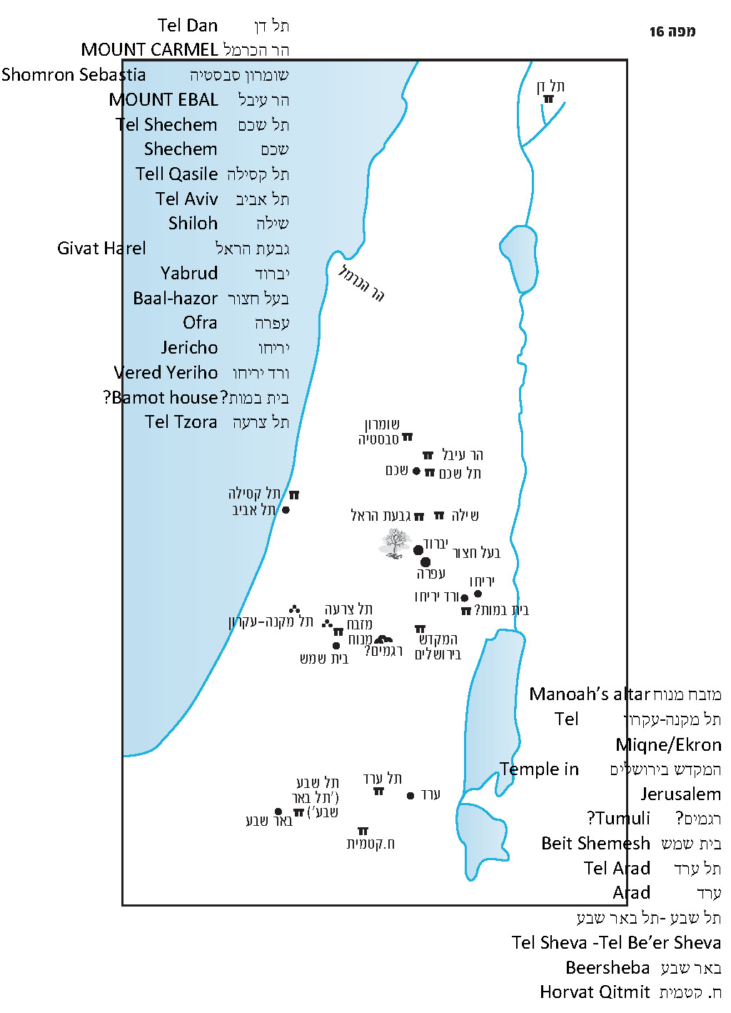

“In Each Place”

At this juncture, we must dedicate a few words to this unique expression: “In each place where I cause My name to be mentioned I will come to you and bless you” (20:21). The critical Bible scholarship is certain that this statement is antithetical to the statement in Deuteronomy that one may only sacrifice “in the place that the Lord will choose” (12:14). Cassuto rightfully points out that this interpretation views the text as if it was detached from its surroundings, and that this is an incorrect approach – a verse can only be understood in light of its context. In reality, this verse is a continuation of the passage that immediately followed the revelation at Mount Sinai, and it cannot be understood without considering this background.

The nation of Israel merited experiencing God’s revelation at Mount Sinai, but they are scheduled to travel from Sinai shortly, to continue on in their journey through the wilderness. Perhaps some people feared that by distancing themselves from the Mountain of God, they would also be distancing themselves from God Himself. In order to prevent this misconception, God explains that He is not connected to Mount Sinai or to any other physical place. “In each place where I cause My name to be mentioned” – meaning that in each place where I allow My name to be mentioned and worship in My honor to take place… in each place where I will reveal Myself… “I will come to you and bless you.” Another important point to note is that in this entire passage, the word “altar” is used in the singular, meaning that even in this passage the intent is for divine worship to be concentrated in one place.

In this context there is an important linguistic point to make as well: The expression “in each place (be-khol ha-makom)” contains a kind of internal contradiction. The word kol, which means “each,” serves to broaden and expand the scope of the term that follows it. This is the exact opposite function of the definite article prefix ha- that is appended to the word makom. The purpose of the prefix ha- is to exclude all subjects other than the one in question. Yehiel Bin-Nun addressed this question, explaining that we have here an internal contradiction that is unique to Biblical Hebrew. In this case, ha- does not single out makom completely – only partially. To quote Bin-Nun:

[The partial ha-] does not limit [the predicate] to this subject precisely, but rather designates a certain area around the subject. It does not point, therefore, to the subject, but limits it, distinguishes it… In modern language we can thus express approximately the message of the above text like so: “In any particular place that is chosen at that time or in that generation.” The text does not intend to suggest to us that mentioning God’s name is truly possible anywhere… (as implied by the language of “In each place where…”), and not even that multiple places can serve that purpose simultaneously (as implied by the language of “in all the places to which…”). Rather, it suggests to us that there are a number of places that may be forcibly sanctified, one of which will be chosen, or occasionally one of them will be actually sanctified.

In our discussion on Parashat Re’eh, we will address the deeper meaning of the word ha-makom – the location of the Divine Presence – in contrast to kol makom (“Take care not to sacrifice your burnt offerings in any place you like” [Deuteronomy 12:13]) and to kol ha-mekomot (“You must destroy all the sites at which the nations… worshiped their gods” [12:2]), which are both terms used in connection to idolatry. The unique phrase in our parasha – kol ha-makom – avoids these linguistic-theological obstacles and delivers the unique message of one single, yet changing location of the Divine Presence.

Altars in Archaeological Findings

Ritual sacrifice is one of the identifying characteristics of all early civilizations. According to the Torah’s account, the Canaanites would frequently sacrifice to their gods “on lofty mountains and on hills or under any luxuriant tree” (Deuteronomy 12:2). The people of Israel perpetuated this custom as well, to the great chagrin of the prophets, and would sacrifice on altars and on shrines (bamot) “in all their settlements” (II Kings 17:9), as well as in open fields, “like stone heaps upon a plowed field” (Hosea 12:12). With the exception of short periods during the reigns of Hezekiah and Josiah, even believers in monotheism would sacrifice to God all through the land on bamot and altars, throughout the Israelite period. During the Second Temple period, the bamot ceased to function in Jewish-inhabited areas, and apparently in Samaritan-inhabited areas as well, but the pagan population that resided in large parts of the land continued in their idolatrous folk culture until the dawn of Christian rule in the land.

For some reason, the archaeological findings do not represent this reality properly. In temples from the Israelite period that were excavated throughout the land, and even outside ritual buildings, close to fifty small incense altars were found, usually featuring four horns. Several incense altars dating from the Late Bronze period on have been found in regions outside of the land of Israel as well. One site in Israel – Tel Miqne, near Kibbutz Revadim, identified with great certainty with the Biblical city of Ekron – is home to the largest collection of these altars. Nineteen incense altars were found there, as well as several unfinished altars, seemingly attesting to the existence of a kind of factory for the production of altars. In the post-Biblical periods, several similar incense altars were unearthed in the land of Israel and in neighboring lands as well.

Prof. Adam Zertal, Haifa University

However, only a very small percentage of these findings were recognized as ancient altars dedicated to animal sacrifice, and of these, only a handful were recognized as such by a consensus of scholars. From the Chalcolithic period and from the Bronze periods, only 8-15 such altars were unearthed in Israel in archaeological excavations, and from the Israelite period only 3-8 such altars were found, in addition to two altar horns. Two of these Israelite altars were found in fortresses from the First Temple period, one in Tel Sheva (“Tel Be’er Sheva”; see our discussion on Parashat Vayigash), which was found dismantled, its stones and horns embedded in a wall, and the second in Arad. The third altar is the large stone altar unearthed by Adam Zertal in the 1980s at the settlement site on Mount Ebal. Its large dimensions, ramp and surrounding ledge located at half the altar’s height fit the descriptions of the altar found in the Mishna and the Talmud with incredible accuracy. Zertal identified the altar that he found with the altar mentioned in Joshua 8. The very identification of the structure as an altar, and in particular its connection to the book of Joshua, stirred up great debate that transcended the professional field of archaeology.

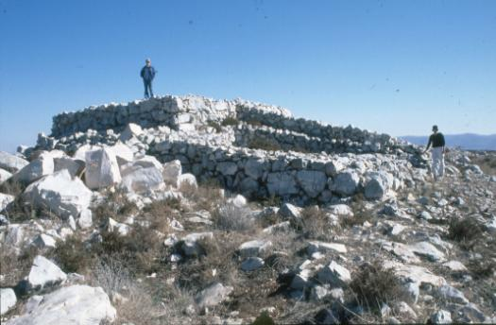
“Joshua’s Altar” in Mt. Ebal (courtesy of Prof. Adam Zertal)

The three altars mentioned here provide an excellent illustration of the passage from our parasha. The altar in Arad was an earthen altar, the altar in Mount Ebal (assuming it is indeed an altar) was an altar of “unhewn stones, over which an iron tool was not wielded” (Midot 3:4, see Deuteronomy 27:5), while the dismantled altar at Tel Sheva was made of hewn stones, against the Torah’s injunction!

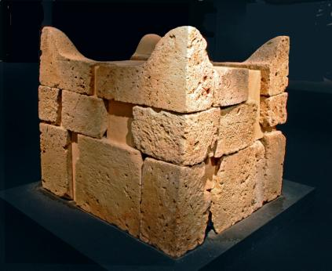
Reconstruction of the horned altar from Tel Sheva (Z. Radovan)

Another type that is not mentioned in the Torah is an altar that is hewn wholly in the rock. Several Nabatean altars of this type can be found in Petra, but these are not relevant for those who are studying Tanakh. Throughout Israel, however, three examples of this type of altar, which, in theory, date back to the Biblical period, can be found. One of these is a huge altar at the foot of the tell of ancient Samaria (Sebastia). The other two are “Manoah’s altar” below Tel Tzora (located today at the edge of the Shimshon industrial area) and the beautiful four-horned altar found by Doron Nir-Zvi in Givat Harel, near Shiloh, whose details I publicized in 2003.

It should be noted that the dimensions of the altar in Arad, Manoah’s altar and the altar in Givat Harel approximately match the dimensions of the burnt-offering altar described in Exodus – five cubits long and five cubits wide and three cubits tall! The latter two altars, as well as the altar at Mount Ebal, are all located in open areas, at the middle of the mountain and not at its peak. This information allows us to speculate that these altars were designed for worshiping God and not for idolatry. It is likely that those who carved the altars out of the natural rock felt that this method of building was fundamentally similar to building an earthen altar.

Altar in Givat Harel (courtesy of L. Leipnik)

More doubtful cases are the altars (or altar bases) in Shechem, in Tell Qasile in north Tel Aviv, in Dan and in Horvat Qitmit in the Negev (an Edomite site). A fortified structure from the end of the First Temple period located south of Jericho, featuring two raised platforms with steps leading up to them, can be added to this list as well. This structure was interpreted (somewhat hesitantly) by the site’s excavator Avi Eitan as a “bamot house.” An early bama that did not serve as an altar can be found in the village of Yabrud, 1.5 miles northwest of modern Ofra. The bama is built from large stones and surrounds a centuries-old Mediterranean hackberry tree, which was apparently preceded by an even more ancient tree before it. It is difficult to determine how old this bama is, but it should be noted that one of the stones of the bama is pentagonal, and contains small pentagonal depressions of the kind found occasionally in Byzantine churches. Aside from these examples, various hewn stone sites here and there have been identified as altars by scholars searching eagerly for remains of ritual.

In the end, the number of incense altars found far outstrips the number of animal altars. This uneven proportion between these two types of altars is surprising, since animal sacrifice is the more basic ritual act. In fact, the Hebrew word for altar – mizbe’ach – is fundamentally connected to the word for slaughtering an offering – zevicha. Thus, the expression mizbach ha-ketoret (incense altar) is a borrowed phrase by its very nature. Why, then, are there so many incense/meal-offering/libation altars and so few animal altars?

Why So Few Animal Altars Survived – A Difficult Question

The answer to this question might be that much of the ritual animal sacrifice was performed on alternative surfaces, including natural rock surfaces, large stones and earthen altars that were not designed to be preserved. The first of these can be found in the story of Manoah and the angel – “and [he] offered them up on the rock to the Lord” (Judges 13:19), and perhaps in archaeological findings as well in the tumuli of western Jerusalem. The second type – large stones – is mentioned in the account of the Battle of Michmas in I Samuel (14:33), and the third type – earthen altars – is mentioned by Naaman, the Aramean army commander (II Kings 5:17). Despite this, it is unclear if these solutions are sufficient. The Tanakh does not merely mention explicitly the existence of ritual animal sacrifice, but also describes the construction of altars, the destruction of altars, and the altar stones themselves. In the story of Gideon (Judges 6), the beginning of the revelation takes place when Gideon places an offering of meat and matzot on a rock, but in that same place an altar was later built and another altar was destroyed. Even the large stone upon which King Saul sacrificed later became an actual altar (I Samuel 14:35). When Elijah challenged the prophets of Ba’al on Mount Carmel, a sacrifice ostensibly takes place in an open area “large enough for two seahs of seed” (I Kings 18:32) surrounded by a hastily erected trench, but there is also a destroyed altar that was restored and an (additional?) altar made up of twelve large stones.

In the end, the hundreds of instances in Tanakh where the word “altar” is mentioned attest to the fact that there is no simple solution to this question. We might claim that altars made of unhewn fieldstones are not designed to be preserved over time, or perhaps that it is difficult to distinguish between them and generic field clearing piles. However, the earthen altar found in Arad and the altar at Mount Ebal demonstrate that even altars made of unattached bricks or of rough stones can be preserved. Perhaps we can assume that the lack of altars is a result of the massive, far-reaching campaigns to purge the land of altars undertaken by Hezekiah and especially Josiah, which were recounted by the Tanakh. The two kings were not as meticulous in their destruction of incense altars, possibly because their small size made it easier for worshipers to hide them. Another possibility is that offering incense outside the Temple in Jerusalem was not considered as grave an offense as animal sacrifice outside the Temple.

For further study:

G. Barkay, “Mounds of Mystery: Where the Kings of Judah Were Lamented,” Biblical Archeology Review 29 (2003), 32-39, 66.

S. Ben-Yosef, “Yabrud,” in: A. Yitzhaki (ed.), Israel Guide: An Encyclopedia for the Study of the Land 8 (1980), 316-318 [Hebrew].

Y. Bin-Nun, Eretz Ha-Moriya: Pirkei Mikra Ve-lashon, Alon Shevut 2006, 219-221 [Hebrew].

U. Cassuto, A Commentary on the Book of Exodus, Jerusalem 1967, 255-256.

A. Eitan, “Vered Yeriḥo,” Hadashot Arkheologiyot 82 (1983), 43-44 [Hebrew].

Yehudah Elitzur, “Le-mahut Ha-regamim Be-ma’arav Yerushalayim,” Israel and the Bible, Ramat Gan 2000, 164-171 [Hebrew].

S. Gitin, “The Four-Horned Altar and Sacred Space: An Archaeological Perspective,” in B. Gittlen (ed.), Sacred Space: Archaeology and the Religion of Israel, Winona Lake, 2002, 95-123.

M. Haran, “Altar-ed States: Incense Theory goes up in Smoke,” Bible Review 11 (1995), 30-37, 48.

A. Kempinski, “Joshua's Altar – An Iron Age I Watchtower,” BAR 12 (1986), 42, 44-49.

A. Mazar, Archaeology of the Land of the Bible, New York 1990, 492-502.

D. Nir-Zvi and Yoel Elitzur, “A Rock-Hewn Altar Near Shiloh,” The Palestine Exploration Quarterly Volume 135 (2003), 30-36.

B. Porten, The Elephantine Papyri in English: Three Millennia of Cross-cultural Continuity and Change, Atlanta 2011, 151.

H. Shanks, “BAR Interviews Avraham Eitan: Antiquities Director Confronts Problems and Controversies” BAR 12 (1986), 30-38.

A. Zertal, “Has Joshua’s Altar Been Found on Mt. Ebal?” BAR 11 (1985), 26-43.

Translated by Daniel Landman

See map.
Regarding another two verses that feature the phrase kol ha-makom, see Bin-Nun there.
Menahem Haran claimed that these altars were not meant for incense offerings but rather for meal offerings, but he did not bring convincing evidence to support his position.
These are about twenty mounds of earth and stones covering small pits in the areas of Givat Massuah, Ir Ganim, Ora, Aminadav and Beit Zayit. The mounds feature burn marks and are surrounded by short fences. According to Ruth Amiran and my late father Yehudah Elitzur, these sites served as altars; according to archeologist Gabriel Barkay, however, they were lamentation sites of the kings of Judah.
There are, however, two archaeological contexts that seem to indicate that Josiah’s agents preferred to bury ritual sites dedicated to the God of Israel rather than destroy them: the altar in Arad (according to Yohanan Aharoni) and the tumuli in western Jerusalem (according to my father, z”l).
This last theory is supported by testimony in the Elephantine papyri, which date back to the fifth century BCE: “And sheep, ox, and goat (as) burnt-offering are [n]ot made there, but (only) incense (and) meal-offering.”

