YESHIVAT HAR ETZION
ISRAEL KOSCHITZKY VIRTUAL BEIT MIDRASH (VBM)
*********************************************************

GEOGRAPHY IN THE PARASHA

PARASHAT MISHPATIM

The Destined Borders of the Land of Israel
By Prof. Yoel Elitzur

I will set your borders from the Sea of Suph to the Sea of Philistia, and from the wilderness to the Euphrates; for I will give into your hands the people who live in the land, and you will drive them out before you. Do not make a covenant with them or with their gods. (Exodus 23:31-32)

Expansive Borders Described Four Times in the Torah

Four times in the Torah, the borders of the Promised Land are described as extraordinarily vast, reaching all the way to the Euphrates River. The first time we find this description is in God’s promise to Abraham at the Covenant of the Pieces: “On that day the Lord made a covenant with Abram, saying, ‘To your offspring I assign this land, from the river of Egypt to the great river, the river Euphrates’” (Genesis 15:18).

The second time is in our parasha, in the closing lines of the covenant of Sinai: “I will set your borders from the Sea of Suph to the Sea of Philistia, and from the wilderness to the Euphrates” (Exodus 23:31).

The third time is in the opening of Moses’s first speech at the beginning of Deuteronomy. Moses cites God’s command to Israel in anticipation of their journey from Horeb:

The Lord our God spoke to us at Horeb, saying: You have stayed long enough at this mountain. Start out and make your way to the hill country of the Amorites and to all their neighbors in the Arabah, the hill country, the Shephelah, the Negeb, the seacoast, the land of the Canaanites, and the Lebanon, as far as the Great River, the river Euphrates. See, I place the land at your disposal. Go, take possession of the land that the Lord swore to your fathers, Abraham, Isaac and Jacob, to assign to them and to their heirs after them. (Deuteronomy 1:6-8)

The fourth time is at the end of the series of faith chapters that open the book of Deuteronomy:

The Lord will dislodge before you all these nations: You will dispossess nations greater and more numerous than you. Every spot on which your foot treads shall be yours; your territory shall extend from the wilderness to the Lebanon and from the River – the Euphrates – to the Western Sea. (11:23-24)

These four sources complete one another. The verses describe six geographical points that delineate the borders of the land:

- In the north – the Euphrates River. The Euphrates River is mentioned in all four parallel passages. It seems that this refers to the northwestern section of the river, north of the river’s “knee.” Today, this area contains an artificial basin adjacent to the Syrian town of Maskaneh, about fifty miles southeast of Aleppo.

- In the west – the Mediterranean Sea, called the Sea of Philistia or the Western Sea in these passages.

- In the south – the Sea of Suph, and in Genesis 15, the river of Egypt. The Sea of Suph bifurcates into two gulfs: the Gulf of Eilat on the east and the Gulf of Suez on the west. North of the Gulf of Suez lies the easternmost branch of the Nile Delta, which carried a stream in ancient times but subsequently ran dry. In the Hellenistic period and the Roman period, this branch was known as the Pelusian arm, after the city of Pelusium, located in what is now Tell el-Farama near Baluza in the northwest Sinai Peninsula. The city was situated on the riverbank and became known for producing fine linen fabrics.

- In the east – the wilderness, and in Deuteronomy 11, the wilderness and the Lebanon. “The wilderness” is apparently the large Syrian Desert east of the inhabited region of the Transjordan. This enormous desert was impassable in ancient times. Therefore, even though the land of Israel is situated west of Babylonia (which accounts for its sobriquet in the Babylonian Talmud: Ma’arava), ancient travelers to the land of Israel from Babylonia, Assyria or Aram would have to journey along the northern Euphrates and enter the land from the north.

The inclusion of the Lebanon among the borders of the land of Israel presents some difficulty, as ostensibly the Lebanon region does not lie on the border but falls within it. A solution to this problem can be found in the Septuagint, which translates the word Ha-Levanon in Deuteronomy 11 as “Antilibanos,” i.e., the Anti-Lebanon mountains, the long mountain range that begins from Mount Hermon and trends northeast, east of the Beqaa Valley. This range is known in Arabic as “al-Lubnan esh-Sharqi” – the eastern Lebanon. It can also be demonstrated that in Biblical Hebrew as well this range is occasionally called “the Lebanon.” The strongest evidence can be found in Song of Songs: “Your brow like the Lebanon tower that faces toward Damascus” (7:5). From western Lebanon it is impossible to see Damascus; from eastern Lebanon, on the other hand – the Anti-Lebanon mountains – it is certainly possible. If we review the borders of the land, it seems that the Torah is referring to the northeastern slopes of the Anti-Lebanon mountains, near the town of al-Qaryatēn. The line that follows the length of the border of the Syrian Desert from south to north, toward the “knee” of the Euphrates mentioned above, passes through this very region.

To summarize, these passages speak of expansive borders, which include all the inhabitable land east of the Mediterranean Sea. Defined another way: all of Greater Syria between Egypt and Mesopotamia, the middle portion of which is known as the Fertile Crescent. This vast region was defined in a national sense, in a manner typical of the zeitgeist of Isaiah’s time: “In that day, Israel shall be a third partner with Egypt and Assyria as a blessing on earth” (Isaiah 19:24).

An Alternate Border in the Book of Numbers

In addition to these borders, there is an additional destined border that is different from the one described above. Parashat Masei delineates entirely different borders for the land of Israel: “Instruct the Israelite people and say to them: When you enter the land of Canaan, this is the land that shall fall to you as your portion, the land of Canaan with its various boundaries” (Numbers 34:1-2). The chapter goes on to describe the borders in great detail. Many have dealt with these borders and suggested identifications for the names mentioned here. Instead of discussing these borders from a geographical perspective, however, we will first highlight what is missing from these borders: the Euphrates River, the Sea of Suph, the wilderness and the river of Egypt.

In place of these expansive borders, we find much smaller borders. In the north, the border extends to Lebo-hamath and Mount Hor. According to the identification advanced by Chazal (in Halakha, Aggada and Targumim) and supported by evidence from Tanakh (II Kings 14:25-28), this peak is located in the Amanus ridge, today the Nur Mountains, above the northeast corner of the Mediterranean Sea. In the south, the border extends to the wilderness of Zin and Kadesh-barnea (in the region known today as the Negev Mountains), in the southwest to the Wadi of Egypt, identified with Wadi el-Arish, and in the east to the Jordan and the Dead Sea. The same borders are mentioned in brief in the description of the land that the spies scouted: “From the wilderness of Zin to Rehob, at Lebo-hamath” (Numbers 13:21). The only border delineated in Parashat Masei that matches the borders we recognize from Genesis, Exodus and Deuteronomy is the western border – the Mediterranean Sea.

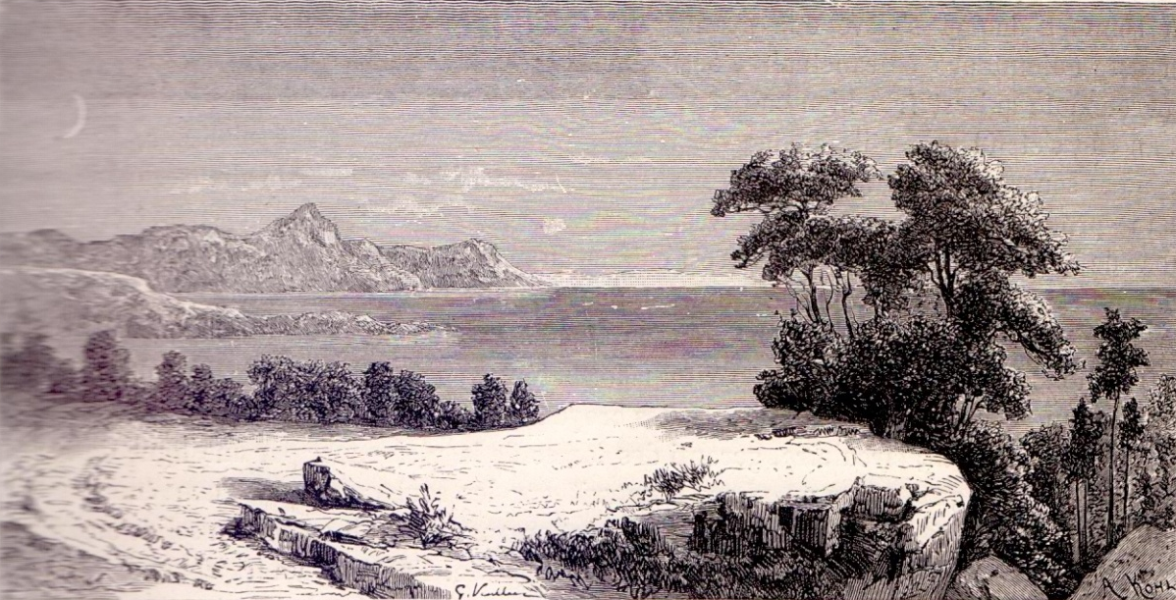
Mount Hor in the Nur Mountains (Louis Lortet, La Syrie, Paris 1880)

The truth is that the entire history of the nation of Israel, from the Exodus to the conquest of the land of Canaan, is based on these reduced borders. If the borders of the land had been defined then by the Sea of Suph and the river of Egypt, this would mean that the people of Israel had already entered the land of Israel the moment they crossed the Sea of Suph. If so, they could have remained in Marah and Elim and saved themselves all those years of wandering in the wilderness! The spies were sent to scout out the land, starting from the region of Kadesh-barnea and the wilderness of Zin, which were the southern borders of the smaller land of Canaan described in Numbers 34. The entire story of the spies and the subsequent decree that the nation would wander in the wilderness can only be understood if these were the actual borders of the land of Israel.

In light of this, it seems that the Torah presents two different sets of borders for the land of Israel, one expansive and one more limited. If we examine the book of Joshua, we find that it, too, presents two sets of borders. At the opening of the book, the expansive borders are presented (Joshua 1:3), using language that closely resembles the passage from Deuteronomy 11. However, Joshua 13 uses the borders of Parashat Masei – “to Lebo-hamath” – as a point of contrast for the achievements of the conquest. Two sets of borders for the land of Israel are hinted at in Deuteronomy as well, in the passages on the cities of refuge: “And when the Lord your God enlarges your territory… then you shall add three more towns to those three” (19:8-9). In other words, there is the basic state in which there are three cities of refuge (in addition to those that Moses designated in the Transjordan), and there is also an expanded state, when God enlarges the borders of Israel, and they will have to add another three cities.

According to the plain meaning of the text (as opposed to the wishful thinking of certain scholars), these two sets of borders are not a practical description of the territory that was conquered or that was settled by the people of Israel at any particular historical period. Rather, these are both theoretical sets of borders mentioned in the Torah prior to the entrance of the people of Israel into the land. However, we must still answer a question that arises from this conclusion: Why was the land of Israel given two different sets of borders from the start?

Why Are There Two Sets of Borders?

Some solve this problem by defining the expansive borders as the “promised borders.” According to this interpretation, it is not incumbent upon the people of Israel to realize these borders; this was simply an abstract promise that only God is required to fulfill. When God desires to bestow these expansive borders upon His nation, He will do so. This approach does not make sense conceptually and does not accord with the language of the text. Conceptually, according to the Jewish faith, God does not make promises that are not applicable to man in a practical sense. Even regarding the manna that sustained the people of Israel in the wilderness – an unparalleled miracle – the people were still required to toil: “The people would go about and gather it, grind it between millstones or pound it in a mortar and boil it in a pot” (Numbers 11:8). And from a textual perspective, consider that the commandment to take possession of the land is said in connection with the expansive borders in Deuteronomy: “Start out and make your way… as far as the Great River, the river Euphrates. See, I place the land at your disposal. Go, take possession of the land…” (1:7-8). In his addenda to Sefer Ha-mitzvot, Ramban cites these verses from Deuteronomy 1 as the primary basis for the positive commandment of taking possession of the land. Thus, the expansive borders constitute destined borders that the people of Israel are commanded to realize, and not merely “promised borders.”

What, Then, Is the Solution?

It seems that the text in our parasha (and similarly in Parashat Ekev in Deuteronomy 7) answers this question. The Torah speaks of the fact that the conquest of the land will be accomplished in a slow process: “I will drive them out before you little by little, until you have increased and possess the land” (Exodus 23:30). The Torah presents two obstacles that may stand in the way of Israel’s conquest of the land. The first is “lest the land become desolate and the wild beasts multiply to your hurt” (23:29), and the second is “You shall make no covenant with them and their gods. They shall not remain in your land, lest they cause you to sin against Me; for you will serve their god – and it will prove a snare to you” (23:32-33). The land that was designated for the people of Israel is large and expansive. In the future, Israel will grow and become as numerous as the stars of heaven and the sands on the seashore; but at the time, their population numbered about 600,000 men, and it was thus impossible to take possession of the entire land. Even if they would be able to conquer all of it, they would be forced to choose between two evils: either to allow their enemies to remain in the land and forge a treaty with them that will inevitably “prove a snare” to Israel; or to destroy the nations of Canaan without being able to then settle the empty tracts of land generated as a result. This second option is a bad one as well, not to mention immoral. God is prepared to expel the land’s inhabitants in anticipation of the people of Israel’s entrance, but not at the cost of bringing utter desolation to the world. The proper, correct solution is to conquer the land by stages. In the Stage A, the Torah outlines the borders of a smaller version of the land, one that the people of Israel would be able to conquer and settle within the same generation. Subsequently, when the people of Israel grow in number and in strength, it will be incumbent upon them to finish taking possession of the entire land, in its full, expansive form. Just as the commandments of appointing a king and building a permanent temple were intended to only be relevant in the future, the completion of the conquest and settlement of the entire land was only intended for the future as well – for Stage B.

This principle – that God designated a territorial nucleus for immediate conquest and established a stage-based program for the remainder of the land – was implemented by Joshua, following God’s command even in the context of the limited borders described in Parashat Masei. In Joshua 13, after the overview of “the territory that remains” (13:2), which he did not manage to conquer, Joshua accepts a divine promise and, with it, a divine command: “I Myself will dispossess those nations for the Israelites; you have only to apportion their lands by lot among Israel, as I have commanded you” (13:6). In Joshua’s final speech to the nation, he declares that he carried out this command:

See, I have allotted to you, by your tribes, [the territory of] these nations that still remain, and that of all the nations that I have destroyed, from the Jordan… The Lord your God Himself will thrust them out on your account and drive them out to make way for you, and you shall possess their land as the Lord your God promised you. (13:4-5)

If we pay close attention to the tribal borders, it is apparent that Joshua added fictitiously two large swaths of land to the territorial regions of two powerful tribes that were not actually conquered: the southern coast – Philistia – to the tribe of Judah (Joshua 15:44-47) and the northern valleys – the Beit She’an Valley, the Jezreel Valley and the northern Sharon plain, called the “three regions” – to the tribe of Manasseh (17:11). Joshua did not allot the remaining land in the north – “to Lebo-hamath” – to the tribes even fictitiously. Joshua estimated correctly that conquering this land was not a goal that could be achieved in the near future, so he left this task to the leaders that would follow him, even on the declarative level.

On the other hand, there was also a significant reversal from the original plans. As a result of the war and conquest of the land of Sihon and the request of the Gadites and the Reubenites, this territory was given to these tribes under a special contract. The territories of Reuben and Gad, which were located beyond the Jordan River and therefore were originally intended to be conquered and settled only during Stage B, were advanced to Stage A. Thus, while Joshua did accomplish his task, he deviated somewhat from the form in which it was given to him; assessing the reality in the light of the principles of the Torah, he added land in the east and neglected land in the north.

Returning to the two sets of borders delineated in the Torah, the Torah not only designates all of “Greater Syria” for the people of Israel, but also commands them to conquer and settle this land. This region includes land stretching from Egypt to the Euphrates River, on both sides of the Great Rift Valley, including the Sinai Peninsula. But this is a destiny for the future, when the nation grows and becomes capable of fulfilling its mission properly. For the first stage, however, the plan is to conquer a much more limited region – the land east of the Mediterranean between the Great Rift Valley and the sea, and in particular, the Cisjordan until the Makhtesh Ramon area in the south.

The prophetic messages that appear frequently in the books of the Prophets in Tanakh, which foretell that in the future the desert will bloom and contain sources of water, are connected to this idea. The ability to take true possession of the entire land – not through imperial rule from above and not over a desolate land – will come in tandem with the divine blessing that allows the desert regions of the land to bloom.

The (Potential) Holy Land

There is another interesting conceptual, perhaps mystical point that we can add to this discussion. It seems that the entire land, in its expansive version, possessed a kind of “potential for holiness” even before it was conquered, which lay dormant until that time. R. Judah Halevi writes in his Kuzari that the prophecy of Moses, Aaron and Miriam was a result of the special quality (segula) of the land of Israel, because

Sinai and Paran are reckoned as belonging to the land of Israel, because they are on this side of the Sea of Suph, as it is said, “I will set your borders from the Sea of Suph to the Sea of Philistia, and from the wilderness to the Euphrates” [Exodus 23:31]. (2:14)

R. Judah Halevi’s purpose was certainly not to contradict the Torah’s assertion that Moses, Aaron and Miriam never entered the land, and that they wandered through Sinai and Paran on the way to the land of Israel. Rather, he was undoubtedly referring to the deeper message that we mentioned above – the land where Moses, Aaron and Miriam prophesied was not the land of Israel in actuality, but only in potential.

We may add that, according to this, the moment that the people of Israel crossed the Sea of Suph and entered the greater boundaries of the Promised Land, even though this was not technically considered part of the land of Israel, the people immediately merited the virtue of song: “Then Moses and the Israelites sang this song to the Lord” (Exodus 15:1). The virtue of song is intrinsically connected to the land of Israel, as the Talmud states: “Hallel is not said for a miracle which occurred outside of the land of Israel” (Megilla 14a). The Talmud challenges: “How then do we come to say it for the Exodus from Egypt, which was a miracle which occurred outside the land of Israel?”; and answers:

As it has been taught: Until they entered the land of Israel, all lands were counted as proper for chanting a hymn of praise [for miracles done in them] – After they had entered the land, other countries were not counted as proper for chanting a hymn of praise [for miracles done in them].

Thus, we may argue on a deeper level that in the end, the Song of the Sea was recited in a place that will one day be included in the holiness of the land of Israel.

One day, the nation of Israel will fulfill its destiny and merit the realization of the Torah’s message:

And when the Lord your God enlarges your territory, as He swore to your fathers, and gives you all the land that He promised to give your fathers – if you faithfully observe all this Instruction that I enjoin upon you this day, to love the Lord your God and to walk in His ways at all times. (Deuteronomy 19:8-9)

When this occurs, it will become clear, in retrospect, that both Song and the Torah were given to Israel – in the land of Israel.

For further study:

Yehudah Elitzur, “Gevulot Ha-aretz Be-mesoret Yisrael,” Israel and the Bible, Ramat Gan 2000, 375-383 [Hebrew].

Yoel Elitzur, “Ha-gam Ha-Levanon Be-Eretz Yisrael?” Nekuda 48, 1983, 10-13 [Hebrew].

Translated by Daniel Landman

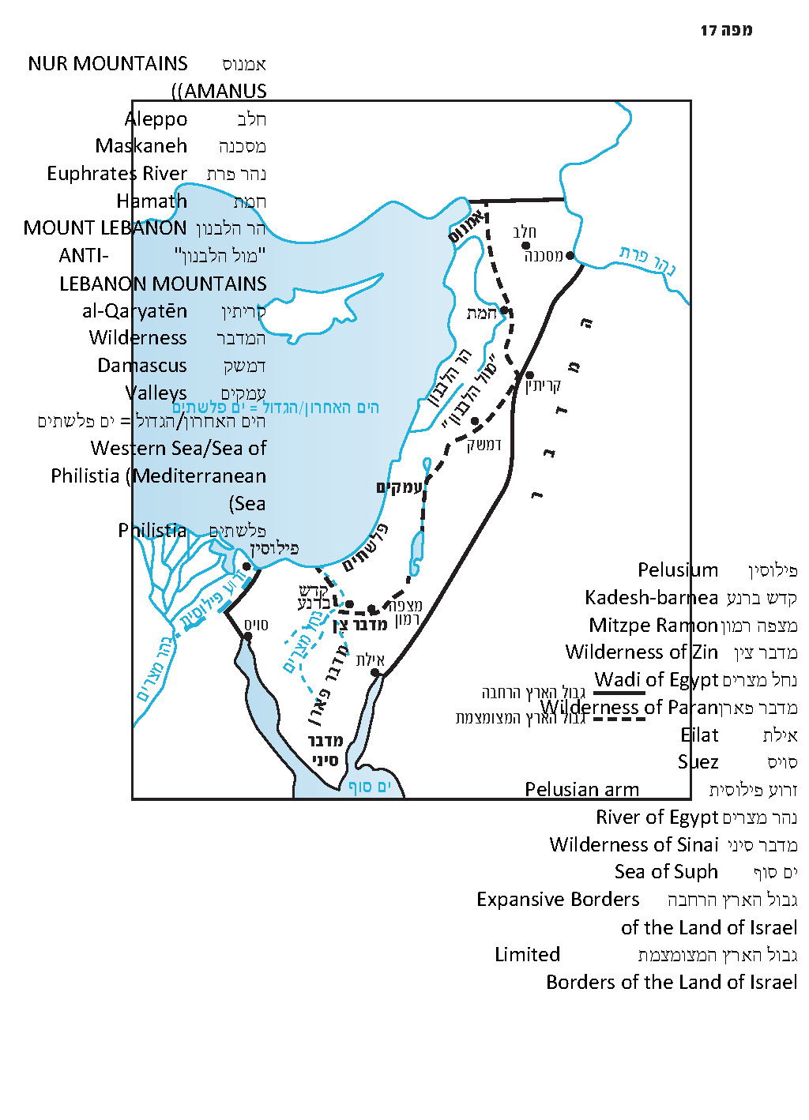

See map at end of the shiur.
See Mishna Yoma 3:7: “In the morning he put on Pelusium linen worth twelve minas.”
This explains Jeremiah’s references to Nebuchadnezzar and the Babylonians: “From the north disaster will be poured out on all who live in the land” (Jeremiah 1:14); and “For I am bringing disaster from the north” (4:6).
“Tower” here seemingly refers to a steep mountain range.
This refers to the northern Mount Hor, rather than the southern Mount Hor where Aaron died.
I would like to thank R. Yoel Bin-Nun for pointing this out to me.
Malbim suggested a similar explanation in his commentary to Numbers 34.

