YESHIVAT HAR ETZION
ISRAEL KOSCHITZKY VIRTUAL BEIT MIDRASH (VBM)
*********************************************************

GEOGRAPHY IN THE PARASHA

For easy printing, see
http://vbm-torah.org/archive/geography/19teruma.htm

PARASHAT TERUMA

The Givlim
By Prof. Yoel Elitzur

Were the Givlim Named for their Profession or their Location?

This week’s haftara relates that the people of Israel were not the only ones engaged in the construction of the Temple; members of other nations participated as well, including Hiram’s masons and the Givlim: “Solomon’s masons, Hiram’s masons, and the Givlim shaped them. Thus the timber and the stones for building the house were made ready” (I Kings 5:32). Who are the Givlim?

Targum Jonathan translates as argovlaya, a rare word that only appears in the Targum one other time, in its translation of “and the masons and the stonecutters” (II Kings 12:13). Similarly, the Syriac Peshitta translates givlim as argovlei, and uses this same word in its translation of “and the laborers” (II Kings 12:12). Apparently, there is a common Targumic tradition that manifests itself in both Targum Jonathan and the Peshitta. Based on the context in II Kings 12, it is clear that this term refers to a kind of craftsman who specializes in building or stonecutting. Writers of historical dictionaries have had difficulty locating an etymological background for this strange, unique word. According to some scholars, it is derived from the Greek word ergolabos, meaning “work manager,” while others connected it to the ancient Sumerian word BUR.GUL, meaning stonecutter. In the end, no one has suggested a truly precise parallel for this word.

However, all of our classical commentators (Rashi, R. Joseph Qara, Radak, Ralbag and the “Metzudot”) rejected the interpretation of the Targum, which states that ha-givlim refers to the name of a profession. Instead, they argue, Ha-Givlim is the name of a nation – the residents of the city of Gebal. Indeed, the Latin Vulgate also interpreted the word in this manner, and this interpretation is accepted in modern exegesis as well.

Gebal is a large, ancient port city that is rich in archaeological findings, located on the northern Lebanese coast between Beirut and Tripoli. The northern section of the Mount Lebanon region is named for this city – “the land of the Gebalites” (Joshua 13:5). Besides the mention of Ha-Givlim in I Kings and “the land of the Gebalites” in Joshua, the city is mentioned one other time in Tanakh, in a context that is critical for understanding the narrative here in I Kings. It appears when Ezekiel is instructed by God to “intone a dirge over Tyre” (Ezekiel 27:1). He laments: “Gebal’s elders and craftsmen were within you, making your repairs” (27:9). We learn two things from this: a. that in the time of Ezekiel, the city of Gebal was subject to Tyre; and b. that it was home to expert builders. It seems, then, that in Solomon’s time as well, the expert builders that King Hiram of Tyre sent to assist in building the Temple hailed from Gebal. Furthermore, the proximity of Gebal to the cedar-rich Mount Lebanon range certainly made it an important source of cedar wood for building.

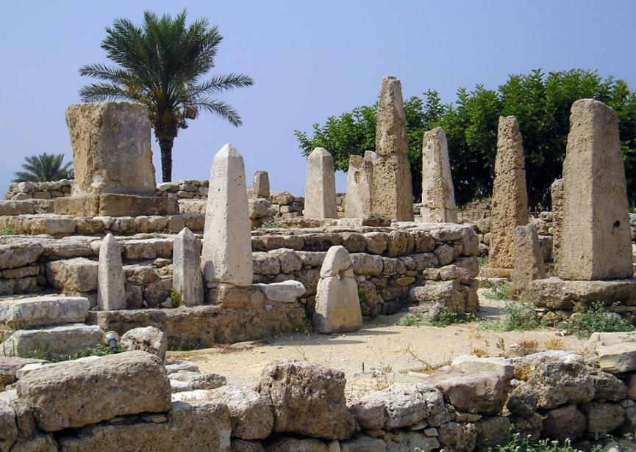
Ancient temple in Gebal – Byblos (Z. Radovan)

The form givli/givlim indicates that the name Gebal is derived from the so-called “segolate” nominal pattern. This pattern features one syllable consisting of a consonant followed by a vowel and then a cluster of two consonants, as in malk (king) or qudš (holiness). The form geval found in Ezekiel probably constitutes the Aramaic equivalent of this same segolate pattern. Arabic sources record the city’s name in the form Jubayl (pronounced today Žbayl).

Comprehensive archaeological excavations conducted at Gebal during the 1920s yielded many impressive discoveries, remnants of a fortified royal city with a magnificent castle. The antiquities found in Gebal included Canaanite inscriptions commemorating the kings of Gebal and their households. The earliest of these kings was Ahiram (the biblical form Hiram was apparently a later shortening of this name), who, according to scholars, predated Solomon by about a century. (A)hiram/Hirom was a common Phoenician name. In the time of Solomon, it was the name of both the king of Tyre and an Israelite master craftsman – “the son of a widow of the tribe of Naphtali, and his father had been a Tyrian” (I Kings 7:14) – who created the copper vessels for the Temple. One of the more interesting findings at Gebal was a statue bearing the name of King Shishaq of Egypt, depicting Shishaq sitting on his royal throne. Shishaq’s name is inscribed in Egyptian, alongside the Canaanite inscription “to King Abibaal of Gebal in Egypt.” From Tanakh, we learn that Shishaq invaded the land of Israel and that King Rehoboam of Judah succeeded in dissuading him from attacking Jerusalem by presenting him with a large bribe. The inscription found in Gebal reveals that Shishaq conquered Gebal in the north as well, and that its king Abibaal was, like Rehoboam, a vassal king subject to Shishaq.

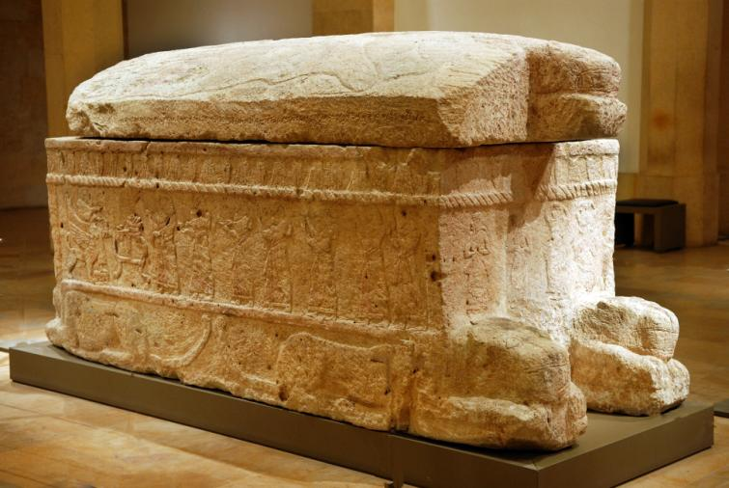
Sarcophagus of Ahiram, king of Gebal – Byblos (tenth century BCE) (Z. Radovan)

Gebal is not merely a location that appears in the haftara; it is also an integral part of the land of Israel. In our discussion on Parashat Mishpatim, we addressed the fact that the land of Israel possesses two sets of borders, one expansive and one more limited. As it turns out, Gebal falls within the borders of the land of Israel even according to its limited borders. We learn this explicitly from Joshua 13. The text delineates the “territory that remains” (13:2) that the people of Joshua’s generation were meant to reach but did not succeed in doing so. The borders of this remaining territory follow the limited set of borders described in Parashat Masei, which includes:

The land of the Gebalites, with the whole [Valley of the] Lebanon, from Baal-gad at the foot of Mount Hermon to Lebo-hamath on the east, with all the inhabitants of the hill country from the [North of the] Lebanon to Misrephoth-maim, namely, all the Sidonians. I Myself will dispossess those nations for the Israelites. (13:5-6)

Thus, according to the Tanakh, it is the nation of Israel’s responsibility to aspire to reach all the way to Gebal.

Two Gebals

There is one final point to make. It is important to distinguish between two different vowelizations of the word Gebal: גְבַל with a patach and גְבָל with a kamatz. All the instances of Gebal that we have mentioned in our discussion thus far are examples of the patach vowelization. The kamatz vowelization can be found in Psalms: “the clans of Edom and the Ishmaelites, Moab and the Hagrites, Gebal, Ammon and Amalek” (83:8). The geographical context here indicates that the verse is speaking of a strip of land in the southern Transjordan. This Gebal is apparently the northern part of Edom, southeast of the Dead Sea. The Jerusalem Targum translates Mount Seir (Har Se’ir) as “Gebala.” This name is found in Greek-Roman sources (in the form “Gebalene”) and was adopted by the Arabs in the form “al-Jibāl.”

The Talmud recounts two incidents that took place in Gebal (גבלא). In the first, R. Hiyya bar Abba, the prominent disciple of the amora Rabbi Yohanan, visited Gebal and encountered a weak, half-assimilated Jewish community (Yevamot 46a, Avoda Zara 59a). The second incident is a beautiful story, one of a series of aggadot in praise of the land of Israel at the end of Masekhet Ketubot:

Rabbi Joshua son of Levi once visited Gebal, where he saw vines laden with clusters of ripe grapes standing up [to all appearances] like calves. “Calves among the vines!” he remarked. “These,” they told him, “are clusters of ripe grapes.” “Land, O Land,” he exclaimed, “withdraw your fruit; for whom are you yielding your fruit? For those Arabs who rose up against us on account of our sins?” Towards [the end of that] year R. Hiyya happened to be there and saw them standing up [to all appearances] like goats. “Goats among the vines,” he exclaimed. “Go away,” they told him, “do not you treat us as your friend did.” (Ketubot 112a)

Which Gebal is the Talmud referring to in these two incidents? The proper vowelization of the Aramaic גבלא is unclear: Is it Gabla – the northern Gebal (Byblos) or is it Gebala – the southern Gebal (Gebalene/Seir)? Most scholars of Talmudic geography are certain that it is Mount Seir, on account of the mention of “Arabs” in the story in Ketubot. However, Prof. Saul Lieberman correctly noted that the scholars were misled here by their use of print versions of the Talmud. The appearance of the word “Arabs” is actually the result of internal censorship implemented in European printings of the Talmud because of fear of the Christians. In the manuscripts and in the first printing (MS Venice 1521), the original text was still in place: “For those gentiles who rose up against us on account of our sins.” The nature of this story and its context within Ketubot teach us that, as Tosafot point out (in Avoda Zara 59a), the Talmud here refers to a location in the land of Israel. Because of this, Lieberman maintains that this story relates to the northern Gebal, which is included in the land of Israel even within its more limited borders delineated in Numbers 34 and mentioned again in Joshua 13. R. Ishtori Haparchi already suggested this identification in his Kaftor Va-ferach (ch. 11). Finally, the first story has parallel versions in the Yerushalmi, and the northern connection is apparent from there as well. It seems therefore that in these two Talmudic stories, the place under discussion was Gabla (which is identical with the Biblical Gebal – with a patach – and the Greek Byblos) and not Gebala (the later name of Mt. Seir).

For further study:

W. F. Albright, “Gebal,” Encyclopaedia Biblica, II, 404-411 [Hebrew].

Ishtori Haparchi, Kaftor Va-ferach, Lunz ed. 251 [Hebrew].

S. Lieberman, Studies in Palestinian Talmudic Literature, Jerusalem 1991, 413, 584-585 [Hebrew].

B. Mazar, “Gebāl,” Encyclopaedia Biblica, II, 403-404.

G. Reeg, Die Ortsnamen Israels nach der rabbinischen Literatur, Wiesbaden 1989, 157 [German].

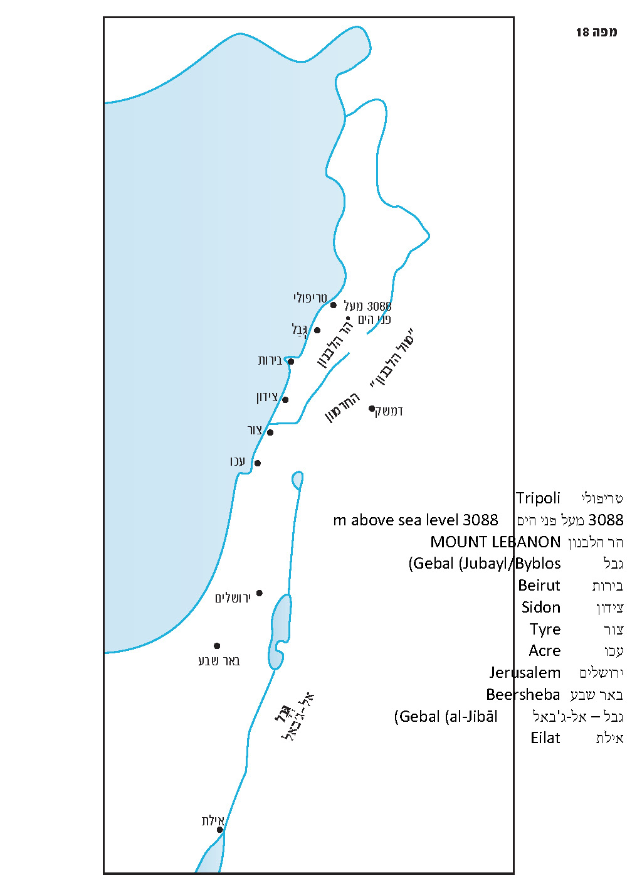

Translated by Daniel Landman

A similar indication can be found in the Amarna letters of the fourteenth century BCE, where the forms gubla and gubli can be found, rendered in Greek as Βύβλος (Byblos). It is presumed that the Greek word biblos/byblos, meaning “book”, originated from the Greek version of the name of the city of Gebal, since in ancient times the Egyptian papyrus passed through Gebal on its way to the Aegean world. It may be that the Hebrew-Canaanite alphabet reached ancient Greece via Gebal as well.
Compare to the Aramaic gevar, which is parallel to the Hebrew gever, and the Aramaic melakh, which is parallel to the Hebrew melekh. In addition, there are several segolate words in Hebrew that are pronounced in the Aramaic manner, such as devash (honey), sevakh (thicket) and the city Bnei Brak.

