YESHIVAT HAR ETZION
ISRAEL KOSCHITZKY VIRTUAL BEIT MIDRASH (VBM)
*********************************************************

GEOGRAPHY IN THE PARASHA

PARASHAT TETZAVEH-ZAKHOR

Remembering Amalek
By Prof. Yoel Elitzur

“Remember what Amalek did to you” (Deuteronomy 25:17). Before we discuss the Amalek incident and attempt to understand it fundamentally, we must first ask a more basic question: Who was Amalek, and where did this nation reside?

Who was Amalek?

Amalek was a nomadic nation, spread out across large desert expanses. The Amalekites were related to the Ishmaelites, the Midianites and the Kedemites, known as the “tent dwellers” (Judges 8:11). Periodically they would penetrate into inhabited settlements, and, according to Judges, “their camels were countless” (7:12).

What is the origin of Amalek? According to the list of the descendants of Esau at the end of Parashat Vayishlach (Genesis 36:12), Amalek was Esau’s grandson, or in other words, the first cousin of the nation of Israel. However, “the territory of the Amalekites” (Genesis 14:7) is mentioned even in Abraham’s time, in the story of the war of the four kings. Chazal explained: “Amalek had not yet arisen, yet you say, ‘and subdued all the territory of the Amalekites’? Rather, [the Torah] declared the end from the beginning” (Bereishit Rabba 41). In other words, the name written in Genesis 14 is merely a reflection of the reality at the time the Torah was written, and not an indication that the Amalekites already existed at that time. However, Balaam later prophesies: “The first of the nations was Amalek; but its fate is to perish forever” (Numbers 24:20). The interpretation of the Targumim and the classical commentaries that Amalek was the first nation to attack Israel following the Exodus seems unlikely in light of the simple reading of the text. The interpretation advanced by Ramban, Samuel David Luzzatto and others that Amalek was the premier nation at the time does not at all fit the image of Amalek as a nation of bandits and raiders who preyed on stragglers. It seems, then, that the correct interpretation is that of Grintz, who wrote that in the Tanakh’s view, Amalek and its lifestyle exemplify the early state of humanity. Grintz cites I Samuel 27:8: “the Geshurites, the Gizrites and the Amalekites – who were the inhabitants of the land from of old….” According to Grintz’s position, Amalek was apparently the name of an ancient nation that spread out over large expanses on the outskirts of the settled part of the land. Amalek son of Eliphaz son of Esau was named for this nation, or alternatively, joined them, similar to the other sons of Esau assimilated with the sons of Seir the Horite.

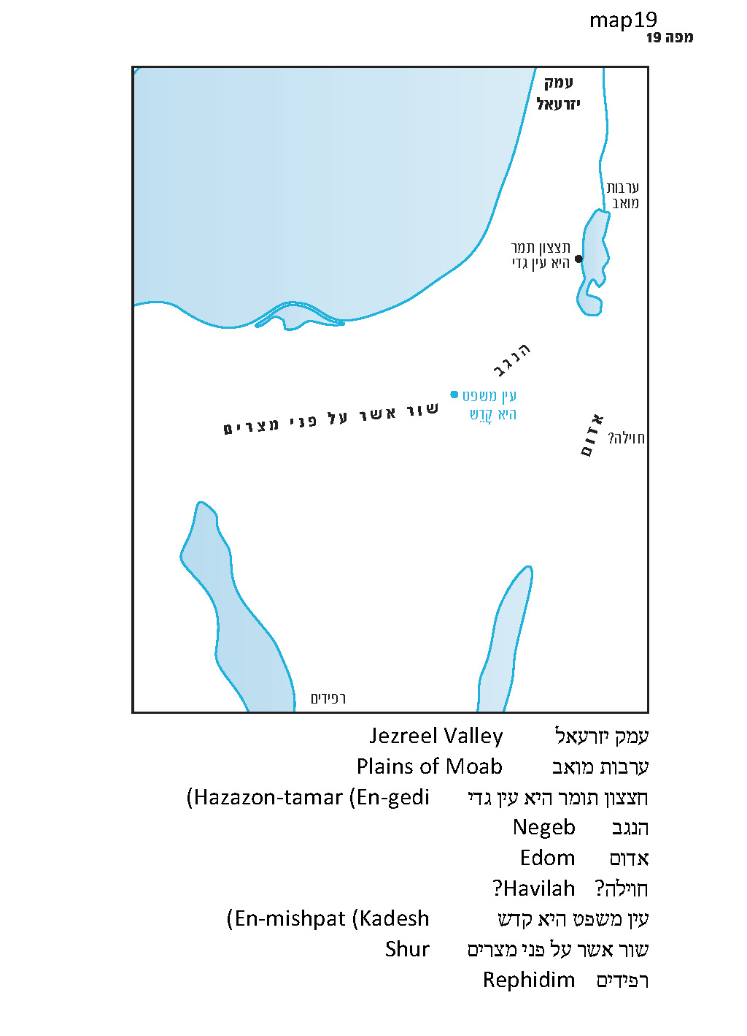

Where did Amalek Reside?

In Numbers, the spies report that “Amalekites dwell in the Negeb region” (13:29), and we read later on in the spies narrative that “the Amalekites and the Canaanites occupy the valleys” (14:25); “the Amalekites and the Canaanites will be there to face you” (14:43); and “the Amalekites and the Canaanites who dwelt in that hill country came down” (14:45). This placement of the Amalekites fits “the territory of the Amalekites” found in Genesis 14 – between “En-mishpat, which is Kadesh” and Hazazon-tamar (En-gedi). This was the basic extent of their territory. But in reality, Amalek reveals itself in many additional places, including Rephidim (Exodus 17), the plains of Moab (Number 24) and the Jezreel Valley (Judges 6). Amalek reaches their greatest level of dispersion in I Samuel: “Saul destroyed Amalek from Havilah all the way to Shur, which is east (al penei) of Egypt” (15:7). This area itself is defined in Genesis as the area to which the Ishmaelites spread: “They dwelt from Havilah, by Shur, which is east of Egypt, all the way to Asshur; they camped alongside all their kinsmen” (25:18). In I Samuel, this regional description returns, in an extremely significant context:

David and his men went up and raided the Geshurites, the Gizrites and the Amalekites – who were the inhabitants of the region from of old, all the way to Shur and to the land of Egypt. When David attacked a region, he would leave no man or woman alive. (27:8-9)

It seems that this emphasis on equivalent geographical areas serves to establish a contrasting parallel between the first two kings of Israel. Saul was disgraced and lost his kingdom when he did not heed the word of God, neglecting to annihilate Amalek completely as commanded. In contrast, David presents a “dowry” to God – even before his crowning – that rectifies the very issue that constituted Saul’s failure. He destroys the same nation of Amalek in exactly the same region – but in contrast to Saul, “he would leave no man or woman alive.”

“From Havilah all the way to Shur, which is east of Egypt” – where is this region? Shur can be found in other places. In the stories of the patriarchs, Shur marks the edge of the western Negeb: “Then Sarai treated her harshly, and she ran away from her. An angel of the Lord found her by… the spring on the road to Shur… between Kadesh and Bered” (Genesis 16:6-7, 14); “[he] settled between Kadesh and Shur” (20:1). On the other hand, it is also mentioned immediately following the crossing of the Sea of Suph: “Then Moses caused Israel to set out from the Sea of Suph. They went on into the wilderness of Shur” (Exodus 15:22). We can infer from the combination of these sources that “Shur” refers to the region known today as northern Sinai.

Havilah, on the other hand, is not easy to identify. It is mentioned in Genesis, in the Garden of Eden narrative: “the land of Havilah, where the gold is” (2:11). In addition, Havilah is the name of one of the sons of Cush (10:7), and the name of one of the sons of Joktan as well (10:29). All of these Havilahs are located in regions far to the south of the land of Israel and its neighboring lands, and thus it seems that our Havilah is a different place entirely. Since Havilah had never been mentioned in the context of southern Canaan, and the Torah states that Abraham’s sons by concubines (among whom the Ishmaelites were certainly included) were sent eastward, to the land of the East, we can estimate that the Havilah of the Ishmaelites and Amalek was some desert region in the southern Transjordan, near Edom. This means that the Amalekites spread out over a large area that apparently included the entire northern Sinai Peninsula, Negeb Mountains and southern Transjordan. If so, this large expanse was the home of various nomadic peoples, including among them the Ishmaelites – and the Amalekites as well.

The Question

Now we must ask the main question: What is the meaning of our eternal conflict with Amalek? “I will utterly blot out the memory of Amalek from under heaven” (Exodus 17:14); “You shall blot out the memory of Amalek from under heaven. Do not forget” (Deuteronomy 25:19); “Now go, attack Amalek, and proscribe all that belongs to him. Spare no one, but kill alike men and women, infants and sucklings, oxen and sheep, camels and asses!” (I Samuel 15:3). The difference between these harsh commands and the attitude that the Torah displays toward Egypt is stark: “You shall not abhor an Egyptian, for you were a stranger in his land” (Deuteronomy 23:8). But is the crime of having “cut down all the stragglers in your rear” (25:18) truly worse than the crime of “every boy that is born you shall throw into the Nile”? Is it not simply the way of warfare to pinpoint and exploit the enemy’s weaknesses? Why is the Torah so much more stringent in its response to a one-time incident that occurred in a military context than in its response to a long period of enslavement, replete with mortar, bricks and cruel taskmasters?

One interesting and original solution to this problem, rooted in a simple reading of the text, was suggested by Ariella Deem, z”l, a writer and Bible scholar from Jerusalem who died at a young age in 1985. Deem examined the various incarnations of Amalek throughout Tanakh, and discovered some interesting information: Apparently, Amalek serves, in a way, as the nation of Israel’s “evil twin.” When the people of Israel leave Egypt and reach Rephidim, on the verge of entering the wilderness of Sinai, Amalek suddenly appears and attacks them. (Note the language of the verse: “And Joshua overwhelmed the nation of Amalek with the sword” (Exodus 17:13) – the moment Israel becomes a nation, we hear the term “the nation” applied to Amalek as well.) Israel continues to wander, and in the fortieth year they encamp at the edge of the Promised Land, in the plains of Moab, at the Jordan near Jericho, atop the ruins of the kingdom of King Sihon the Amorite. Whom do they encounter at this critical moment? Once again, none other than Amalek. The Torah relates that Balaam peered out from the mountaintop at Israel in its tribal encampment, and immediately thereafter: “He saw Amalek and, taking up his theme, he said…” (Numbers 24:20). In the time of the Judges, when Israel was already settled in their land, there was no king in Israel, and each tribe had to fend for itself, we find Amalek again by their side with tribes of their own: “Now Midian, Amalek and all the Kedemites were spread over the plain, as thick as locusts; and their camels were countless” (Judges 17:12). The Amalekites spread throughout the land, raiding produce from the farmlands and filling the Jezreel Valley. When Israel starts to become an organized nation, led by their first king – Saul, Amalek acquires their first king as well – Agag. This is also the first we read of the city of Amalek: “Then Saul advanced as far as the city of Amalek and lay in wait in the wadi” (I Samuel 15:5).

Ariella Deem (1935-1985)

In contrast to the rest of Esau’s descendants, who chose the land of Edom and became integrated therein, dispossessed some of the Horites and assimilated into the rest, Amalek instead clings to Israel, refusing to let go. When Israel sets its eyes on the land of Canaan, Amalek does the same. Ariella Deem writes: “Before us a monstrous figure begins to appear, inching closer to us like a murky shadow, a kind of twin of ours, growing and developing with us, wrapped around our ankles, a dark specter, our menacing twin….”

Amalek refuses to leave us alone. Wherever we go, Amalek is there as well. At every stage of our national development, Amalek develops along with us. Whenever we attempt to take possession of a piece of land, we find that Amalek is interested as well. Amalek is a figure that competes with us for our identity and for our place – in our land, in the world, in history. The war with Amalek is more than just revenge; it is an act of defense – it is either us or them. We are commanded to blot out the memory of Amalek, but it is no less important, first and foremost, for us to be able to distinguish between Israel and Amalek. The harsh war with Amalek is, in essence, Israel’s only means to survive and endure.

My father, z”l, added that the command to annihilate Amalek in the time of Samuel and Saul was not rooted in the events of the past. In the book of Samuel, the Amalekites are a corrupt people who subsist on theft and pillaging. I Samuel recounts the decisive battle between Israel and the Philistines. The Amalekites wait until the moment is right and take advantage of the departure of the two armies from their respective camps, gleefully plundering both sides of the conflict: “And there they were, scattered all over the ground, eating and drinking and making merry because of all the vast spoil they had taken from the land of the Philistines and from the land of Judah” (30:16). The Amalekites stormed in, burning Ziklag (David’s city at the time), taking all the women and children captive and seizing all of their possessions. As they traveled from Ziklag, they abandoned an Egyptian boy who was taken captive in one of their earlier raids because he fell ill with the flu, or with indigestion.

Saul is commanded to “go and proscribe the sinful Amalekites; make war on them until you have exterminated them” (15:18). When Samuel is about to execute Agag, he does not recite a blessing over the fulfillment of the mitzva of destroying Amalek; rather, he proclaims: “As your sword has bereaved women, so shall your mother be bereaved among women” (15:33). According to the simple understanding, Saul and Samuel’s war with Amalek had little to do with Agag’s family ties or with fulfilling any religious obligations. Amalek was a generic name that included other nomadic raiders of their type as well; only the Kenites, who performed an act of kindness for the nation of Israel, were commanded to “withdraw from among the Amalekites, that I may not destroy you along with them” (15:6). This is a war for survival.

In one of the last sentences in Ariella Deem’s short article, she writes: “It is almost difficult to avoid modern-day comparisons, and every generation has its own Amalek….”

The mitzva to remember Amalek is eternal. We remember Amalek even when the historical nation of Amalek has already been mixed up throughout the nations. According to Ariella Deem, when we search for the quality of “Amalek-ness” in the world, we are not necessarily referring to evil, but rather to competition with Israel. When a religion claims that it is the true Israel – when a nation claims that it is the chosen race, while the Jews are an inferior nation that must be destroyed – when people claim that that this land is not the land of Israel, but a land with a different name, belonging to them – perhaps this is the essence of Amalek, about whom the Torah commanded: “Remember” and “Do not forget.”

For further study:

A. Deem, “Reishit Goyim Amalek,” Maariv (literary supplement), 3/1/85 [Hebrew].

Yehudah Elitzur, Israel and the Bible, Ramat-Gan 2000, 125 [Hebrew].

Y. M. Grintz, Studies in Early Biblical Ethnology and History, Tel Aviv 1969, 95-96 [Hebrew].

Da’at Mikra commentary on Numbers 24:20 and I Samuel 15:3

Translated by Daniel Landman

See map.
The preposition al penei should be interpreted here like kedem – east.
The Asshur mentioned here is not Assur in northern Iraq, but the name of the territory of one of the descendants of Keturah (Genesis 25;3).
His ailment must not have been very serious – David and his men were able to restore him to health with merely a pressed fig cake, two raisins and a jug of water!
The article was published posthumously several weeks after Deem’s passing.

