YESHIVAT HAR ETZION
ISRAEL KOSCHITZKY VIRTUAL BEIT MIDRASH (VBM)
*********************************************************

GEOGRAPHY IN THE PARASHA

PARASHAT ACHAREI MOT-KEDOSHIM

Kir
By Prof. Yoel Elitzur

Kir in Tanakh

This week’s haftara is the closing section of the book of Amos. The haftara begins: “To Me, O Israelites, you are just like the Ethiopians – declares the Lord. True, I brought Israel up from the land of Egypt, but also the Philistines from Caphtor and the Arameans from Kir” (Amos 9:7). Kir is mentioned one other time in Amos, at the start of the book:

Thus said the Lord: For three transgressions of Damascus, for four, I will not revoke it: Because they threshed Gilead with threshing boards of iron. I will send down fire upon the palace of Hazael, and it shall devour the fortresses of Ben-hadad… and the people of Aram shall be exiled to Kir – said the Lord. (1:3-5)

This prophecy of Amos was indeed fulfilled relatively soon thereafter: “The king of Assyria responded to his request; the king of Assyria marched against Damascus and captured it. He deported its inhabitants to Kir and put Rezin to death” (II Kings 16:9). Aside from the two verses in Amos and the verse in Kings, Kir is seemingly mentioned in one other place in Tanakh: “While Elam bore the quiver in troops of mounted men, and Kir bared the shield” (Isaiah 22:6). The meaning of this last verse is disputed, but the prevailing opinion is that it refers to warriors in the Assyrian army who were native to Kir. Some maintain that the preceding verse – “mekarkar kir ve-sho’a el ha-har” – refers to the people of Kir as well, translating the verse “Kir raged… and Shoa on the hill.” However, it seems more likely that the word kir here simply means “wall,” and the verse should be translated, “a battering down of walls and a shouting to the mountains.” The repetition of the word kir in the following verse can be ascribed either to coincidence or the use of wordplay.

Thus, Kir is mentioned all of four times in Tanakh, all during the same period – the period of Amos and Isaiah. Three of these instances are connected to the Aramean nation, which originated in Kir and was eventually exiled back to Kir.

The Location of Kir According to Scholars

Most of the early translators identified Kir with the ancient city of Cyrene (Kyrēnē in Greek), due to the linguistic similarity between the two names. But from a geographical-historical perspective, Cyrene – located in modern-day Libya in North Africa – could not have been the homeland of the Arameans, nor could it have been the place where the Assyrian king Tiglath-Pileser III exiled them.

Modern scholarship has not fared any better in identifying Kir. The name does not appear in any extrabiblical sources (one suggestion to identify it using an Akkadian source was rejected in the scholarly literature), and we do not possess any Assyrian sources describing the conquest of Damascus and the exile of the Arameans. Most of the suggested identifications are based on the method of searching for geographical names that bear some slight resemblance to Kir. Some scholars attempted to search for names that translate to “wall” or “city” (based on the word kir in Moabite) in various ancient languages. This method led some scholars to place Kir in northern Syria, Babylonia or Assyria, while others strayed as far as eastern Media and Ararat, northern Armenia and even as far north as Georgia.

The First Clue: A Talmudic Source

I believe that I have discovered a clue that may aid in identifying Kir. I lectured on this topic at the Fifteenth World Congress of Jewish Studies, and I published the content in a scholarly forum.

The clue is an aggadic anecdote found in the Talmud Bavli:

[As to] the Garden of Eden, Resh Lakish said: If it is in the land of Israel its gate is Beth-shean; if it is in Arabia its gate is Beth Gerem; and if it is between the rivers its gate is Dumaskanin. In Babylon, Abaye praised the fruit of Eber Yamina and Rava praised the fruit of Harpania. (Eruvin 19a)

The manuscripts contain several textual changes, none of which is particularly interesting for us here except for one: the name Dumaskanin is rendered as Durmaskanin.

The phrase “between the rivers” appears several other times in the Talmud, and it refers to the region between the Tigris and the Euphrates north of Babylon. Following the Arabian conquest, the region became known as “al-Jazira,” a name whose literal meaning in Arabic is “the island.” This name was fitting because the region is surrounded by two great rivers like an island in the middle of the sea.

What is the meaning of the name Du(r)maskanin? Clearly, this is a reference to the city of Damascus, whose name has taken on several variant forms in different sources – apart from the common Dammesek – including: Dummesek, Darmesek (found consistently in Chronicles and in the Great Isaiah Scroll from Qumran), and Durmesek. It is worth quoting from Sifrei: “Rabbi Jose ben Durmaskith said to him… I call upon heaven and earth to witness that I am from Damascus…” (Sifre Deuteronomy 1).

It seems, then, that Du(r)maskanin was a place that was home to people who originated in Damascus. It stands to reason that these people from Damascus arrived at “between the rivers” in the time of King Tiglath-Pileser III of Assyria, who destroyed Damascus in 733 BCE and exiled its inhabitants.

At this juncture, it is worth mentioning an interesting source from the Persian period: the archives of the Murashu family of the Babylonian city Nippur, which was exiled as early as the nineteenth century BCE. The Murashu family consisted of wealthy landowners who acquired numerous plots of land, employed a large number of sharecroppers and conducted many financial transactions during the time of Artaxerxes I and Darius II (464-404 BCE). In the documents found in the archive (written mostly in Akkadian cuneiform) several place names are mentioned that – scholars speculate –were the new Babylonian homes of groups of exiles from various locations: Ishqalluna, named for Ashkelon in the land of Philistia; Khazati, for Gaza; Khammanai, for Amman; Khashbaya, for Heshbon; and Khattai, for Khattu, the coast of Syria and Lebanon in Akkadian terminology. Other similar examples from the archive include: Bît Ṣurrai – “the house of the people of Tyre”; sha Nêrebaya – “of the people of Nayrab” in northern Syria; Qidish, for Kedesh in the Galilee or Kadesh in Syria; Khatalua, for Hethlon (Ezekiel 48:1); and Qidari, for Qedar. In recent years, Babylonian documents were found that mention exiles from Judea! The earliest of these documents (from 572 BCE, fourteen years after the destruction of the First Temple) mentions a city called URU sha LÚ Iakhudaia – “city of the people of Judea” – and the later documents shorten this name to URU Ikhudu – “city of Judea” – and other variations.

Against the background of this reality, it is no wonder that there existed a place for exiles from Damascus that was named for their native city. Fortunately for Du(r)maskanin, its name was preserved until the Talmudic period. According to the Talmud, this was a warm, well-watered place, similar to Beth-shean in the land of Israel, and it was thus worthy of being considered “the gate to the Garden of Eden.” This brings up an interesting point: The original Damascus possessed similar physical characteristics to those that the Talmud ascribes to Du(r)maskanin. It is a warm region, receiving ample water from the Amanah and Pharpar (modern-day Barada and A’waj) Rivers, which flow from the Anti-Lebanon Mountains and transform a large expanse of land into a green, fertile desert oasis. It may be that here too the Assyrians implemented their policy of “I will take you away to a land like your own” (II Kings 18:32; Isaiah 36:17).

“Between the Rivers” – Where?

We have thus established that Durmaskanin is located in “between the rivers,” and it seems to have been the most fertile place in that strip of land.

What else do we know about “between the rivers” from the Talmud? Kiddushin 72a mentions two places in “between the rivers,” one in the south called Ihi Dekira and one in the north called Shot-Mishot. In a nutshell, the background to the Talmudic discussion there is as follows. It is well known that the Jews who lived in Babylonia during the Amoraic period enjoyed two privileges that were not shared by those who were exiled to other lands. The first was the ability to produce a valid get without having to declare that “it was written in my presence and it was signed in my presence.” The second was genealogical purity likened to “pure fine flour,” which was unparalleled even compared with that of residents of the land of Israel. These Babylonian Jews took immense pride in their lineage, saying: “All countries are as dough in comparison with the land of Israel, and the land of Israel is as dough relative to Babylonia” (71a). The most genealogically inferior places were the mountainous lands of Media and Elam east of Babylonia: “Media is sick, and Elam is dying.” Regarding “between the rivers,” the law was unclear. On the one hand, the Talmud took great care to point out the borders between Babylonia and “between the rivers,” and there were even differences of opinion regarding the precise location of the border. On the other hand, the Talmud relates an anecdote stating that Rabbi Isaac Nappaha permitted a man from Shot-Mishot to enter into the congregation, using as his rationale the fact that Shot-Mishot is located between the rivers. In response, “said Abaye in the name of Rabbi Hama bar Ukba in the name of Rabbi Jose son of Rabbi Hanina: Between the rivers is as Babylonia in respect of genealogy.” The Talmud certainly chose Shot-Mishot as an example that would allow them to establish a general rule about the broader region of “between the rivers,” so Shot-Mishot was probably located in the far reaches of the region, a great distance from Babylonia. In the vicinity of the northern Euphrates, there are, in fact, two Arabic place names that resemble Shot-Mishot: Sumaysat (Samosata in Roman sources) and Shimshat. It may be speculated that one of these names constitutes a preservation of the Talmudic Shot-Mishot.

In the southern part of “between the rivers,” the Talmud mentions Ihi Dekira (in another version: Hai Dekira): “And where is [‘between the rivers’] situated? Rabbi Johanan said: From Ihi Dekira and upward.” The Gemara challenges Rabbi Johanan’s claim in a parallel discussion:

How far does Babylonia extend? ... How far [does it extend] on the upper reaches of the Euphrates? Rav said: To Fort Tulbakene (MS: Tulbaneke). Samuel said: To the bridge of the Euphrates. Rabbi Johanan said: As far as the ford of Gizama.

Thus, Rabbi Johanan’s two statements contradict each other. The solution is “Abaye said: A strip issues [beyond that limit].”

Ihi Dekira is found in two other places in the Talmud, both of which can help us learn more about its location and its population. The first is the following passage:

Rami bar Abba said in the name of Rabbi Isaac: If one sees the River Euphrates by the Bridge of Babylon, he says, “Blessed is He who has wrought the work of creation.” Now, however, that the Persians have changed it, only if he sees it from Be Shavor and upward. Rabbi Joseph says: From Ihi Dekira and upward. (Berakhot 59a)

The blessing of “who has wrought the work of creation” is recited only upon witnessing forces of nature that have not been altered by human hands. The Euphrates from Ihi Dekira and upward originally flowed on a completely straight course, without veering away at all, and without any canals connecting it to the Tigris or redirecting its waters for irrigation purposes.

For our geographical discussion, the second mention in the Talmud of Ihi Dekira is more critical:

It has been stated: If a barrel of wine is found floating on the River [Euphrates]. Rav says, if it is opposite a town where the majority of the inhabitants are Jews, the wine is permitted, and if opposite a town where the majority of the inhabitants are non-Jews, the wine is prohibited. Samuel, however, says that even if it is found opposite a town where the majority of the inhabitants are Jews, it is prohibited, because it may be supposed to have come from Ihi Dekira. (Bava Batra 24a)

In the continuation of the passage, the Talmud explains that Rav is not concerned with the possibility that the barrel originated in Ihi Dekira, because according to him, if the barrel came from there it would not have survived the “bays and the shallows” of the Euphrates. The barrel would have either become stuck or sunk before reaching Rav’s city of Sura or Samuel’s city of Nehardea, both of which were situated along the Euphrates. Based on this passage, Ihi Dekira was a non-Jewish city situated on the banks of the Euphrates north of the Jewish region in the northern part of Babylonia. It was also a city where wine barrels were commonly found.

In Greek and Roman Sources

Ihi Dekira is mentioned by name in non-Jewish sources as well. The earliest of these is the famous geographer Ptolemy, who lived in Alexandria during the Tannaitic period (second century CE). In his Greek work Geography, Ptolemy includes a city named Idikara in a list of Mesopotamian cities, but does not write anything about it. For our discussion, it is important that we quote two historians who lived during the Talmudic period and mentioned Ihi Dekira in their writings, adding important information in their descriptions of the city. The first is Ammianus, the last of the great Roman historians (330-400 CE), who actually served in the Roman army in the east and describes the army’s attack on the Persians: “We then crossed the river, and… we entered the city of Diacira… which we found empty of inhabitants but full of corn and excellent salt… and [we] passed a bituminous spring...”

The second historian is Zosimus, a Byzantine historian who, in the years following 425 CE, wrote a six-volume work in Greek entitled New History, which outlined the events that transpired in the Roman Empire and in the rest of the world (with an emphasis on the East) from the time of Augustus until the year 410 CE. He writes:

He arrived at Dakira, a town on the right hand, sailing down the Euphrates. The soldiers, finding this place forsaken by its inhabitants, took away a large quantity of corn that was laid there, and many other things… on the opposite shore was a fountain of asphalt…

We can learn from these sources that the place was rich in corn and that it contained mines of fine salt, as well as a unique attraction – a bituminous spring.

Bitumen (in Latin), or asphalt (in Greek), is mentioned in both of the above historical accounts, and its presence is an extremely important piece of information. Using this information, we can identify the place in other sources, and in today’s reality as well. We should first explain here that asphalt – the material that the Tanakh calls chemar – was very important in Babylonian culture. It was used as mortar in the large buildings and fortifications that abounded in Babylonia, echoing the verse, “and asphalt (chemar) served them as mortar (chomer)” (Genesis 11:3). This is reflected in the archaeology of Babylonia as well. In ancient times, materials like asphalt, pitch, tar and petroleum were only produced in places where natural layers of the earth containing these resources were discovered. In the Iraq-Iran region there are three areas that are rich in asphalt: one area east of the Tigris, between the river and the mountains; a second area on the opposite side of the Karun River, near the city of Susa (Shushan); and a third area – the richest of the three – between Ramadi and Hīt on the Euphrates (see the map below). This center of asphalt production is the closest to ancient Babylon and it was the source of the asphalt used in its ancient buildings. The asphalt was shipped to Babylon on boats, which sailed all along the river. Ihi Dekira must have been located in this region.

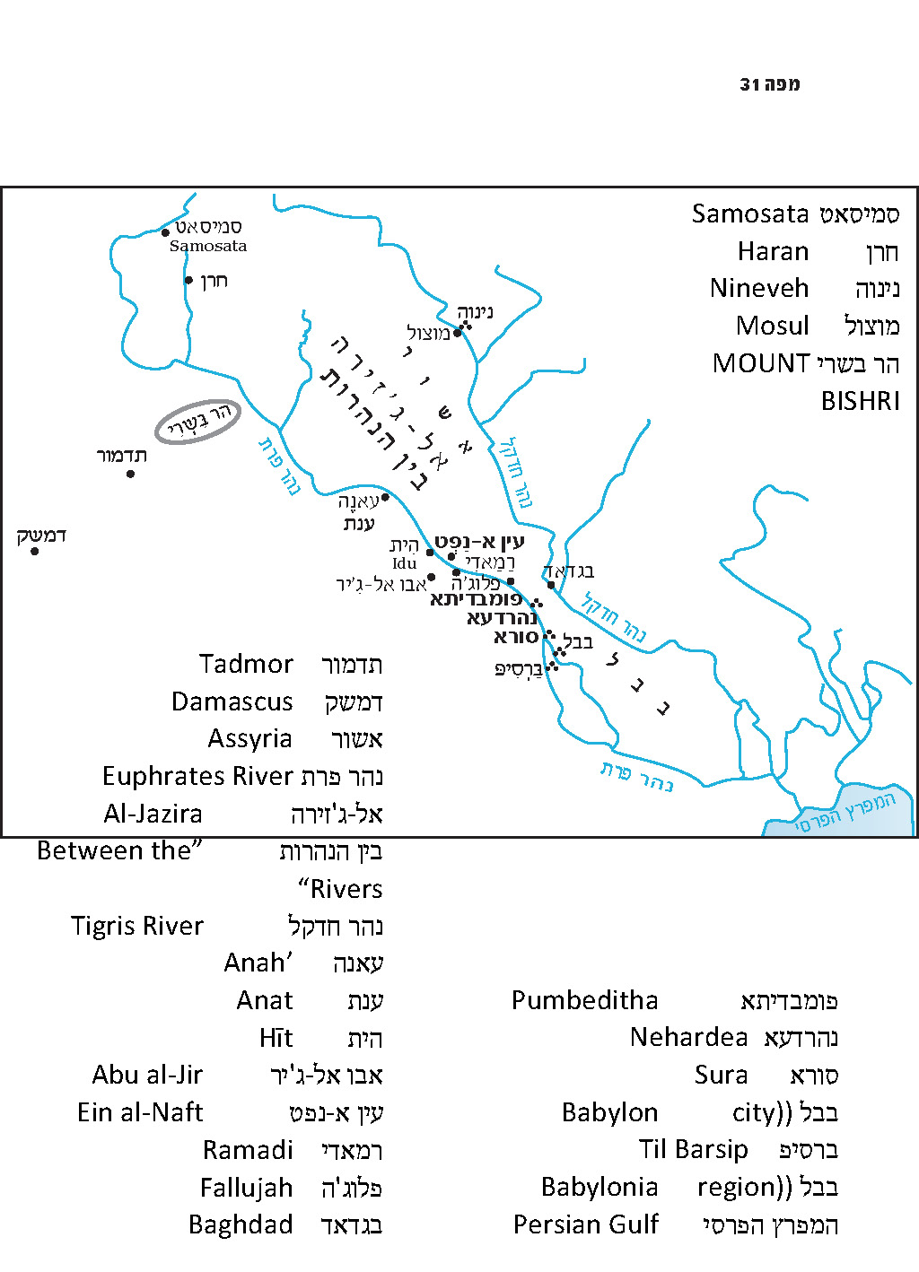

The famous historian Herodotus (c. 440 BCE) described a city in this region that bore a different name:

Now there is another city distant from Babylon a space of eight days’ journey of which the name is Is; and there is a river there of no great size, and the name of the river is also Is, and it sends its stream into the river Euphrates. This river Is throws up together with its water lumps of asphalt in great abundance, and thence was brought the asphalt for the wall of Babylon. (Herodotus I, 179)

In light of Greek linguistic patterns, the name Is may have been a Greek version of the word id or idu. Indeed, a city named ID or Idu – on the Euphrates, north of Babylon – is found in Akkadian sources as early as the Mari Letters (from the Patriarchal age) and one Assyrian source mentions explicitly that bituminous springs existed on the eastern bank of the Euphrates, opposite Idu. It is generally assumed that the Arabic name Hīt (recognized from the birth of Islam until today) is a later version of that very name. Hīt is situated on the western bank of the Euphrates, about 120 miles from Baghdad. In the Medieval period, Hīt was a commercial center, due to the nearby presence of a bridge crossing the Euphrates, on which convoys traveled from Baghdad to Aleppo in Syria, and onward toward the land of Israel and Egypt. The Islamic geographers praised Hīt’s grains and dates, and poets sang of its excellent wine. Even today Hīt is home to ample fruit orchards, as well as date and grain plantations. Hīt’s fertile nature, its wine and its neighboring bridge across the Euphrates seem to clearly evoke the traits of Ihi/Hai Dekira of the Talmudic period.

A third name of a city in this area is mentioned in a source from the Roman period: Isidore of Charax, a Greek writer who lived in southern Mesopotamia during the first century BCE and the first century CE. In about 25 CE, Isidore wrote “The Parthian Stations,” an itinerary listing all the caravan stations on the trade route from Babylon to Alexandria in Egypt. There, he mentions the city of Aipolis, “where there are springs of asphalt.” It may be that the “Ai” component in this city’s name is equivalent to “Ihi” or “Hai” in the name Ihi/Hai Dekira.

And now, for a linguistic revelation: In Akkadian, the ancient language spoken by the nations of the Tigris and the Euphrates, there are actually two words for asphalt/bitumen. Crude asphalt is called ittû or iddû, whereas refined asphalt is called qīru. Most probably, the place name Id(u)/Hīt is derived from the former, and the name Ihi Dekira is derived from the latter!

Here we reach the crux of the matter. It is very reasonable to speculate that Du(r)maskanin, “the gate to the Garden of Eden,” was situated in this region in the vicinity of Hīt – the most fertile part of “between the rivers.” In light of this, the connection between the Biblical city of Kir and the Akkadian qīru and Ihi Dekira of the Amoraim and the Greek and Roman sources seems self-evident. Apparently, it was to this region that the Assyrians exiled the Arameans from Damascus, and it was there that the name Damascus was preserved for centuries in the form of Du(r)maskanin.

“And the Arameans from Kir”

All that is left for us to do now is to clarify the nature of the emigration of the Arameans from Kir – “True, I brought Israel up from the land of Egypt, but also the Philistines from Caphtor and the Arameans from Kir.”

The Arameans are a nation whose history is characterized by extreme change. We may speak of three major periods:

- The Ancient Period: From the Patriarchal age to the time of Saul

In the stories of the patriarchs, we encounter the family of Abraham’s brother Nahor. Nahor, his son Bethuel and his grandson Laban are Arameans living in Aram-naharaim. They and the other inhabitants of Aram-naharaim live as shepherds, and everyone seems to know one another: “‘My friends, where are you from? … Do you know Laban the son of Nahor?’ … ‘Yes, we do’ … ‘Is he well?’ … ‘Yes, he is; and there is his daughter Rachel, coming with the flock’” (Genesis 29:4-6). Their lives seem to operate at a leisurely pace: “Until all the flocks are rounded up; then the stone is rolled off the mouth of the well and we water the sheep” (29:8). When someone’s daughter is married, the entire town is invited to the wedding: “And Laban gathered all the people of the place and made a feast” (29:22). For these early Arameans, kings and wars are nowhere on the horizon. There is a three-day journey connected with the streaked, speckled and spotted flocks, and there is a sheep-shearing in a distant location, but there is no hint of ornate temples, priests and worship – with the sole exception of Laban’s household idols.

Not far from there was Pethor, “which is by the Euphrates” (Numbers 22:5) – the city of Balaam, also described as “Pethor of Aram-naharaim” (Deuteronomy 23:5). We might theorize that the group of Arameans living in Aram-naharaim was part of a larger Aramean region that was not mentioned in the Torah. Even the term “Aramean” was sometimes used as a symbol for a penniless nomad, or for a homeless refugee, as in: “My father was a fugitive Aramean” (Deuteronomy 26:5).

- The Period of the Aramean Kingdoms: The Tanakh gives no indication that the status of the Aramean nation had changed until Saul’s time.

During the time of Saul, there is, for the first time, a laconic mention of “the kings of Zobah” (I Samuel 14:47) in the list of enemies surrounding Israel whom Saul fought successfully. David had already fought wars against the kings of Aram, wars that were, in practice, the greatest military accomplishments of David and his talented commanders Joab and Abishai, the sons of Zeruiah. II Samuel 8 and 10 mentions several aggressive Aramean kingdoms, possessing extensive armies. The Tanakh records that David defeated Aram of Zobah and Aram of Damascus, Maacah and the men of Tob, and even “the Arameans from across the Euphrates.” He forged a treaty with King Toi of Hamath, who was the enemy of King Hadadezer of Zobah. Thousands of Aramean charioteers were killed, along with tens of thousands of foot soldiers, and a vast amount of copper was taken as plunder. David knew full well why he was investing such a tremendous effort in subduing the Arameans; this was a preventative strike that delayed the rise of Aramean power by more than a hundred years.

In the book of Kings, as early as Solomon’s time, the Arameans began to show signs of recovery. Rezon son of Eliada established a kingdom in Damascus and was an “adversary” to Solomon and to Israel (I Kings 11:23). From the time of Asa until the time of Ahaz, Aram was Israel’s bitter enemy. The Tanakh states that during certain periods, the king of Aram “trampled [Israel] like the dust under his feet” (II Kings 13:7). At the end of this difficult period, Aram’s power began to decline, to the point that Isaiah called its king Rezin “a smoking stub of a firebrand” (cf. Isaiah 7:4). The conquest of Damascus at the hands of Tiglath-Pileser, the execution of Rezin and the exile of the inhabitants of Damascus to Kir signified – all at once – the endpoint of the history of Aram.

- The Rise of the Aramaic Language

Paradoxically, and for reasons that are beyond the scope of this discussion to trace, it was only after the destruction of the Aramean nation that the Aramaic language rose to prominence. The Assyrian kings made Aramaic the international diplomatic language, and it continued to serve in this role during the rise of the Babylonian Empire and thereafter during the rise of the Persian Empire, until the conquests of Alexander the Great. At first, only members of the ruling classes were able to speak Aramaic, and not the masses (II Kings 18:26; Isaiah 36:11), but the language eventually became a vernacular language as well. For more than 1300 years until the Arab conquest, Aramaic even became the most commonly spoken language in vast areas of the world.

From the perspective of the nation of Israel, the first half of this lengthy period yielded two books of the Tanakh, half of which was written in Aramaic: Ezra and Daniel. In the second half of this period, some of our greatest spiritual works were created, written in Aramaic or in a fusion of Aramaic and Hebrew: the Talmud Bavli, the Talmud Yerushalmi, the Midrashim and the Targumim.

Let us return now to the Arameans. The transition from the pastoral first stage to the second stage, the period of the militarily powerful Aramean kingdoms, is correlated with a change in location. The Aramean kingdoms described in Samuel and Kings were generally in the West, north of the land of Israel. Geshur and Maacah, Tob, Helam and Rehob were located in the Golan region and by the headwaters of the Jordan; Zobah and Hamath were located in western Syria; and between them lay Damascus, the strongest and most important of all the Aramean cities.

The archaeological findings corroborate this notion. In various places, usually along the length of western Syria, more than thirty royal inscriptions written in Aramaic have been found, dating from the tenth, ninth and eighth centuries CE. The inscription among them found farthest south was discovered about twenty years ago in Tel Dan. In contrast, the Arameans from the ancient periods lived in Haran (as well as Nahor and Serug, geographic names not far from Haran), which was situated far to the east, across the Euphrates, over 150 miles from the Mediterranean coast. Some critical scholars, basing themselves on the wealth of Aramean findings from the period of Aramean kingdoms compared to the complete lack of Aramean findings from earlier periods, rejected the authenticity of the Torah’s claim that Arameans featured in the patriarchal narratives. These scholars view the mention of Arameans and the Aramaic name Yegar-sahadutha (Laban’s name for the mound of stones that marked his pact with Jacob) in the Torah as a “historical anachronism.” In truth, however, the reason for the lack of inscriptions from the early period is the nature of the Aramean nation, which, during the early periods, was a nation of tribal shepherds with no walled cities and no kings or the wars that accompany them.

The first extrabiblical sources that mention the Arameans are the inscriptions of King Tiglath-Pileser I of Assyria, who reigned during the years 1114-1076 BCE. This was toward the end of the period of the Judges, one generation before Saul and two generations before David. The information contained in these inscriptions is interesting, and helps to complete the picture of the Arameans that arises from the Tanakh. In the inscriptions, the Arameans are categorized into groups called “houses,” meaning households. In two inscriptions he describes how he attacked and defeated the Arameans, but in a third inscription – written toward the end of his lifetime – he is forced to admit that the Arameans defeated him in battle (an unusual display of frankness for an Assyrian inscription!) and conquered the great city of Nineveh for a certain period of time.

The Location of the Arameans According to Tiglath-Pileser I

Now we arrive at the geographical angle of the discussion. Where did the Arameans reside during the time of Tiglath-Pileser I? The inscriptions mention explicitly that they lived in the Sūḫu region (i.e., the middle Euphrates), the northern part of the Syrian desert and Mount Bishri. In the summarizing inscription of his wars, he describes the areas where he defeated the Arameans: “From the foothills of Mount Lebanon, Tadmor of Amurru, Anat of Sukhu, until Rapiku of Babylonia.” The last location is not identified, but it is certainly located in northern Babylonia. Anat is known today as 'Anah on the Euphrates, about eighty miles north of Hīt. Hīt and its surrounding area, where, according to our conclusion above, the Talmud’s Ihi Dekira and the Tanakh’s Kir were located, is situated at the midpoint between Anat and Babylon. This is where the tribes of Aram were most heavily concentrated at the end of the period of the Judges, and from there they began to invade westward, establishing aggressive kingdoms during the early stages of the monarchy in Israel.

It seems that it is to this transitional phase – the movement of the Aramean nation’s center of gravity, accompanied by its rise to political and military power – that Amos refers when he states “I brought Israel up from the land of Egypt, but also… the Arameans from Kir.”

From a prophetic perspective, the return of the Aramean exiles from Damascus to Kir and their subsequent decline into oblivion perhaps signify that they have come full circle in a moral experiment. God may transport nations from one place to another, giving them roles that are appropriate for them at a given time. He may even use them, unbeknownst to them, as the proverbial rod that will punish His chosen people who have gone astray. But the Arameans abused their position, losing their sense of humanity and engaging in excessive hatred and wickedness far beyond their divine dispensation. “Because they threshed Gilead with threshing boards of iron,” they were sentenced to return to their meager beginnings and forfeit all their power.

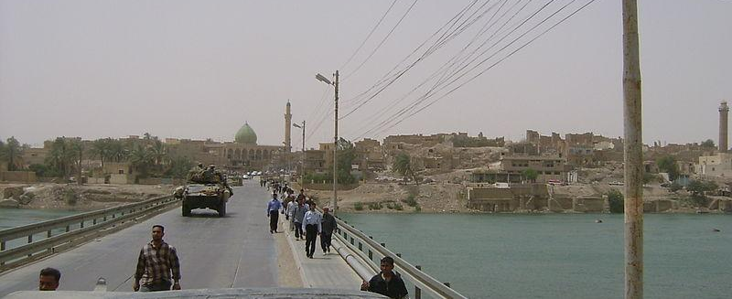
Hīt, Iraq in 2004, as seen from a bridge over the Euphrates. The Arameans probably originated from here, and were later exiled back here as well. (Wikimedia Commons)

For further study:

S. Abramski and A. Parnas, “Ḥemar,” Encyclopaedia Biblica 3, 187-190 [Hebrew].

Yoel Elitzur, “Qīr of the Aramaean: A New Approach,” Shnaton: An Annual For Biblical and Ancient Near Eastern Studies, 21 (2012), 141-152 [Hebrew].

Y. M. Grintz, Studies in Early Biblical Ethnology and History, Tel Aviv 1969, 58-59 and notes [Hebrew].

E. Lipiński, The Aramaeans: Their Ancient History, Culture, Religion, Leuven 2000, 39-45.

G. L. Mattingly and H. O. Thompson, “Kir,” Anchor Bible Dictionary 4, 83.

B. Mazar, “The Aramaean Empire and its Relations with Israel,” The Early Biblical Period: Historical Studies (eds. S. Ahituv & B. A. Levine), Jerusalem 1986, 151-172.

A. R. Millard, “A Wandering Aramean,” JNES 39 (1980), 153-155.

A. Oppenheimer, Babylonia Judaica in the Talmudic Period, Wiesbaden 1983, 164-168, 436-442.

J. N. Postgate, “Idu,” Reallexikon der Assyrologie, 5, 33.

M. Streck, “Hīt,” The Encyclopaedia of Islam: New Edition, 3, 510.

Translated by Daniel Landman

The word chemar, in its “asphalt” sense, also exists in a similar form in Arabic, ancient South Arabian languages, the Christian Aramaic of the land of Israel, Egyptian and Coptic.
However, linguistically speaking, since Sumerian, Akkadian and Greek do not have the phoneme h, Hīt might be the original name, while ID/Idu and Is might be its Sumerian/Akkadian and Greek attestations respectively.
This last word appears in the Aramaic of the Talmud Bavli in the form qira. This should not be confused with the Talmud’s word for wax, which is spelled the same way in Aramaic but derives from a different, Greek source.
As R. Ovadia Sforno interprets: “My father Jacob was, for a time, a fugitive Aramean, without a home of residence, and thus he was not prepared to establish a nation worthy of inheriting the land.”
The one exception is the episode involving Cushan-rishathaim, king of Aram-naharaim, who was seemingly not a typical Aramean.
Compare to the Midianites – another nomadic nation: “He [Zur] was the tribal head of an ancestral house in Midian” (Numbers 25:15).

