YESHIVAT HAR ETZION
ISRAEL KOSCHITZKY VIRTUAL BEIT MIDRASH (VBM)
*********************************************************

GEOGRAPHY IN THE PARASHA

PARASHAT BEHAR

Walled Cities
By Prof. Yoel Elitzur

The Walled City: An Exception to the Laws of Yovel

Parashat Behar deals with the laws of the land of Israel and the yovel year, and it is in this context that the unique phrase “a dwelling house in a walled city” appears. The Torah states:

If a man sells a dwelling house in a walled city, it may be redeemed until a year has elapsed since its sale; the redemption period shall be a year. If it is not redeemed before a full year has elapsed, the house in the walled city shall pass to the purchaser beyond reclaim throughout the ages; it shall not be released in the jubilee. (Leviticus 25:29-30)

This law essentially constitutes an exception to the laws of yovel. According to the laws of yovel, every field returns to its original owners during the yovel year. In contrast, the Torah states in the above passage that a house in a walled city does not return to its original owners (though the seller has the right to annul the transaction within a year of the sale).

What is the reason for this law? A logical assumption might be that in the reality of urban life, the concept of ancestral territory becomes irrelevant. It would be ludicrous for a person to claim, for instance, that the second floor of a luxury apartment building in Tel Aviv is part of his ancestral territory. These buildings change over the years; they are destroyed and rebuilt, they change ownership according to the city’s needs and its development. In such a reality, the notion of ancestral territory cannot exist. In contrast, “houses in chatzerim (villages) that have no encircling walls shall be classed as open country; they may be redeemed, and they shall be released through the jubilee” (25:31). This is an exception to the exception: a house in an unwalled town is part of the framework of rural life, and thus it is equivalent to fields for the purposes of yovel – it returns to its original owner.

The Walled City in Three Halakhot

The first halakha is the one we discussed above: the explicit Torah law that a house in a walled city is not released through yovel. The second halakha is presented in the Mishna:

Walled cities are holier [than the rest of the land of Israel], for metzora’im must be sent out of them; and a corpse, though it may be carried about within them as long as it is desired, may not be brought back once it has been taken out. (Kelim 1:7)

There is one other halakha that is stated almost explicitly in the Tanakh: the date for celebrating and reading the megilla on Purim. We read:

That is why unwalled Jews, who live in unwalled cities, observe the fourteenth day of the month of Adar and make it a day of merrymaking and feasting, and as a holiday and an occasion for sending gifts to one another. (Esther 9:19)

The megilla continues, immediately thereafter, “…charging them to observe the fourteenth and fifteenth days of Adar, every year” (9:21). We can infer from these two verses that residents of walled cities observe Purim on the fifteenth day of Adar and not on the fourteenth, as stated in the Talmud: “Since the “unwalled” [are to read] on the fourteenth, the “walled” [must read] on the fifteenth” (Megilla 2b).

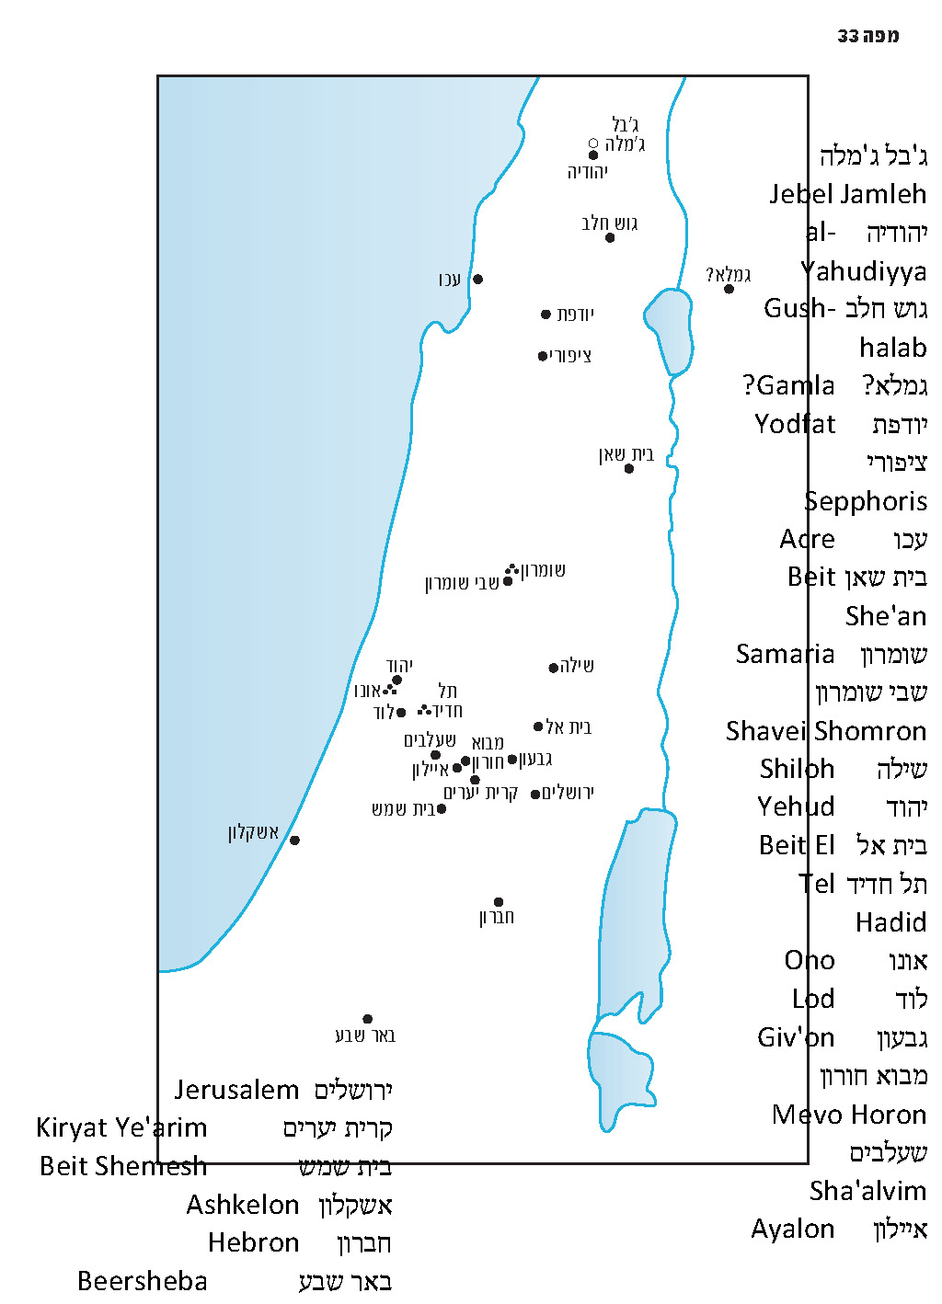

How Many Walled Cities Were There in the Land of Israel at the Time of Joshua’s Conquest?

According to the Mishna (Megilla 1:1, Arakhin 9:6), the factor that determines if a city is “walled” or “unwalled” is whether it was walled during “the days of Joshua son of Nun,” or as Rambam expresses it, “surrounded by a wall at the time when Joshua conquered the land” (Shemita Ve-yovel 12:15). How many walled cities did Joshua and the people of Israel encounter when they conquered the land? The answer is apparently hundreds. The Torah notes that in a single district in the land of Israel – the district of Argob – there were sixty cities that “were fortified with high walls, gates and bars” (Deuteronomy 3:5). It follows, then, that throughout the rest of the land there were many times more than that.

Furthermore, the distinction that our parasha makes between a walled city and “houses in chatzerim that have no encircling walls” aids us greatly in understanding the chapters in Joshua that discuss the apportionment of the land. The formula used consistently throughout these geographical lists is “[number] arim (cities), with their chatzerim.” Based on Parashat Behar, this means that all the cities listed by name in Joshua were walled cities.

The Talmud Yerushalmi records a dispute among Amoraim regarding the nature of the cities listed in Joshua: “Rabbi Simeon son of Lakish said: He counted walled cities. Rabbi Jose son of Hanina said: He counted cities near the boundary” (Yerushalmi Megilla 1:1 [70a]). In the continuation of the discussion, the Yerushalmi supports the second opinion, and the Talmud Bavli echoes this approach: “Rav Judah also said in the name of Rav: Joshua enumerated only the cities on the borders” (Bava Batra 56a). But it seems that even the second opinion does not conflict with the simple meaning of the phrase “cities, with their villages.” Rather, it merely adds additional detail to the first opinion, stating that Joshua did not enumerate all the walled cities, but only those that were situated on the borders. See also Ramban’s commentary at the beginning of Masekhet Megilla: “Also, in Hutsal of Benjamin a few of them had a tradition that it was enumerated in Joshua in the portion of Benjamin.” Thus Ramban indicated his clear belief that every city that Joshua enumerated fell into the category of walled cities.

Mishna Arakhin 9:6 MS Parma 1 (Courtesy of the Bibliotheca Palatina, Parma)

“And These are the Walled Cities”

The Mishna at the end of Arakhin presents a list of walled cities in the land of Israel. Before doing so, the Mishna defines the term “walled city”:

[A house within] a city whose roofs form its wall, or that was not encompassed by a wall in the days of Joshua son of Nun, is not considered a dwelling house in a walled city. [A house in any of] the following is accounted a house in a walled city: [Those in a city] of no less than three courtyards, having two houses each, which have been encompassed by a wall in the days of Joshua son of Nun, such as the old castle of Sepphoris, the fort of Gush-halab, old Yodfat, Gamla, Gador, Hadid, Ono, Jerusalem and the like. (9:6)

First of all, the Mishna clarifies that a walled city can actually be quite small. Even a plot of land containing three courtyards, each of which containing two houses, is considered a walled city if it has been encompassed by a wall since the days of Joshua. In other words, the Mishna hints here that many of the cities from the time of Joshua were small cities.

In addition, the list in the continuation of the mishna implies that cities during the Biblical period were relatively small. The Mishna stresses: “the old castle of Sepphoris, the fort of Gush-halab.” In other words, the fortified area overlooking each of these two cities constituted the “walled city” from Joshua’s time. The implication is that Sepphoris and Gush-halab at the time of the Mishna were large cities, and according to Rabbinic tradition, only their old fortresses had been walled since the time of Joshua.

We can also infer from this mishna that in the cases of Sepphoris and Gush-halab, the Biblical city was situated atop a summit, while the later city was built on the surrounding slopes. This phenomenon can be found in countless sites in the archaeology of the land of Israel; usually the Canaanite-Israelite cities were situated atop a summit and were fortified well, while the towns built during the Hellenistic-Roman-Byzantine period were larger and tended to spread out on the slopes and spurs. The reason for this, seemingly, is that in earlier periods, each city was responsible for its own defense and fortification, whereas in later periods these concerns were generally the responsibility of the central government.

The list of eight walled cities from the time of Joshua is interesting, and even at the time of the later Tannaim was the focus of a dispute between Rabbi Ishmael son of Rabbi Jose and his brother, Rabbi Elazar son of Rabbi Jose. One argued that this was an exclusive list, while the other argued that it simply listed several examples, while other such walled cities did exist (a position shared by our mishna as well, as one might conclude from the language of the end of the mishna: “…and the like”).

According to Rabbi Ishmael son of Rabbi Jose, the eight cities listed were the only ones that were re-sanctified by the returning exiles, while all the others “lost their privilege when the land lost its sanctity” (Megilla 10a) following the destruction of the First Temple. According to Rabbi Elazar son of Rabbi Jose, the eight cities were merely representative examples:

And not only in these alone, but in every one in regard to which you shall find a tradition from your ancestors that it was walled from the days of Joshua son of Nun, all these precepts are to be observed.

This dispute hinges on a critical, fundamental question in halakha: Was the first holiness conferred for the time being and for all future time, or was it not conferred for all future time?

In any case, both positions agree that the list refers to the cities that the returning exiles found when they entered the land of Israel, and that at least these cities had been walled during Joshua’s time and were still walled when they returned from Babylonia – which is why they were listed in the mishna.

Identification of the Cities and Archeological Findings

Almost all the places mentioned in this mishna are identified with certainty. Gamla is the only city whose identification is somewhat debatable. The baraita in Torat Kohanim, Behar 4 and in Arakhin 32a states that Gamla is “in the Galilee,” while the Gamala that was the site of a Roman siege during the Great Revolt preceding the destruction of the Second Temple is identified today with certainty in the Golan. Many today believe that the western Golan, due to its close connection with the Galilee and its wealth of Jewish settlement, should be considered part of the Galilee. This suggestion is supported by the name of the Jewish rebel Judas son of Hezekiah “the Galilean,” who, according to Josephus, was originally from the city of Gamala. While Josephus usually refers to Judas as “the Galilean,” on one occasion he calls him “the Golanite.” Regardless, Samuel Klein and Gustaf Dalman – classical scholars of Rabbinic geography and sources from that period – maintained that it is impossible to call the Golan “Galilee.” Moreover, in their opinion Josephus’ use of the term “Golanite” is simply the error of an overly clever copyist; he must have known of the Golanite city of Gamala and “corrected” Josephus’ text accordingly. Klein and Dalman identified the Galilean city of Gamala with Jebel Jamleh, north of Tibnin in the Lebanese portion of the Upper Galilee, south of the Litani River. At the southern feet of Jebel Jamleh lies a small village called al-Yahudiyya, which preserves a tradition of Jewish presence in the region. One consideration in support of this position and against the identification of Gamla in the Golan is that there was a time – probably during the Second Temple period – when Gamla served as a city of refuge in place of the Galilean city of Kedesh. The city of Golan in the Bashan served as a city of refuge at the same time, and it is unlikely that there were two functioning cities of refuge in the same region.

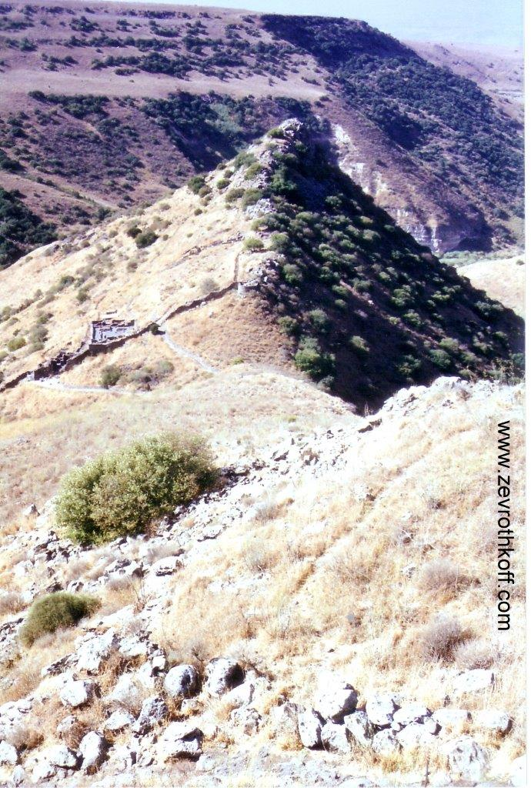
Gamla (Courtesy of Dr. Zev Rothkoff)

It is interesting to note that none of the cities in the Mishna’s list (with the exception of Jerusalem) is mentioned in the book of Joshua. What is the reason for these omissions? It may be that two factors played a role here: a) in the Galilee, most place names were changed between the Biblical period and the Rabbinic period, and thus the newer names could not have appeared in the Tanakh; and b) the cities belonging to the tribes of Ephraim and Manasseh were not enumerated in the book of Joshua.

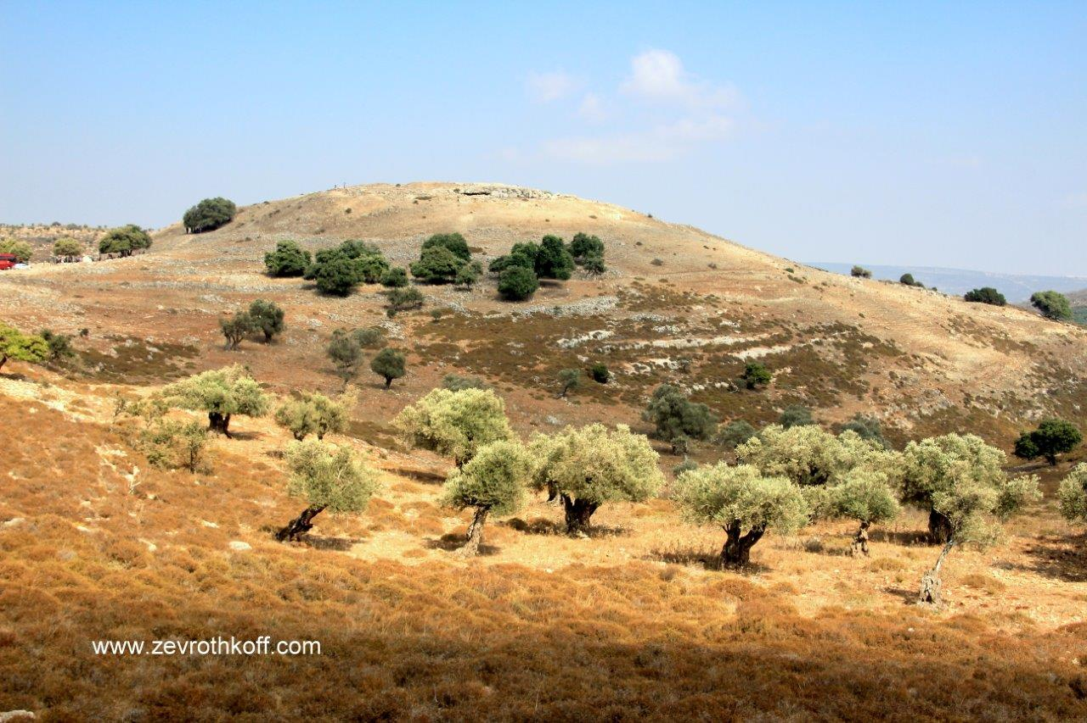
Yodfat (Courtesy of Dr. Zev Rothkoff)

Archaeological examinations have been undertaken in most of the cities on the list. Some of these yielded findings that match the Mishna’s account well, while others did not. In Yodfat, Gamla (in the Golan) and Sepphoris, remnants that fit with the simple understanding of the Mishna have not yet been found, but such remnants were indeed found in the other cities. In light of a survey that he conducted in the Upper Galilee, Yohanan Aharoni noted that Gush-halab was a fortified city from the Late Bronze or Late Canaanite Age, e.g., the period of Joshua’s conquest of the land that we are discussing here. In Tel Hadid (formerly al-Haditha, a village that was destroyed in 1948, about half a mile east of the modern-day moshav Hadid near the Jerusalem-Tel Aviv highway), remnants were found indicating the presence of a fortified city from the Late Canaanite period through all the Israelite periods. This matches the tradition cited in the Mishna excellently, despite the fact that the city is not mentioned in the book of Joshua.

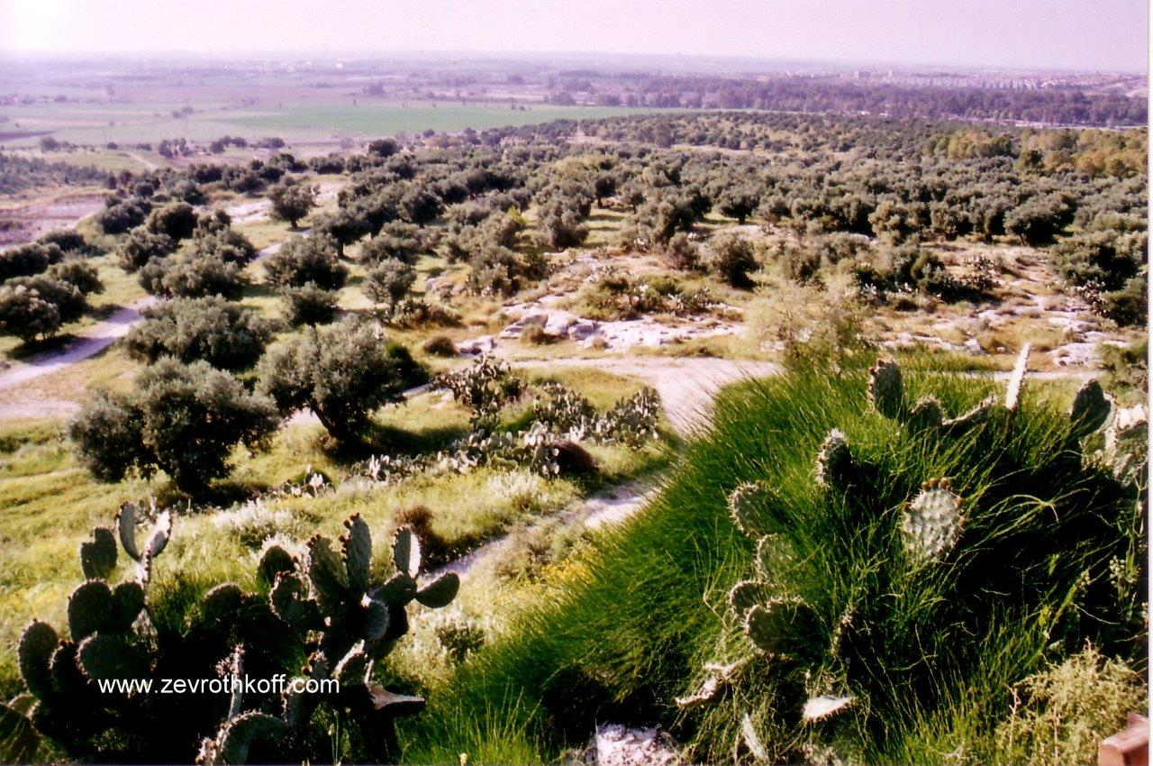
Hadid (Courtesy of Dr. Zev Rothkoff)

A tradition recorded by Rabbi Joshua son of Levi, a resident of the city of Lod and the leader of its sages at the beginning of the Amoraic period, should be added to the Mishna’s list: “Lod and Ono and Ge Haharashim were walled in the days of Joshua son of Nun” (Megilla 4a).

Lod contains archaeological finding that match the Rabbinic tradition as well. Lod’s ancient tell is almost unnoticeable within the city’s flat topography. Nevertheless, remnants from the Middle and Late Canaanite periods, as well as from all the Biblical periods and later, were found at the center of the tell. The Mishna does not enumerate Lod, perhaps because it was not walled at the time of the return from Babylon.

Walled Cities in Israel Today

Today, the issue of walled cities in Israel only has practical relevance for the question of when to observe Purim and to read the megilla; is it on the fourteenth day of Adar or on the fifteenth? The laws of yovel do not apply today, and tzara’at of the type described in the Torah does not exist today either. Since observance of the mitzva to read the megilla and celebrate Purim in both walled and unwalled cities is not limited to the land of Israel – the Talmud invokes the megilla’s expression, “from India to Nubia” – it is accepted that the question of when to observe Purim is determined based exclusively on the historical question whether a city was walled at the time of Joshua’s conquest, unconnected to questions of the holiness of the Land. The walls of the city in the days of Joshua are the only determining factor, even if the city is currently unwalled. As we saw above, there were hundreds of walled sites at the time of Joshua, and since according to the Talmud the adjacent suburbs of each walled city must celebrate Purim together with the city (Megilla 2b), there must be hundreds of places throughout the land today whose residents should observe Purim on the fifteenth.

However, in today’s reality, only Jerusalem (including its outlying neighborhoods) has retained its identity as a walled city in this regard, its residents observing Purim on the fifteenth of Adar alone. There are other places where residents observe Purim on both days due to “uncertainty,” and in most of these places the main celebrations generally take place on the first day in practice. On the second day – the fifteenth of Adar – they suffice with reading the megilla without reciting a blessing, in order to discharge their obligation. We are fortunate that many famous ancient cities in the land of Israel have experienced a great revival in our generation, and are now settled by members of the nation of Israel in and around their ancient sites. (These include, for instance, Beit Shemesh, Beit She’an, Beersheba, Ashkelon, Acre and Yehud.) Quite surprisingly, for various reasons, these places observe Purim as unwalled cities – on the fourteenth of Adar alone. To be sure, we can cling to halakhic technicalities such as uncertainty of a city’s precise location, the question of “the city was destroyed, or became [possessed by] non-Jews,” etc. But at the end of the day the result cannot be right; it cannot be that the law of walled cities has practically disappeared from the face of the earth. It cannot be that out of the hundreds of walled cities that existed in the land, only Jerusalem has survived – as though the law of walled cities is just another byproduct of the sanctity of Jerusalem.

Years ago, I wrote several articles addressing this question, which piqued the interest of the Torah luminaries at the time. In 1980, I proposed suggestions with respect to the new settlements that had been established during that period of time (Beit El, Shiloh, Mevo Horon, Shavei Shomron, Giv’on and Kiryat Ye’arim “Telz Stone”), and in 1988 I wrote an extensive article proposing that residents of the city of Lod observe Purim on the fifteenth of Adar, like in Jerusalem. The chief rabbi of Lod, Rabbi Nathan Ortner, supported my line of reasoning, albeit with certain reservations regarding the complete elimination of observance on the fourteenth. Rabbi Ortner indeed went on to implement the observance of Purim in Lod on both days. I was personally invited several times to lecture on the topic in Lod before audiences of rabbis and Torah students in several of the city’s batei midrash. In Beit Shemesh and in Ramat Beit Shemesh (which is adjacent to Tel Yarmuth – among the central cities in the time of Joshua) there has been a movement in recent years to observe Purim (with all its attendant halakhot) on both days, and the same practice has begun to take root in Beersheba and other places as well. Recently, most of the contemporary halakhic discussions on this topic were collected and recorded in a book by Rabbi Yehuda Zoldan. At the end of the day, despite the fact that observance of Purim on the fifteenth day alone continues to prevail only in Jerusalem, there has nonetheless been a resurgence throughout Israel of awareness of this issue, and of the desire to return the walled cities of Israel to their former glory.

For further study:

D. Adan-Bayewitz, “The Tannaitic List of ‘Walled Cities’ and the Archaeological-Historical Evidence from Iotapata and Gamla,” Tarbiz 66 (1996-1997), 449-470 [Hebrew].

Y. Aharoni, The Settlement of the Israelite Tribes in the Upper Galilee, Jerusalem 1957 [Hebrew].

Y. Aharoni, The Land of the Bible (trans. and ed. A. F. Rainey), Philadelphia 1979, 220.
E. Ben-David, Purim De-Mukafin Bi-Be’er Sheva, Beersheba 2011 [Hebrew].

G. Dalman, Sacred Sites and Ways, trans. P. P. Levertoff, London 1935, 9.

Yoel Elitzur, “Time of Purim in the New Settlements,” Shana be-Shana 1980, 268-279 [Hebrew].

Yoel Elitzur, “When Purim Should Be Celebrated in Beit El and the Army Camps Around It,” Tehumin 1 (1980), 109-136 [Hebrew].

Yoel Elitzur, Ancient Place Names in the Holy Land, Jerusalem-Winona Lake 2004, 139 and references there.

S. Klein, The Land of the Galilee (2nd ed.), Jerusalem 1967, 27-28 [Hebrew].

N. Ortner, “Purim in the City of Lod,” and Yoel Elitzur, “The Time of Purim in the City of Lod,” Tehumin 9 (1988), 341-380 [Hebrew].

E. H. Palmer, The Survey of Western Palestine: Arabic and English Name Lists, London 1881, 22, 27.

Y. Rosenson, “Arim Mukafot Choma – Reshima Akra’it O Text Megamati?” Sidra 17 (2001-2002), 205-215 [Hebrew].
Y. Zoldan, Megilla Be-mukafot Choma, Ramat Gan 2013 [Hebrew].

Translated by Daniel Landman

See Map 33 below.
Some exceptions to this rule likely exist, specifically in places where the number of cities enumerated does not match the number recorded in the Tanakh’s summarizing statement.
Compare as well to Eruvin 26a, where the Tannaim dispute whether a “medium-sized city” is as large as a beth kor (about 4.5 acres) or as large as forty beth se’ah (about 6 acres).
Another opinion cited in the Talmud is that the disputants were two students of Rabbi Ishmael son of Rabbi Jose.
The Palestine Exploration Fund’s list of place names in that region includes the name “Khŭrbet Jumleh” – “the ruin of Gamala.”
See our discussion on Parashat Masei.
Also see Yerushalmi Megilla 1:1 (70a): “Lod and Ge Haharashim.” The Talmud explains that it was not necessary to mention Ono, which is enumerated in Nehemiah 11 alongside Lod and Ge Haharashim, because it is already listed in the Mishna in Arakhin.
See Rambam Hilkhot Megilla 1:4, Tur and Shulchan Arukh, Orach Chayim 688.
I am aware that in Hebron and Shiloh, residents conduct festive Purim meals and take care to fulfill the mitzvot of sending gifts to one another and giving presents to the poor on both days.

