YESHIVAT HAR ETZION
ISRAEL KOSCHITZKY VIRTUAL BEIT MIDRASH (VBM)
*********************************************************

GEOGRAPHY IN THE PARASHA

PARASHAT BECHUKOTAI – YOM YERUSHALAYIM

Names of Jerusalem in the Tanakh
By Prof. Yoel Elitzur

Yom Yerushalayim always falls out on the calendar not long after we read Parashat Bechukotai. This is fitting, as there is nothing like Parashat Bechukotai to remind us of the miraculous victory of the Six-Day War:

You shall give chase to your enemies, and they shall fall before you by the sword. Five of you shall give chase to a hundred, and a hundred of you shall give chase to ten thousand; your enemies shall fall before you by the sword. (Leviticus 26:7-8)

When we read about “normal” wars throughout history, a very different pattern emerges. We see, for example, how the British and Ottoman armies sat entrenched on either side of the line of the “two Aujas” for several long months during World War I. The two sides would each advance one kilometer only to be driven back two kilometers, shelling each other seemingly without end. In the Tanakh as well, a war in which twenty cities were conquered – certainly an exceedingly protracted affair – was considered a great victory: “He utterly routed them – from Aroer as far as Minnith, twenty cities – all the way to Abel-cheramim. So the Ammonites submitted to the Israelites” (Judges 11:33).

But in the Six-Day War, a modern-day conflict, we witnessed wonders that may have been unprecedented in history. It was the stuff of fantasy, but it all happened in real life. The villains, who had all the strength on their side, banded together to destroy Israel, declaring their intent explicitly in blustering, blood-curdling pronouncements. But in the early morning on June 5, 1967, the tables were turned, and within six days Israel had captured vast swaths of land in the north, east and south. The once-arrogant enemy had fled into the desert sands with such haste that some even left their boots behind them to hasten their retreat. The Israeli army actually saved the lives of many of these fleeing soldiers, who were dying of thirst in the desert. But the crowning moment of this remarkable war of salvation was the recapture of the Old City of Jerusalem and the Temple Mount. All of Israel leapt to their feet, and not a single eye was dry, when the voice rang out: “The Temple Mount is in our hands! I repeat: The Temple Mount is in our hands!”

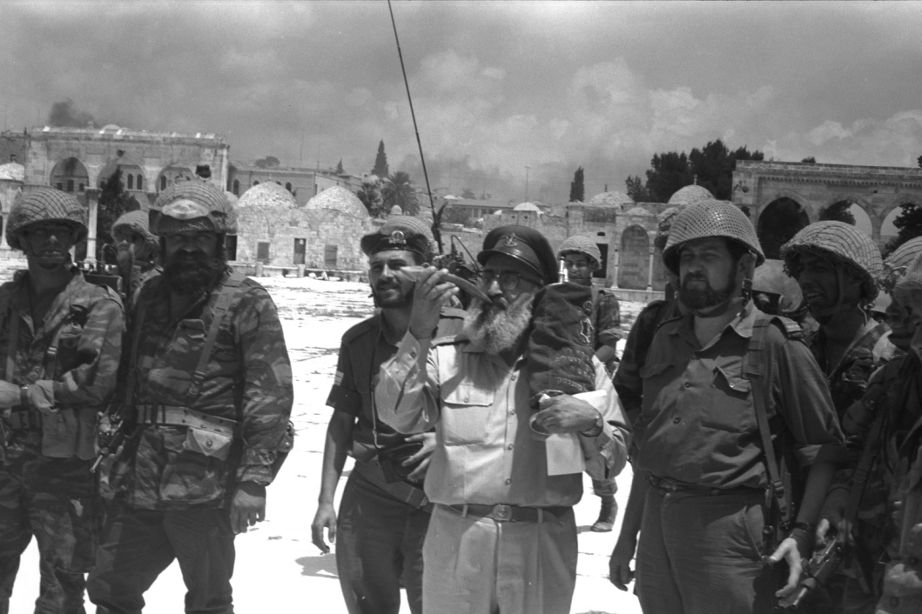
“The Temple Mount is in our hands!” Rav Goren on the Temple Mount with a shofar and a Torah scroll, June 7, 1967 (Courtesy of the Government Press Office of Israel)

In honor of Yom Yerushalayim, I will deal here with the names of Jerusalem in the Tanakh. I will not use this forum to list all of the many epithets given to Jerusalem in the Tanakh – “perfect in beauty,” “joy of all the earth,” “city of God,” “the faithful city,” etc. My purpose in this discussion is to examine and analyze the true names of the eternal city of Jerusalem. As we will see, the city has several names, whose meanings and origins are not particularly clear.

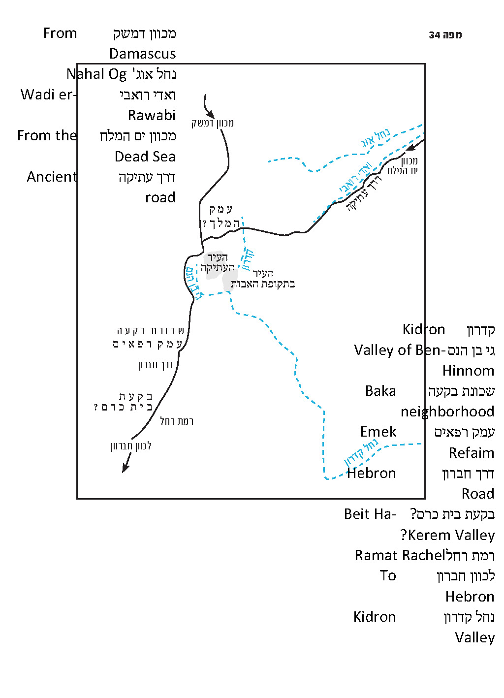

Salem (Shalem)

The first time the city is mentioned in the Tanakh is in Genesis 14:18:

The king of Sodom came out to meet him in the Valley of Shaveh, which is the Valley of the King. And King Melchizedek of Salem brought out bread and wine; he was a priest of God Most High.

Salem is identified with Jerusalem in the simple understanding of the verse. This is derived, first of all, from the name of Salem’s king – Melchizedek. “King Melchizedek of Salem” is parallel to “King Adoni-zedek of Jerusalem” who features in Joshua 10 (we will discuss the background for this name in greater depth below).

An additional piece of information is the Valley of the King mentioned in the previous verse, where Melchizedek brought out bread and wine. Melchizedek suddenly bursts onto the scene during the story of the war between the four kings and the five kings. His appearance is certainly a result of the meeting between Abraham and the king of Sodom, along with their men, on his territory. Melchizedek acts as a host, bringing out bread and wine for his guests. For reasons unspecified in the verses, the king of Sodom came out to meet Abraham in “the Valley of Shaveh, which is the Valley of the King.” The name “Valley of the King” recurs in the Tanakh in a much later period. The Tanakh states in II Samuel 18:18 that David’s son Absalom set up a pillar in the Valley of the King, calling it “Absalom’s Monument.” It is reasonable to assume that Absalom set up this pillar near Jerusalem, where he aspired to rule. We learn from this that the name “Valley of the King” was an early name that referred to this place even at the time the Torah was written. We do not know the identity of the valley’s royal namesake. In the time of Abraham, it was called “the Valley of Shaveh.” Why did Abraham and the king of Sodom meet in the vicinity of Jerusalem? It seems that Abraham, who was returning from his victorious war north of Damascus, was traveling toward Elonei Mamre on his way home. Naturally, he traveled along the Hill Road – known as the Way of the Patriarchs – which runs from Nablus to Hebron by way of Jerusalem and Bethlehem. The king of Sodom, who was indebted to Abraham for saving the residents of his city and their possessions, set out from the Dead Sea Valley to meet him at the intersection of road leading from the northern Dead Sea region and the road that traverses the length of the land of Israel. According to the map of the Palestine Exploration Fund from 1880, the most convenient ancient road from the northern Dead Sea region to Jerusalem ascended along a spur south of Wadi er-Rawabi from the tributaries of Nahal Og, and reached the vicinity of Augusta Victoria Hospital in the northern part of Mount of Olives. From there, the road turned west, crossing Nahal Kidron (Wadi al-Joz) at its northern, relatively placid section and eventually reaching the area north of the Old City of Jerusalem. During the Patriarchal age, this area was an open plain about half a mile north of the city.

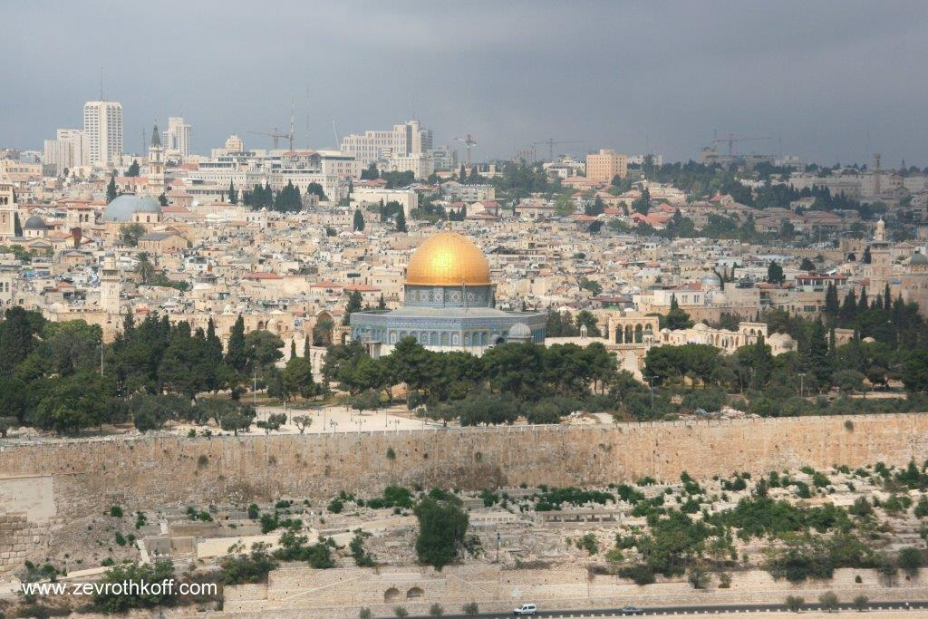
The Temple Mount and the Old City, seen from Mount of Olives, 2010 (Courtesy of Dr. Zev Rothkoff)

We should comment here on the identification of the Valley of the King and the location of Absalom’s Monument. In an article that I published not long ago, based on the teachings of my father, z”l, I demonstrated that while the English word “valley” (following the Latin vallis) can refer to either wide plains or narrow ravines, the word emek in Biblical Hebrew (as in emek ha-melekh – “the Valley of the King”) never refers to a wadi or a gorge. In fact, the word emek, meaning “plain,” sometimes refers even to an elevated plateau in a mountainous region. Abraham’s journey certainly took place on the main north-south road, and the Valley of the King was a plain located near Jerusalem. The plain that borders Jerusalem on the southwest is called “Emek Refaim” (according to Joshua 15:8, 18:16). Thus, perhaps we may speculate that the Valley of the King was the plain to the north of Jerusalem, through which Highway 1 currently passes. This is also a more appropriate location for a meeting between someone traveling from the north and someone traveling from the Dead Sea Valley.

Absalom’s Monument was not located where the folk tradition places it. The folk tradition is based on a misunderstanding of the word emek, and perhaps also on the notion that there must be some connection between “the Valley of the King” and “the Garden of the King.” The magnificent “nefesh” (monument placed near a grave) associated with Absalom in the Kidron Valley is actually from the late Second Temple period, with parallel structures from that same period in Petra and Herodium. Josephus (Antiquities 7:243) recorded that Absalom’s Monument in his time was located at a distance of two stadia (1150-1300 feet) from Jerusalem, but he did not write to which side of Jerusalem he was referring. A different tradition from the late Second Temple period, reflected in the Qumran scrolls, connected Absalom’s Monument to the Beit Ha-Kerem Valley, seemingly located in the Bak’a neighborhood of Jerusalem and the Hebron Road, at the foot of Ramat Rachel (Genesis Apocryphon XXII, 14 and the Copper Scroll X 5, 12). According to what we presented above, it is reasonable to speculate that the original Absalom’s Monument was located in the plains to the north of the Old City of Jerusalem.

The tradition of identifying Salem with Jerusalem is very ancient and is found even in the book of Psalms: “Salem became His abode; Zion, His den” (76:3). Psalm 110 makes a literary-homiletical connection between Genesis 14 and David: “The Lord has sworn and will not repent, ‘You are a priest forever, a rightful king (malki-tzedek) by My decree’” (110:4). David, a righteous king ruling in Jerusalem, is given epithets that allude to an ancient king – Melchizedek, who was a “priest of God Most High.” This literary connection is undoubtedly based on the firm knowledge that the Salem that appears in Genesis is the same city as David’s Jerusalem.

The existence of the royal city in Jerusalem during the time of Abraham is corroborated by a famous extrabiblical source: the execration texts from the nineteenth-eighteenth centuries BCE – which is probably Abraham’s period. The execration texts are names of enemy cities and rulers written alongside curses on pottery sherds or figurines. The sherds or figurines were then smashed and buried in Egyptian temples as a magical means of subduing those enemies. Among the cities listed on these execration texts was “3wš3mm,” which, according to the Egyptian transliteration rules of that period, can be read rushalimum. This is essentially Jerusalem, with a letter mem added to the end, a typical feature in Semitic languages. The archaeological findings at the City of David demonstrate as well that there existed here a heavily fortified city even during that period, the Middle Bronze Age IIA.

Is it possible to speculate on the origin of the name Shalem? First of all, as a general rule one should always remember Ramban’s cautionary words: “There is no need to seek out the reason for names of places” (commentary on Genesis 23:9). The geographical names in the Torah are so ancient, the languages spoken there at the time these places were named are not well known to us and the cultural lives and agricultural-economic reality at the time are very foreign to us. Because of all of these factors, outside of instances where the meaning of a name is exceedingly clear, we are relegated to baseless speculation in these matters. Several scholars attempted to connect the name Shalem to the Assyrian deity Šulmānu (mentioned in the form šlmn in a Phoenician dedicatory inscription from the Tyre area) which may be equivalent to shalem, a theophoric component of Ṣṭqšlm, a man’s name in Ugaritic texts. According to them, this was originally the location of a city built around a temple dedicated to that forgotten deity, before King Melchizedek adopted the belief in the God Most High.

The prevailing scholarly view is that Shalem is simply a literary abbreviation of Yerushalem. In another direction, one scholar proposed emending the verse to read “Melchizedek, king of his peace (melekh shelomo),” meaning that Melchizedek was allied with the king of Sodom. On a homiletical level, one can easily wax poetic on the virtues of peace (shalom) and wholeness (shelemut) that Jerusalem symbolizes. However, I believe that even the simple understanding of the name – if it is decipherable at all – is not far from this. From a grammatical perspective, the word shalem – like the words kaved, zaken, chametz and even amen – is derived from a nominal pattern that reflects an ongoing state. In these forms, as a result of their ongoing nature, the Hebrew past tense form and present tense form appear the same. A description of an ongoing state is fitting for a place name, and thus a considerable number of Biblical place names are derived from this nominal pattern. Examples of this include Avel, Gader, Charem, Yavesh and Aner. Other names take the feminine ending -a, such as Gedera, Azeka and Kehelata. The root Š-L-M is ubiquitous in Hebrew and in other Semitic languages, and thus we can cautiously speculate that the original name of the city expressed that this was a place of peace and tranquility. Compare to place names like Naamah (from the root N-^{c}-M, meaning “pleasure”), Janoah and Manahath (both from the root N-W-Ḥ, meaning “rest”), which seem to express similar ideas.

Yerushalem

Yerushalem has been the city’s most distinctive name throughout history until today. The form Yerushalayim, with its dual ending -ayim, is certainly secondary to Yerushalem. In the Tanakh, there is in this name a consistent kerei u-khetiv (discrepancy between the traditional pronunciation and the Masoretic text). In 660 instances, the ketiv (Masoretic text) reads Yerushalem, but the kerei (traditional pronunciation) is Yerushalayim. There are only five instances where both the ketiv and the kerei are in the form Yerushalayim. The shorter form Yerushalem appears frequently in the later books of the Tanakh as well (147 times in Chronicles, 9 times in Daniel and 85 times in Ezra and Nehemiah), and even in the verified manuscripts of Rabbinic sources. Furthermore, the English “Jerusalem” (apparently based on the Septuagint’s “Hierusalēm”) and the Aramaic Yerushlem match the ketiv form, not to mention the obvious connection with the early name Shalem.

What is the linguistic background for the dual form Yerushalayim? Doug Tushingham, who conducted excavations in Jerusalem with Kathleen Kenyon, believed that the background is historical-geographic. Tushingham and Kenyon held the “minimalist” view on the question of the size of Biblical Jerusalem, maintaining that it was originally fully contained with the small confines of the City of David, and it was only during the Second Temple period that it expanded into the upper city (the Jewish and Armenian quarters and Mount Zion). Based on this approach, Tushingham suggested that the linguistic transition to the dual form Yerushalayim reflects the city’s doubling in size, becoming two cities on either side of the Tyropoeon Valley following the Biblical period. Aside from the historical problems that this theory creates, which are beyond the scope of this discussion, we must point out that Yerushalayim is not the dual form of Yerushalem but of *yerushal. According to Aaron Demsky, the reason for Yerushalayim is phonetic: The proximity between the lamed and the mem at the end of the name necessitated the addition of a yod. Personally, I have a hard time accepting this linguistic claim, and I do not believe that the examples that Demsky cites to support his claim do so effectively.

In my opinion, the preferable explanation is that of Bauer and Leander in their work on Hebrew grammar. In their view, two linguistic phenomena have coincided here, causing this suffix to exist. On the one hand, there is a common phenomenon among geographic names involving the addition of a seemingly dual ending to the name. This ending is not an integral part of the name, like other additions, and it can be removed or added on easily. Thus, the demonym of Mitzrayim is Mitzri and the demonym of Efrayim is Efrati. The book of Samuel opens: “There was a man from Ramathaim (Haramatayim)” and continues: “And they went back home to Ramah (Haramata)” (1:19). This practice continues in later periods as well, as in the name of Dalton in the Galilee, alternately written as Deltayim and Dalata, versions preserved in the Arabic name Dalata. On the other hand, there was a phonetic tendency in various Hebrew dialects to contract the diphthong ay into the vowel ē. It seems that this is an example of overcorrection. Hebrew speakers, who were used to the ending -ayim affixed to place names but at the same time were also used to the contraction of ay to ē, intuitively “corrected” Yerushalem to Yerushalayim.

The name Yerushalem appears in very early sources. As we noted above, it is mentioned in the earliest source we know of that contains names of cities in the land of Israel – the execration texts – in which the name occurs three times in the form 3wš3mm (rushalimum, with its added mem at the end). The Akkadian sources first mention this name in the Amarna Letters (early fourteenth century BCE), in the form urusalim, and in Assyrian sources in the form ursalimmu. The name appears in a version similar to the Akkadian one in Nabatean, Syriac and Mandaic (three Aramean dialects) until it evolved to Ûrshalîm al-Quds in modern Arabic. However, it must be stressed that this last name is only used in Israeli publications written in Arabic. In actual Arab sources this is considered an artificial name, appearing only on rare occasions alongside the name Bayt al-Maqdis, the official name of Jerusalem.

In Sumerian, which was a major influence on Akkadian, the word URU means “city.” It is tempting to think, as did some scholars, in light of the persistence of the version ur(u)salim throughout history and through various languages, that this is the original form of the city’s name, and that its original meaning was “the City of Shalem.” However, we must reject this suggestion for three reasons. First, it would be unexpected for a place name in the land of Israel to be in Sumerian. Second, the notion that uru, a word with actual meaning, would transform into the meaningless yeru is illogical. The opposite would make much more sense: Akkadian speakers might very well have taken yeru, a foreign component, and adapted it to a form that was more recognizable for them – especially considering that there is no “y” sound in Akkadian. Third, the form of the name that appears in the execration texts is similar to the Hebrew version. It seems, then, that Yerushalem is the original form. The component yeru can be found in the geographical name Yeruel (II Chronicles 20:16) and in the person’s name Yeruba’al, and the same root can be found as well in the geographical names Giv’at Ha-moreh, Elon Moreh and Eretz Ha-moriya. Most likely, this root expressed a certain topographical, scenic or agricultural essence that existed in the Jerusalem area, which is why that broader region was known as Eretz Ha-moriya. The component yeru as its own entity is hinted at in the verse: “And Abraham named that site Hashem-yireh (‘the Lord will see’) whence the present saying, ‘On the mount of the Lord there is vision (yera’eh)’” (Genesis 22:14). In our discussion on Parashat Vayetze, we learned that in such situations we must search for a name (a place name or a person’s name) that sounds similar to the keyword of the verse, and assume that the purpose of the verse is to connect the incident in question to the place or person’s name using the homiletical approach to name interpretation. The difficulty inherent in the content and syntax of this verse, along with the doubling of the keyword yir’eh-yera’eh fits very well with the Torah’s typical methodology for name interpretation.

Dr. Mordechai Mishor of the Hebrew Language Committee presented to me a solution to the discrepancy between the different versions: It is likely that the first component in the name was originally wuru, and each language adapted this component to its own pronunciation system. Hebrew, in a manner typical of northwestern Semitic languages, changed the “w” to a yod and reduced the vowel that followed to a schwa due to its distance from the word’s stress. Akkadian eliminated the weak consonant “w” entirely, beginning the word with the vowel following it.

It seems that in the beginning, the two versions Shalem and Yerushalem coexisted (as we see, for instance, in the coexistence of Beth-meon/Baal-meon/Beth-baal-meon and Kiriath-jearim/Baalah which is Kiriath-jearim/Kiriath-baal/the region of Jaar). Since the time of Joshua, however, the exclusive use of the name Yerushalem became established.

Jebus (Yevus)

Yevus, Ha-Yevusi or Ir Ha-Yevusi was the primary name of the city during the period between the apportionment of the land until David’s conquest of the city, named for the nationality of its residents. There were certainly Jebusites living in Jerusalem even before this time, and some may even have remained thereafter, but what is unique about the generations between the apportionment and David’s time is that Jerusalem (the city, and apparently the large region south of the city as well) was at the time a large Jebusite enclave in the heart of the land. During this period, all the surrounding area, from the mountainous region north of Samaria to the region south of Mount Hebron, was already in Israelite hands. In the chapters in Joshua describing the tribal territories and in the parallel chapter in Judges 1, Jerusalem is mentioned five times, each time using the epithet Ha-Yevusi. Of particular note is the list of Benjaminite cities at the end of Joshua 18. The chapter lists twenty-six cities in the territory of Benjamin, and “Jebus (Ha-Yevusi) – that is, Jerusalem” is twenty-fourth on the list. This placement on the list is certainly a result of the fact that Jerusalem was not a territory that was settled in practice.

As a side comment, I will mention the following: Most of the critical scholars are convinced that the apportionment chapters of Joshua were written during the monarchy period, only disagreeing about what part of the period it was. Yehezkel Kaufmann rejected this approach, demonstrating that the lists clearly reflect that they were compiled during the tribal period that followed the apportionment. Among his other claims, Kaufmann correctly argued against scholars who dated the lists to the time of Josiah (!):

Is it really possible that, in an official district list of the seventh century, Jerusalem – the capital of a great king, the glorious city of God – would have been mentioned in the terms used here? In the city line, as in the boundary list, Jerusalem is still Jebus! This name is followed by the explanation: “that is Jerusalem” (18:28). It is listed at the end of Benjamin’s second district – a remote place, one of the twenty-six cities of Benjamin. To the list of Judah’s cities is attached the note, that Jerusalem was still occupied by the Jebusite (15:63).

As we have seen, this claim holds true against those who would date the lists to the time of David and later as well.

Zion (Tziyyon)

This name, more than any of Jerusalem’s other names, is brimming with yearning and longing, expressing the inner essence of the connection between the nation and its land, between the nation and its city, from the prophets of Israel to Rabbi Judah Halevi and later Hebrew poets, to Hovevei Zion and the Zionist movement. What is the background of this name?

It is important to pay attention here to the historical and statistical aspects of the name’s appearance in the Tanakh. The name Zion is mentioned 154 times in the Tanakh, first in II Samuel 5, in the story of the conquest of Jerusalem in the time of David. Aside from this context and one other time – the story of Solomon transporting the Ark to the newly built Temple (I Kings 8:1) – the name does not appear again in a concrete, prosaic context. It is unsurprising, then, that the name does not appear in Ezra-Nehemiah, a historical, prosaic work. It is used frequently as a literary device by the poetic authors of Psalms and the Later Prophets, but not by all of them. In contrast to the books of Isaiah, Jeremiah and Lamentations, which mention the name frequently, it is entirely absent from all the prophecies of Ezekiel. In the books of the Twelve Prophets, the use of the name Zion varies by book: Joel, Amos, Obadiah, Micah, Zephaniah and Zechariah mention the name; Hosea, Jonah, Nahum, Habbakuk, Haggai and Malachi do not.

This information teaches us that the name Zion that is used by the poets and the prophets is essentially the literary cooptation of a name that was only used in a narrow context during a short period, after which point it ceased to be used practically. It should not come as a surprise that not every writer in the history of the people of Israel used this name, as such is the nature of literary expressions. There are additional examples of similar literary revivals of once-defunct names. We already cited above the use of the epithet malki-tzedek for David and avi-melekh for Achish. In our discussion on Parashat Lekh Lekha, we noted, following Y. M. Grintz, that the name Beth-aven originally served as a concrete geographical name for a short time during the Biblical period. Once the site was destroyed and forgotten, Hosea and Amos (and only these two prophets) used the name a derogatory epithet for the neighboring city of Bethel.

The conclusion is that if we want to attempt to understand the etymological background of the name Zion, we must focus on the small number of instances in which the name bears actual geographical meaning, rather than literary meaning. Unfortunately, all we possess is the story of the conquest of Jerusalem (II Samuel 5:4-10 and the repetition in I Chronicles 11:4-9) and one word in the story of the transportation of the Ark (I Kings 8:1, and again in II Chronicles 5:2).

II Samuel reads: “But David captured the stronghold of Zion; that is, the City of David… David occupied the stronghold and renamed it the City of David.”

I Kings reads: “To bring up the Ark of the Covenant of the Lord from the City of David, that is, Zion.”

The “City of David” is the southeast hill of ancient Jerusalem, above the Gihon Spring, located today outside of the city walls. A full examination of the identification of the City of David and the size of ancient Jerusalem is beyond the scope of this discussion. It must be stressed, however, that scholars erred when they interpreted the phrase “the City of David” to mean “the city belonging to David” – in other words, that the territorial extent of Jerusalem was limited to the City of David during David’s time or when this passage was written. A more reasonable interpretation of the intent of the verse is that the stronghold itself was named “the City of David.” This stronghold was previously named – apparently by the Jebusites – “the stronghold of Zion,” and after conquering it David changed its name to “the City of David.”

Before we attempt to uncover the meaning of the name Zion, let us once again remind ourselves of Ramban’s forthright assertion that in most cases it is difficult and unnecessary to track down the origins of geographical names.

What is the meaning of Zion and what is the connection between this meaning and the stronghold in Jerusalem? What do the scholars have to say about the name Zion? First of all, there is no consensus regarding the name’s etymology. Most believe that Tziyyon is derived from the root Ṣ-Y-Y, with the addition of the ending -on (a common ending in the nominal patterns of names, and geographical names in particular). However, some believe that the root is Ṣ-Y-N, and the name shares a nominal pattern with words like gibbor and kinnor. The problem here is the imbalance between the etymology and the morphology. Supporters of the root Ṣ-Y-N note the Arabic root Ṣ-W-N, meaning “protection” or “defense,” as well as the Arabic word ṣawwān, meaning “flint.” This root is the perfect match for a fortified stronghold in a rocky area. However, the downside of this position is that the nominal pattern qittōl is rarely found in geographical names (the only examples are Milo and, with a minor adjustment, Ḥuqqōq), while the ending -on is very common. On the other hand, if we follow the more common nominal pattern, the name’s root would be Ṣ-Y-Y, a root that produced the word tziyya, meaning “wilderness” or “desolation,” a very poor descriptor for Jerusalem with its bountiful spring. One particularly sharp Biblical scholar name Albert Shanda proposed eighty-three years ago a suggestion that miraculously seems to match modern-day Jerusalem perfectly. According to his theory, place names with the ending -on are often built on the basis of animal names. One clear-cut example of this is the name “Eglon,” which is related to the word egel, or “calf.” Based on various etymological explanations, Shanda succeeded in applying his theory to the interpretation of the names “Hebron” and “Heshbon” as well. Shanda went on to connect the name Tziyyon with the word tziyyim, as in “but desert creatures (tziyyim) will lie there” (Isaiah 13:21) and “desert creatures (tziyyim) will meet with hyenas (iyyim)” (34:14). The word tziyyim here refers to animals that inhabit ruins, perhaps a kind of cat. According to Shanda, then, Zion is “the city of cats...”

Personally, it seems to me that there is another way to integrate the more likely nominal pattern for geographical names on the one hand, and the more common dictionary definition of the root Ṣ-Y-Y, without resorting to farfetched theories. The answer is connected to two topics that we encountered in our discussion on Parashat Shemini: the meaning of two-word place names and the territorial approach of the Tanakh. The territorial region that borders the City of David from the south and the east is a desert area (see Mishna Yoma 6:8), and it may be that it was called Tziyyon, meaning “land of wilderness and desolation.” It is likely that “the stronghold of Zion” meant “the stronghold of the Zion area,” although the stronghold itself was not located within the desert. The Biblical expressions “the mountain of the house [kerei: daughter] of Zion” (Isaiah 10:31) and the standalone phrase “the daughter of Zion” fit this approach.

The semantic connection between the name Tziyyon and the word tziyya can also help us understand the Syriac and, later, the Arabic version of the name: Ṣahyūn (ṣahē means “thirsty” in Aramaic).

At the end of this discussion, I would like to comment on the erroneous name “Mount Zion” given today to the southern part of the western hill of Jerusalem (located today outside the city walls). This name apparently originated in a Christian approach from the early Byzantine period. In the Tanakh, “Mount Zion” refers to Jerusalem or to the Temple Mount.

Zedek (Tzedek)

I believe that Jerusalem had another early name: Zedek. The names “King Melchizedek of Salem” and “King Adoni-zedek of Jerusalem” are similar in form to “Adoni-bezek”: “They found Adoni-bezek in Bezek” (Judges 1:5). Using this verse as a model, the natural meaning of the first two names is that Adoni-zedek and Melchizedek were kings of a place called Zedek. Thus the meaning of the verse, “The king of Babylon made Mattaniah, Jehoiachin’s uncle, king in his place, and changed his name to Zedekiah” (II Kings 24:17), becomes clear: Once Mattaniah was made king of Jerusalem, his name was changed to match the name of the city itself.

The literary expressions “righteousness (tzedek) once dwelt in her” and “afterward you will be called ‘the City of Righteousness (Ir Ha-Tzedek)’” (Isaiah 1) take on a new dimension of depth once we understand that these expressions fundamentally constitute a prophetic name interpretation. The prophet declares: You, Jerusalem – your name “Zedek” was very fitting for you, but now you are the city of oppression. When you repent and mend your ways, only then will you rightfully be called Ir Ha-Tzedek “the City of Righteousness.” We find similar examples of this in Jeremiah, in his admonition: “Woe to him who builds his house without righteousness (be-lo tzedek)” (Jeremiah 22:13); in his prophecy of comfort: “I will raise up for David a righteous branch (tzemach tzaddik)… [who] will do what is just and right (mishpat u-tzedaka) in the land… This is the name by which he will be called: The Lord Our Righteousness (tzidkeinu)” (23:5-6); and later: “May the Lord bless you, O abode of righteousness (neveh tzedek), O holy mountain” (31:23). Each of these verses hints at the name of the city that was known to the prophet, to his audience and even to the foreign king Nebuchadnezzar.

Kodesh?

The expression “the holy city (ir ha-kodesh)” appears twice in the book of Isaiah as a flowery literary epithet: “For they call themselves after the holy city, and lean on the God of Israel” (48:2); “Put on your beautiful garments, O Jerusalem, the holy city” (52:1). In Nehemiah, the name is already used in a prose context: “To live in Jerusalem, the holy city” (11:1); “All the Levites in the holy city” (11:18).

In Arabic, there is a short, one-word name for Jerusalem: al-Quds. This name, which is used on its own today, is not the term that medieval Arab writers used to refer to Jerusalem. The earliest of these Arabic authors called Jerusalem Iliya, reflecting the Roman-Byzantine name Aelia Capitolina (despite the fact that they themselves were not aware of the origin of the name and sought to find a different etymology for it). Generally, the name of the city in medieval Arabic sources is Bayt al-Maqdis, while in a few instances the two names were integrated: Iliya hia Madinat Bayt al-Maqdis, meaning “Iliya, which is the city of the Temple.” Starting from the tenth century CE, the name al-Quds began to be used sporadically, and as stated above, it has since become the prevailing Arabic name for Jerusalem in the modern era. Does this name have an origin that predates Islam?

My good friend Hanoch Alon opened my eyes here to a connection in the Tanakh. We read in Psalms: “May He send you help from the sanctuary (mi-kodesh) and support you from Zion (mi-tziyyon)” (20:3). It is well known that parallel couplets provide the most authentic commentary on the poetic chapters of the Tanakh. In this case, the parallelism in the verse seemingly teaches us that kodesh was synonymous with tziyyon. Perhaps it is possible that Kodesh was an ancient name for Jerusalem that lay dormant for many generations, until finally surfacing and reappearing in the form of the Arabic al-Quds.

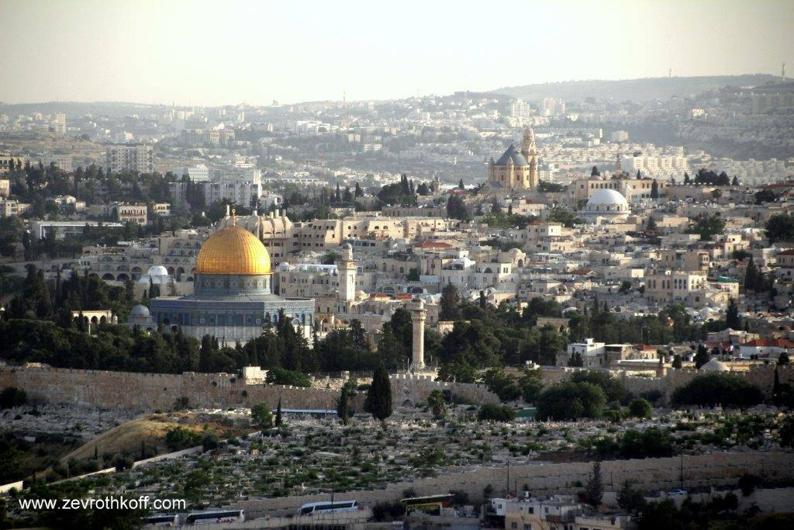
The Temple Mount and “Mount Zion” – Yom Yerushalayim, 2014 (Courtesy of Dr. Zev Rothkoff)

For further study:

W. F. Albright, “Abram the Hebrew: A New Archaeological Interpretation,” BASOR 163 (1961), 52.

H. Bauer and P. Leander, Historische Grammatik der Hebräischen Sprache des Alten Testamentes, Hildesheim 1965, 518-519 [German].

W. Borée, Die Alte Ortsnamen Palästinas, Hildesheim 1968, 57-61 [German].

A. Demsky, “Hebrew Names in the Dual Form and the Toponym Yerushalaim,” in These are the Names (ed. A. Demsky) 3, Ramat Gan 2002, 11-20.

Yehudah Elitzur, “Rishumei Gevuloteha shel Mamlekhet Yerushalayim ha-trom-Yisraelit ba-mikra u-vimekorot Makbilim,” Israel and the Bible, Ramat Gan 2000, 71-72 [Hebrew].

Yoel Elitzur, Ancient Place Names in the Holy Land, Jerusalem-Winona Lake 2004, 141 n. 4, 283-290.

Yoel Elitzur, “‘So He Sent Him Out of the Vale of Hebron’: On the Hilly ^{c}Emeq in the Hebrew Bible,” Beit Mikra 54:2 (2009), 5-20 [Hebrew].

Y. Kaufmann, The Biblical Account of the Conquest of Canaan (trans. M. Dagut), Jerusalem 1985, 24.

J. Klein, “Pray for the Peace of Jerusalem – the Origin and Meaning of the Name Jerusalem,” Y. Boussidan (ed.), Jerusalem – Names in Praise, Jerusalem 2005, 22-31.

L. Koehler and W. Baumgartner, “ציון” and “II שָלֵם” in The Hebrew and Aramaic Lexicon of the Old Testament, trans. ed. M. E. J. Richardson, 3-4, 1996-1999, 1022, 1539.

B. Mazar, “Yerushalayim: Shemot Ha-ir Ve-khinuyeha,” Encyclopaedia Biblica 7, 791-793 [Hebrew].

R. Reich, “The Recent Discovery of a Middle Bronze II Fortification in the City of David, Jerusalem,” City of David: Studies of Ancient Jerusalem 4 (2009), 13-33.

A. Šanda, review of: P. Heimisch, Das Buch Genesis, Bonn 1930, AfO 7 (1931-1932), 288 [German].

J. Simons, Jerusalem in the Old Testament, 247 n. 1.

Y. Tsafrir, The Southwestern Hill of Jerusalem and its Place in the Urban Development of the City in the Byzantine Period, doctoral dissertation, Jerusalem 1975 [Hebrew].

A. D. Tushingham, “Yerushalayim,” in Archaeology in the Levant: Essays for Kathleen Kenyon (eds. R. Moorey and P. Parr), Warminster 1976, 183-193.

Translated by Daniel Landman

See map below (Map 34).
Similarly, in Psalms 34:1 King Achish of Gath is given the literary name “Abimelech,” alluding to the Philistine king during the time of Abraham of the same name.
In the Tanakh, compare to “Leshem” (Joshua 19:47), which is equivalent to “Laish” (Judges 18).
This is the equivalent of *Ṣdqšlm; the letter dalet became a tet to match the two emphatic consonants surrounding it.
In my view, a phrase like melekh shelomo, meaning “a king allied to him” or the like seems awkward in the Hebrew language.
This form is related to the Arabic derived stem fa’ila and the Aramaic stem pe’il; it is parallel to the Akkadian stative form qatil.
Jeremiah 26:18; Esther 2:6; I Chronicles 3:5; II Chronicles 25:1, 32:9
In the Masoretic text, compare for example cheik (“bosom”) rather than the expected *chayik, chel ve-choma (“wall and rampart”) rather than *chayil and amudei shesh (“marble pillars”) rather than shayish.
Yāqūt al-Hamawi, the great thirteenth-century Muslim geographer, cites this name in three possible versions – ʾūrīšalim, ʾūrīšalam and ʾūrīšalm – stating: “This is the name of Bayt al-Maqdis in Hebrew.” Later, he adds a version in which the name is pronounced with a sin and not a šin, while others have the versions: ʾūrīšalūm, ʾūrīšallam, ʾūrāsalam or ʾūrā salim. The multitude of versions attests to the non-currency of the name.
For examples in which the yod at the beginning of a word is dropped, see Yechizkiyahu/Chizkiyahu and Yivle’am/Bil’am.
The explanation given for the name in Judges 6:32 – “Let Baal contend with him (yarev bo ha-ba’al)” is a homiletical interpretation; see our discussion on Parashat Vayetze.
In Joshua 13:6, Joshua was commanded to apportion even places that had not yet been conquered. In Joshua 23:4, Joshua declares that he fulfilled this command.
In the parallel passage in Chronicles, the phrase “the rest of the city” is mentioned explicitly.
Wilhelm Borée, who researched Biblical place names and sources of that period enumerated eighty-four names with this suffix.
Targum Jonathan translates iyyim as chatulin – “cats.”
Compare to yeshimon, which is a general term for a desolate wilderness, as well as a proper noun that the Tanakh and Rabbinic sources use to refer to specific regions in the land of Israel.
Some have written that “the daughter of Zion” refers to the residents of Jerusalem, but the phrases “the mountain of the daughter of Zion” and “the wall of the daughter of Zion” (Lamentations 2:18) indicate that the phrase refers to the city itself.

