YESHIVAT HAR ETZION
ISRAEL KOSCHITZKY VIRTUAL BEIT MIDRASH (VBM)
*********************************************************

GEOGRAPHY IN THE PARASHA

PARASHAT NASO

Zorah and Eshtaol and the Territory of Dan
By Prof. Yoel Elitzur

This week’s haftara begins, “There was a certain man from Zorah, of the family of the Danites” (Judges 13:2) and concludes, “The spirit of the Lord first moved him in the encampment of Dan, between Zorah and Eshtaol” (13:24).

Zorah

Zorah and Eshtaol are a pair of cites that are usually mentioned together. Zorah was the more important of the two, and it is sometimes mentioned alone. For precision’s sake, Eshtaol is mentioned eight times in the Tanakh, always together with Zorah. Zorah is mentioned an additional five times alone. Zorah is also mentioned in one extrabiblical source from the Biblical period – in the Amarna Letters from the early fourteenth century BCE: “May the king, my lord, know that the Ḫabiru wrote (or sent) to Aijalon (^{URU}a-ya-lu-na) and to Zorah (^{URU}ṣa-ar-ḫa), and the two sons of Milkilu [the ruler of Gezer] barely escaped being killed” (EA 273). Based on the chronology that I consider correct, it may be that this letter constitutes a testimony of the Israelite conquest of the land of Israel.

The name Zorah was preserved in the name Ṣar’a, an Arab village that was destroyed during the War of Independence. The village is located adjacent to a summit just over a mile northeast of Kibbutz Tzora, between the moshav of Tarum and the Shimshon industrial area. The peak overlooking the village contains two grave markers. A recent Jewish tradition identifies these graves as those of Samson and his father, an identification that runs counter to the verse “they buried him between Zorah and Eshtaol” (Judges 16:31), as these graves are adjacent to Zorah itself. The area surrounding the summit is full of ancient cuttings (including an oil press cave from the Roman-Byzantine period), which teaches us that this region was located outside the limits of the ancient city itself. In the area of the destroyed village, ancient building stones and pottery can be seen. Excavations have not been undertaken there.

At the foot of the hill, at the edge of the industrial area, there is an unusual finding – an ancient rock-hewn altar, referred to as “Manoah’s altar.” It is about five feet high, its surface about 8x10 feet, dimensions that are similar to those of the burnt-offering altar described in Exodus 27:1-2. A positive note about this village, which was destroyed in 1948: While visiting the site, I saw a discarded concrete lintel with an Arabic inscription reading, “In the name of Allah the All-Merciful, the victory is to God and the liberation is near, year 1355 of the Hijra, 1936 of the birth [CE].” This lintel is a testimony of what is known as the Great Arab Revolt of 1936. As a God-fearing Jew, I take this inscription at face value and thank God for our victory in the War of Independence at this site and at other sites, twelve years after this inscription was engraved.

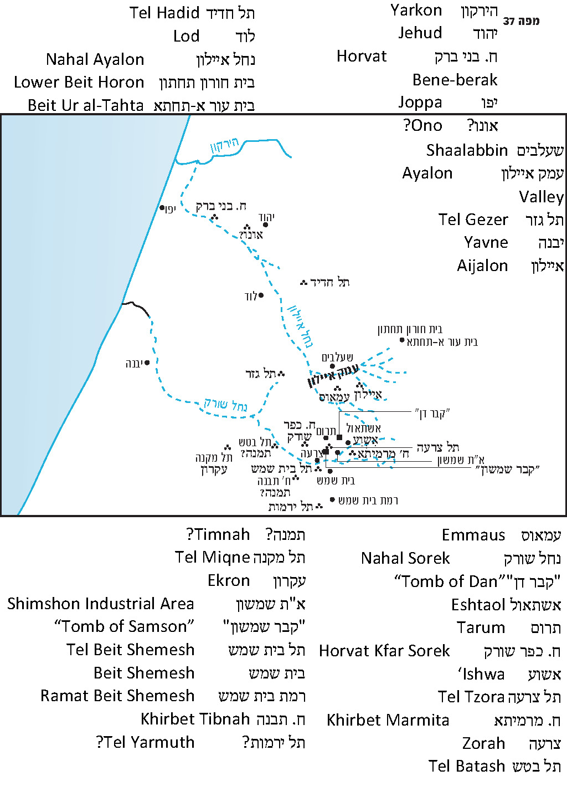

Eshtaol

The identification of Eshtaol is not known, but it is clear from the Tanakh that its distance from Zorah cannot be more than a few miles. The modern-day moshav of Eshtaol is situated atop the ruins of the village of Ishwa’, about one mile east of the ruins of Zorah. Scholars drew a comparison between the names “Ishwa’” and “Eshtaol.” The French explorer Victor Guérin writes that on June 21, 1863, he heard from elderly Arabs in Bēt ‘Iṭāb that the village of “Ashua’” was previously known as “Ashua’l” or “Ashtua’l.” The elders also told him that the wali consecrated to Sheikh Gherib between Ishwa’ and Ṣar’a (in recent years labeled “the Tomb of Dan, son of Jacob”) was previously known as “Kabr Shamshun” – the Tomb of Samson. In truth, the connection between Eshtaol and Ishwa’ is completely fictive. Regarding Guérin’s testimony, it is highly doubtful if this information can be trusted. First, no other sources attest to such names. Second, the connection to the Biblical names is so fantastic that one suspects that the source of the information was actually conversations between the Arab villagers and European travelers who passed through the area prior to Guérin.

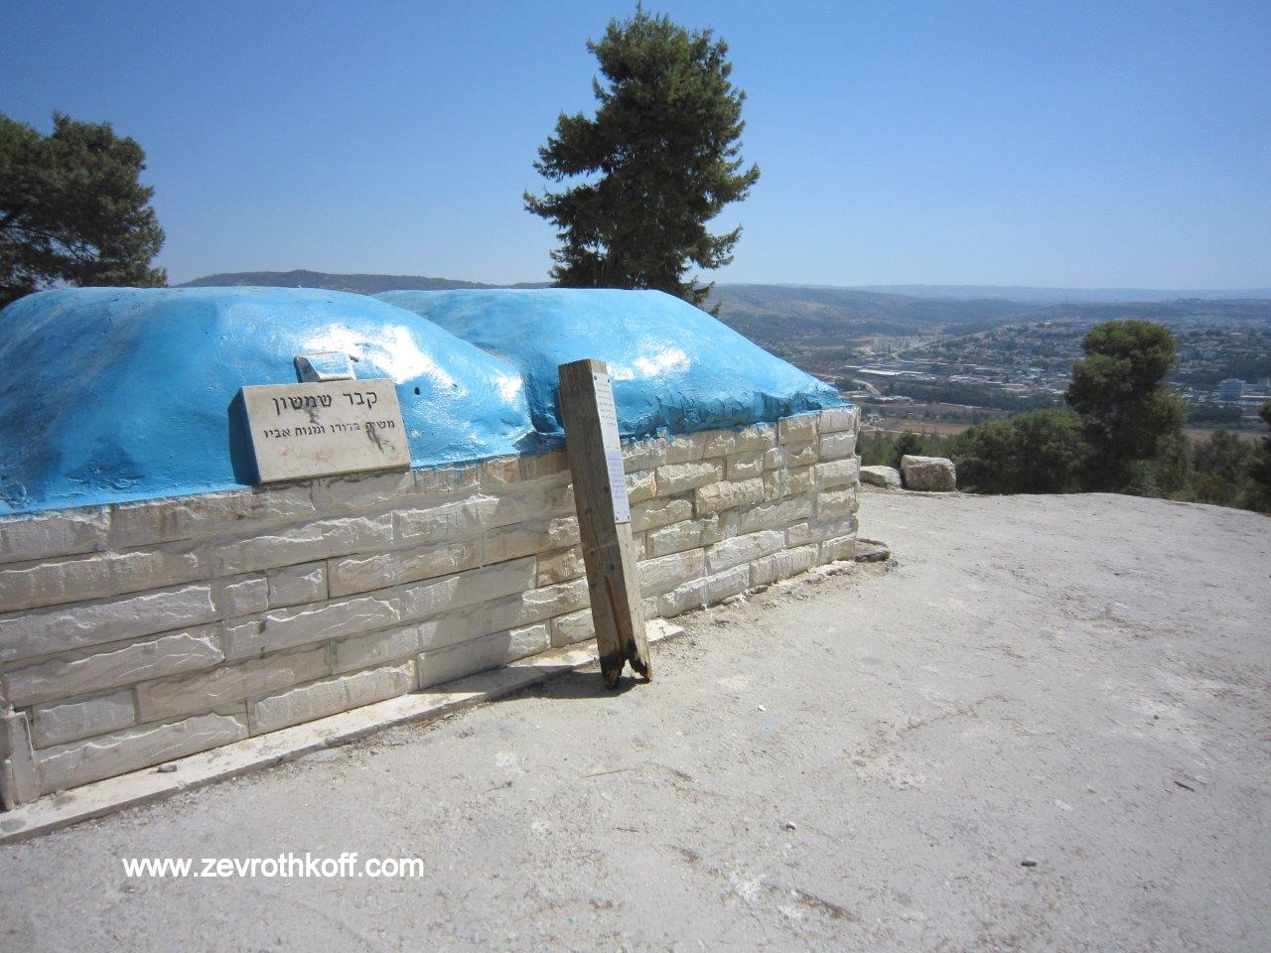
The “Tomb of Samson,” formerly “Sheikh es-Samet” on the peak of ancient Zorah (Courtesy of Dr. Zev Rothkoff)

Eusebius, in his Onomasticon (approx. 320 CE) recognized Zorah and Eshtaol as existing villages during his time. He described the two villages, along with Beth-shemesh, with the following words: “Ten miles from Eleutheropolis [Beit Guvrin] on the road to Nicopolis [Emmaus].” This description, used for all three locations, demonstrates that there was apparently a crossroads with a path leading to each of the three settlements. In any case, the distance is too short; it is actually about twelve miles. For Jarmuth, Eusebius dedicated two entries. In one of them (“Iermus”), the description is very similar to that of Zorah, Eshtaol and Beth-shemesh: “There is now a village Hiermokhōs ten miles from Eleutheropolis on the way to Jerusalem.” Eusebius is undoubtedly referring to Tel Yarmuth, known until the modern era as “Khirbet al-Yarmouk,” today located near Ramat Beit Shemesh. The distance between Beit Guvrin and Tel Yarmuth is indeed ten Roman miles. In the second entry dedicated to Jarmuth, the text of the Greek manuscript is defective, but fortunately this entry was cited by Procopius of Gaza about one hundred years after the Onomasticon was written. In this entry, Eusebius writes that “Ierimuth” is situated fourteen miles from Eleutheropolis, near Eshtaol, a village [in the region of] Adullam. Scholars speculated that Eusebius was not referring here to Tel Yarmuth but to a location farther north, perhaps Khirbet Marmita about half a mile east of Naham. In any case, the distance of fourteen miles fits with the Naham area, the Shimshon Junction and the moshav of Eshtaol.

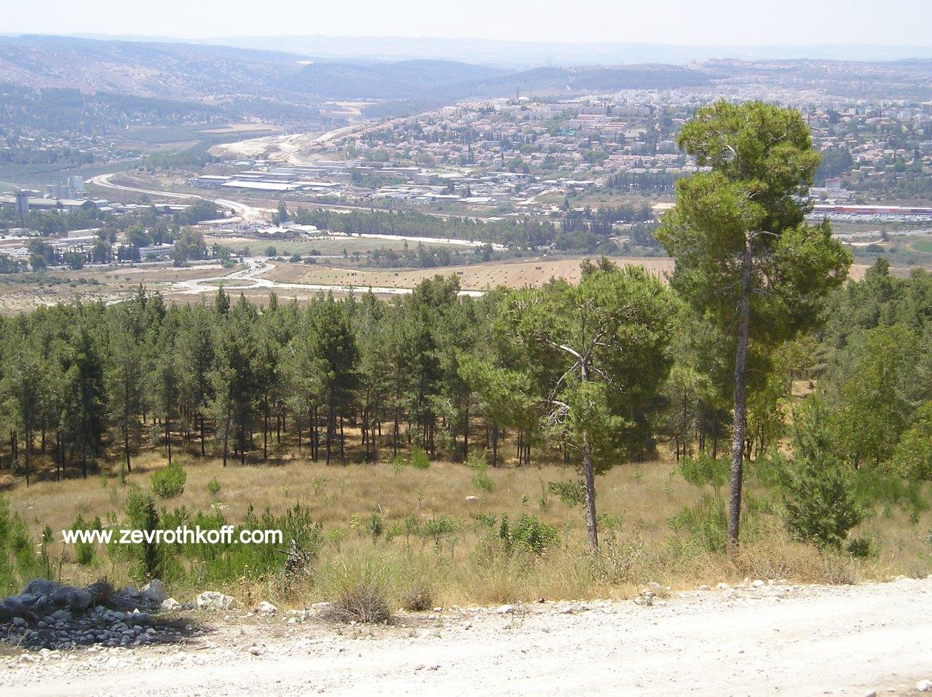
Modern-day Beit Shemesh, viewed from the northwest (Courtesy of Dr. Zev Rothkoff, 2006)

R. Ishtori Haparchi wrote in 1322: “South of Lod about three hours east is Zorah and Eshtaol; their names have not been altered.” R. Joseph Schwarz wrote in 1845: “The village of Ṣara is Zorah. West of Ṣara about one hour, slightly to the south is the village of Shtual, which is Eshtaol.” R. Schwarz, a German-born Jew, was not sensitive to the guttural sound of the letter ‘ayn, so he spelled “Ṣara” with a Hebrew alef rather than an ‘ayin. But it is clear that he is referring to the village of Ṣar’a. Regarding the testimony on “Shtual” west of Zorah, I do not know of any support for this in other sources, but a certain degree of support can likely be found in Eusebius’ Onomasticon. The Onomasticon mentions the village of Sorek on two occasions, and both times Eusebius highlights the connection to Nahal Sorek, the brook where Samson came to meet Delilah for the first time. In one of the mentions he writes that the site is near Zorah, and in the other mention he writes that it is near Eshtaol. Sorek itself is identified with Khirbet Surik (two miles west of Ṣar’a). Eusebius’ biblical identification of Sorek is questionable, but his testimony on the ground is presumably trustworthy. Based on this, we must ostensibly seek out the Eshtaol that Eusebius recognized west of Zorah rather than east of it; this issue requires further study.

In the end, it seems that in the past Eshtaol continued to be recognized by its ancient name, but in the last few centuries its identity has been forgotten. It is likely that in the future, additional sources will be found that will shed more light on this question. The distance that Eusebius records in his “Iermus” entry seems to fit with the region of modern-day Eshtaol, but the other details that he recorded fit this region less; it is difficult to ascertain the truth of the matter.

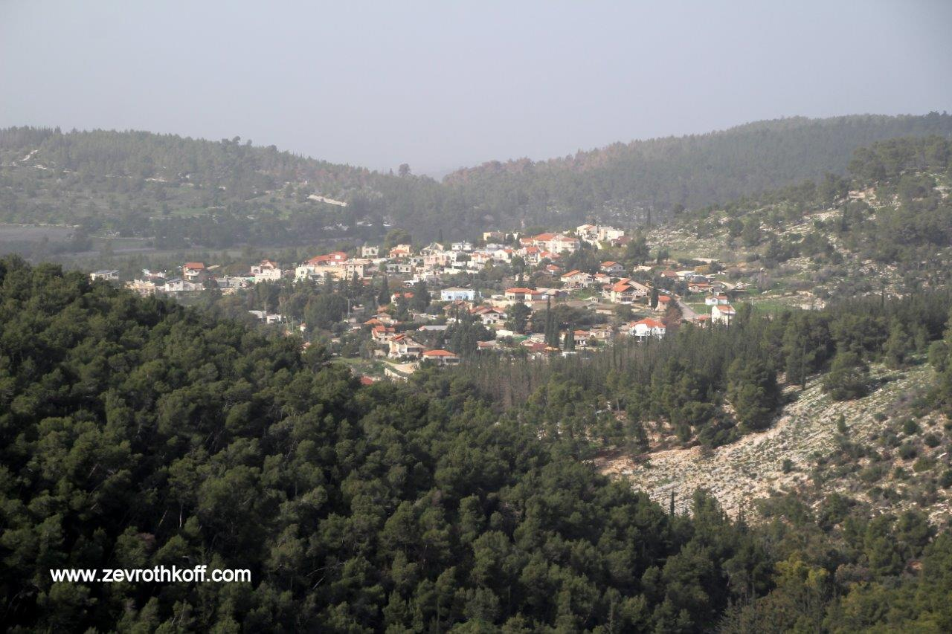
Moshav Eshtaol on the ruins of the village of ‘Ishwa, surrounded by forests (Courtesy of Dr. Zev Rothkoff, 2015)

To Which Tribe Did Zorah and Eshtaol Belong?

Zorah and Eshtaol are places that are typically associated with the tribe of Dan. The pair appears at the beginning and end of the series of narratives involving the Danite judge Samson: “The spirit of the Lord first moved him… between Zorah and Eshtaol” (Judges 13:25); “They buried him between Zorah and Eshtaol” (16:31). The book of Judges contains another set of stories involving the tribe of Dan, a multi-strand narrative surrounding the conquest of Laish and Micah’s idol. In this narrative as well, Zorah and Eshtaol are the centers of life for the tribe of Dan. “Valiant men” set out from there to spy out the land on behalf of their kinsmen; the spies would return there to report their findings; and “six hundred strong, girt with weapons of war” departed from there on their way to conquer Laish in the north, traveling via the home of Micah in Mount Ephraim (18:2, 8, 11). It is well known that the narrative in chapter 18 occurred chronologically at the start of the period of the Judges – the story was already recounted in brief in Joshua 19:47 and the end of the story seems to feature a grandson of Moses - whereas the story of Samson that appears in prior chapters actually occurred at the end of the period of the Judges. We can learn from this that only a portion of the tribe of Dan traveled north, while the rest of the tribe remained in the original Danite territory. The Song of Deborah (“And Dan – why did he linger by the ships?” [5:17]) teaches us that there were some Danite sailors, who perhaps settled in Jaffa.

However, in the book of Joshua we find that Zorah and Eshtaol are enumerated twice: in 15:33 the cities appear first in the list of the cities of the Shephelah belonging to the tribe of Judah; and in 19:41 they appear first in the list of cities belonging to the tribe of Dan. To whom do the cities belong? Rashi explained that they were border cities: “They belonged to Judah and the border of the Danites fell near them.” This explanation is difficult to accept: To whom did the cities actually belong? To Judah or to Dan? On several occasions in the allotment chapters, we find that the Tanakh stresses the status of the border cities. Regarding Kiriath-jearim on the border of Judah and Benjamin, the verse states that it was “a city of the Judites” (Joshua 18:14). The Benjaminite border runs through the region of Beth-horon “to the hill south of Lower Beth-horon” (18:13). There is no prominent hill in the Lower Beth-horon region; the intent of the verse was to declare that Beth-horon itself belonged to Ephraim. If so, why didn’t the verse explicate similarly in the case of Zorah and Eshtaol? It may be that Rashi intended to distinguish between the city and the territorial region, in the same vein as “The region of Tappuah belonged to Manaseh; but Tappuah, on the border of Manasseh, belonged to the Ephraimites” (17:8) and regarding Hebron – where the city itself was a priestly city while its territory was given to the clan of Caleb – “They gave the fields and the villages of the city to Caleb son of Jephunneh as his holding” (21:11). But why was this point not stated explicitly by the Tanakh itself? In addition, we will see below that the problem of Zorah and Eshtaol is only a small part of a wider question, one that necessitates an overarching solution.

The author of the Metzudot suggested a radical solution: “Zorah and Eshtaol: It may be that these [cities] were not those that were on the border of Judah.” It is very difficult to accept this kind of solution. While there are indeed examples of multiple cities in the land of Israel that bear the same name, most of the time these duplicate names have readily understandable meanings, most often describing the topographical or agricultural landscape. Examples include Ramah (“rise”); Mizpah (“lookout”); Gibeah (“hill”); En-gannim (“garden spring”); and Tappuah (“apple”). In contrast, unique names like Zorah and Eshtaol do not lend themselves to duplication. But more significantly, from a statistical perspective it is hard to imagine that the pair of Zorah and Eshtaol would be duplicated in two regions not far away from each other.

One ostensible solution could have been that the cities were given to Judah only for the initial, temporary allotment. Joshua 18 describes two stages in the apportionment of the land. In the first stage, five tribes settled their territory semi-spontaneously: Reuben, Gad and the half-tribe of Manasseh in the Transjordan; and Judah, Ephraim and the other half-tribe of Manasseh in the Cisjordan. The Tanakh relates that Joshua brought the nation to Shiloh, berating the remaining tribes: “How long will you be slack about going and taking possession of the land which the Lord assigned to you?” (18:3). He then sent delegations to determine the proper borders for the land and to divide the remaining territory among the seven remaining tribes. If so, we might suggest that Zorah and Eshtaol were given to Judah in the first allotment, only to be transferred to Dan in the second allotment. Nevertheless, this solution is also impossible. In I Chronicles at the end of chapter 2, the Tanakh lists the families of Judite ancestry along with their places of residence. There we read the following:

And the families of Kiriath-jearim: the Ithrites, the Puthites, the Shumathites and the Mishraites; from these came the Zorathites and the Eshtaolites. The sons of Salma: Bethlehem, the Netophathites, Atroth-beth-joab, and half of the Manahathites, the Zorites. (2:53-54)

In other words, the Judite families settled in practice throughout the generations in Zorah and Eshtaol.

The Many Owners of Aijalon

Joshua 19:42 states that Aijalon was given to the tribe of Dan. Joshua 21:24 (and its parallel verse in I Chronicles 6:54) states that it was given to the Levites. Judges 1:35 states that the Amorites seized Aijalon and settled it, until the House of Joseph got involved: “But the hand of the House of Joseph bore heavily on them and they had to perform forced labor.” To complicate matters further, I Chronicles 8:13 speaks of the Benjaminites Beriah and Shema – “chiefs of clans of the inhabitants of Aijalon, who put to flight the inhabitants of Gath.” That the city was given to Dan and then devoted to the Levites is a normal phenomenon. (The explanation for this is apparently that generally the fields and farmlands – the prime sections of the territory – remained under the possession of the tribe, while the Levites only received residences for them and their families, as well as space for their cattle and other property.) However, the fact that the city changed hands so many times indicates that Aijalon was located in a kind of “Wild West” in which the most powerful group at a given time would take control.

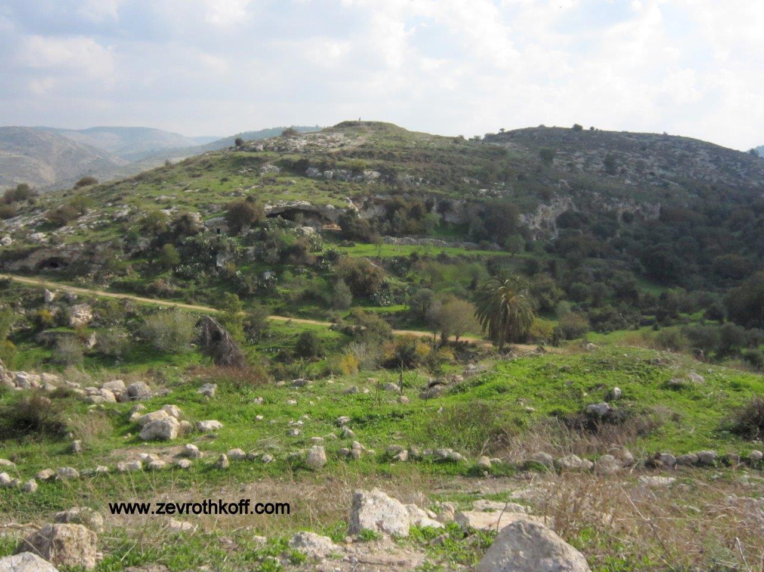
Yalu, the site of Aijalon. The raised area on the top of the hill was a fortress overlooking the ancient city (Courtesy of Dr. Zev Rothkoff).

It seems that this collection of information illustrates well the weakness of the tribe of Dan, of whom the Tanakh states: “But the territory of the Danites slipped from their grasp” (Joshua 19:47); and “The Amorites pressed the Danites into the hill country; they would not let them come down to the plain” (Judges 1:34).

However, Judges 18:1 presents a picture that hints at the fact that the problem had already begun from the time of the apportionment: “In those days the tribe of Dan was seeking a territory in which to settle; for to that day no territory had fallen to their lot among the tribes of Israel.” In light of this, let us examine the Biblical description of the allotment of the tribe of Dan.

Here we must preface this discussion by stating that by taking a simple step, one that begs to be taken: to read the allotment chapters in Joshua exactly as they are written; to attempt to identify the places mentioned in the verses based on Biblical and extrabiblical parallels and on the facts on the ground; and to try to understand the background and historical circumstances behind what is described in the Tanakh. This is a lonely task, as the classical commentators were not familiar with the land or with the extrabiblical sources, and many of the God-fearing students today who take interest in these matters believe that they should not pursue information or sources that were beyond the purview of the classical commentators. On the other hand, most of the scholars who study Biblical geography and history do not pay attention to what the Tanakh says about itself. They date the Biblical text centuries later and raise dozens of different historical theories regarding when each list was written and the “agendas” behind each one. We will take the minority approach here: We will read the Tanakh as it is written and attempt to understand what exactly it is saying, with the help of all the historical, geographical, archaeological and linguistic tools available to us.

The Territory of Dan

The territory of Dan is described last among the tribal territories in Joshua 19:40-48:

The seventh lot fell to the tribe of the Danites, by their clans. Their allotted territory comprised: Zorah, Eshtaol, Ir-shemesh, Shaalabbin, Aijalon, Ithlah, Elon, Timnah, Ekron, Eltekeh, Gibbethon, Baalath, Jehud, Bene-berak, Gath-rimmon, Me-jarkon and Rakkon, at the border near Joppa. But the territory of the Danites slipped from their grasp. So the Danites migrated and made war on Leshem. They captured it and put it to the sword; they took possession of it and settled in it. And they changed the name of Leshem to Dan, after their ancestor Dan. That was the portion of the tribe of the Danites, by their clans – those cities, with their villages.

Among the descriptions of the tribal territories there are several models. The territories of Judah and Benjamin are the most orderly; the Tanakh describes the borderlines systematically at the four cardinal directions and then goes on to list the cities within the territories. In the description of the territories of Ephraim and Manasseh, the Tanakh describes only partial segments of the outer borderlines, and there is no list of cities at all. For the other tribes, the descriptions feature some combination of borderline and territorial cities. The description of the territory of Dan does not include any borderline, but only a list of cities. Modern commentators and historical atlas writers have tried to map out the borders of the territory based on the enumerated cities, but they generally do not address the question why the Tanakh itself did not provide a description of the tribe’s borderline – or at least partially, as it does in the case of several other tribes.

A second question is why several important cities – situated between the southern line connecting Zorah, Eshtaol, Beth-shemesh, Timnah and Ekron and the northern line connecting Jehud and Bene-berak – are seemingly missing from the list. According to various sources and findings, these missing cities – which include Lod, Ono, Hadid, Gezer and Jabneh – were central cities in the region at the time. Why, then, were they omitted?

One scholar who tried to answer these two questions was Aaron Demsky. His solution is that here too, the Tanakh listed only the border cities of Dan, along Nahal Sorek in the south, the mountain slope line in the east, and Nahal Ayalon and the Yarkon in the north. According to Demsky, the list of cities is essentially a description of the borderline, though the text does not say so explicitly (see map). This suggestion does not solve our problem completely. Some of the cities on the list have not been identified, and their integration in the outer borderline is perhaps wishful thinking. The cities of Lod, Hadid and Ono are basically situated on that line – yet they were omitted.

Prof. Aaron Demsky

However, the most important question here is a different one: the comparison of the territory of Dan to the territories of Judah and Ephraim. There is no overlap between the northern border of Judah (Joshua 15:5-11) and the southern border of Ephraim (16:1-3). On the eastern portion of the borderlines, from the Jordan to Kiriath-jearim on the border of Judah and to Lower Beth-horon on the border of Ephraim, there is a space between the two territories that is occupied by the tribe of Benjamin (18:11-20). Additionally, there is another narrow area in which there is a small amount of space – the Aijalon area. However, from there on, for over fifteen miles of Shephelah and coast, the borders basically overlap. Gezer, which is listed as part of the southern border of Ephraim, and Jabneel (Yavne), which is listed as part of the northern border of Judah, are situated along the same line of latitude. What this means is that there was no room left for the tribe of Dan. In other words: Beth-shemesh, Zorah, Eshtaol, Timnah and Ekron were part of the territory of Judah. Shaalabbin, Jehud, Bene-berak, Gath-rimmon and Joppa belonged to Ephraim. What land does this leave for the territory of Dan?

My Solution

It seems that the territory of Dan (19:40-46) is similar in character to the territory of Simeon (19:1-9). The descriptions of both of these two territories include lists of cities but no surrounding borderline. In the territory of Simeon there is an abundance of cities with no identification, whereas in the territory of Dan scholars have identified most of the cities. We can determine that the territory of Dan contains neither surrounding borderline nor territorial contiguity. What is the background of this character of the territory? As for Simeon, the Tanakh states: “Since the share of the Judites was larger than they needed, the Simeonites received a portion inside their portion” (19:9). The verse reveals in Judges 1:3 that the Judites and the Simeonites formed a pact in which they agreed to fight together in the wars of conquest and to share their territory as well. It appears that Simeon was a weak tribe without organizational abilities. We may even speculate that the tribe of Simeon was then in a state of shock following the loss of tens of thousands of their number. Simeon was the only tribe whose numbers decreased drastically; they effectively lost most of their population between the census taken in the second year since the Exodus and the census taken in the fortieth year (from 59,300 to 22,200). Chazal explained that all the 24,000 people who died in the plague following the incident of Baal-peor were from the tribe of Simeon, the tribe of Zimri son of Salu. It is well known that Moses did not impart a unique blessing to Simeon, merely hinting at the tribe in Judah’s blessing: “Hear (shema), O Lord the voice of Judah” (Deuteronomy 33:7).

Most of the cities that Simeon received from Judah are enumerated twice in the book of Joshua as well, once in the list of Judah’s cities in the Negeb (15:20-33) and again in the list of Simeonite cities (19:1-9). It is reasonable to assume that the Judites did not abandon these cities, but rather that they and the Simeonites lived in the cities side by side. It is difficult to imagine that a central city like Beersheba could have been purely Simeonite. More likely, it remained in Judite hands while the Simeonites were given the right to settle there.

From here, we can return to the Danites. The tribe of Dan was the second-largest tribe of Israel (after Judah), and it preserved its high population until the fortieth-year census. However, despite its strength in numbers, the tribe did not seem to possess actual power. In the wilderness, Judah was the vanguard while Dan was “the rear guard of all the divisions.” When the people of Israel reached the land, Judah was first and foremost in both conquering and settling the land, while no exploits of the tribe of Dan during that period are recorded. The process of settling the land hinged primarily on the tribes’ motivation and their ability to act. The Judites and the Josephite tribes – the Manassites in particular – were the ones who were strong enough and ambitious enough to take possession of the land. Joshua 14 relates that upon their request, Caleb son of Jephunneh and the Judites were granted permission to go to war against the giants in Mount Hebron and to settle Hebron and the fortified cities surrounding it. Caleb promised his daughter’s hand in marriage to the man who would attack and capture Kiriath-sepher. The Manassites settled the Gilead and the Bashan, while the daughters of Zelophehad demanded portions among their brothers. Joshua gave the land of the valleys – which had been designated for Issachar and Asher – to the Manassites, in the hope that they would be able to dispossess the Canaanites there who possessed iron chariots (17:11, 18). The indolent tribes remained in Gilgal while the five zealous tribes fought and engaged in conquering the wasteland. It is likely no coincidence that the tribe of Dan was left until the end; the Danites were the “rear guard” of the tribes in the settlement process as well.

In Joshua 18, the nation assembles and Joshua urges the seven remaining tribes to follow in the footsteps of the five industrious tribes and discharge their responsibility with respect to conquering and settling the land. Joshua establishes a just principle: “Judah shall remain by its territory in the south, and the house of Joseph shall remain by its territory in the north” (18:5). In other words, the entire nation of Israel shows its thanks to the industrious tribes for their initiative in conquering and dispossessing the land. The thought that these five tribes would be required to clear out the places they conquered for the benefit of other tribes was never even entertained. They would stay where they were, while the rest of the tribes would divide the remaining land. We may even speculate that this secondary allotment of the remainder of the land was dependent to some extent on the eagerness and demand of the tribes to receive their portion. By the time Dan’s turn was reached, there was no portion left for the tribe. I can picture the scene: The elderly Joshua turns to his close friend and partner in loyalty to God and to the cause of settling the land of Israel Caleb son of Jephunneh, saying: Look, we need to solve the problem of the tribe of Dan, the most laggardly of the laggardly tribes. Let us give them the right to settle in the cities of our Shephelah, where the Canaanites still need to be dealt with – half from your territory and half from mine.

“Of the Family of the Danites”

This understanding explains another unique feature of the Danites of Zorah and Eshtaol. All the stories involving the Danites in the book of Judges include the word mishpacha, meaning “family.” Regarding the Danites who travel north, the verse reads: “The Danites sent out five of their number, from their family seat (mi-mishpechotam) at Zorah and Eshtaol – valiant men – to spy out the land and explore it” (18:3). Then again later: “They departed from there, from the family seat of the Danites (mi-mishpachat Ha-Dani), from Zorah and Eshtaol, six hundred strong, girt with weapons of war” (18:11). And our haftara opens similarly as well: “There was a certain man from Zorah, of the family of the Danites, whose name was Manoah” (13:2). What is the nature of this emphasis? My father, z”l, explained in the Da’at Mikra commentary on Judges 13:2:

Every tribe is divided into families (extended divisions, each consisting of numerous households) and in the tribe of Dan there was only one family (Numbers 26:42). Therefore Dan may be called a tribe and it may be called a family.

Begging my father’s forgiveness, I would like to offer a different interpretation. In my humble opinion, the explanation is tied to the reality of the settlements in question. The reality was that Zorah and Eshtaol were Judite cities, in which one Danite family was given permission to settle alongside the Judites, dividing the cities’ lands between them. When the Tanakh refers to the Danite residents of Zorah and Eshtaol, it feels the need to emphasize that the group in question is the Danite family in Zorah.

The Omission of Dan (and Simeon) from the List of Levite Cities in Chronicles

I Chronicles 6 enumerates the Levite cities. This list is parallel to the list of Levite cities in Joshua 21, but the lists differ from each other in several details. While the list in Joshua contains forty-eight cities (forty-four cities plus four more that appear in a minority of versions of the text, but are omitted from the primary versions), in line with the Torah’s account (Numbers 34:7), the list in Chronicles enumerates only forty-two cities, and some of the names of the cities have changed. In contrast to the prevailing view in the scholarly literature that the two lists are two versions of the same text, and that the differences between them are merely minor textual variations, the Tanakh itself provides a different answer: In Joshua, the Tanakh states that it is listing an apportionment plan that was devised during the time the land was being settled, whereas in Chronicles it states that it is providing a snapshot of the current state of the Levite cities from generations later.

The list of Levite cities is also a list of the tribes of Israel, as the verses point out which cities were given over to the Levites by each tribe. This leads us to an interesting discovery. In the list in Joshua, which, as we said, reflects the original plan for the territorial allotment, all twelve tribes of Israel are mentioned. However, in the list in Chronicles, the tribe of Dan is missing and Simeon is only mentioned in a summarizing note appended to the section on Judah (6:50). This effectively reflects the settlement status of these two tribes. Both Simeon and Dan are essentially subtenants of Judah and Ephraim. Presumably, there was not one city that was given over for the exclusive use of Simeon or Dan. From the official, schematic perspective of Joshua 21, both Simeon and Dan are mentioned. But from the practical perspective of Chronicles, Simeon and Dan are not landowners, and so are unable to give cities to the Levites from their territory. As they themselves are “guests” in the home of another tribe, they certainly cannot invite new “guests” of their own.

For further study:

A. Demsky, “The Boundary of the Tribe of Dan (Joshua 19:41-46),” Sefer Moshe: The Moshe Weinfeld Jubilee Volume (eds. C. cohen, A. Hurvitz and S. M. Paul), Winona Lake, 2004, 261-284.

Yoel Elitzur, Ancient Place Names in the Holy Land, Jerusalem-Winona Lake 2004, 111, 361.

G. S. P. Freeman-Grenville, R. L. Chapman and J. Tailor, The Onomasticon of Eusebius of Caesarea, Jerusalem 2003, 36, 52, 61, 62, 86, 87, 88.

V. Guérin, Description Géographique, Historique et Archéologique de la Palestine, II, Paris 1869, 382 [French].

R. Ishtori Haparchi, Kaftor Va-ferach, ed. Lunz, Jerusalem 1897, 302 [Hebrew].

W. L. Moran, The Amarna Letters, Baltimore-London 1992, Letter 273.

R. Joseph Schwarz, Tevu’ot Ha-aretz, ed. Lunz, Jerusalem (1845) 1968, 121 [Hebrew].

Translated by Daniel Landman

See our discussion on Parashat Shemot.
The pronunciation of Sar’a matches the name’s pronunciation as recorded in the Amarna letter, as well as that of the Septuagint: Saraa.
The site is known as Sheikh es-Samet.
See our discussion on Parashat Yitro.
See Map 37 below.
In Jerome’s edition: “Iermucha.”
It is a shame that this new city was not named Yarmut, as this was the original historic name for the site.
Once it is written as “Sōrēk” (Jerome: “Sorec”); a second time in the Greek manuscript it is written incorrectly as “Barēch” (Jerome: “Cafarsorech”).
See Seder Olam 12 and Bava Batra 109b and parallels.
The reason for this reversed order is that in the book of Judges, two long narratives were added to the end of the book – after the normal chronology of the period of the Judges was completed – to illustrate the low spiritual and national state of the nation in those days.
The exact interpretation of this verse is debated among the commentators, but it may be that the verse actually adds a sixth owner of Aijalon – the inhabitants of Gath (either Canaanites or Philistines).
In Yerushalmi Megilla 1:1, Chazal addressed this matter, using this as a support for the position of Rabbi Jose son of Hanina that the book of Joshua only enumerated cities that were near the borders; see our discussion of Parashat Behar.
In our discussion on Parashat Masei, I will expand on this matter.

