YESHIVAT HAR ETZION
ISRAEL KOSCHITZKY VIRTUAL BEIT MIDRASH (VBM)
*********************************************************

GEOGRAPHY IN THE PARASHA

PARASHAT BEHA’ALOTEKHA

The Wilderness of Paran
By Prof. Yoel Elitzur

Just Under a Year in the Wilderness of Sinai

Parashat Beha’alotekha marks the endpoint of the nation of Israel’s encampment in the wilderness of Sinai. The nation of Israel arrived at Sinai on 1 Sivan of their first year in the wilderness: “On the third new moon after the Israelites had gone forth from the land of Egypt, on that very day, they entered the wilderness of Sinai” (Exodus 19:1); they settled there for almost a year. During this year, the nation of Israel underwent several powerful experiences that shaped their identity, for better and for worse. Sinai was where the people experienced both the divine revelation and the sin of the golden calf. Sinai was where the Mishkan was constructed and dedicated, and where Aaron’s sons died a fiery death. Sinai was where the tribal chieftains were appointed and where the nation’s judicial and administrative infrastructure – including magistrates and officials, as well as chiefs of thousands, hundreds, fifties and tens – was established. Sinai was where the firstborn were initially performed the divine service, until the priests and Levites took their place in that role. The wilderness of Sinai is the setting for all the events of the book of Exodus starting from Parashat Yitro, the entire book of Leviticus and the book of Numbers until the middle of Parashat Beha’alotekha. The nation of Israel’s stay in Sinai begins with the formation of a covenant, reading from the “record of the covenant” and the proclamation that “all that the Lord has spoken we will do!” (19:8); and “all that the Lord has spoken we will faithfully do!” (24:7). It ends with blessings, curses and the promise of “I will remember in their favor the covenant with the ancients” (Leviticus 26:45). It is in this light that Rashi cites the following midrash in his commentary on Deuteronomy 1:6:

“You have stayed long enough at this mountain”: You are due much greatness and reward because you have settled at this mountain. You made a Mishkan, a menorah and the holy vessels; you received the Torah; you appointed for yourselves a Sanhedrin, as well as chiefs of thousands and hundreds.

From Sinai to Paran, to Zin and Kadesh

In Parashat Beha’alotekha we depart from Sinai:

In the second year, on the twentieth day of the second month, the cloud lifted from the Tabernacle of the Pact and the Israelites set out on their journeys from the wilderness of Sinai. The cloud came to rest in the wilderness of Paran. (Numbers 10:11-12)

Their first stop came after a three-day journey (10:33), and they stayed there for at least a month (11:20); this was where the incidents of Taberah and Kibroth-hattaavah took place. “Then the people set out from Kibroth-hattaavah for Hazeroth” (11:35), where Miriam was shut out of the camp for seven days. “After that the people set out from Hazeroth and encamped in the wilderness of Paran” (12:15), which was the point of departure for the spies. This place was also called Kadesh (“at Kadesh in the wilderness of Paran” [13:26]), and its full name was Kadesh-barnea (“when I sent them from Kadesh-barnea to survey the land” [32:8 and similarly in Deuteronomy 1:19]). Kadesh-barnea is also located in the wilderness of Zin (“They went up and scouted the land, from the wilderness of Zin” [Numbers 13:21]). Kadesh-barnea is also the midpoint of the southern border of “the land of Canaan with its boundaries” (34:2). The entire southern border is entitled “the wilderness of Zin alongside Edom” (34:3) and the point nearest to Kadesh-barnea on this border is Zin (34:4).

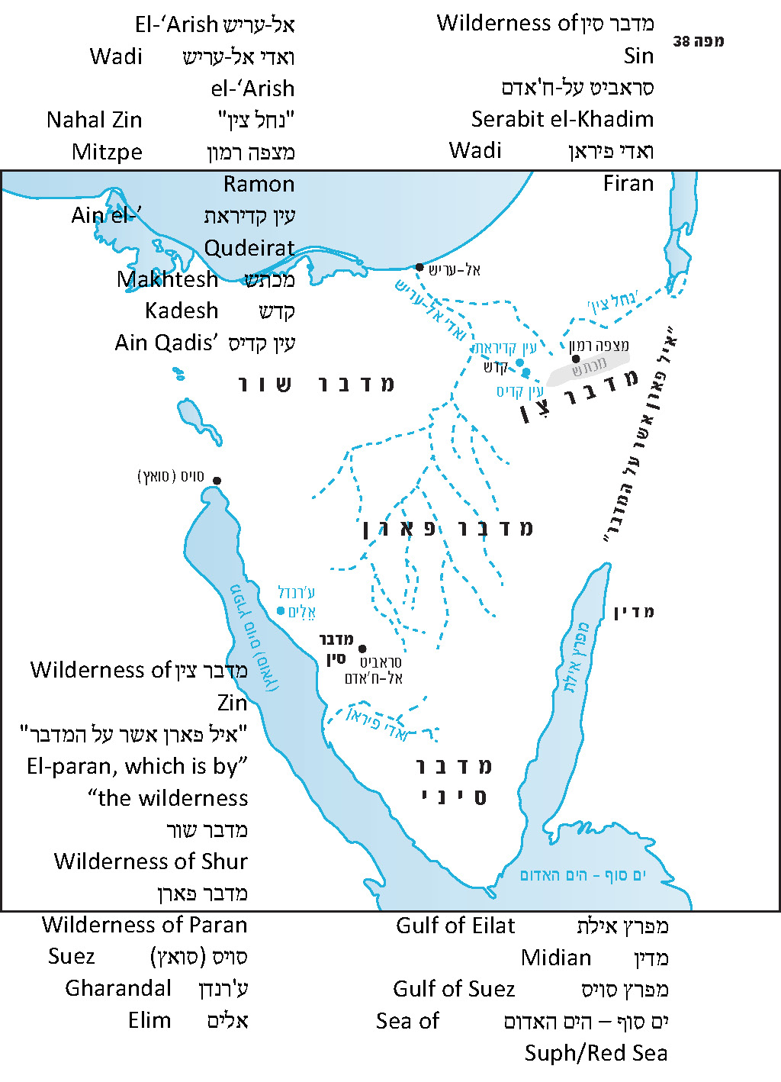

We see from this that the entire area between the wilderness of Sinai and Kadesh-barnea (an eleven-day journey according to Deuteronomy 1:2) is known as the wilderness of Paran. Since the wilderness of Paran is mentioned both before Hazeroth and after it, it is clear that Hazeroth is a point within the wilderness of Paran. It may be that Hazeroth was an oasis, and was mentioned by name simply because it had one. In contrast, the other places within the wilderness of Paran did not have any known names, and thus the Torah sufficed with giving these places the general name “the wilderness of Paran.” The region in the northern part of the wilderness of Paran, on the border of the land of Canaan, was called the wilderness of Zin, where Kadesh-barnea was located. The area where the people of Israel encamped at the time the spies were sent on their mission was originally given the general, neutral name “the wilderness of Paran” and only afterward was labeled more specifically as “Kadesh” or “Kadesh-barnea.” The spies’ point of departure was called “the wilderness of Zin” as well. In the list of the marches of the people of Israel, this particular place was called Rithmah (Numbers 33:18). In other words, even “Kadesh/Kadesh-barnea” is a territorial name in our context, referring to the “wilderness of Kadesh” (Psalms 29:8). The specific point or small region of Kadesh-barnea is located farther north, within the boundaries of the land of Canaan, as the borderline delineated in Parashat Masei indicates (“south of Kadesh-barnea” [34:4]).

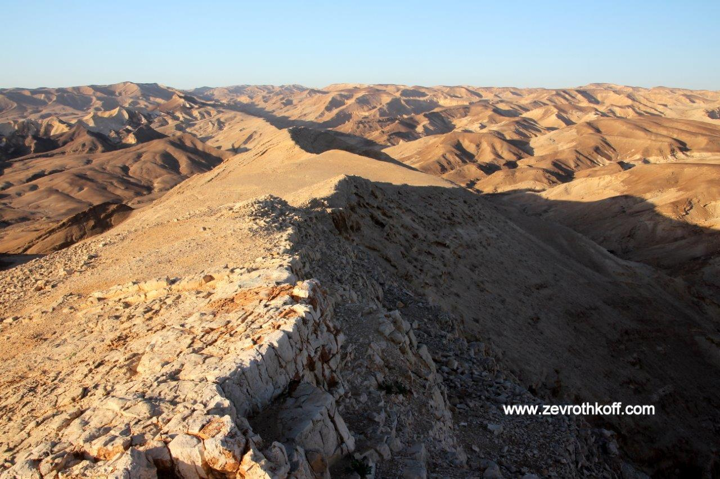
Nahal Masor – a typical view in the wilderness of Zin (Courtesy of Dr. Zev Rothkoff)

Identifying Kadesh

About twenty miles west of Mitzpe Ramon and about two miles west of the western border of modern-day Israel, there is a spring called ‘Ain Qadis that represents a precise preservation of the name Kadesh. There is a larger spring called ‘Ain el-Qudeirat about five miles northwest of ‘Ain Qadis, surrounded by a large oasis containing remnants from prehistoric times, as well as a fortified Israelite castle that was in use from Solomon’s time until the destruction of the First Temple. Following the return to Zion, the site was home to an unwalled Jewish settlement that was abandoned before the Hellenistic period and has not been settled since then. Israeli archaeologists have excavated the site, starting in 1956 – immediately after the Sinai War – and again during the years 1976-1982 when the Sinai Peninsula was in Israeli hands. The findings at the site include several Hebrew inscriptions written on pottery from the First Temple period and from the Persian period. (To our great sorrow, all of these Israelite findings were handed over to the Egyptians as a condition of the “Egypt-Israel peace treaty” of 1979.) The name “Qudeirat” is the name of a Bedouin tribe and its meaning is unimportant for our purposes. Upon traveling in the region in 1838, Robinson and Smith pointed out that the Bedouins generally refer to the spring as simply “el-‘Ain,” without any addition. Modern maps reflect this as well, labeling the wadi that originates at the spring and flows in the direction of Wadi el-‘Arish “Wadi el-‘Ain.” The region containing these two springs is generally identified with the Biblical Kadesh, which, as we said, was a territorial name for an entire desert expanse and not for one specific point alone. “En-mishpat, which is Kadesh” (Genesis 14:7) likely refers to one of the two springs mentioned here. Placing Kadesh-barnea in this region fits with the descriptions of the southern border of the land in Canaan in Numbers 34 and that of the territory of Judah in Joshua 15. It is true that the borderline runs “south of Kadesh-barnea.” However, as we have said, even the region where the people of Israel were situated during their second year in the wilderness – when the spies were sent out – and again in the fortieth year when they returned from their wanderings (Numbers 20:1) – which was presumably slightly south or west of this border – was given the territorial names Kadesh and Kadesh-barnea.

The expression “Kadesh-barnea” is mentioned in Tanakh in connection with the sin of the spies that took place during the second year in the wilderness, and it is usually mentioned alongside either the Amalekites and the Canaanites or the Amorites. In contrast, “Kadesh, in the wilderness of Zin” and “the wilderness of Zin, which is Kadesh” are mentioned in connection with the fortieth year in the wilderness, and they are usually mentioned alongside the Edomites. Some classical commentators and modern scholars believe that the names represent two places that are located at a great distance from each other. Using this theory, it is possible to solve several Biblical questions and even to corroborate the tradition that Aaron’s tomb is located next to Petra. In practice, however, this theory is impossible; as we demonstrated above, even Kadesh-barnea is located within the wilderness of Zin. Despite this, there is some logic to the notion that Kadesh-barnea and Kadesh in the wilderness of Zin were two subregions in relatively close proximity to each other within the wilderness of Kadesh. Compare to the expressions “the Negeb of Arad,” “the Negeb of the Kenites,” “the Negeb of the Jerahmeelites” and similar expressions in the Negeb cities on Shishaq’s list. Here too, these are two subregions within one large semidesert region.

The name Rithmah is certainly derived from the word rotem, referring to the broom bush, because of the high concentration of these plants at that location. Whether it is possible for us to identify Rithmah, however, is uncertain. As we said, it must be a relatively anonymous place in a region that was defined in Tanakh alternately as Kadesh-barnea, the wilderness of Zin and the wilderness of Paran. However, it cannot be located at the site of one of the Kadesh springs themselves, as the springs were located within the land of Canaan. With due caution, I will permit myself to direct the attention of the reader to the interesting information recorded by Robinson and Smith in the description of their travels in 1838. Robinson and Smith mention one of the tributaries of Wadi el-‘Arish called Wadi Abu Retemat. This wadi, located about three miles west of ‘Ain el-Qudeirat on the opposite side of a mountain that separates between them, contains a high concentration of broom bushes and desert scrub. Nevertheless, this is not considered a clear name preservation, as the Hebrew word rotem exists in Arabic as well (in Arabic ritm), with the same meaning, and a place name derived from this word should have arisen naturally at a late date. (There are several known Arabic names derived from the name of this plant, in several locations in the desert.) In any case, the location seems to be well in line with the information found in the Biblical text, and thus this identification may indeed hold water.

Sections of the Sinai Peninsula

The application of the name “Sinai” to the entire vast area between the Mediterranean Sea and the two arms of the Red Sea is a phenomenon of modern terminology. In the Tanakh, as we have already seen, Sinai is only a small part of this area. The Sinai Peninsula, including what is known today as the central and southern Negev, can be divided into three main sections. The northern section bordering on the Mediterranean Sea contains dune fields, but its climate is not extreme; indeed, its high groundwater levels have allowed for the existence of settlements throughout history. The southern section is primarily known for its lofty granite mountains, which reach an altitude of 8500 feet above sea level and contain flowing streams. The central section, which constitutes most of the area of the Peninsula and includes within it the Negev from Makhtesh Ramon southward, is known in Arabic as at-Tih or Tih Bani ‘Isra’il (after the people of Israel’s wanderings). It is an absolute desert, mostly flat and large in area – almost 7.5 million acres with virtually no signs of life.

The southern section is Sinai or Horeb. The region northwest of the Sinai Massif is called the wilderness of Sin “which is between Elim and Sinai” (Exodus 16:1). Elim is identified with Wadi Gharandal, near Ras Mal’ab, south of Ras Sudr, which was an Israeli military center during the time when Israel controlled Sinai. The region between Elim and the Sinai Massif includes mountains that are not as high. One famous historical site in this region is the ancient turquoise mines and the Egyptian-Canaanite temple in Serabit el-Khadim, where the earliest-known alphabet was discovered. Between the wilderness of Sin and the wilderness of Sinai is Rephidim. It make sense to identify Rephidim in the area of Wadi Firān (no connection to the Biblical Paran).

The northern section of the Sinai Peninsula is known in the Torah as Shur. It is mentioned in Genesis in connection to the patriarchs and their settlement in the western Negeb (Genesis 16:7, 20:1); in the description of the settlement patterns of the Ishmaelites (25:18; compare to I Samuel 15:7, 27:8); and in Exodus as the wilderness that the people of Israel entered after they crossed the Sea of Suph (Exodus 15:22).

The large, desolate central section is the wilderness of Paran, which features in our parasha, stretching from the wilderness of Sinai to the border of the land of Canaan. It is interesting to note the language that Moses uses in Deuteronomy to describe the wilderness of Paran as he summarizes the marches of Parashat Beha’alotekha: “We set out from Horeb and traveled the great and terrible wilderness that you saw, along the road to the hill country of the Amorites, as the Lord our God had commanded us, and we reached Kadesh-barnea” (Deuteronomy 1:19). Parashat Ekev adds to the description of this “great and terrible wilderness”: “Who led you through the great and terrible wilderness with its seraph serpents and scorpions, a parched land with no water in it” (8:15). It seems that within a certain oasis in this territory there was also a settlement called Paran. I Kings 11:17-18 relates the story of the Edomite Hadad, who traveled from Midian (east of the Gulf of Eilat) toward Egypt via Paran, where additional men joined him.

In the northern part of the wilderness of Paran, in that part’s eastern section, around Kadesh-barnea, was the wilderness of Zin. Based on Numbers 34:3 and its parallel in Joshua 15:1, the entire desert region between the southern edge of the Dead Sea (which apparently reached past the modern-day moshav of Neot HaKikar at the time the Torah and the book of Joshua were written) and the “wadi of Egypt,” i.e., Wadi el-Arish – in other words, lower Nahal Zin and the areas to its south and the Makhtesh Ramon area and the territory to its west, “south of Kadesh-barnea” – was called the wilderness of Zin. The southern borderline of “the land of Canaan with its boundaries” and of the territory of Judah in the southern part of the land is the same line that separates between the wilderness of Zin and the inhabited area. The view of Ze’ev Meshel placing the borderline atop the cliff of Makhtesh Ramon seems quite reasonable.

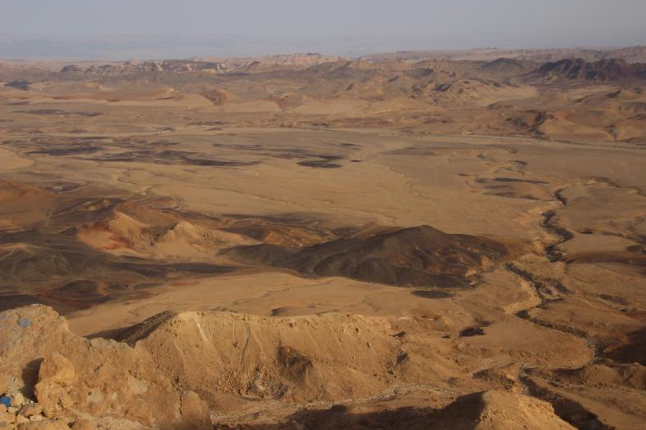
Typical view of the wilderness of Paran (Courtesy of Dr. Joshua Schmidt)

“El-Paran, Which Is by the Wilderness”

This unique expression is mentioned in Genesis 14:6. Amraphel, Chedarlaomer and their allies attacked the Horites of Mount Seir “as far as El-paran, which is by the wilderness.” It is accepted in the scholarly literature to identify “El-paran, which is by the wilderness” with Eilat on the banks of the Red Sea. In my opinion, this identification is not likely at all, for three reasons: a. Eilat is always written with a feminine ending (e.g., Elath, Eloth, Aela Elana in Greek-Roman sources and ‘Ayla in Arabic source); b. Eilat is always connected to the Red Sea and to Edom – and not to Paran; c. Based on the context, it is very likely that El-paran represents a line demarcating the edge of the land of the Horites, and not a point within it.

The descriptor “which is by the wilderness” is also surprising. Since Mount Seir is surrounded by deserts on all sides, to what can this expression possibly refer? In my article on the Biblical concept of elon, I cited evidence supporting the interpretation of the Aramaic Targumim and the Midrash, which translate elon as meshar, meaning plain. This is in contrast to the translation of the Septuagint, the Peshitta and the accepted view today, which maintains that elon refers to a kind of tree or clump of trees. In my article, I also lent support to these Targumic interpretations in their application to El-paran, translating the name as meshar Paran. In light of this, the verse should be understood as saying, “as far as El-paran, which is by the wilderness of Paran.” The most fitting candidate for “the plain of Paran, which is by the wilderness of Paran” is the Arabah between the Dead Sea and the Red Sea, which truly marks the edge of Mount Seir for its entire length.

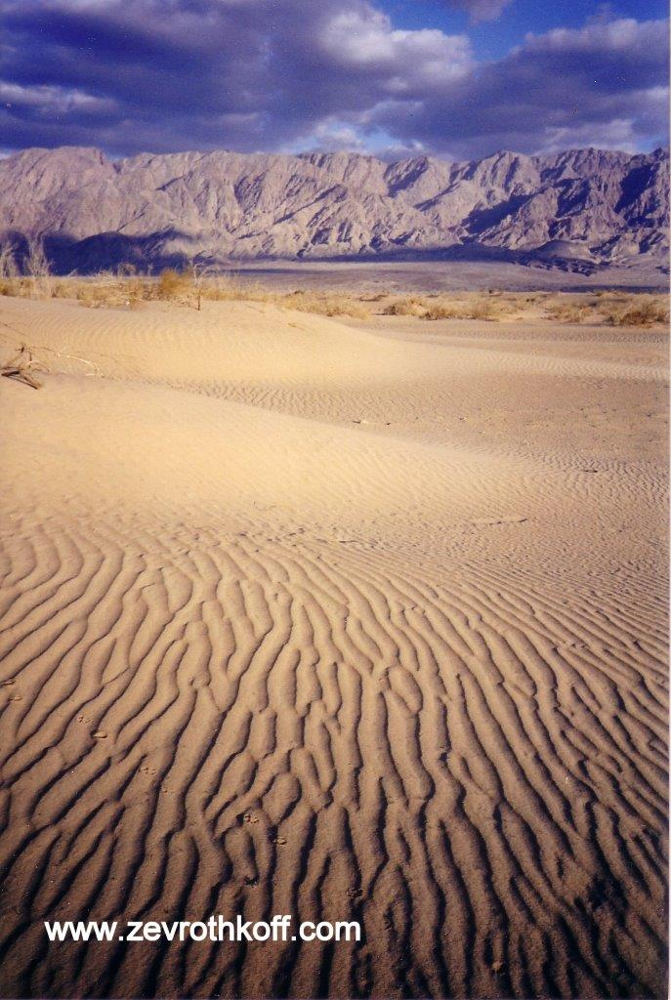
“El-paran, which is by the wilderness”; a view in the southern Arabah (Courtesy of Dr. Zev Rothkoff)

For further study:

Yoel Elitzur, “Geographical Terminology in the Bible: nhr, nḥl, and nḥl ‘ytn,” Iggud: Selected Essays in Jewish Studies 1 (2008), 6-7 [Hebrew].

Yoel Elitzur, “Elon – Meshar – αὐλών,” Eshel Beer-sheva 8 (Yaakov Bentolila Jubilee Volume), Beer-sheva 2003, 1-11 [Hebrew].

A. Frumkin and Yoel Elitzur, “The Rise and Fall of the Dead Sea,” Biblical Archaeology Review 27:6, 42-50.

I. Gilead and R. Cohen, “Kadesh-barnea,” The New Encyclopedia of Archaeological Excavations in the Holy Land 3, Jerusalem 1993, 841-847.

J. M. Hamilton, “Paran,” Anchor Bible Dictionary, 5, 162.

Z. Meshel, “The Southern Border of Canaan and Judah—The Geographical Aspect,” Judea and Samaria Research Studies 9, Ariel 2000, 27-37 [Hebrew].

E. Robinson and E. Smith, Biblical Researches in Palestine, and in the Adjacent Regions, A Journal of Travels in the Year 1838², I, Boston 1858, 189-190.

Translated by Daniel Landman

Taberah and Kibroth-hattaavah are two names for the same place; for more on this phenomenon, see our discussion on Parashat Vayetze.
See Map 38
The name “Rephidim” was given after the Six-Day War to the IDF encampments in the Bir Gafgafa area, far from the original Rephidim.
Jerome, in his Vulgate – the most common Latin translation of the Tanakh – and in his commentaries, as well as Ramban in his commentary on the Torah, integrated these two interpretations in an unconvincing manner.

