YESHIVAT HAR ETZION
ISRAEL KOSCHITZKY VIRTUAL BEIT MIDRASH (VBM)
*********************************************************

GEOGRAPHY IN THE PARASHA

PARASHAT CHUKAT

Wadi Zered
By Prof. Yoel Elitzur

Wadi Zered on Maps and in Encyclopedias

On modern maps, Wadi Zered can be found southeast of the Dead Sea. This wadi, known in Arabic as Wadi al-Hasa or al-Ahsa, is over fifty miles long, thirty miles of which maintain a constant flow of water west-northwest. The wadi discharges near Safi (which most accept as the identification for the Biblical Zoar) into the salt marshes south of the Dead Sea. This wadi is one of the four major east-west streams in the Transjordan: Yarmouk, Jabbok, Arnon and Zered. Wadi Zered is the border between the mountains of Edom to its south and the mountains of Moab to its north. The mountainous region south of the wadi contains the notable towns of Tafileh and Buseira (identified with Bozrah, a famous Edomite city). The mountainous region north of the wadi contains the notable city of al-Karak (identified with the Biblical Kir of Moab) and the town of Rabba (Rabbath Moab).

This identification of Wadi Zered with Wadi al-Hasa is also accepted in all encyclopedias, in modern Biblical exegesis and in scholarly literature in general. Other positions regarding its identification are mentioned occasionally in passing, but the prevailing opinion in both exegesis and scholarship confidently identifies Wadi Zered with Wadi al-Hasa.

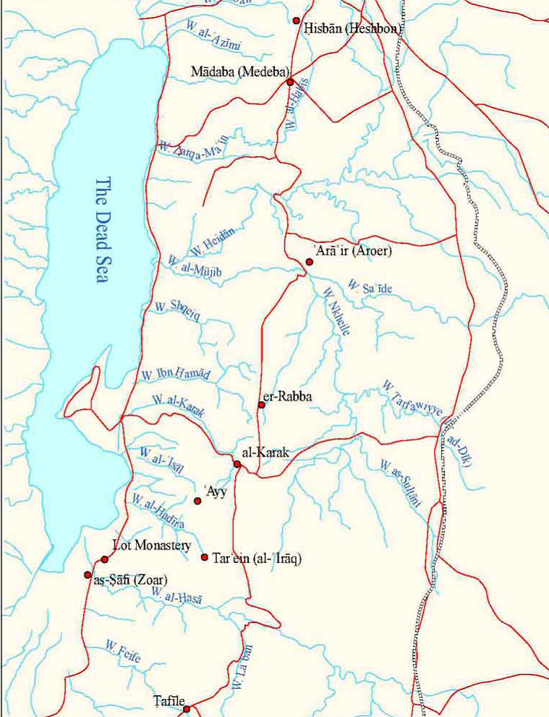
The land of Moab with all the candidates for Zered (Tamar and Reuben Sofer)

What Does it Say in the Torah?

Our parasha describes the people of Israel’s journey around the land of Edom and the southern part of the Transjordan. The people of Israel did not receive permission to pass through Edom, and after Aaron died at Mount Hor on the border of Edom, they set out to circumnavigate the land of Edom. Let us examine the Torah’s account of the continuation of the people of Israel’s journey:

The Israelites marched on and encamped at Oboth. They set out from Oboth and encamped at Iye-abarim, in the wilderness bordering on Moab to the east. From there they set out and encamped at Wadi Zered. From there they set out and encamped beyond the Arnon, that is, in the wilderness that extends from the territory of the Amorites. (Numbers 21:10-13)

The identification of Oboth is unknown. The direction that the people take here is south to north. This passage teaches us that the people of Israel first passed through “the wilderness bordering on Moab to the east” and then crossed Wadi Zered. Immediately afterward, they seemingly crossed the Arnon River as well, which was then the northern border of the land of Moab (after Sihon king of the Amorites conquered the entire region north of the Arnon from Moab; see 21:26). They then found themselves east of the land of the Amorites – “in the wilderness that extends from the territory of the Amorites.” This indicates that Wadi Zered flows basically east-west in the northeastern part of the land of Moab.

A similar picture is painted in Parashat Devarim, with an additional point of emphasis. There, Moses stands before the nation and reviews the details of the journey through the wilderness that they have undergone:

We then moved on, away from our kinsmen, the descendants of Esau, who live in Seir…

And we marched on through the wilderness of Moab (derekh midbar Moav). And the Lord said to me: Do not harass the Moabites or provoke them to war...

Up now! Cross the wadi Zered! So we crossed the wadi Zered. The time that we spent in travel from Kadesh-barnea until we crossed the wadi Zered was thirty-eight years, until that whole generation of warriors had perished from the camp, as the Lord had sworn concerning them. Indeed, the hand of the Lord struck them, to root them out from the camp to the last man. When all the warriors among the people had died off, the Lord spoke to me, saying: You are now passing through the territory of Moab, which is Ar. You will then be close to the Ammonites; do not harass them or start a fight with them…

Up! Set out across the wadi Arnon! See, I give into your power Sihon the Amorite, king of Heshbon, and his land. (Deuteronomy 2:9-25)

The order of events that Moses recounts fits well with the order in our parasha. After they go around the land of the Seirites, they pass through the wilderness east of Moab, then cross Wadi Zered and immediately afterward cross the Arnon River. This passage in Deuteronomy contains an important emphasis that is absent from our parasha. The crossing of Wadi Zered is portrayed here as a festive event possessing historical significance. Wadi Zered represents the end of the period of Israel’s wanderings, the culmination of thirty-eight years of wandering that were decreed following the sin of the spies. What is so special about Wadi Zered that it was chosen to mark the momentous conclusion of this period of exile? The answer is that it is the final point before entering the land of the Amorites, which is part of the land of Israel, as it was bequeathed to the tribes of Israel.

It is very easy to see that in both passages, which are the only two places in the Tanakh that mention Wadi Zered, the location of the wadi does not match its location on modern maps! According to the verses, Wadi Zered is located in the northern part of Moab, whereas modern maps place it on Moab’s southern border.

How Do Scholars Resolve This Discrepancy?

Several solutions have been suggested in order to resolve the discrepancy between the Torah’s account and the accepted identification, each solution in line with the views of its author. Some explained that since Biblical Hebrew does not recognize ordinal directions (such as northeast or southeast), the term mizrach ha-shemesh, generally translated simply as “east,” can actually mean “southeast.” Thus, the people of Israel passed south of the eastern section of Wadi al-Hasa, which the Torah called mi-mizrach ha-shemesh. This solution is far-fetched; why would the Torah call the wilderness of Edom “the wilderness of Moab”? II Kings 3 relates that the king of Judah, the king of Israel and the king of Edom traveled on “the road through the wilderness of Edom” and eventually reached Kir of Moab and attacked it. If so, why wouldn’t the Torah use the proper name for this region here as well?

Some writers, using linguistic sophistries, succeeded in matching the accepted identification of Wadi Zered with the Torah’s account – at least in Deuteronomy 2. They explain that derekh midbar moav should not necessarily be interpreted as “through the wilderness of Moab,” but “in the direction of the wilderness of Moab” means, “on the road that will eventually lead to the wilderness of Moab.” Furthermore, “You are now passing through the territory of Moab” means “You are now entering the territory of Moab.” Moderate Bible critics suggested a slight emendation of the words of the verse, or alternatively, a change in the order of the verses, so that the verses match the “correct” wadi. One radical Bible critic named J. Maxwell Miller (and others following him) decided that, in light of this and other difficulties in this chapter, it is clear that not only is the history described here completely fictional, but the same is true of the geography – it is based entirely on rumors. Thus, claims Miller, the author of Numbers 21 may have lived in the Babylonian exile and was not familiar with the geography of the land of Moab. The author or redactor of Deuteronomy 2 was influenced by the author of Numbers 21 and copied his errors.

Why Did Most Scholars Identify Wadi Zered with al-Hasa in the First Place?

Firstly, it seems to me that this identification was influenced by the schematic structure of the eastern bank of the Jordan River. The mountainous center of the western bank of the Jordan splits into numerous tributaries that reunite into a sizeable number of streams, some of which flow into the sea and others into the Jordan Rift Valley. In contrast, vast sections of the eastern bank of the Jordan consist of high plateaus, all the drainage of which flows west. In addition, the main part of the drainage is through large, deep wadis – from north to south: Yarmouk, Jabbok (Zarqa in Arabic), Arnon (al-Mujib) and Zered (al-Hasa). The centrality of these wadis, which divide the bank of the Jordan into five large plateaus, causes many – perhaps unwittingly – to identify them with the large wadis mentioned in the sources. Other questions of identification are beyond the scope of this discussion, but it seems that we can establish with certainty, based on various pieces of information, that the identifications of the Jabbok with the Zarqa River and the Arnon with Wadi Mujib are entirely accurate. As a result, completing the picture by identifying Wadi Zered with Wadi al-Hasa may seem to be the next logical step.

The Madaba Map

However, the main source that served as the basis for the identification of Wadi Zered with Wadi al-Hasa is the Madaba Map, the famous Greek mosaic map from the sixth century CE (some say the seventh century CE). The Madaba Map is the oldest map of the land of Israel that is known to us in the original, and not from a copy. All the scholarly literature points out the fact that the Madaba Map features an illustration of a wadi descending westward, south of “[XAP]AXMWBA” (Charach Moba, identified with the Biblical Kir of Moab, today al-Karak) and discharging into the southern part of the Dead Sea near “ZOOPA” (Zoora/Zoar, today es-Safi) and the “Sanctuary of Saint Lot.” This wadi, which, according to its geographical features, must be Wadi al-Hasa, is adorned on the map with the caption “[Ζ]ΑΡΕΔ” (Zared).

This demonstrates that at least at the end of the Byzantine period it was already accepted to identify Wadi Zered with Wadi al-Hasa. While there is no guarantee that this Christian identification tradition is necessarily accurate, it certainly represents a point of departure for the discussion, and anyone arguing against this tradition must bear the burden of proof.

Can This Be True?

After examining the Madaba Map carefully, the answer to this question became clear to me: absolutely not. The first thing that I noticed was that the last letter in the caption accompanying the name of the wadi is not, in fact, delta (Δ), as we had previously stated. In all the captions on the Madaba Map, the letter delta and the letter alpha (Α) appear quite similar. Both look much like an isosceles triangle. In the case of the delta, its base is a horizontal line forming a complete triangle. In contrast, the crossing stroke of the alpha is slightly diagonal; on the left side it touches the bottom of the left stroke of the letter, while on the right side it touches the right stroke at a slightly higher point. This distinction between the two letters is consistent throughout the map, and can be illustrated clearly by comparing names such as “Dan” and “Judah,” both of which contain the two letters side by side.

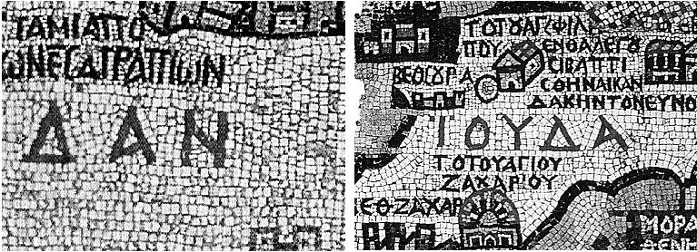
ΔΑΝ (Dan) and IOYΔA (Judah) in the Madaba Map. Note the shapes of the delta (Δ) and the alpha (A). (Courtesy of the Studium Biblicum Franciscanum)

Having established the distinction between the appearance of the letters alpha and delta on the Madaba Map, we can see that in the last letter of the word generally read as “Zared,” the base of the letter is clearly diagonal. In other words, the last letter is clearly not delta, but alpha. Once I began to suspect that this was the case, I took measurements and found that the presumed addition of the letter zeta ([Z]) at the beginning of the name is not actually possible. The wadi is accompanied on the map by cliffs on both sides as well as at its head. The section of the cliffs at the head of the wadi was damaged over the course of time and was not preserved. The wadi’s caption was integrated within these cliffs, and through careful and precise measurements, it is possible to continue the line of cliffs that have been preserved and determine that there is no room for the letter zeta in the damaged section. We must then conclude that the caption of this wadi on the Madaba Map does not read ΖΑΡΕΔ (Zared) but APEA (Area).

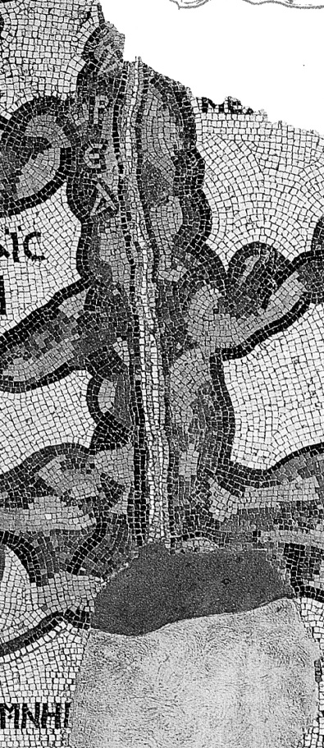
APEA (Area) and not [Z]APEΔ (Zared) (Courtesy of the Studium Biblicum Franciscanum)

What does “Area” mean in Greek? It is not particularly important. What is important is that this is not Wadi Zered. By way of speculation, I thought that perhaps this is a Greek version of the Biblical name Ar, which is sometimes used as an alternate name for Moab in general (or for its southern part), and on one occasion it refers to a Moabite city. In Byzantine-era sources, a city is mentioned south of the Arnon River called Areopolis, which preserves the Biblical name Ar. Eusebius, in his Onomasticon, writes that this is the Greek name for Rabbath Moab. Rabbath Moab is known today as Rabba, about six miles north of al-Karak, and thus it may be that Area was the name of the entire region surrounding this city. However, if we follow this interpretation, we must assume that the artisan who created the Madaba Map erred by placing the caption close to the wadi instead of spreading out its letters across the region to its north.

Here is another minor discovery in the Madaba Map. We have already seen that the wadi illustrated in the Madaba Map is not Wadi Zered. It seems that this wadi does not represent Wadi al-Hasa either. According to the illustration on the map, the wadi discharges into the Dead Sea at a significant distance from the southern edge of the sea, between Charach Moba on one side and Zoora and the Sanctuary of St. Lot on the other – closer to Charach. This information does not fit with Wadi al-Hasa, which flows more than twelve miles south of al-Karak and discharges into the salt marshes south of the Dead Sea, very close to Safi. In the past, this discrepancy could perhaps have been resolved by assuming that the map was not precise in its geographical proportions, and further assuming that the water level of the Dead Sea was higher during the Byzantine period (though according to recent geological research, modern geologists believe that the water level was actually low during that time). But then an archaeological discovery came to light that may very well close the discussion once and for all. The discovery was the Sanctuary of Lot, situated atop the cave where tradition has it that the incident involving Lot and his daughters transpired – and containing an inscription reading “Agios Lot” (St. Lot). The monastery was found in 1983 at a site called Deir ‘Ain ‘Abata, north of Wadi al-Hasa, and was excavated during the years 1988-1996. This monastery is undoubtedly the sanctuary illustrated on the Madaba Map, while its location on the Madaba Map is south of the wadi that appears on the map. It seems, then, that the wadi illustrated on the map is one of the two wadis between al-Karak and Wadi al-Hasa, likely the southern of the two. It is somewhat surprising, in truth, that the map chose to depict this wadi and not the larger Wadi al-Hasa. In the area northwest of the Dead Sea as well, the map depicts Nahal Og rather than the larger Nahal Prat (Wadi Qelt).

In short, the common identification of Wadi Zered was erroneous from A to Z. Madaba Map is entirely irrelevant to our discussion, as it depicts neither Wadi Zered nor Wadi al-Hasa. The accepted identification of Wadi Zered with Wadi al-Hasa is not rooted in any ancient source, and it clearly contradicts the two places in the Tanakh that mention Zered.

So What Is Wadi Zered?

Wadi Zered must be a significant wadi, one that is worthy of the festive remarks surrounding its appearance in Deuteronomy: “Up now! Cross the wadi Zered! So we crossed the wadi Zered. The time that we spent in travel from Kadesh-barnea until we crossed the wadi Zered was thirty-eight years…” (2:13-14). The people of Israel crossed the wadi in northeast Moab, just before they crossed the Arnon River.

One prominent candidate, which fits with these pieces of information, is Wadi Nukheile, a wadi in the eastern part of the land of Moab that flows south-north, with a slight tilt to the west. It discharges in the Arnon, below Aroer, near the place where the main road crossed the Arnon from ancient times until today. Not long ago, an ancient road was discovered that crossed Wadi Nukheile and immediately thereafter Wadi Sa’ida – the eastern section of the Arnon. This road may fit with the path taken by the people of Israel described in our parasha and in Parashat Devarim.

One other possible suggestion is Wadi Tarfawiyye (called Wadi ad-Dik on some maps), a long intermittent stream that discharges into Wadi Nukheile about six miles south of where Wadi Nukheile discharges into the Arnon. This suggestion was proposed by Yisrael Zev Horowitz in the early twentieth century. The benefit of this suggestion is that it fits with an ancient identification tradition mentioned in the Aramaic Targumim of the land of Israel (as tarvaya and similar variations), but it is likely that this name simply referred in the past to Wadi Nukheile, the stream into which Wadi Tarfawiyye discharges.

Did the People of Israel Pass Through the Land of Moab?

The verses seem to contradict one another on this matter. Based on the two passages that we examined in Parashat Chukat and Parashat Devarim, the people of Israel passed through “the wilderness bordering on Moab to the east” but did not actually enter the land of Moab. The passage in Deuteronomy emphasizes that Israel was warned not to harass the Moabites, “for I will not give you any of their land as a possession; I have assigned Ar as a possession to the descendants of Lot” (2:9). In our parasha, the Torah states that the people of Israel requested permission from the king of Edom to pass through his territory; when the king refused, they went around his land. In Jephthah’s retelling of this story to the king of the Ammonites, who demanded the return of all the land from the Arnon to the Jabbok, he adds that “they also sent a mission to the king of Moab, and he refused,” and emphasized that “they kept to the east of the land of Moab until they encamped on the other side of the Arnon; and they never entered Moabite territory” (Judges 11:17-18).

On the other hand, in that same chapter in Deuteronomy, which tells of the nation’s passage through the wilderness east of Moab, the Torah seems to tell a different story in its description of Moses’ entreaty to Sihon: “Let me pass through your country… What food I eat you will supply for money… as the descendants of Esau who live in Seir did for me, and the Moabites who dwell in Ar” (2:28-30). Rashi’s solution – that the Moabites did not allow the people of Israel to pass through their land, and that Moses’ statement to Sihon was in reference to their sale of food and water to the Israelites – seems far-fetched in terms of peshat. The most important part of Moses’ request was permission to pass through, while “what food I eat you will supply for money” is an additional statement meant to put Sihon at ease so he would not reconsider allowing Israel’s passage. Why, then, would it make sense to cite as a reference a nation that did not allow Israel to pass through its land?

Ibn Ezra challenged this notion further, invoking a verse from later in Deuteronomy: “Because [the Ammonites and the Moabites] did not meet you with food and water on your journey after you left Egypt, and because they hired Balaam son of Beor… to curse you” (23:5). Commentators old and new resolved this contradiction in various ways. (These solutions include: they did not meet Israel with food and water, but they did sell them these provisions; the Ammonites were the ones who did not provide food and water, whereas the Moabites were the ones who hired Balaam; some of the Edomites and Moabites gave Israel permission to pass through, while others did not; the descendants of Esau who live in Seir were different from the rest of the Edomites, and the Moabites who live in Ar were different from the rest of the Moabites. I will note that, in the context of our discussion here, critical writers had difficulty resolving this problem as well. Since the contradiction in Deuteronomy 2 is within the same sequence of events, this precludes the possibility of splitting the passage into two or more assumed contradictory sources.

If we accept the identification of Wadi Zered with Wadi Nukheile, this means that the people of Israel passed through the semidesert region in the eastern part of Moab, but west of Nukheile – in other words, inside the land of Moab, but not in the settlement centers or the agricultural areas. After they requested permission to pass through the inhabited areas and the Moabites denied them permission to do so, they chose to travel through the semiarid eastern region. By doing this, the people of Israel made it clear to the Moabites that they were not planning to attack them or to harm them in any way. As a result, the Moabites allowed them to pass through this eastern region of their land and purchase food and water from them. This permission was not given at first, nor was it given wholeheartedly or even amicably; it was a kind of compromise. This understanding may provide a harmonious explanation for all the texts dealing with the passage of the people of Israel through the land of Moab. (The contradiction regarding the descendants of Esau may perhaps be resolved with a similar explanation.)

Summary

According to our conclusion, the Wadi Zered that is mentioned in Numbers 21 and in Deuteronomy 2 does not appear on the Madaba Map. Based on the information found in the Tanakh, it is located in the northeast part of Moab. It should be identified with Wadi Nukheile or perhaps with Wadi Tarfawiyye, which discharges into Nukheile, but certain considerations suggest that Wadi Nukheile may be a better match. Wadi al-Hasa, which serves as the border between Moab and Edom, is not Wadi Zered.

Final Note

Wadi Zered is mentioned in one other source that we did not mention here: the baraita that discusses the regions of the land of Israel (preserved in Sifrei on Parashat Ekev, in the Yerushalmi and the Tosefta of Masekhet Shevi’it and in the Rehov Inscription in the Beit She’an Valley. Our identification of Zered with Nukheile might suit the geographical logic of the baraita as well. However, this topic is beyond the scope of this discussion.

For further study:

D. Ben-Gad, “‘Waheb be Suphah’ and the Settled Country of Ar,” Cathedra 95 (2000), 7-24 [Hebrew].

H. Donner, “The Sanctuary of St. Lot,” The Near East in Antiquity 4 (1994), 87-92.

Yoel Elitzur, “Zared or ‘Aρεα’? One Significant Detail in the Madaba Map,” Scripta Classica Israelica 19 (2000), 155-162.

Yoel Elitzur, “Naḥal Zered in the Bible and the Baraita de-Teḥumim,” PEQ 145 (2013).

K. Politis, “The Sanctuary of Agios Lot, the City of Zoara and the Zared River,” in M. Piccirillo and E. Alliata (eds.), The Madaba Map Centenary, Jerusalem 1999, 225-227.

Translated by Daniel Landman

The Arabic word used to mean “irrigated places in a sandy area.”
In the early twentieth century and in other periods throughout history, the water level of the Dead Sea was higher than it has been over the last sixty years, and extended farther south. In those times, Wadi Zered would discharge directly into the sea.
See the Midrash Tanchuma’s description (cited in Rashi) of the miracles that occurred at the Arnon: “The mountain of the land of Israel trembled, like a maidservant going out to greet her mistress.”
Incidentally, upon reading Miller’s article, I was unsurprised to find basic errors in his Biblical citations and in his understanding of the Hebrew language.
Yarmouk is not mentioned in the Tanakh, but it appears in other sources.
Alternatively, tarvaya may have referred to both wadis.

