YESHIVAT HAR ETZION
ISRAEL KOSCHITZKY VIRTUAL BEIT MIDRASH (VBM)
*********************************************************

GEOGRAPHY IN THE PARASHA

*********************************************************
Congratulations to our translator Daniel Landman and his wife Sarah
on the birth of their son. May they be zocheh legadlo
leTorah, leChuppa, uleMa’asim Tovim!
*********************************************************

*********************************************************
Dedicated le-ilui nishmat Henri Sueke z”l
R’ Moshe ben Yaakov and Shoshana,
Whose shloshim falls on Friday July 3rd.
A much loved husband, father, son and brother,
May the family be comforted among the mourners of Yerushalayim
*********************************************************

PARASHAT BALAK

The Land of Moab
By Prof. Yoel Elitzur

Parashat Balak: Entirely in the Land of Moab

The final verse in the previous parasha is the opening verse for the Balak narrative, according to the accepted division of chapters: “The Israelites then marched on and encamped in the plains of Moab, across the Jordan from Jericho” (Numbers 22:1). From this point on, through the end of the Torah until Joshua 3, the people of Israel remain in the same location – the plains of Moab across the Jordan from Jericho. Our parasha emphasizes that this place is adjacent to the land of Moab: “And Moab said to the elders of Midian, ‘Now this horde will lick clean all that is about us as an ox licks up the grass of the field’” (22:4); “There is a people that came out of Egypt; it hides the earth from view, and it is settled next to me” (22:5).

King Balak of Moab and his dignitaries set out to meet Balaam in “Ir-moab, which is in the vicinity of the Arnon, at the edge of the border” (22:36) and then the entire party accompanies Balaam to Kiriath-huzoth, where they eat and spend the night. The next morning, they ascend to Bamoth-baal, where they “could see a portion of the people” (22:41). Balaam advances from there on his own until he sees the entire encampment of Israel, at which point he returns to Balak, bearing a blessing instead of a curse for the people of Israel. The second attempt to curse Israel occurs at Sedeh-zophim, on the summit of Pisgah, where only a small portion of the nation’s encampment was visible (23:13-14). This attempt was unsuccessful as well, leading Balak to bring Balaam to the peak of Peor, which overlooks the wasteland (23:28).

As Balaam looked up and saw Israel encamped tribe by tribe, the spirit of God came upon him. Taking up his theme, he said: Word of Balaam… How fair are your tents, O Jacob, your dwellings, O Israel! (24:2-5)

Balak’s furious response to this blessing inspires Balaam to take up his theme once more in the same place, going on to guarantee to Moab that “in days to come” they are destined to succumb to Israel, along with “all children of Seth” and the nation of Edom (23:14-19). From this vantage point, Balaam was also able to look out at Amalek and at the Kenites, who were encamped next to Israel, and to speak briefly about them as well. Before Balaam returns home, he ends with a mysterious prophecy concerning events far in the future: “Alas, who can survive except God has willed it!” (24:23). In total, Balaam delivers seven prophecies.

As usual, in this discussion too, we will focus less on the story itself and on Balaam’s lofty speeches and more on the geography that is involved. Most of the places we mentioned above are difficult to identify precisely, but the general framework of the region is clear. The plains of Moab are a vast, flat area of land in the southeast Jordan River Valley, northeast of the Dead Sea “across the Jordan from Jericho.” This region is also known in the Torah as “the valley near Beth-peor” (Deuteronomy 3:29 and others), and at the end of the list of the marches of the people of Israel it is described in detail: “they encamped by the Jordan from Beth-jeshimoth as far as Abel-shittim, in the plains of Moab” (Numbers 33:49). Beth-jeshimoth is the southern border of this region, generally identified with Suweimeh in the northeast Dead Sea region, and Abel-shittim is the northern border of the region. Chazal estimated that the area of this region is twelve mil by twelve mil (Eruvin 55b, Yerushalmi Shevi’it 6:1 and parallels). This estimate fits quite well with the actual geography of the region (despite its source in the Bavli – Rabba bar bar Hana, who was known for his exaggerations; in the Yerushalmi, the estimate is unattributed, indicating that it was a fact that was known to all). In fact, this estimate is the source of the statement that appears throughout rabbinic literature that the size of the Israelite camp was twelve mil by twelve mil (Sifrei Devarim 343 and parallels), a figure that has halakhic ramifications. All the points where Balak and Balaam stood and looked out upon Israel are located atop hills that overlook this large plain, and thus cannot have been very far from the plain itself. The one point that was located at a significant distance from the plain was the first point mentioned in the narrative – “Ir-moab, which is in the vicinity of the Arnon, at the edge of the border.” The Arnon River is one of the central streams in the Transjordan, flowing east-west and discharging into the Dead Sea about twenty-two miles south of Beth-jeshimoth and the plains of Moab. The Torah refers to this point as “the edge of the border,” and we will soon clarify the meaning of this name.

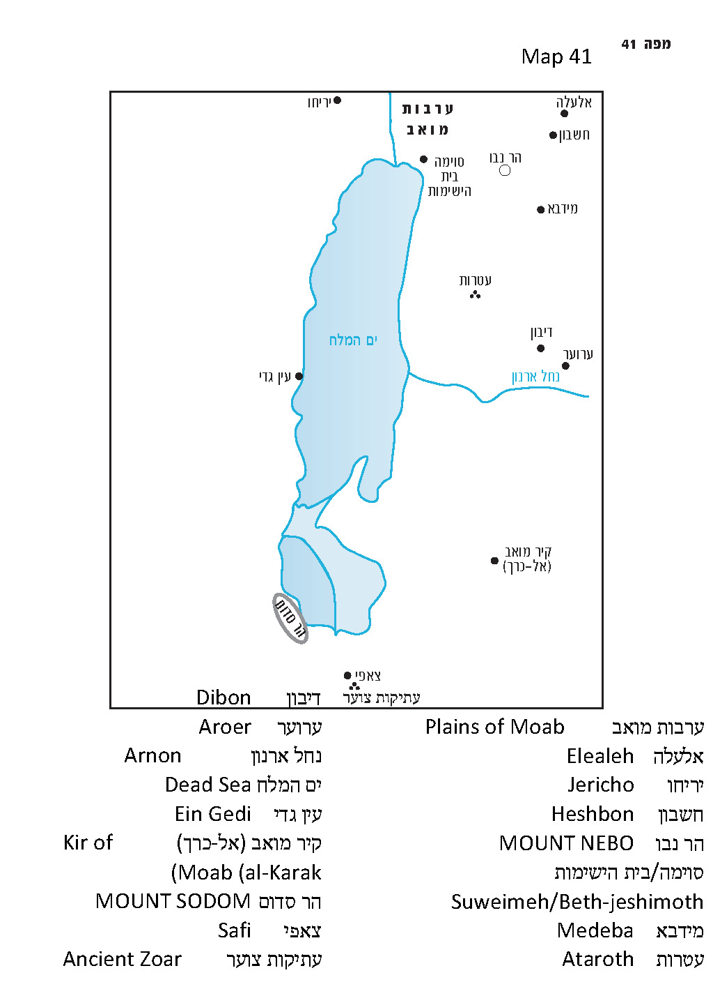

“Ammon and Moab Became Purified Through Sihon”

The primary question here is if the people of Israel were permitted to enter the land of Moab. In Parashat Chukat (chapter 21), we learned that the people of Israel requested permission from the king of Edom to pass through his territory. When he refused, they circumnavigated his land. In the case of Moab as well, they did not pass through the land, but only through “the wilderness bordering on Moab to the east” (21:11). In the book of Judges, Jephthah recounts the story from Numbers 21, adding the clarification: “They also sent a mission to the king of Moab, and he refused… they kept to the east of the land of Moab… and they never entered Moabite territory” (11:17-18). In his overview of the nation’s journey in Deuteronomy 2, Moses relates that God was the one who prohibited the people of Israel from entering Mount Seir, the land of Moab and the land of the Ammonites. The reason for this prohibition was that the land of Seir was given as an inheritance to the descendants of Esau and that the lands of Moab and the Ammonites were given as an inheritance to the descendants of Lot.

If so, Israel did not battle Moab, nor did they enter the land of Moab (though they did receive permission to pass through the semidesert at the eastern edge of this territory, as we explained in our discussion on Parashat Chukat). How, then, can we explain the fact that the people of Israel dwelled in the plains of Moab? The answer to this question, which the Torah deals with in great detail, is well known. The verse toward the end of Parashat Chukat reads: “Now Heshbon was the city of Sihon king of the Amorites, who had fought against a former king of Moab and taken all his land from him as far as the Arnon” (21:26); immediately thereafter comes the “Song of the Bards” accompanying this conquest: “For fire went forth from Heshbon, flame from Sihon’s city, consuming Ar of Moab, the lords of Bamoth by the Arnon. Woe to you, O Moab! You are abandoned, O people of Chemosh!” (21:28-29). In other words, at first the land of Moab included the entire territory north of the Arnon, until Heshbon. But Sihon set out from Heshbon and conquered half the land of Moab until the Arnon, leaving only the territory south of the Arnon to the Moabites. Following this conquest, the northern border of Moab became the Arnon River: “For the Arnon is the boundary of Moab, between Moab and the Amorites” (21:13); “since Moab ends at the Arnon” (Judges 11:18). Thus, the moment that Israel cross the eastern section of the Arnon River, they immediately entered “the wilderness that extends from the territory of the Amorites.” And when Sihon denied them permission to pass through his land peacefully, they went to war against him and took possession of his land, “from the Arnon to the Jabbok, as far as [the land] of the Ammonites” (21:23). In light of this, the plains of Moab where the people of Israel currently reside are actually “Moab” in name only – at the time the territory was captured by the people of Israel it was part of the kingdom of Sihon. In essence, Sihon’s conquest of this territory allowed Israel to conquer it in turn, as they were not prohibited from conquering Amorite territory as they were that of the Moabites and the Ammonites. Chazal summarized this phenomenon, pronouncing that “Ammon and Moab became purified through Sihon” (Gittin 38a).

Moab De Facto, Sihon De Jure

.Our conclusion at this stage of the discussion is that the region north of the Arnon was formerly a Moabite territory, then it was conquered by Sihon king of the Amorites and afterward the Israelites took it from him. In our parasha as well, there is one piece of information that fits into the picture we have illustrated thus far – the first meeting between Balak and Balaam: “He went out to meet him at Ir-moab, which is in the vicinity of Arnon, at the edge of the border.” Indeed, Arnon is the border of Moab and the city situated near the Arnon is located at the extreme end of this border.

However, the continuation of the parasha teaches us that things are not so simple. If the area north of the Arnon was captured from the Moabites years prior to this point, by the Amorites who then lost the territory to the Israelites, how can Balak and all his dignitaries stroll through the region in broad daylight, traveling from summit to summit overlooking the Israelite camp, more than twenty miles north of the edge of their kingdom, building seven altars at each point to sacrifice oxen and sheep? Even the expressions that Balak uses at the beginning of the parasha – “all that is about us”; “and it is settled next to me” – alludes to a much closer proximity between Moab and Israel. In other places in Numbers and Deuteronomy as well, it is apparent that the residence of the people of Israel is consistently referred to as “the plains of Moab.” There are even a few instances where the location is actually called “the land of Moab”: “On the other side of the Jordan, in the land of Moab, Moses undertook to expound this Teaching” (Deuteronomy 1:5); “These are the terms of the covenant which the Lord commanded Moses to conclude with the Israelites in the land of Moab” (28:69); “Mount Nebo, which is in the land of Moab” (32:49); “So Moses died there… in the land of Moab… He buried him in the valley in the land of Moab” (34:5-6). Can it truly be that all of these are no more than historical names – bearing no significance to the geographical reality at the time?

During later periods, we find that the entire area that Moses conquered north of the Arnon, including cities like Dibon, Medeba, Heshbon, Elealeh, Nebo and Baal-meon, were considered part of the land of Moab for all intents and purposes. This area contained Israelite cities belonging to the Reubenites and the Gadites, but it never completely shed its Moabite identity. At the beginning of the period of the Judges, Ehud son of Gera killed King Eglon of Moab. According to the description in Judges, Eglon resided somewhere in the plains of Moab opposite Jericho and Gilgal, while his soldiers occupied the City of Palms in the Jericho area. Several centuries later, the royal city of King Mesha of Moab was Dibon, north of the Arnon, where his famous stele was discovered, which enumerated numerous Moabite cities by name – especially in the northern part of Moab. Mesha captured the Israelite cities Ataroth and Nebo, decimated and enslaved their inhabitants and reinhabited the cities with his own people. In Isaiah and Jeremiah’s Moab prophecies (Isaiah 16 and Jeremiah 48), numerous Moabite cities are enumerated once more, again with an emphasis on the north. In the end, the general picture that arises from the Tanakh is that the land of Moab included the entire territory east of the Dead Sea, from its northern end to its southern end, extending until the wilderness in the east (parallel to the territory of Judah to its west) – for most of its history. Our parasha teaches us that even during and following the time of Moses’ conquests, when the people of Israel dwelled in the plains of Moab, the region north of the Arnon was still considered a de facto integral part of the land of Moab. From Balak’s perspective, the conquests of Sihon merely represented a temporary episode. The land was his land, and the people of Israel were no more than desert raiders who had seized control of a portion of his territory. It would seem that even some members of the nation of Israel were convinced by his version of the reality: Zimri son of Salu, chieftain of a Simeonite ancestral house, who saw fit to cohabit with the daughter of one of the five chieftains of the nomadic nation of Midian, certainly saw himself as one of the chieftains of the nomadic nation of Israel.

Despite this, the Torah regards the people of Israel as a nation that is conquering what is rightfully his. From the Torah’s perspective, Sihon’s conquest from Moab was a critical historical – one might even say halakhic –event. It determined that this strip of land between Heshbon and the Arnon River was no longer in Moabite hands; it now belonged to the Amorites, which meant that it became permissible for Israel to conquer it. Toward the end of the period of the Judges, the historical debate over what exactly occurred in this region during Moses’ time flared up again. The king of the Ammonites, who decided that he represented Moab as well, claimed: “They seized the land which is mine, from the Arnon to the Jabbok as far as the Jordan. Now, then, restore it peaceably!” (Judges 11:13). Jephthah, though he was not one of the better leaders of Israel, was able to respond courageously, in a manner befitting the solid concept of the nation of Israel: “Israel did not seize the land of Moab or the land of the Ammonites… Now, then, the Lord, the God of Israel, dispossessed the Amorites before his people Israel; and should you possess their land?” (11:15-23).

The moral of the story for us today is that from a national-historical perspective, it is the definition of historical events and situations that is important, and that should matter for the future. Even before we begin to discuss questions of physical control of the land, it is important to maintain a stable way of looking at past events, in order to see things clearly in the face of “alternative narratives” and give those past events their proper names.

For further study:

Yehudah Elitzur, “Yiftach Be-doro Ki-Shmuel Be-doro,” Israel and the Bible, Ramat-Gan 2000, 85-88 [Hebrew].

Yehudah Elitzur, “Massa Mo’av U-ketovat Meisha,” Israel and the Bible, Ramat-Gan 2000, 175-182 [Hebrew].

B. MacDonald, East of the Jordan, Boston 2000, 171-174.

Translated by Daniel Landman

See Map 41 below.
See our discussion on Parashat Devarim (forthcoming).
The Torah only mentions this “purification” in the case of Moab, but a similar process in the case of the Ammonites can be inferred from the verse in Joshua: “Half of the country of the Ammonites” (13:25).
According to my father, z”l, there is a connection between the lists of cities in the Moab prophecies and Mesha’s list.

