YESHIVAT HAR ETZION
ISRAEL KOSCHITZKY VIRTUAL BEIT MIDRASH (VBM)
*********************************************************

GEOGRAPHY IN THE PARASHA

PARASHAT PINCHAS

*********************************************************
Dedicated by the Wise and Etshalom families
in memory of Rabbi Aaron M. Wise z”l,
whose yahrzeit is 21 Tamuz. Yehi zikhro barukh.
*********************************************************

Zelophehad’s Daughters and Their Portion
By Prof. Yoel Elitzur

The Tribe of Manasseh is Counted for the First Time

Parashat Pinchas relates that in the fortieth year of the people of Israel’s sojourn in the wilderness, a census was implemented. The total population of the people of Israel comes out to 601,730, a number that is similar to the result obtained in the previous census, conducted in the second year following the Exodus: 603,550. During the time between the two censuses, the population was completely replaced:

Among these there was not one of those enrolled by Moses and Aaron the priest when they recorded the Israelites in the wilderness of Sinai. For the Lord had said of them, “They shall die in the wilderness.” Not one of them survived, save Caleb son of Jephunneh and Joshua son of Nun. (Numbers 26:65-66)

The obvious difference between the two censuses is that in the census of the fortieth year, each family is mentioned by name. In this sense, a parallel can be drawn between the census of Parashat Pinchas and the list in Parashat Vayigash of the seventy people who descended to Egypt (Genesis 46). While the list of families in Parashat Pinchas and the list of families in Parashat Vayigash are largely parallel, there is one glaring difference: The inclusion in the later census of the tribes of Ephraim and Manasseh. Ephraim and Manasseh were born in Egypt, and their families are not listed among the seventy immigrants to Egypt listed in Genesis. In Parashat Pinchas, however, they are enumerated in detail.

Zelophehad’s Daughters in the Torah and in the Book of Joshua

I would like to focus here on the families of the tribe of Manasseh that are particularly interesting. The Torah lists six sons born to Gilead, Manasseh’s grandson, forming six families:

These were the descendants of Gilead: [Of] Iezer, the clan of the Iezerites; of Helek, the clan of the Helekites; [of] Asriel, the clan of the Asrielites; [of] Shechem, the clan of the Shechemites; [of] Shemida, the clan of the Shemidaites; [of] Hepher, the clan of the Hepherites. (26:31-33)

The account continues, focusing on one particular individual: “Now Zelophehad son of Hepher had no sons, only daughters. The names of Zelophehad’s daughters were Mahlah, Noah, Hoglah, Milcah and Tirzah” (26:34). The five daughters of Zelophehad are central characters from our parasha and onward. Immediately following the account of the census, we read that the five daughters stand before Moses, the tribal chieftains and the entire congregation, presenting their claim: “Let not our father’s name be lost to his family just because he had no son! Give us a holding among our father’s kinsmen!” (27:4). Their argument is accepted, and God commands Moses: “The plea of Zelophehad’s daughters is just: You should give them a hereditary holding among their father’s kinsmen; transfer their father’s share to them” (27:7).

Later on, in Numbers 36, the “Zelophehad’s daughters incident” returns to the headlines. The leaders of the Gileadite families listed above voice their concern that Zelophehad’s daughters will marry men from a different tribe, causing each daughter’s territory to be transferred to the tribe of her husband, and thereby diminishing the overall territory belonging to the tribe of Manasseh. The ruling was handed down, instructing the daughters to marry their cousins, thus insuring that their portions remain in the hands of Manasseh. The book of Numbers closes with the acknowledgment that the daughters did just this: “Mahlah, Tirzah, Hoglah, Milcah and Noah, Zelophehad’s daughters, were married to sons of their uncles” (36:11).

An additional detailing of these events, with special emphasis on the practical apportionment of territory to the families of Manasseh and on the integration of Zelophehad’s daughters into the territorial map, can be found in Joshua 17. The list of families here should be familiar to us from our parasha:

And this is the portion that fell by lot to the tribe of Manasseh – for he was Joseph’s firstborn… And now assignments were made to the remaining Manassites, by their clans: the descendants of Abiezer, Helek, Asriel, Shechem, Hepher and Shemida. Those were the male descendants of Manasseh son of Joseph, by their clans. Now Zelophehad son of Hepher son of Gilead son of Machir son of Manasseh had no sons, but only daughters. The names of his daughters were Mahlah, Noah, Hoglah, Milcah and Tirzah. They appeared before the priest Eleazer, Joshua son of Nun and the chieftains, saying: “The Lord commanded Moses to grant us a portion among our male kinsmen.” So, in accordance with the Lord’s instructions, they were granted a portion among their father’s kinsmen. Ten districts fell to Manasseh… as Manasseh’s daughters inherited a portion together with his sons, while the land of Gilead was assigned to the rest of Manasseh’s descendants. (Joshua 17:1-6)

What Are the “Ten Districts” of Manasseh?

According to a simple reading of the account in Joshua, the calculation is as follows: Gilead son of Machir son of Manasseh had six sons. One of these sons – Hepher – had one son – Zelophehad – who, in turn, had five daughters. This adds up to ten portions: one portion for each of Zelophehad’s five daughters and one portion for each of the five remaining Gileadite families (Aviezer, Helek, Asriel, Shechem and Shemida).

While this interpretation may reflect the most straightforward reading of the text, from a logical perspective this is very difficult to understand. As R. Papa points out in the Talmud: “Whom does [the verse ‘ten districts fell to Manasseh’] enumerate? If [all] children are enumerated, there were [surely] more [than ten]; if fathers’ houses are enumerated, [these] were [only] six!” (Bava Batra 118b). Seemingly, the five portions designated for Zelophehad’s daughters are merely five subdivisions of one of the six portions allotted to Gilead’s six sons. Just as the portion allotted to Hepher was divided between his five granddaughters, surely Hepher’s five brothers produced numerous male progeny between whom to divide their respective portions. But the verse seems to bestow equal standing in this regard upon Zelophehad’s daughters and Aviezer and his brothers. But how can this be? Let us recall what Zelophehad’s daughters requested in the first place: to be regarded as the equals of their male peers. How can it be, then, that they are suddenly given the same hereditary status as their five great-uncles?

For this reason, the Sages explained that the “ten districts” of Manasseh do not include the personal portions of Mahlah, Noah, Hoglah, Milcah and Tirzah. Rather, the sum of ten was reached by factoring in additional portions – not mentioned in the Scripture – that the five daughters inherited as a group. First, Zelophehad was among those who participated personally in the Exodus from Egypt, each of whom received his own portion in the initial distribution of the land. Furthermore, the Sages continue, Zelophehad managed to amass additional portions by inheriting those of an unnamed brother (or two brothers, as some claim) who died childless in the wilderness. Finally, Zelophehad merited an extra portion by virtue of being the firstborn in his family. While the calculations are somewhat murky, the Sages conclude that Zelophehad himself held five portions of land, which his five daughters inherited collectively.

Malbim, in his characteristic pursuit of the simplest understanding of the text, suggests that the ten districts of Manasseh are actually ten distinct geographic portions, entirely unconnected to the intricacies of the Manasseh family tree.

Yet both of these interpretations seem strained in light of the actual text in Joshua. The subject of that passage is the list of the families of Manasseh and of Zelophehad’s daughters. The verse states, “Ten districts fell to Manasseh,” and immediately clarifies: “as Manasseh’s daughters inherited a portion together with his sons,” implying that these ten portions were tied to the families of Manasseh and to Zelophehad’s daughters.

Do we truly have no alternative but to favor the logical explanation here, despite the contextual indications to the contrary?

An Archaeological Finding that Supports the Simple Reading

An important and famous archaeological finding seems to support the simple reading of the text unambiguously. This is the Samaria Ostraca, dozens of inscriptions written in ink on sherds that were found in 1910 in the treasury of the palace of the kings of Israel in ancient Samaria. The Samaria Ostraca are receipts, tax records or shipment records, which mention the year, names of officials, names of places and occasionally names of families as well. Some of these sherds also list the name of the product being transported, such as nbl yn (“a jar of wine”) or nbl šmn rḥṣ (“a jar of fine oil” or “a jar of anointment oil”).

Here are a few examples:

Ostracon 6: bšt. (in the year) htš‘t. (the ninth) mqṣh. (from the place qṣh) lgdyw. (to the official gdyw, i.e., Gaddiyau) nbl. yn. yšn.

Ostracon 28: bšt. רΛ (digits, perhaps 15) m’b‘zr. (from the family of Abiezer) l’š’. ’ḥmlk. b‘l’. (to Asha, Ahimelekh, Ba’ala, apparently names of officials or the like) m’lmtn. (from the place Elmatan)

Ostracon 42: [b]št. רΛ mšr’[l] (from šr’l, apparently a shortened version of the family name Asriel) lyd‘yw. mrnyw. gdy[w] (from the officials rnyw and gdyw) m‘šrt (from the place ‘Aseret)

Ostracon 50: bšt. רΛ lgmr. mn‘h. (from the family Noah) ‘bdyw. (Obadiau) l’byw. (to Abiau; apparently names of officials)

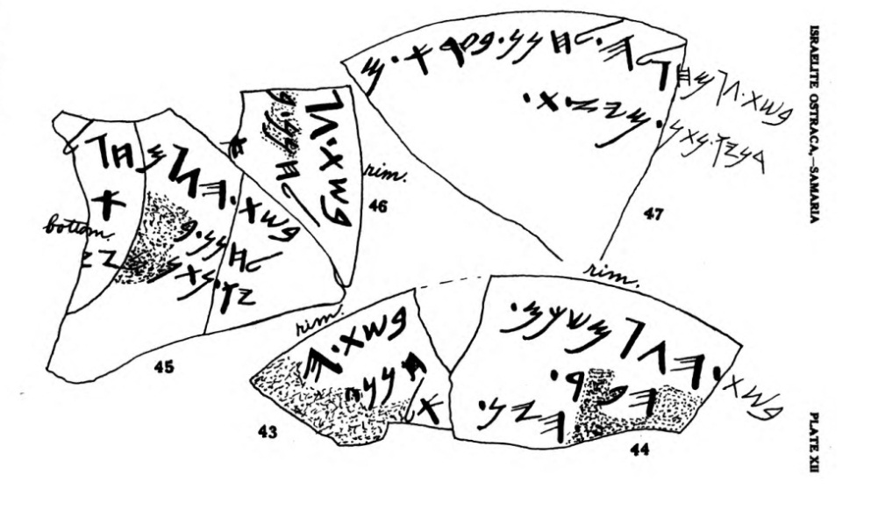
Samaria Ostraca nos. 43-47 (G. A. Reisner, Israelite Ostraca from Samaria [no date]) 43: In the year… [to] Hanan… El... 44: [In the year] רΛ from Shekhem… hp.r… hyn. 45: In the year רΛ from Holg[ah] to Hanan (son of) b…’…yw (son of) Nathan from Yaz[ith]. 46: In the year רΛ to Hanan (son of) b…’. 47: …from Hoglah to Hanan (son of) Ba’ara m… from Yazith.

Scholars have disputed almost every detail that can be disputed. During which king’s reign were the ostraca written? How to decipher the digits of the year numbers? What is the commercial or administrative function of each ostracon? We will leave all of these questions to the historians and linguists. The details that interest us most for this discussion are the family/territory names mentioned in the ostraca. Seven such names appear in the ostraca: Shemida, Abiezer, Helek, [A]sriel, Shechem, Hoglah and Noah.

This finding proves that the simple reading in Joshua 17 is the correct one; the districts were indeed given permanent names for the major households of Manasseh, as well as for Zelophehad’s five daughters! We see in the ostraca that there are districts called Hoglah and Noah just as there are districts called Abiezer and Shemida.

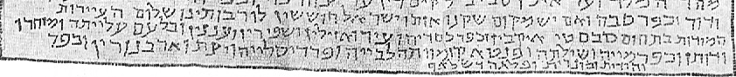
The last passage in the Rehov Inscription: The permitted towns in the district of Sebaste Iqbin and Kefar Kasdaya and Zir and Azilin and Shappirin and ‘Ananin and Higher Bil’am and Mazharu and Dothan and Kefar Mayya and Shilta and Pentakumwata, Labaya and Pardislaya and Yazith and Arbanurin and Monarith and half of Shalaf (Courtesy of the Israel Antiquities Authority).

The Territory of Hoglah

There is one clue in the Samaria Ostraca that can even point to the location of the territory of Hoglah. The two ostraca that mention Hoglah also mention the city of Yazith (Ostracon 45: bšt h רΛ mḥgl[h] lḥnn. b‘r’ ywntn. myṣ[t]. Ostracon 47: …mḥ]glh. lḥnn b‘r’ m[…]. myṣt). Yazith is mentioned in three other ostraca, along with the official aḥn‘m (or adn‘m). This official is mentioned in an ostracon labeled nbl. yn. yšn (“a jug of aged wine”) that arrived from the city of Geba. This leads us to conclude that the two cities of Yazith and Geba were located in the same district – the district of Hoglah. The two cities appear in much later Hebrew sources as well. Geba is mentioned in the Mishna, the Tosefta and the Yerushalmi alongside a place called Bedan (in other editions: Badan). Geba and Bedan/Badan became famous for their high-quality agricultural produce: the pomegranates of Bedan and the vegetables of Geba, which the Sages declared must always be tithed, no matter where they are acquired. Yazith is mentioned in the mosaic inscription from the ancient Rehov synagogue in the Beit She’an Valley, the longest ancient Hebrew inscription ever found in the land of Israel. This inscription, a halakhic-geographic inscription dealing with the land-bound commandments and the commandments that relate to the sanctity of the land, lists Yazith among the “permitted towns in the territory of Sebaste.” In other words, these were towns in the district of Sebaste (Samaria) that were inhabited by non-Jews during the Tannaitic period, and thus they were exempt from the laws of tithes and the Sabbatical year.

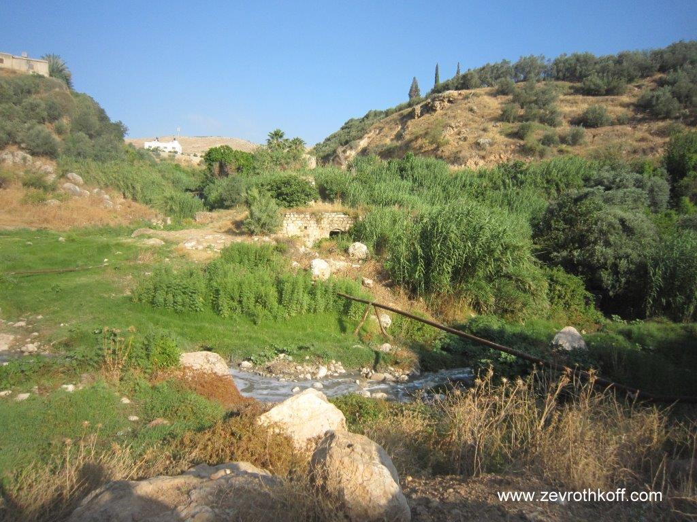
Bedan, whose pomegranates must always be tithed (Courtesy of Dr. Zev Rothkoff)

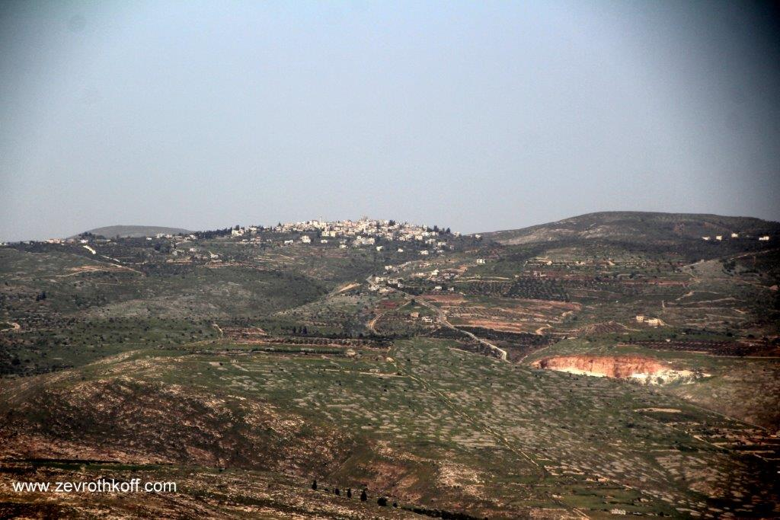
Yazith – modern-day Yasid (Courtesy of Dr. Zev Rothkoff)

Yazith is identified with the village of Yaṣid in northern Samaria, north of Mount Ebal. Four miles southeast of Yasid are the Badan springs, and four miles northwest of Yasid is the village of Jaba, i.e., Geba of the house of the Cutheans. The two villages west of Jaba – Fandaqumiya and Silat ad-Dhahr – are seemingly mentioned in the same list in the Rehov Inscription, as Shilta and Pentakumwata. At the top of the hill above Fandaqumiya and Silat ad-Dhahr, the ruins of the settlement of Homesh – destroyed in 2005 by the Sharon administration – can be found. The name Homesh is the Hebrew version of the Greek name Pentakomia (“[center of] five villages”), which evolved into “Pentakumwata” (featuring an Aramaic ending) and Fandaqumiya (Arabic version). Atop a small hill at the foot of Fandaqumiya and Silat ad-Dhahr stand the remnants of the settlement of Sa-Nur. A British police station and a synagogue were left intact to serve as memorials. Apparently, all of these places – both the Arab villages that took the place of the ancient Israelite cities and the Israeli settlements that the Israeli government decided to depopulate and destroy – are located within the district of Hoglah, the daughter of Zelophehad.

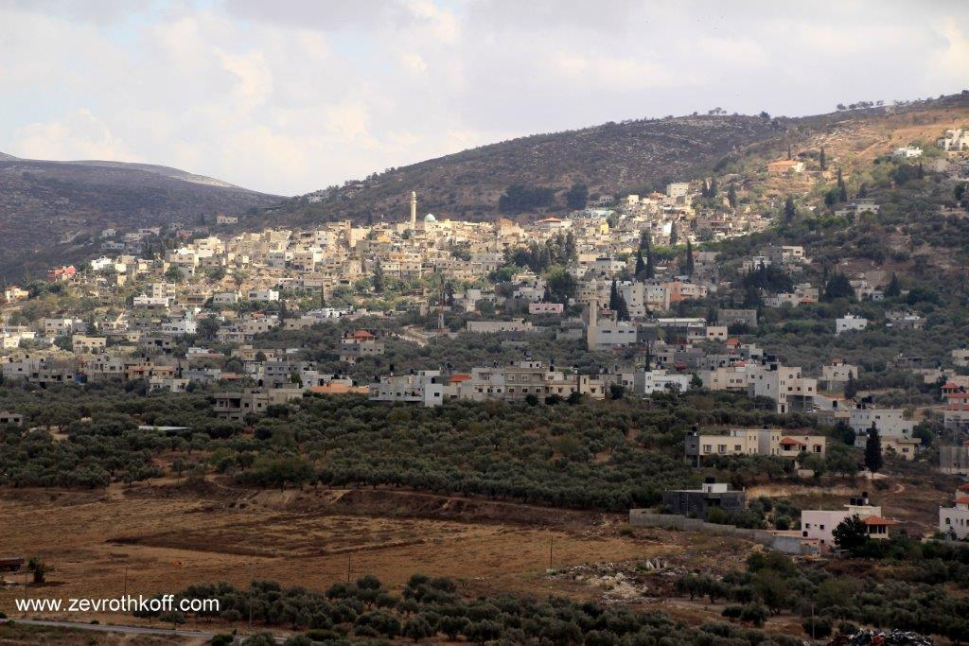
Shilta – modern-day Silat ad-Dhahr (Courtesy of Dr. Zev Rothkoff)

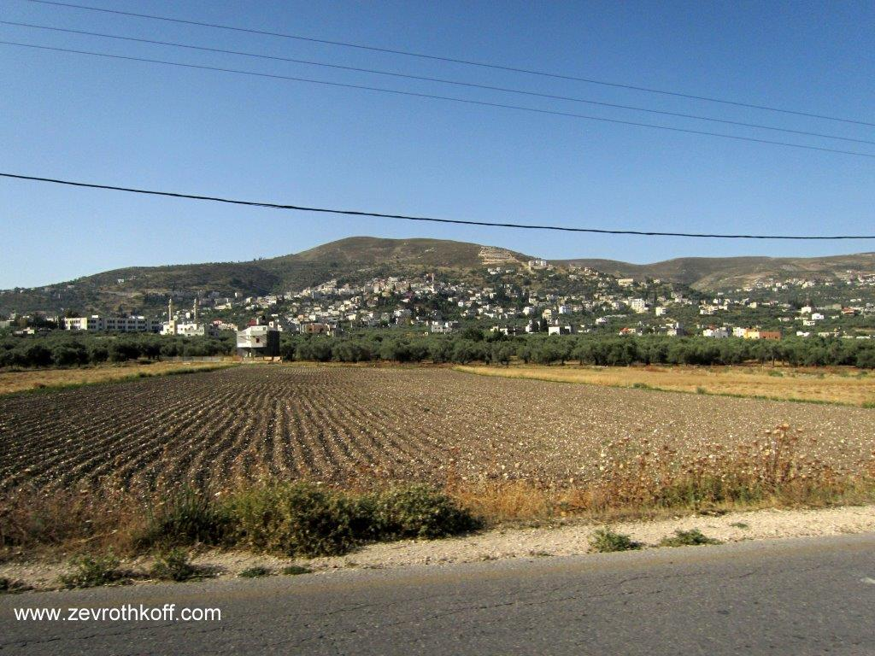
Pentakumwata – modern-day Fandaqumiya (Courtesy of Dr. Zev Rothkoff)

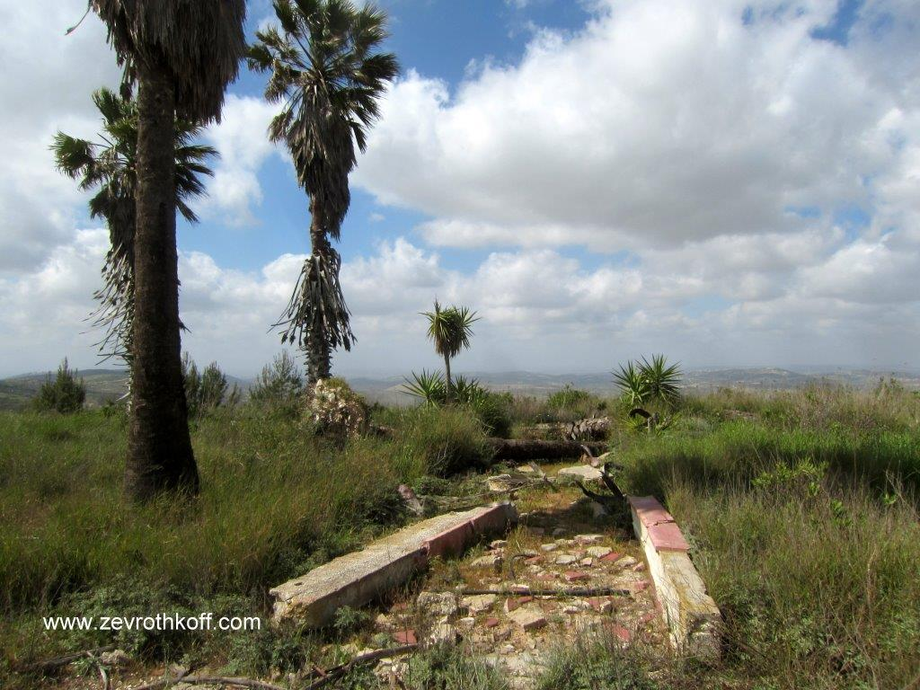
Ruins of the settlement of Homesh (Courtesy of Dr. Zev Rothkoff)

Returning to Our Original Question

How can it be that the granddaughters of the tribal elders were given equal status to that of their forebears? The exact turn of events can be difficult for us – thousands of years removed from that era – to grasp. The book of Joshua can teach us that the procedure for territorial inheritance was not a simple thing; it was not merely the administrative matter of casting lots. Much effort and practical ability was needed, as well as courage and valor in order to dispossess the Canaanites, deforest the land and rejuvenate desolate areas. We read in Joshua 18 that Joshua rebuked the tribes who dawdled in inheriting the land. The Manassites were among the strongest and swiftest tribes in inheriting the land – on both sides of the Jordan – so Joshua also instructed them to dispossess the Canaanites who dwelled in the valley, an area that had originally been designated for the less enthusiastic tribes (Joshua 17:11-13, 18). Perhaps we can speculate that there was something special about the personalities of the five daughters that helped launch them upward in hereditary status. The text of the Tanakh gives the impression that these were unique women, unusually eloquent and assertive. It seems that these women were tribal leaders in their own right and wielded such a great degree of influence that the districts they inherited were named for them. That is to say, this was not simply a matter of equal rights. Zelophehad’s daughters’ request – “Give us a holding!” – can perhaps be compared to the Judites’ request, voiced by their chieftain Caleb son of Jephunneh: “So assign to me this hill country… if only the Lord is with me, I will dispossess them, as the Lord promised” (Joshua 14:12). Like the Judites, Zelophehad’s daughters were volunteering for a mission beyond that of requesting equal rights. In the end, the reward that they received was far greater than what they requested, which was to be considered equal to their Manassite cousins. It is no coincidence that the cousins who eventually married Zelophehad’s daughters remain anonymous. It may be surmised that these cousins were lesser than their wives in terms of both power and communal influence. As a result, the districts that they inherited were named for the daughters rather than the men, teaching us that feminism predated the modern era.

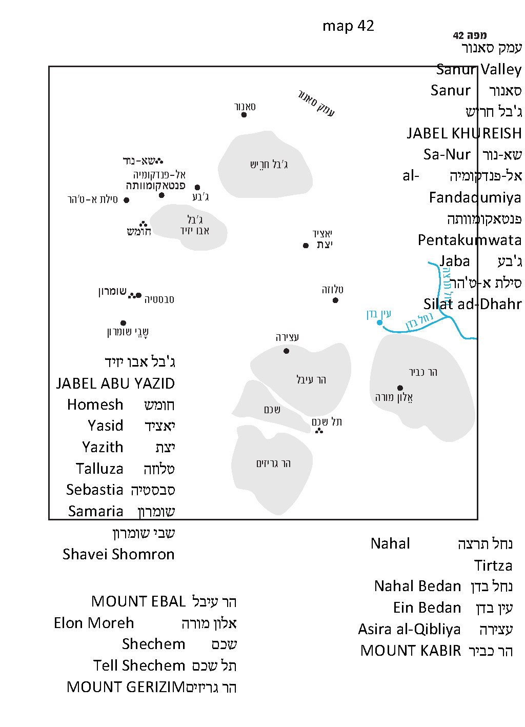

For further study:

Y. Aharoni, The Land of the Bible: A Historical Geography, translated and edited by A. F. Rainey, Philadelphia 1979, 356-368.

S. Aḥituv, Echoes from the Past: Hebrew and Cognate Inscriptions from the Biblical Period, translated and edited by A. F. Rainey, Jerusalem 2008.

A. Demsky, “The Permitted Villages of Sebaste in the Reḥov Mosaic,” IEJ 29 (1979), 182-193.

Z. M. Ehrlich, “The Inheritance of Hoglah, Daughter of Zelophehad,” Beit Mikra 28:3 (1983), 232-235 [Hebrew].

Yoel Elitzur, Ancient Place Names in the Holy Land, Jerusalem-Winona Lake 2004, 299.

I. Press, “Bedan,” A Topographical-Historical Encyclopaedia of Palestine, 1, Jerusalem 1951, 63; “Geva³,” 139 [Hebrew].

Y. Sussman, “A Halakhic Inscription from the Beth-Shean Valley,” Tarbiz 43 (1973-1974), 88-158 [Hebrew].

Translated by Daniel Landman

The exact breakdown is quite complex, and the details are debated in the Mishna, Tosefta and both the Talmud Bavli and Talmud Yerushalmi. In the end, even Chazal’s combination does not provide perfect uniformity, since Zelophehad’s original inheritance and his “firstborn portion” are two subdivided portions within Hepher’s primary portion.
Known here as “Geba of the house of the Cutheans.”
This rule was enacted because the Cutheans would not tithe the produce they would sell to others.
The tav-dalet substitution at the end of the names is similar to that of Tzefat-Ṣafad.
In recent years, Homesh has been home to a permanent semi-underground Jewish presence.
This was the only synagogue in all the settlements that were destroyed in 2005 that was not razed and burned. Instead, it was completely covered in earth, and the site now appears like a small mound.
The Talmud states: “The daughters of Zelophehad were wise women; they were exegetes; they were virtuous” (Bava Batra 119b).
See Map 42.

