YESHIVAT HAR ETZION
ISRAEL KOSCHITZKY VIRTUAL BEIT MIDRASH (VBM)
*********************************************************

GEOGRAPHY IN THE PARASHA

PARASHAT MATOT-MASEI

The Conquests of Machir, Jair and Nobah
By Prof. Yoel Elitzur

The Disappearance and Sudden Reappearance of the Manassites

The central part of Parashat Matot is dedicated to the long and difficult negotiations between Moses and the Gadites and Reubenites over their colonization in the recently captured Transjordan (chapter 32). The Torah repeatedly emphasizes the identity of the petitioners:

The Reubenites and the Gadites owned cattle in very great numbers… the Gadites and the Reubenites came to Moses and Eleazar the priest… Moses replied to the Gadites and the Reubenites… Then they stepped up to him and said… Moses said to them… The Gadites and the Reubenites answered Moses… Then Moses gave instructions concerning them to Eleazar the priest, Joshua son of Nun and the family heads of the Israelite tribes. Moses said to them, “If every shock-fighter among the Gadites and the Reubenites crosses the Jordan with you to do battle, at the instance of the Lord…” The Gadites and the Reubenites said in reply, “Whatever the Lord has spoken concerning your servants, that we will do…” (Numbers 32:1-31)

Once each side was satisfied with the terms of the agreement, the Torah states:

So Moses assigned to them – to the Gadites, the Reubenites and the half-tribe of Manasseh son of Joseph – the kingdom of Sihon king of the Amorites and the kingdom of King Og of Bashan, the land with its various cities and the territories of the surrounding towns. (32:33)

The Torah refers to the Gadites and the Reubenites by name six times. When the back-and-forth deliberations finally conclude and the time comes for the territorial allotment, suddenly the half-tribe of Manasseh enters the scene!

At the end of the chapter, in the description of the conquests of the two and a half tribes, the Manassites figure prominently in the narrative:

The Gadites rebuilt… The Reubenites rebuilt… The descendants of Machir son of Manasseh went to Gilead and captured it… so Moses gave Gilead to Machir son of Manasseh… Jair son of Manasseh went… And Nobah went and captured Kenath and its dependencies, renaming it Nobah after himself. (32:34-42)

Why were the Manassites absent from the entire discussion and why were they suddenly and surprisingly included in the practical territorial allotment? These questions become much sharper when viewed in the context of the serious accusations that Moses levied toward the Reubenites and the Gadites:

Are your brothers to go to war while you stay here? Why will you turn the minds of the Israelites from crossing into the land that the Lord has given them? That is what your fathers did when I sent them from Kadesh-barnea to survey the land… they turned the minds of the Israelites from invading the land that the Lord had given them… And now you, a breed of sinful men, have replaced your fathers, to add still further to the Lord’s wrath against Israel… you will bring calamity upon all this people. (32:6-15)

This whole furious screed does not include the Manassites. Why?

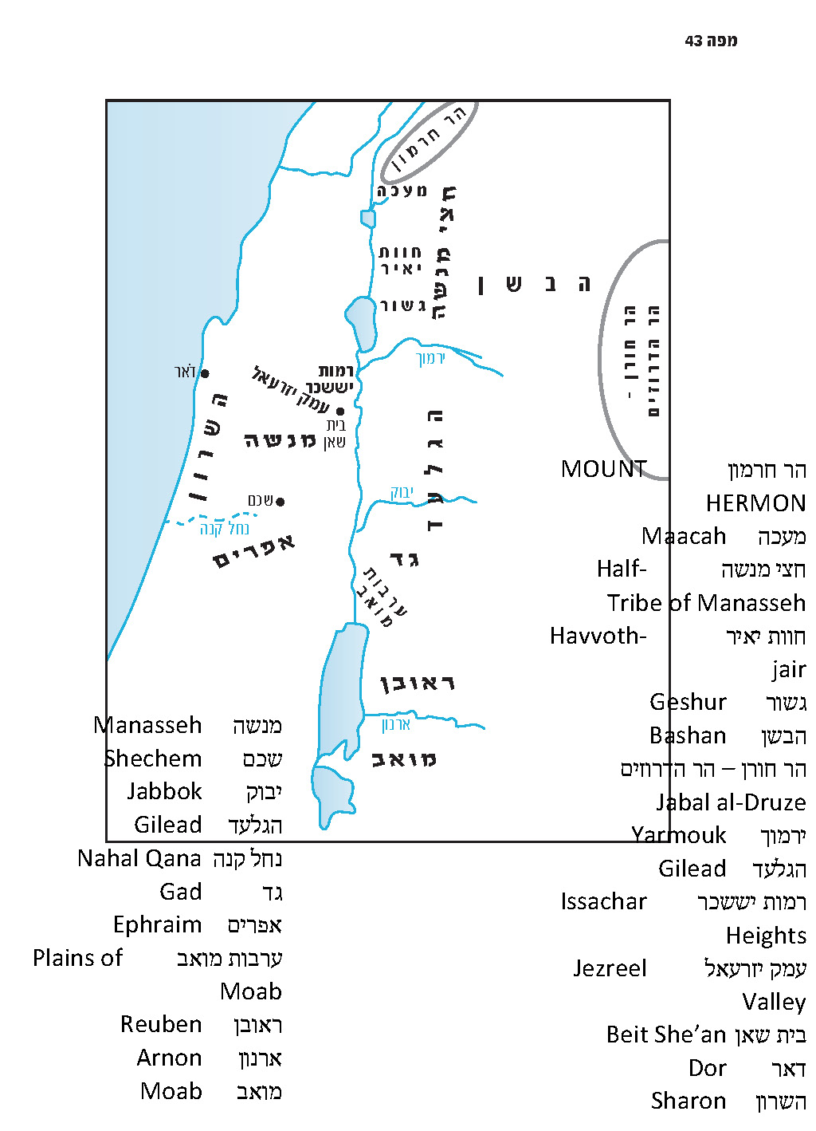

The Samaritan “Solution”

The Samaritan version of the Torah contains a miracle solution to our problem. The version reads:

The Gadites, the Reubenites and the half-tribe of Manasseh owned cattle in very great numbers… the Gadites, the Reubenites and the half-tribe of Manasseh came to Moses and Eleazar the priest… Moses replied to the Reubenites, the Gadites and the half-tribe of Manasseh… Then they stepped up to him and said… Moses said to them… The Reubenites, the Gadites and the half-tribe of Manasseh answered Moses… Then Moses gave instructions concerning them to Eleazar the priest, Joshua son of Nun and the family heads of the Israelite tribes. Moses said to them, “If every shock-fighter among the Reubenites, the Gadites and the half-tribe of Manasseh crosses the Jordan with you to do battle, at the instance of the Lord…” The Reubenites, the Gadites and the half-tribe of Manasseh said in reply, “Whatever the Lord has spoken concerning your servants, that we will do…” So Moses assigned to them – to the Reubenites, the Gadites and the half-tribe of Manasseh son of Joseph – the kingdom of Sihon king of the Amorites and the kingdom of King Og of Bashan, the land with its various cities and the territories of the surrounding towns.

The Samaritans have a well-known predilection for solving difficulties in the Torah by means of textual emendations. There are many cases throughout the Samaritan Torah that can serve as a didactic tool: Almost every time we find a difficulty in the Torah or a contradiction between parallel verses, the Samaritan Torah records what “should” be written. In each of these cases, a teacher would be well-served to ask his students: Why indeed wasn’t the original text of the Torah written like the Samaritan version?

“They Marched On and Went Up the Road to Bashan”

In the course of the people of Israel’s passage through the Transjordan, which the Torah describes in detail in Numbers 21 and again in Moses’ speech at the beginning of Deuteronomy, we read that after the people of Israel avoided entering the lands of Edom and Moab, they approached Sihon and requested permission to enter his land. When their request was denied, they attacked him and conquered his land. Then the Torah makes the surprising statement: “They marched on and went up the road to Bashan, and King Og of Bashan, with all his people, came out to Edrei to engage them in battle” (21:33). Why did they go to Bashan? The path to the Jordan and the land of Canaan had become clear for passage with their conquest of the kingdom of Sihon, so what is the explanation for their deviation northward to Bashan?

It seems, then, that the land of Bashan, the territory of the half-tribe of Manasseh, is part of the land that had already been designated for conquest. As Chazal put it: “The Manassites did not take [the land] of their own accord” (Yerushalmi Bikkurim 1:8 [64b]). The Reubenites and the Gadites requested to remain in territory that had not been designated for allotment to the tribes, and because of this Moses compared them to the spies, who wanted to remain in the wilderness of Paran and not enter the land. In contrast, the Manassites receive a territory in the northern part of the Transjordan that was designated for them in the first place. The question is merely how and when this connection between the Manassites and Gilead and Bashan was established.

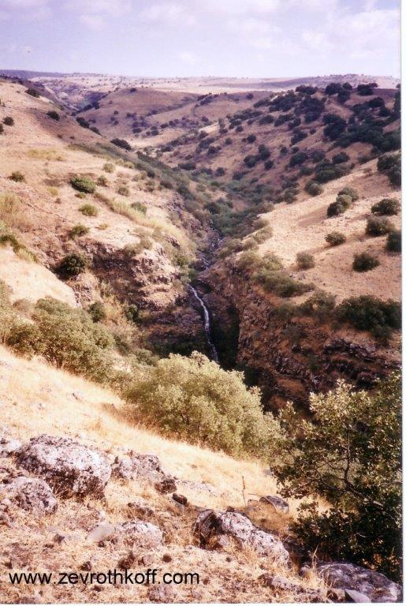
Yehudiya in the Bashan – the land of the half-tribe of Manasseh (Courtesy of Dr. Zev Rothkoff)

Territorial Apportionment in the Patriarchal Age

In our discussion on Parashat Va’era, I cited my father, z”l, who demonstrated that many of Jacob’s grandsons who were born in Egypt were named for places in the land of Israel. This phenomenon was particularly common among the Manassites, who used names like Gilead, Hepher, Shechem and Tirzah – all of which refer to places in Manassite territory on both sides of the Jordan – while they were still in Egypt. My father, z”l, explained that Jacob’s children, who were men of action, related seriously and practically to the national destiny that they received from their ancestors: “To your offspring I assign this land.” With this in mind, they began apportioning the regions of the land between themselves before their emigration to Egypt. Of course, this kind of apportionment was necessarily general, as, in the end, the size of each tribe and its abilities were the deciding factors in the final apportionment. The brothers also wandered through the land of Israel setting up residence in places that were designated for them. (For example, Judah set up residence in Timnah, Adullam and Chezib in the Judean foothills.) The emigration to Egypt disrupted this natural process, but even in Egypt Jacob’s sons continued to pine for their territories in the Promised Land and thus gave their children names that kept the fire burning. As a result, when the people of Israel finally returned to the land in the time of Moses and Joshua, they were able to relate to and connect with the places whose memory was preserved for all those years.

According to my father, the geographical allusions to tribal territories in the verse, “He went in pursuit as far as Dan” (Genesis 14:14), and in the blessings of Jacob and Moses to the tribes, referred to that first, theoretical territorial map. Not all of the territorial boundaries established in that map became reality later on. The factors that led to changes in the map were the transplantation of the Reubenites and the Gadites to the Transjordan against the original plan, Joshua’s inability to dispossess the far north of the land, the differences in ability and motivation between the various tribes and perhaps other reasons as well – as they say: plans change. Bible critics generally take the opposite approach in their explanation, claiming that the later reality influenced the narrative of the earlier generations after the fact. However, those who explain in this manner become tripped up by the details of the earlier texts that never became reality in the future. For instance, in the end Zebulun never dwelled “by the seashore… until Sidon” – this territory was inherited by the tribe of Asher. Similarly, the Reubenites never played a prominent role in the leadership of the nation of Israel.

Returning to the matter at hand, we learned that the Manassites had an early connection to Gilead and Bashan on one side of the Jordan and to northern Samaria on the other side, a connection that had been recognized by the sons of Jacob themselves. Thus, when the road leading up to Gilead and Bashan became clear, the entire nation joined in going up and engaging in battle with King Og of Bashan, and the northern part of the Transjordan was rightfully given to the Manassites.

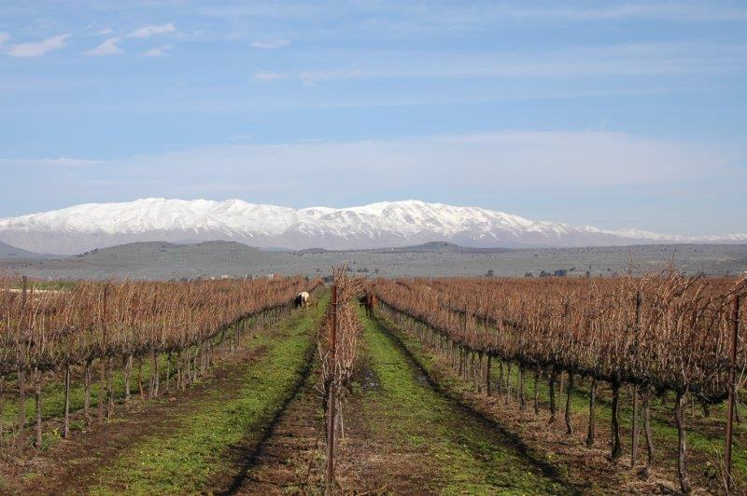
View in the Bashan and Hermon – the Land of the Half-Tribe of Manasseh
(Courtesy of Rina Nagila for non-commercial use only)

The Novel Solution of “The Student of Rabbi Saadia Gaon”

There are two questions that arise at this point. First, considering that Manasseh was born in Egypt, how and when did he develop connections to his territory? Second – a larger question about the apportionment map in general – if Manasseh, as one of Joseph’s two children, was only a half-tribe in the first place, why was his territory so enormous? Indeed, Manasseh’s territory is the largest of the tribes of Israel. In the Transjordan, Manasseh inherited the entire land of King Og of Bashan, from half of Gilead in the south up to and including Mount Hermon in the north, and from the Sea of Galilee and the northern Jordan in the west until Jabal al-Druze in the east. In the Cisjordan, Manasseh’s territory includes northern Samaria from Shechem and Nahal Qana in the south until the Jezreel Valley in the north, including most of the Sharon plain in the west and the Jordan Rift Valley in the east (as well as additional territory in the valleys and in the northern Sharon; see Joshua 17:11). How did such a thing come to be?

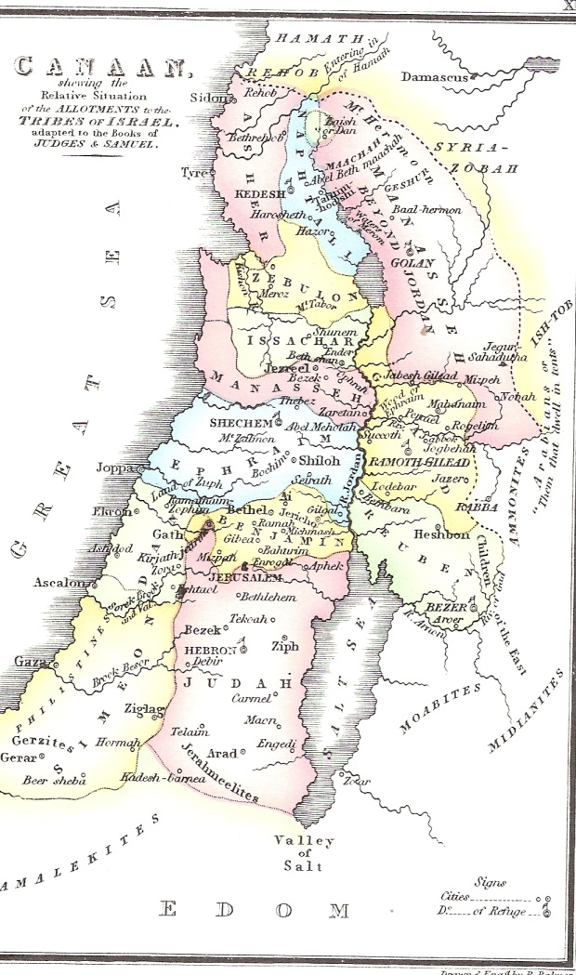
“The Allotments of the Tribes of Israel” (from R. Palmer, The Bible Atlas, London 1831, plate XIX). The general framework fits the approach of contemporary scholarship. Note the two portions allotted to Manasseh.

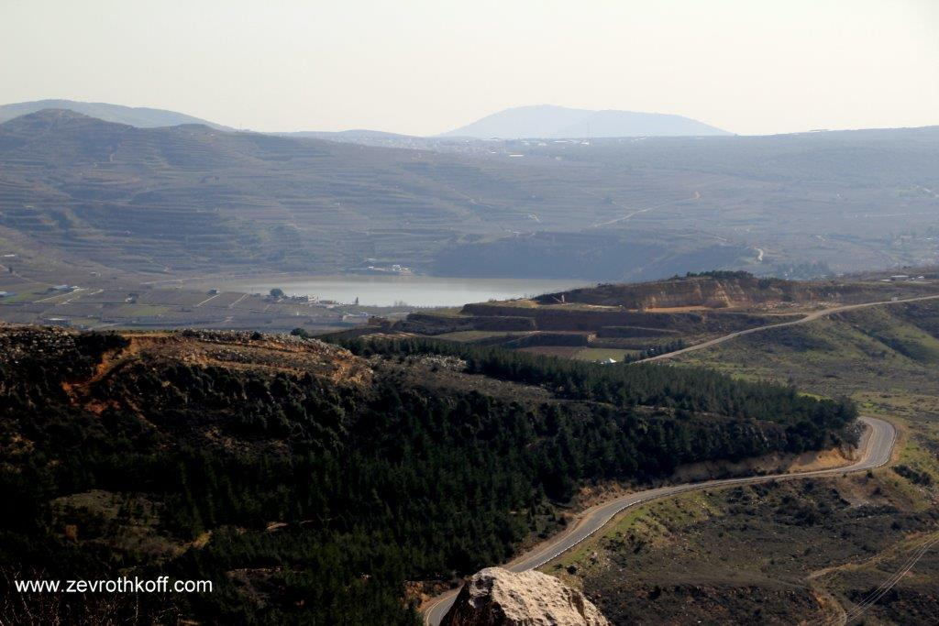
View of Mount Hermon – the land of the half-tribe of Manasseh (Courtesy of Dr. Zev Rothkoff)

The answer to these questions was supplied by an early and original commentator on the book of Chronicles, known as “the student of Rabbi Saadia Gaon.” The genealogical lists in Chronicles (I Chronicles 2:21) mention the conquests of Jair son of Manasseh (who was related to Manasseh through his paternal grandmother and to Judah through his paternal grandfather) in Gilead and Bashan in connection with the early generations of the tribe of Judah, without mentioning at all the Egyptian enslavement, the Exodus or the conquests of Joshua. “The student of Rabbi Saadia Gaon,” in his commentary there, maintains that Machir and his sons took possession of territory in the land of Israel “during the rulership of Joseph, who was king of the land.” After Joseph died, the land changed hands:

The gentiles attacked them, took [the territories] from their hands and settled in them until [Israel] came to the land of Israel [during the time of Moses]. Because of this, the descendants of Machir desired to settle the land of Gilead, so Moses gave them land from the holdings of their ancestor.

The presumption of “the student of Rabbi Saadia Gaon” that there were Egyptian provinces in the land of Israel on both sides of the Jordan was apparently based on various verses in Genesis (e.g., “So all the world came to Joseph in Egypt to procure rations” [41:57]; “And the money gave out in the land of Egypt and in the land of Canaan” [47:15]; “Chariots, too, and horsemen went up with him… they came to Goren Ha-Atad” [50:9-10]). Today this approach might be supported by the Egyptian sources and by the Amarna Letters.

“The student of Rabbi Saadia Gaon” points out another significant verse in this context: “Since Machir, the first-born of Manasseh, was a valiant warrior, Gilead and Bashan were assigned to him” (Joshua 17:1). Chazal interpreted this verse to mean that Machir lived to be almost two hundred fifty years old. He was born during Jacob’s lifetime and died after Moses’ death, and at the age of about two hundred thirty-five he fought in battles and conquered territory (Seder Olam 9 and parallels). It is clear that this is a homiletic explanation, but what is the simple truth of the matter? From a linguistic perspective it is difficult to interpret this verse to mean that the family of Machir consisted of valiant warriors. The phrase “a valiant warrior” is rendered in the singular and not in the plural. According to “the student of Rabbi Saadia Gaon,” however, this verse is not referring to the time of Joshua but to the time of Joseph. Machir – the man, Joseph’s grandson, whose children were “born upon Joseph’s knees” (Genesis 50:23) – was a valiant warrior and Gilead and Bashan were assigned to him. Since Machir and his sons held possession of the territories of Gilead and Bashan years earlier, their descendants were given these territories during the time of Moses and Joshua.

Having established this interpretation of the verse, “the student of Rabbi Saadia Gaon” suggests an innovative explanation for the final verses in Parashat Matot: “Know, now, an excellent explanation – that those details in the Chumash regarding Machir, Jair and Nobah are related retroactively, for Machir, Jair and Nobah did not take any [land] in the wilderness” (i.e., in the time of Moses after the period of wandering in the wilderness). Rabbi Yehuda Kiel, in his introduction to his Da’at Mikra on Chronicles, cites another original author who developed similar ideas: Rabbi Judah the Pious, the leader of Hasidei Ashkenaz during the time of the Tosafists, in his commentary on the Torah in the name of his father Rabbi Samuel the Pious. Rabbi Samuel draws our attention to the Tanakh’s description of Ephraim son of Joseph in I Chronicles:

The sons of Ephraim: Shuthelah, his son Bered, his son Tahath, his son Eleadah, his son Tahath, his son Zabad, his son Shuthelah, also Ezer and Elead. The men of Gath, born in the land, killed them because they had gone down to take their cattle. And Ephraim their father mourned many days, and his brothers came to comfort him. He cohabited with his wife, who conceived and bore a son; and she named him Beriah, because it occurred when there was misfortune in his house. His daughter was Sheerah, who built both Lower and Upper Beth-horon, and Uzzen-sheerah. His son Rephah, his son Resheph, his son Telah, his son Tahan, his son Laadan, his son Ammihud, his son Elishama, his son Non, his son Joshua. (7:20-27)

Sheerah daughter of Ephraim lived six generations before Joshua son of Nun and built cities in the land (in the territory of Ephraim!). Rabbi Judah the Pious writes (in his commentary on Exodus 1:7):

My father would prove from Chronicles that throughout the time that Israel was in Egypt, they would occasionally travel to the soil of Jacob our father and would build cities there. And I believe that the descendants of Joseph specifically would do this, and they had permission [to do so] from Pharaoh; in respect to Joseph, Pharaoh would treat them with respect, [allowing them] to improve and strengthen their inheritance. And they would settle the land with tenants and charge them a tax…

A similar opinion, slightly different in tone, is found in the commentary of Rabbi Isaac Abrabanel on our parasha:

Some say that Joseph, a”h, bought these cities during the time of famine in Egypt, and after his death Ammon and others seized them. And now that Israel has gained the upper hand over them and the cities have been restored to Israel’s possession, the descendants of Machir requested the inheritance of their matriarch.

To summarize: The picture that arises from the innovative approach advocated earliest by “the student of Rabbi Saadia Gaon,” later by Rabbi Samuel the Pious and his son Rabbi Judah and in the previous generation by my father and Rabbi Yehuda Kiel, is that the sons of Jacob had already drawn up a general, basic plan for apportioning the land between themselves in the future – even before they emigrated to Egypt. In addition, the sons of Joseph were active in settling whole regions of the land during the time that their father served as second-in-command to Pharaoh, perhaps even at his behest. After Joseph, his brothers and that entire generation died out, when “a new king arose over Egypt who did not know Joseph,” the people’s grip on these holdings in the land of Israel collapsed. However, their yearning for the land and the territories that were designated for each of the tribes continued to resonate within the people. This yearning influenced the names they gave their children, the blessings that Moses bestowed upon the people and, in the end, the very conquest of the land and its apportionment.

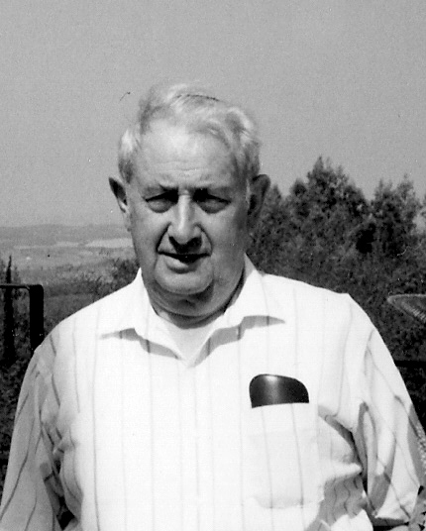
Yehuda Kiel, z”l (Courtesy of the Kiel family)

Adding Another Level to the Theory of “The Student of Rabbi Saadia Gaon”

My own generation, which already grew up on Da’at Mikra and was familiar with my father’s teachings, has paved a new path within this discourse, one that continues in the same direction as that of the older generation, but with a more radical bent. These new ideas have percolated among us for a long time as a kind of oral tradition. Recently, Rabbi Yaakov Medan formulated these ideas elegantly and convincingly in print. I will follow in his footsteps, with slightly different points of emphasis.

Let us begin with the strongest point: the comparison between the two censuses in the book of Numbers. The first census took place at Sinai, not long after the Exodus. The second census took place in the plains of Moab, in the fortieth year following the Exodus. Between the two censuses, an entirely new generation took the place of the old one. By the second census, the members of the people of Israel who left Egypt had died and their children, who were about to enter and settle the land of Canaan, were the ones who were counted. It is interesting to note that the total population of the nation had not changed by much. At the first census, the total count was 603,550, while at the second census the count was 601,730. The counts for each individual tribe had grown or shrunk – though not extremely so. (Reuben: 46,500-43,730; Gad: 45,650-40,500; Judah: 74,600-76,500; Issachar: 54,400-64,300; Zebulun: 57,400-60,500; Ephraim: 40,500-32,500; Benjamin: 35,400-45,600; Dan 62,700-64,400; Asher: 41,500-53,400; Naphtali: 53,400-45,400.) The counts for two tribes, however, changed dramatically: Simeon, which shrank from 59,300 to 22,200 and Manasseh, which grew from 32,200 to 52,700.

Chazal addressed the question why Simeon shrank to such an extent, explaining that all of the 24,000 people who died at the incident of Baal-peor were from the tribe of Simeon. This supposition has ramifications for our understanding of the sin of Baal-peor in general and in particular on Simeon’s role in the conquest of the land and its apportionment. But the tribe under discussion here is Manasseh: What is the background for the unexpected surge – over twenty thousand additional men – in Manasseh’s population?

Perhaps we may make a bold speculation, going one step beyond what the previous generation’s scholars dared suggest. It may be that the twenty thousand men that were added to the tribe of Manasseh in the plains of Moab were descendants of Machir, Jair and Nobah, who never returned to Egypt after establishing cities in the Transjordan, but rather remained in the land of Bashan. Because these representatives of the nation of Israel stayed in the land of Israel for all those years, they were able to avoid the bitter experience of the harsh Egyptian enslavement, never toiling with “mortar and bricks” and never encountering the edict of “Every boy that is born you shall throw into the Nile.” On the other hand, these people also missed out on the high points of Israel’s period of early nationhood, such as the Exodus, the Song at the Sea and the pronouncement of na’aseh ve-nishma – “we will faithfully do.” Imagine our ancestors arriving in the plains of Moab after all the hardships of the wilderness, after thirty-eight years of wandering during which the entire previous generation died, when suddenly a group of tanned “sabras” – who have never felt the sting of exile – come riding out from the hills. Imagine how emotional this meeting with their Hebrew-speaking cousins – partners in the heritage of Abraham, Isaac and Jacob, keeping the flame alive in the land of Israel – must have been. Their lives here certainly were not easy once they lost the protective support of the sympathetic Egyptian government. It must not have been easy to weather the rise to power of Geshur and Maacah (see I Chronicles 2:23), heralding the reign of King Og of Bashan to whom they were certainly subject. But they survived and continued to settle the northern Gilead and Bashan, and perhaps some of their counterparts existed here and there in the Cisjordan as well, Ephraimites or descendants of Aner, Eshkol and Mamre, members of Abraham’s household or servants in Jacob’s household who never emigrated to Egypt.

The primary task at hand was to liberate the land of these new/old brothers from the hegemony of King Og of Bashan. Moses and the people of Israel happily and hastily accomplished this task. After the victory over King Og and his people, it was understood that the vast territory throughout which the Manassites were scattered would be immediately authorized as the tribal territory of the people who preserved it throughout these difficult years.

Rabbi Yaakov Medan explains that from a spiritual and religious perspective it was very important at this juncture to incorporate these brothers – who had retained the ethos and belief system of the patriarchs – into the divine covenant as it was formulated at the Exodus and at Sinai. Because of this, the covenant was forged anew at the plains of Moab.

“Just as Israel Did”

This theory may explain as well a seemingly problematic expression found in Parashat Devarim, when Moses outlines the changes that occurred in the Transjordan: The Moabites dispossessed the early Emim, the descendants of Esau wiped out the Horites and settled the land in their place and the Ammonites dispossessed the Zamzummim. Moses then presents an analogy: “Just as Israel did in the land of their inheritance, which the Lord had given to them” (Deuteronomy 2:13). The difficulty is clear: The people of Israel had not yet conquered any part of the land at this point! Several farfetched answers have been proposed: that Moses’ comment here is one of several statements that deviate chronologically from the order of the book of Deuteronomy and actually refer to the conquest of Sihon and Og that occurred later (Chizkuni, Sforno); that these statements refer to Joshua’s future conquest of the land of Canaan (Ramban, Abrabanel); or that this is a later editorial comment regarding the conquest of Canaan (most modern scholars). Based on its structure, the chapter seems to be referring generally to the nations residing in various parts of the Transjordan (with an addition concerning the Caphtorim who dispossess the Avvim in the Cisjordan) and the time frame of the chapter precedes the Israelite conquest in both sides of the Jordan. The assumption that the descendants of Manasseh were consistent residents of the northern Transjordan during the generations of slavery and wandering through the wilderness may shed new light on this verse as well. Upon reaching the Transjordan, the people of Israel meet the nations of Edom, Moab and Ammon, as well as the two Amorite kings. They also meet tens of thousands of Israelites who also had an ancient territory in the northern region of the Transjordan. In this framework, it is certainly appropriate to include these Israelites among the nations who carved out a territory in the Transjordan – “just as Israel did in the land of their inheritance.”

The First Aliyah

The situation at the time that the people of Israel entered the land during the time of Moses and Joshua can be compared to Israel’s revival in our time. The state of Israel was born in the years following the Holocaust, when Holocaust survivors banded together with Jews from Arab countries in the land of Israel, fought against the Arab nations and triumphed. In addition to these immigrants, there were already many Jews in the land, some of whose families had been living there for over two hundred years. This group included Sephardim, Hasidim, students of the Vilna Gaon and immigrants from the First Aliyah in the late nineteenth century. While struggling with Arab terror attacks, disease and lack of resources, these people built colonies and, afterward, moshavim and kibbutzim. These were the “sabras” who never felt the sting of exile. If one were to write a history of Israel in the modern era, from a national-historical perspective, one might very well ignore the presence of these early settlers, since the critical contours of the nation-building process never passed their way. One might highlight Herzlian Zionism, the later Aliyot, the Holocaust and the mass immigration that took place after the birth of the state. Despite this, a different author might recount the development of the land of Israel specifically from the perspective of these early “land-of-Israel” Jews.

Both approaches are correct – each in its own framework and context. We must view the events of the Tanakh and the way they are described in the same manner. The “mainstream” faction of the people of Israel experience the enslavement in Egypt, the Exodus under Moses’ leadership, the journey through the wilderness and the conquest of the land; indeed, the Torah and the book of Joshua follow the narrative of this primary faction. In contrast, the genealogical chapters in Chronicles focus on the other members of the people of Israel, who preserved the reality of Israel’s continuous settlement in the land.

For further study:

Yoel Elitzur, “Anashim Ve-nachalot Bi-Menasheh U-veshivtei Yisrael,” Al Atar 4-5 (1999), 243-249 [Hebrew].

Y. Kiel, Da’at Mikra: Divrei Ha-yamim I (introduction), 64-66; II, 87-89 [Hebrew].

R. Kirchheim (compiler), Peirush al Divrei Ha-yamim: Meyuchas Le-echad Mi-talmidei Sa’adia Ga’on, Mutza Le-or al pi Shelosha Kitvei Yad, Jerusalem 1966 (Frankfurt am Main 1874) [Hebrew].

Y. Medan, “Chavira el Ha-Eretzyisraelim,” Makor Rishon: Shabbat, Erev Shabbat Parashat Matot-Masei, 27 Tammuz 5770 (July 9, 2010), 2-3 [Hebrew].

E. Viezel, “Context, Harmonization, and the Uniqueness of the Commentaries to the Book of Chronicles,” Jewish Studies Quarterly 22 (2015), 10-15.

Translated by Daniel Landman

See Map 43 below.
The Samaritan text features the expression “and the half-tribe of Manasseh (ve-lachatzi shevet Ha-Menasheh)” six times. The Hebrew text of the seventh occurrence, ve-lachatzi shevet Ha-Menasheh ben Yosef, is syntactically curious; it literally means “and the half-tribe of the Manasseh son of Joseph. This point, along with the very use of “son of Joseph” in the final case rather than in the first occurrence in the passage here, is evidence of the clumsiness of this renovated text.
As we discussed there, it is possible to demonstrate that the geographical names preceded the personal names.
This name was given to him by the Tosafists. He apparently lived during the tenth century CE. He quotes extensively from the writings of Rabbi Saadia, but also from the first grammarian Rabbi Judah ibn Quraysh and from the teachings of the sages of Kairouan, in modern-day Tunisia.
See our discussion on Parashat Bemidbar.
See our discussion on Parashat Vayechi.
I am indebted to my dear friend Prof. Haim Ben David for bringing this source to my attention.
It may be that the covenant at Mount Ebal during the time of Joshua was similarly forged for the purpose of assimilating the parallel Hebrew population in the land of Canaan into the nation of Israel.

