YESHIVAT HAR ETZION
ISRAEL KOSCHITZKY VIRTUAL BEIT MIDRASH (VBM)
*********************************************************

GEOGRAPHY IN THE PARASHA

*********************************************************
IN LOVING MEMORY OF

Jeffrey Paul Friedman
August 15, 1968 – July 29, 2012

לע"נ

יהודה פנחס בן הרב שרגא פייוועל
כ"ב אב תשכ"ח – י' אב תשע"ב

ת.נ.צ.ב.ה
*********************************************************

PARASHAT VA’ETCHANAN

The Lebanon
By Prof. Yoel Elitzur

That Good Hill Country and the Lebanon

“I pleaded with the Lord at that time, saying… Let me, I pray, cross over and see the good land on the other side of the Jordan, that good hill country and the Lebanon” (Deuteronomy 3:23-25). What is “that good hill country and the Lebanon”? Targum Onkelos, the midrashim of Chazal and Rashi explain that this refers to the Temple. In other words, “the Lebanon” is another name for the Temple. Indeed, this is an ancient epithet that is found as early as the prophecy of Zechariah: “Throw open your gates, O Lebanon” (Zechariah 11:1). In any case, this name certainly began to be used only after Solomon built the Temple using the cedars of Lebanon. In our parasha, there is no need to look beyond the simple reading of the verse in order to understand it. Moses makes a pleading request to be permitted to see a very specific location: Mount Lebanon in the far north of the land. Moses longs to see Mount Lebanon, a site that, in his eyes, represents the very epicenter of the beauty of the land of Israel.

I was in Lebanon over thirty years ago, during the First Lebanon War in 1982. It truly took my breath away to see the arresting Lebanese landscapes, the abundant rivers and streams in particular. It seems that when the Torah states, “For the Lord your God is bringing you into a good land, a land with streams and springs and fountains issuing from plain and hill” (Deuteronomy 8:7), it was referring first and foremost to the region of the Lebanon. Moses’ expression of yearning for the remote Lebanon, as he stood in the plains of Moab, across the Jordan from Jericho, five miles from Jericho and twenty miles from Jerusalem, teaches us that the Torah views the Lebanon as possessing a greater degree of sanctity than the Transjordan. This notion runs counter to the modern Zionist approach, and even to the approach of the Greater Israel maximalists who speak of “two banks of the Jordan – both of them ours” but never considered the Jewish connection to Lebanon.

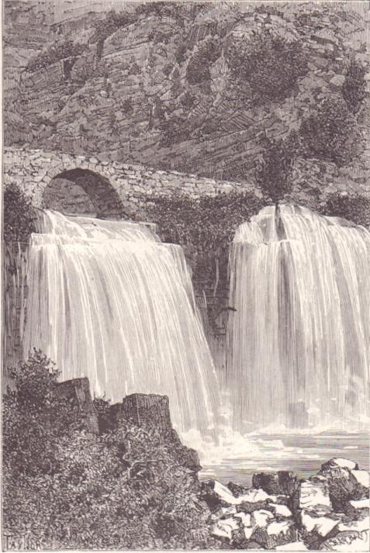
“A land with streams and springs and fountains issuing from plain and hill” – an abundance of water under the Afqa Bridge in Lebanon (Lortet 1884)

The Lebanon’s Role in the Land’s Borders

We encounter the Lebanon in the Torah’s description of the borders of the land of Israel. Similarly, in the Torah’s presentation of the mitzva to inherit the land within its expansive borders, we read:

Start out and make your way to the hill country of the Amorites and to all their neighbors in the Arabah, the hill country, the Shephelah, the Negeb, the seacoast, the land of the Canaanites and the Lebanon, as far as the Great River, the river Euphrates. (Deuteronomy 1:7)

We see this again in the list of the borders of the Promised Land at the end of Parashat Ekev: “Your territory shall extend from the wilderness to the Lebanon and from the river – the Euphrates – to the Western Sea” (11:24). As we discussed earlier (in Parashat Mishpatim), the Torah contains two sets of borders for the Holy Land, one limited and one expansive. The expansive set of borders (mentioned in Parashiyot Lekh Lekha, Mishpatim, Devarim and Ekev) reaches north until the Euphrates, while the limited set of borders (described in detail in Parashat Mas’ei) reaches only to the northern Mount Hor and Lebo-hamath. We explained that the expansive border is the ideal permanent border for the land of Israel, intended for later generations to realize after the nation’s population was to expand, allowing the people to settle the full extent of these vast regions. In contrast, the limited border is the nucleus of the land of Israel, designated for the first stage of the conquest. For our discussion here, it is important to stress that the Lebanon was included even within the initial, limited set of borders. We can see this, first of all, from our parasha, where Moses is located in the very heart of the spacious Promised Land – and requests to see the Lebanon.

We see this again in Joshua 13. The first few verses in the chapter list the “territory that remains” in Canaan, which Joshua did not manage to capture. It is easy to see that this list is based on the limited border of the land of Israel and not on the expansive border, and it showcases the gaps between the land that was actually conquered and the borders described in Parashat Mas’ei. The Euphrates River is not mentioned in Joshua 13; in its place appears Lebo-hamath, the location that best typifies the limited border of Parashat Mas’ei. Sure enough, the list of “territory that remains” in Joshua 13 includes “the whole Lebanon… to Lebo-hamath on the east” (13:5) as well as “all the inhabitants of the hill country from the Lebanon (i.e., from the northern end of the Lebanon) to Misrephoth-maim” (13:6). With this in mind, what does God promise Joshua? “I Myself will dispossess those nations for the Israelites.”

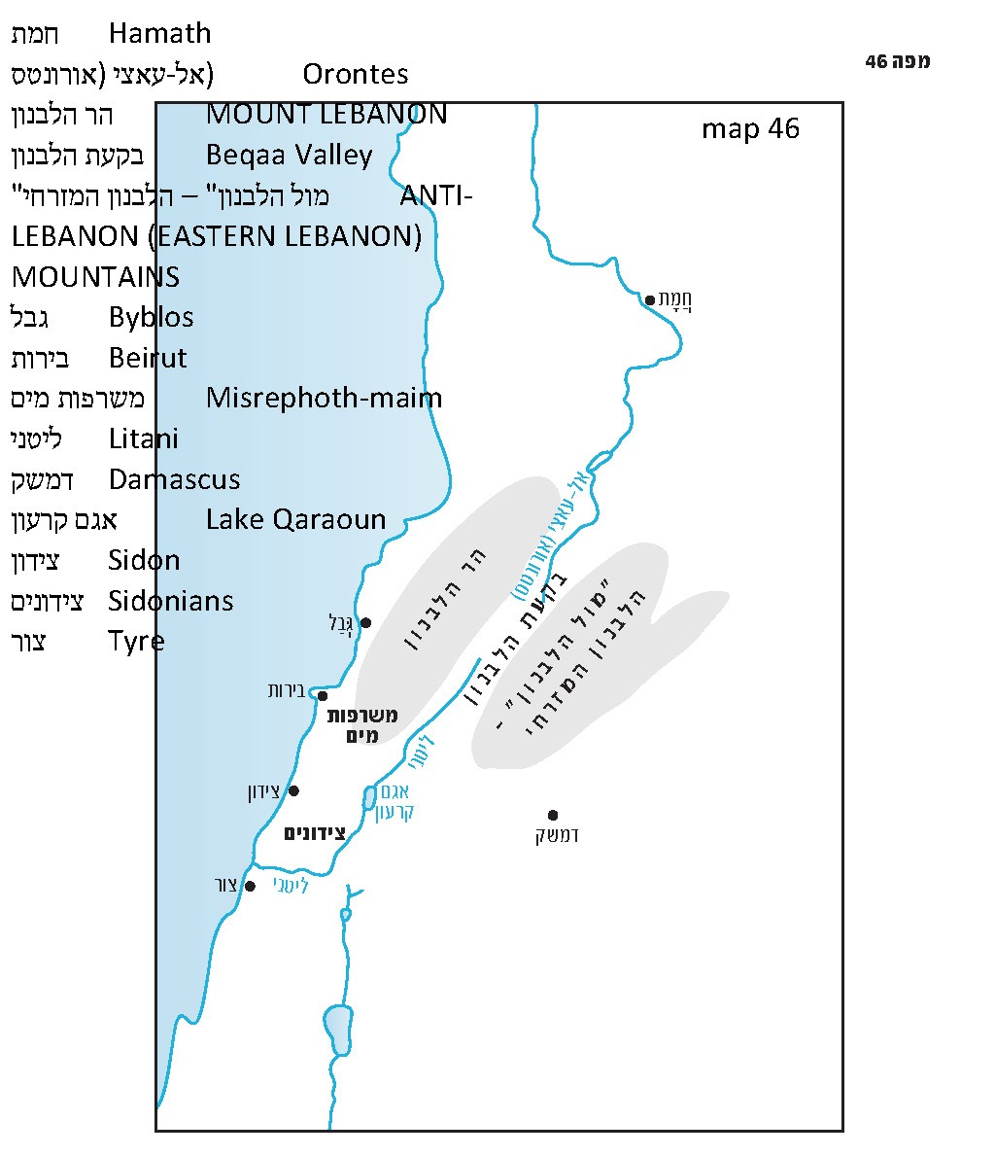

To summarize, the Lebanon is part of the land that God promised to the nation of Israel, which He commanded them to conquer even during the early stages of that process and which is mentioned as part of the “territory that remains” after Joshua and the members of his generation are unable to realize the intended plan of conquest.

In the language of the Tanakh, the Lebanon refers first and foremost to the tall Mount Lebanon range, which bears this name until today. However, it occasionally refers to the Beqaa Valley (Valley of the Lebanon) east of the range (as in Joshua 13:5, cited above), and in certain cases it even refers to the mountain range known today as the Anti-Lebanon mountains on the east, opposite Mount Lebanon.

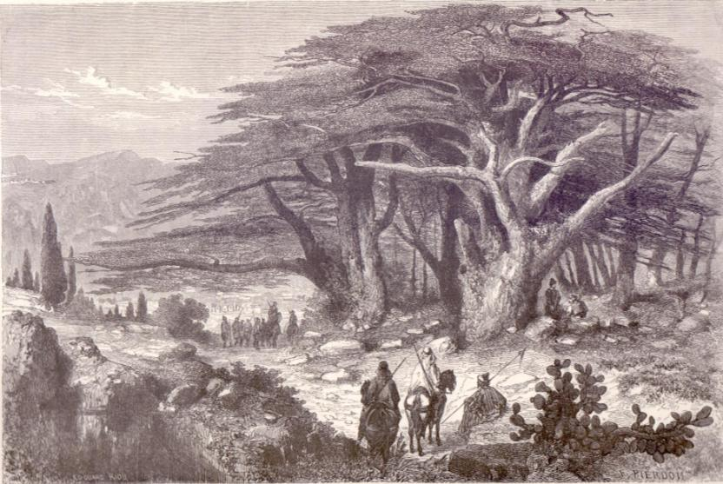
The cedars of Lebanon (Lortet 1884)

“The” Lebanon

From a linguistic perspective, it is appropriate to refer to the region as the Lebanon – using the definite article – as the name appears in this form (Ha-Levanon) in almost every instance in the Tanakh. Moreover, this name form has important significance in the Hebrew language, especially in the Tanakh but in the language of Chazal and in modern Hebrew as well, in that the names of the various regions of the land of Israel are written and said using the definite article (e.g., Ha-Galil, Ha-Karmel, Ha-Sharon, Ha-Bashan). In contrast, the names of other Biblical lands, such as Ammon, Moav, Bavel (Babylon) or Mitzrayim (Egypt), as well as the Modern Hebrew names of most modern countries, e.g., Sefarad (Spain), Tzarefat (France) or Anglia (England), do not use the definite article. The use of the definite article in the case of the Lebanon highlights the fact that this is the name of a territory within our land, rather than the name of a foreign country.

In historical terminology, the southern part of the modern-day state of Lebanon, south of the Litani River, is essentially part of the Upper Galilee. The Tanakh refers to this region, along with the region north of this region until Sidon, using the territorial name “Sidon” or “Sidonians.” The First Lebanon War of the summer of 1982 (which Prime Minister Menachem Begin named “Operation Peace for Galilee”) took place, for the most part, in the Lebanon, in the Biblical sense of the name as well, while the Second Lebanon War of the summer of 2006 took place mostly in the Upper Galilee. The frustrating aftermath of the First Lebanon War from the perspective of the nation of Israel and the state of Israel (despite Israel’s military success in that war) and the failures of the Second Lebanon War are tied, in my opinion, to the fact that the nation and its leaders – even those on “the right” – believed that they were fighting in a foreign country. If they were familiar with the Tanakh and they understood where they were located during those wars, it may be that things would have turned out differently. Even minor details connected to our perception of the land take on a grotesque appearance when a location is viewed through a lens of foreignness.

One example of this is the village of Qana, mentioned frequently in the news during the 2006 war, as well as ten years earlier during Operation Grapes of Wrath. In both incidents, Israel launched airstrikes targeting terrorists in the village, and as a result dozens of civilians were killed alongside them. These incidents led to worldwide condemnation of Israel, and Israel apologized for the civilian loss of life in both cases. The events themselves are not the concern of this book. In the framework of this discussion, however, it is important that I address the name of the village. Due to a tendency to eagerly overcorrect in such cases, certainly owing in part to a feeling of foreignness toward the location, the name Qana was commonly spelled in Israeli sources with the initial word kafr and with a kaf as the first letter. This form is incorrect and most likely influenced by the existence of a village bearing that name (spelled with a kaf) in the Lower Galilee. The name of the Lebanese village is more correctly spelled with a qof, yielding a name that appears in Joshua 19 in the tribal territory of Asher: “The fifth lot fell to the tribe of the Asherites, by their clans. Their boundary ran along… Ebron, Rehob, Hammon and Kanah, up to Great Sidon” (19:24-28). Thus, Kanah is one of the locations given to the tribe of Asher, along with Great Sidon. It would be perfectly reasonable for the Israeli government to decide that the time is not yet right to realize the inheritance of the land in that particular location. However, the distortion of its name, relating to it as if it were some strange, foreign entity lurking beyond the edge of the known universe, is a step too far; it takes the basic concept of our immanent connection to the land of Israel and turns it on its head.

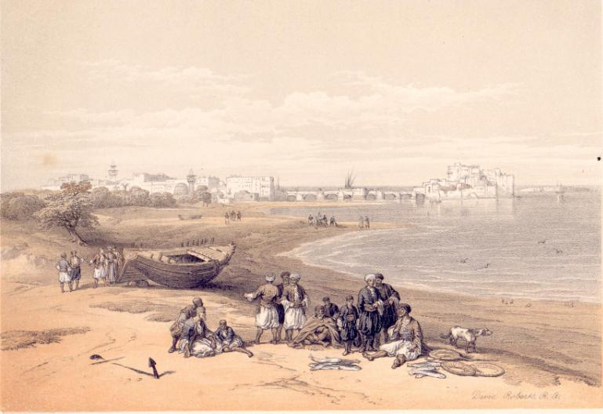
Sidon (Roberts 1855)

A Personal Story

During the First Lebanon War, I was one of the infantry soldiers who advanced north through the length of the Beqaa Valley. When we passed through the area of Lake Qaraoun, the rations we took with us ran out. We reached a kind of dried fruit factory, where we found packs of dried figs that were grown locally. We ate them, and they were both delicious and filling. When I finished eating these figs to my heart’s content and stood to recite the berakha acharona, I had to make a quick decision on the spot regarding a seemingly picayune matter – but one that at the same time bore colossal significance. According to halakha, the blessing that one recites after consuming fruit from outside the land of Israel concludes with the formula “for the land and for the fruit (al ha-aretz ve-al ha-peirot)”; after consuming the fruit of the land of Israel, however, one recites, “for the land and for its fruit (al ha-aretz ve-al peiroteha).” That moment of realization filled me with exhilaration, as I recited – with utmost focus and intent – “for the land and for its fruit”!

The author (right) with a friend in Kamed el-Lawz in the Beqaa Valley in Lebanon
(Summer 1982)

For further study:

Yoel Elitzur, “Ha-gam Ha-Levanon Be-Eretz Yisrael?” Nekuda 48, 1983, 10-13 [Hebrew].

H. O. Thompson, “Kanah,” Anchor Bible Dictionary 4, 5.

Translated by Daniel Landman

Onkelos translates: “Tura tava ha-dein u-veit makdesha.”
According to Yehuda Kiel’s accurate analysis in Da’at Mikra, we can see from the context in this verse as well as from Joshua 11:8 that Misrephoth-maim refers to a certain point at the top of the southern or central Mount Lebanon region.
See Map 46 below.
The name levanon, from the word lavan, meaning “white,” certainly refers to the white snow that adorns its peaks.
See our discussion on Parashat Mishpatim.
See our discussion on Parashat Noach.

