YESHIVAT HAR ETZION
ISRAEL KOSCHITZKY VIRTUAL BEIT MIDRASH (VBM)
*********************************************************

GEOGRAPHY IN THE PARASHA

*********************************************************
IN LOVING MEMORY OF

Jeffrey Paul Friedman
August 15, 1968 – July 29, 2012

לע"נ

יהודה פנחס בן הרב שרגא פייוועל
כ"ב אב תשכ"ח – י' אב תשע"ב

ת.נ.צ.ב.ה
*********************************************************

PARASHAT EKEV

Israel: The Chosen Land
By Prof. Yoel Elitzur

Parashat Ekev: The Parasha of the Land of Israel

The geographical location we will be discussing this week is, of course, the land of Israel. Parashat Ekev is full of words of inspiration and encouragement for the people of Israel in anticipation of their arrival in the land of Israel and forthcoming possession of the land. The parasha opens with a promise of blessing in the land:

And if you do obey these rules and observe them carefully, the Lord your God will maintain faithfully for you the covenant that He made on oath with your fathers: He will favor you and bless you and multiply you… in the land that He swore to your fathers to assign to you. (Deuteronomy 7:12-13)

The parasha continues, addressing the possession of the land:

You shall faithfully observe all the Instruction that I enjoin upon you today, that you may thrive and increase and be able to possess the land that the Lord promised on oath to your fathers. (8:1)

The parasha then praises the virtues of the land:

For the Lord your God is bringing you into a good land, a land with streams and springs and fountains issuing from plain and hill; a land of wheat and barley, of vines, figs, and pomegranates, a land of olive trees and honey; a land where you may eat food without stint, where you will lack nothing; a land whose rocks are iron and from whose hills you can mine copper. When you have eaten your fill, give thanks to the Lord your God for the good land which He has given you. (8:7-10)

Toward the end of the parasha we read: “That you may long endure upon the soil that the Lord swore to your fathers to assign to them and to their heirs, a land flowing with milk and honey” (11:9) and finally:

The Lord will dislodge before you all these nations… Every spot on which your foot treads will be yours; your territory shall extend from the wilderness to the Lebanon and from the River – the Euphrates – to the Western Sea. No man shall stand up to you… (11:23-25)

Parashat Ekev is the climax of the Torah’s emphasis of the connection between the nation of Israel and its land. This connection manifests itself throughout the Torah, from the very first divine command to Abraham – “Go forth from your native land and from your father’s house to that land that I will show you” (Genesis 12:1) – to Moses’ message to his nation moments before his ascent to Mount Nebo: “Through it you shall long endure on the land that you are to possess upon crossing the Jordan” (Deuteronomy 32:47).

Why Was This Land Chosen?

Are there truly no other “good lands” in the world? Parashat Ekev addresses this question:

For the land that you are about to enter and possess is not like the land of Egypt from which you have come. There the grain you sowed had to be watered by your own labors, like a vegetable garden. But the land you are about to cross into and possess, a land of hills and valleys, soaks up its water from the rains of heaven. It is a land which the Lord your God looks after, on which the Lord your God always keeps His eyes, from year’s beginning to year’s end. (Deuteronomy 11:10-12)

The Midrash explains this passage:

“Not like the land of Egypt” – but better than it. In Egypt, if you work [the land] with chisel and ax, and labor assiduously on it, it will be good; if not, you will gain nothing from it. But the land of Israel is not so; rather, there they sleep in their beds and the Omnipresent brings rain for them. Rabbi Simeon son of Yohai says: In the valley, [a piece of land] produces a beit kor; in the hill country the same piece of land produces a beit kor from the north, a beit kor from the south, a beit kor from the east, a beit kor from the west and a beit kor from above – in total five times as much [as in the valley]. (Sifrei 38-39)

“Hebron was founded seven years before Zoan of Egypt” (Numbers 13:22) – What was Zoan? It was the royal city, as it says, “His officers are present in Zoan” (Isaiah 30:4). What was Hebron? It was the detritus of the land of Israel. This leads to an a fortiori argument: If Hebron – the detritus of the land of Israel – is finer than the finest part of the land of Egypt – which is itself the finest of all the lands – how much more so must the land of Israel be praised. (Sifrei 37)

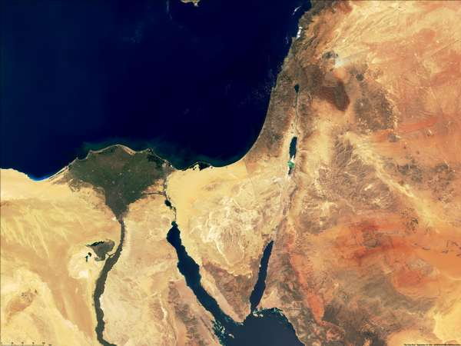
Satellite image of Israel and Egypt: Note the clear distinction in color between the green of the Nile Delta and the yellows, browns and grays of the Promised Land.

These are only a few examples of the kind of praise that the spirit of the nation heaps upon the land of Israel. But the truth is that these words of praise do not represent the simple reading of the text. Rashi cites several of these aggadic passages, but the rest of the commentators – Rashbam, Ibn Ezra, Chizkuni and especially Ramban – clarify that the simple reading of the text indicates the precise opposite of the message of the Midrash. If one were to ask a farmer what he would prefer: an even land that has an abundant source of natural irrigation all year long; or a hilly land that relies on rain alone for water – he would certainly answer that the first option is preferable from a standpoint of both efficiency and economy. Even Rashi himself was aware of this, as he states in his commentary on Deuteronomy 1:27 (citing Bemidbar Rabba and Tanchuma, Parashat Shelach):

“It is because the Lord hates us that He brought us out of the land of Egypt” – He brought us out because He hated us. It can be compared to a king of flesh and blood who had two sons and two fields, one of which was irrigated and one of which was watered by rain. He gives the irrigated field to the more beloved son, while he gives the field watered by rain to the more hated son. The land of Egypt is irrigated, as the Nile rises up and irrigates it, and the land of Canaan is watered by rain. God took us out of Egypt to give us the land of Canaan.

Already in the book of Genesis, Lot was confronted with this same choice between these two types of land, and he did not hesitate in making his decision: “Lot looked about him and saw how well watered was the whole plain of the Jordan… like the garden of the Lord, like the land of Egypt! So Lot chose for himself the whole plain of the Jordan” (Genesis 13:10-11).

Thus, the Torah’s purpose here is to emphasize the opposite: It is true that the land of Egypt contains excellent farmland. But the land of Israel, in contrast, is a land “on which the Lord your God always keeps His eyes, from year’s beginning to year’s end” – it is a land of divine providence. It is true that God is omnipotent, and it would not be overly difficult for Him to destroy an exceptionally fertile land in an instant, or to irrigate an arid land in an instant. But the laws of nature dictate that an irrigated land is always fertile and productive, while an arid land is dry and desolate. The land of Israel is unique in that nothing is ever certain in this regard: It can receive a large quantity of rainfall in a particular year, and will then be blessed with fertility and abundance; but on a very dry year, with little rainfall, it can become a veritable desert. God always keeps his eye on the land of Israel, from year’s beginning to year’s end, to determine its fate in this respect. If God desires it, the land and its inhabitants will enjoy the highest degree of plenty, but at the same time, if God desire it, they will experience the lowest degree of destitution.

In the context of this characterization of the nature of the land, the Torah follows that passage with a warning:

If, then, you obey the commandments that I enjoin upon you this day, loving the Lord your God and serving Him with all your heart and soul, I will grant the rain for your land… Take care not to be lured away to serve other gods and bow to them. For the Lord’s anger will flare up against you, and He will shut up the skies so that there will be no rain and the ground will not yield its produce; and you will soon perish from the good land that the Lord is assigning to you. (Deuteronomy 11:13-17)

The characterization of the land leads to a reiteration of a theme that we encounter many times in the Torah and in the words of the prophets: the complete destruction and desolation of the land during the period of the exile; and the promise that the desert will bloom – “It shall blossom abundantly; it shall also exult and shout” (Isaiah 35:2) – during the time of the redemption.

Thus, the inhabitants of the land of Israel, by the very nature of the land, live in a constant state of miracles.

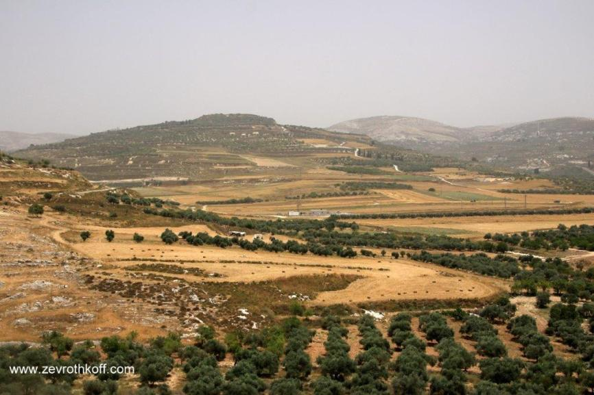
“A land of olive trees”: a view in northern Samaria (Courtesy of Dr. Zev Rothkoff)

The Land of Diligence and Humility

The land of Israel is a place where, even when God bestows upon it the full extent of His blessing, it is still necessary to work the land and invest considerable effort in it. Anyone who is familiar with traditional dryland farming, which is still practiced today by the Arabs living in the land of Israel, knows that it entails an extraordinary amount of labor and practical wisdom. In order for the rain to have its proper effect, the rainfall must be preceded by a comprehensive array of activities, including repeated plowing, stone clearing and weed removal, evoking the verse, “He broke the ground, cleared it of stones and planted it with choice vines. He built a watchtower inside it; he even hewed a wine press in it” (Isaiah 5:2), and the Mishna’s statement, “Any field to which there are at least three trees to every beit se’ah… the entire area may be plowed for their sake” (Shevi’it 1:2). The farm work necessitated by dealing with seeds and trees continues throughout the whole year.

The diligence that this kind of farming demands is an ethical value that is stressed in the book of Proverbs (see, in particular, 6:6-14, 12:11 and 24:30-34). Chazal relate in Menachot 85b the story of an industrious farmer in Gush Halab who was breaking up the earth around his olive trees, like a menial laborer. It was only after he finished this chore that it became clear that this was a very wealthy man, who would wash his feet in a golden bowl and who owned enough oil to support an entire city in Syria and more.

Similarly, we read in Bereishit Rabba 39:

Rabbi Levi said: At the time that Abraham was walking about Aram-Naharaim and Aram Nahor, he saw [people] eating and drinking and lazing about. He said: “I hope I have no portion of this land.” Once he arrived at the promontory of Tyre, he saw [people] engaged in hoeing at hoeing time and weeding at weeding time. He said: “I hope I have a portion in this land.” The Holy One, blessed be He, said to him: “To your offspring I will give this land.”

From a historical and geographical perspective, this aggada does not fit with the simple reading of the Biblical text, which states that Abraham first arrived in Elon-moreh, apparently via Succoth and Penuel like his grandson Jacob. However, it expresses very clearly the essence of the land and the lifestyle of its inhabitants. Indeed, the land of Israel is conducive to a humble lifestyle, practiced by hardworking men of action, both in their service of God and in their work on the land. It is a land that is meant for those who work with humility and dedication, knowing that God bestows his abundance upon those who participate with Him in encouraging the land to bear fruit, rather than those who simply wait for gifts to fall from the heavens.

Zephaniah’s prophetic vision of the redemption stresses this point. The prophet rages about the members of the Jerusalem aristocracy who were living a lifestyle of sin and debauchery: “I will punish the officials and the king’s sons and all who don a foreign vestment” (Zephaniah 1:8); “The officials within her are roaring lions; her judges are wolves of the steppe, they leave no bone until morning. Her prophets are reckless, faithless fellows; her priests profane what is holy, they give perverse rulings” (3:3-4). But when the redemption comes, Israel will come into possession of the magnificent “houses of Ashkelon” – yet they will live simple lives within those houses:

The seacoast shall become an abode for shepherds and folds for flocks, and shall be a portion for the remnant of the House of Judah; on these [pastures] they shall graze [their flocks], they shall lie down at eventide in the houses of Ashkelon. For the Lord their God will take note of them and restore their fortunes. (2:6-7)

But I will leave within you a poor, humble folk, and they shall find refuge in the name of the Lord. The remnant of Israel shall do no wrong and speak no falsehood; a deceitful tongue shall not be in their mouths. Only such as these shall graze and lie down, with none to trouble them. (3:12-13)

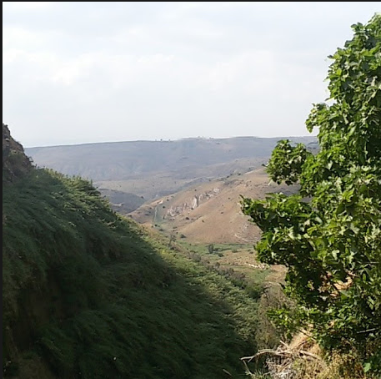
“A land flowing with milk and honey” (Courtesy of Ma’ayan Farbstein)

“A Land Flowing With Milk and Honey”

It is worth paying some attention to the “calling card” of the land of Israel – the famous epithet that is repeated numerous times in Tanakh: “A land flowing with milk and honey.” These words describe a primordial quality of earth that is a pleasure to walk on, to sense, to breathe in, to extol in poetry. But from an economic perspective, matters are quite different; it is far preferable from an economic standpoint to possess rolling plains, upon which one can cultivate fields and vineyards in an orderly manner, rather than scenic hills and mountains. Furthermore, we see from Isaiah 7:21-22 that having to subsist on butter and honey is actually a sign of devastation and ruin, a state in which agricultural growth has disappeared in favor of thorns and thistles, where only a small number of cattle, sheep and honey bees remain. In a discussion described in an aggada in Megilla 6a, the tribe of Zebulun expresses its indignation, complaining to God for giving their fellow tribes fields and vineyards, while leaving them with hills and mountains. The Talmud is puzzled by this complaint, as the region surrounding Sepphoris – located within the territory of Zebulun – was termed by Resh Lakish “a land flowing with milk and honey.” The Talmud answers: “Even so, [Zebulun] preferred fields and vineyards.”

It seems, then, that the most illustrious praise of the land of Israel is not its production of the greatest agricultural yield, but its beautiful, spiritually uplifting landscapes, and the ability of its inhabitants to work the land, serve God faithfully and live a life of humility, diligence and joy.

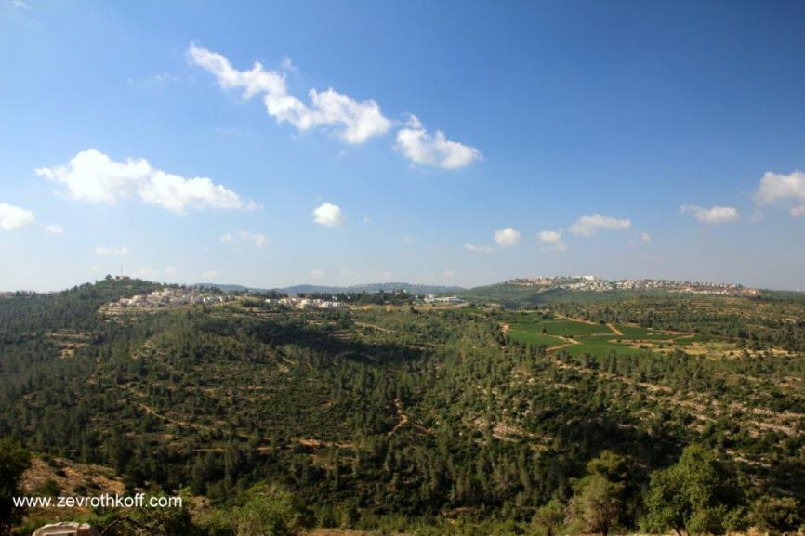
Earth that is a pleasure to walk on, to sense, to breathe in, to extol in poetry: a view in the Judean hills (Courtesy of Dr. Zev Rothkoff)

The Geopolitical Perspective

My father and mentor, Prof. Yehudah Elitzur, z”l, on whose teachings this entire discussion is based, extended the scope of this idea even further, demonstrating that this essence of the land of Israel is not limited to economics and agriculture. The contrast between artificial irrigation and a dependence on rain water is only one side of the story.

This idea applies to the land of Israel from a geopolitical perspective as well. The land of Israel is situated at the nexus of three continents. It is a land that every ruler and conqueror – indeed, anyone with any kind of political agenda in the region – immediately covets. In this sense, every political threat to the land of Israel is an existential one. This land is called “the Promised Land,” but in practice it seems that this “promise” is not at all guaranteed, whether in terms of the economic reality or the political reality. From the perspective of natural law, the land of Israel is one of the most vulnerable places in the world. The only guarantee we have that the “promise” will be realized is the word of God, and the land is constantly and completely dependent on this word. It can be said that the land of Israel, in its absolute essence, is the perfect match for the nation of Israel, and runs fundamentally counter to modern-day aspirations toward “peace” – merely to exist in quiet, without responsibility or obligations.

The only time in history when the nation of Israel succeeded in becoming a world empire, in the period of David and Solomon, was a moment in time when it was as if history itself held its breath. It was a one-time opportunity when, for the briefest moment, the strength of the northern kingdoms waned and Egypt was weakened in the south. Thousands of years have passed since then, and the balance of power in the world has shifted dramatically, but once again the state of Israel remains the only country in the world that is surrounded by enemies bent on its destruction – and the God of Israel alone gives us the strength to stand up to them.

In the end, this is a land whose very existence constantly defies the laws of nature. The reality in the land of Israel is such that one is always subject to the divine will. As a result, one must maintain a direct connection with God, emulate Him, live a life of hard work and humility, be faithful to oneself, to the heritage of one’s ancestors, to morality and to the mitzvot. These are the means by which one can be worthy of the goodness of this good land.

For further study:

Yehudah Elitzur, “Eretz Pelishtim Bi-nevuat Tzefaniya”; “Lama Nivchera Eretz Yisrael Mi-kol Ha-aratzot,” Israel and the Bible, Ramat-Gan 2000, 247-250, 271-279 [Hebrew].

Translated by Daniel Landman

A unit of area for measuring land
The interpretation of Benno Jacob here, that “like the garden of the Lord, like the land of Egypt” is a quote from Lot is especially convincing, as this phrase seems to belie the Torah’s statement in Parashat Ekev.
Much information about this agricultural practice in earlier periods can be found in various chapters in Tanakh and in particular in rabbinic literature.

