YESHIVAT HAR ETZION
ISRAEL KOSCHITZKY VIRTUAL BEIT MIDRASH (VBM)
*********************************************************

GEOGRAPHY IN THE PARASHA

PARASHAT NITZAVIM

“That Land”
By Prof. Yoel Elitzur

An Appendix to the Blessings and Curses at the Beginning of Parashat Nitzavim

The opening passage of Parashat Nitzavim is a majestic epilogue to the Parashat Ki Tavo, summarizing and concluding the story of the covenant of the blessing and the curse:

You stand this day, all of you, before the Lord your God… to enter into the covenant of the Lord your God, which the Lord your God is concluding with you this day, with its sanctions; to the end that He may establish you this day as His people and be your God, as He promised you and as He swore to your fathers…I make this covenant, with its sanctions, not with you alone, but both with those who are standing here with us this day before the Lord our God and with those who are not with us here this day. (Deuteronomy 29:9-14)

Following these verses is a kind of appendix, dealing with individuals and with families:

Perchance there is among you some man or woman, or some clan or tribe, whose heart is even now turning away from the Lord our God to go and worship the gods of those nations… The Lord will never forgive him…. (29:17-20)

The Torah then apparently goes back to speaking about the nation of Israel in general: “And later generations will ask – the children who succeed you, and foreigners who come from distant lands…” (29:21). Here, the Torah fills in what it left out in the lengthy curse section of Parashat Ki Tavo: the curse that will befall the land if the nation violates the terms of the covenant: “All its soil devastated by sulfur and salt, beyond sowing and producing, no grass growing in it, just like the upheaval of Sodom and Gomorra, Admah and Zeboiim, which the Lord overthrew in His fierce anger” (29:22). Finally, the section ends with the uplifting, unique, mysterious verse: “Concealed acts concern the Lord our God; but with overt acts, it is for us and our children ever to apply all the provisions of this Torah” (29:28). The next verse begins a new narrative entirely, one that concerns the eventual redemption and return: “When all these things befall you…” (chapter 30).

This Land and That Land

In this conclusion to the blessing and curse section, the expression “that land” appears twice:

And see the plagues and diseases that the Lord has inflicted upon that land… All nations will ask, “Why did the Lord do thus to this land? Wherefore that awful wrath?” They will be told, “Because they forsook the covenant that the Lord, God of their fathers, made with them… So the Lord was incensed at that land and brought upon it all the curses recorded in this book. (29:21-26).

The nations that ask these questions use the intuitive expression “this land (ha-aretz ha-zot)” to refer to the land of Israel, but in the response that they are given, as well as in the Torah’s own description of the ravaged land, it is called “that land (ha-aretz ha-hi).” The expression “this land” has appeared earlier in the Torah, as recently as the beginning of Parashat Ki Tavo. When a person brings bikkurim (first fruits) during happy times, he stands before God and says, “He brought us to this place and gave us this land, a land flowing with milk and honey” (26:9). Thus, the land of Israel during its good times is “this land,” where one’s children eat its fruits, where one is sated by its goodness and where one goes on to thank God for this bounty. During times of exile, banishment and desolation, the land is called “that land,” a language that implies distance and possibly even revulsion. The land is not here; it is something remote, far from all normal reality.

A Command for the Later Generations

Here we find a remarkable and very fundamental point that is connected to the essence of the land of Israel and to its ever-changing character throughout history. As Ramban emphasized upon viewing the ruins of the land with his own eyes: “You will not find anywhere in the world a land so good and spacious, which was once so developed and is [now] in such a state of ruin” (Commentary on Leviticus 26:32). The Talmud states that the nation of Israel is unique in that when they rise, they rise to the stars; but when they fall, they fall to the dust (Megilla 16a). Indeed, the same is true of the land of Israel: When the nation rises, the land rises along with them to the heavens, and when they fall and are scattered and cast away to distant lands, the land falls as well, sinking into the depths of doom and oblivion.

Here in Parashat Nitzavim, the Torah gives a kind of long-distant command to future generations, “the children who succeed you, and foreigners who come from distant lands,” to come and witness for themselves the “plagues and diseases that the Lord has inflicted upon that land.” The land will be a remote, distant, wretched place, bearing no resemblance to settled areas throughout the world. Visitors who gaze upon the land with plaintive wonder cannot help but ask: “Why did the Lord do thus to this land? Wherefore that awful wrath?”

Mark Twain

I will present here a few select excerpts – some of which may already be familiar to readers – from Mark Twain’s book The Innocents Abroad, in which he includes a chapter (entitled “Pleasure Excursion to the Holy Land”) recounting his visit to the land of Israel in 1867. Twain, a humorist extraordinaire and an acute observer, sensed that he was facing something that could not be spoken of humorously. When standing in the Hula Valley near Ain Mallaha, a spring without any trees or vegetation in the middle of the wilderness, he writes:

Stirring scenes like these [i.e., the war between Barak and Sisera and the bravery of Jael] occur in this valley no more. There is not a solitary village throughout its whole extent – not for thirty miles in either direction. There are two or three small clusters of Bedouin tents, but not a single permanent habitation. One may ride ten miles, hereabouts, and not see ten human beings.

To this region one of the prophecies is applied:

“I will bring the land into desolation; and your enemies which dwell therein shall be astonished at it. And I will scatter you among the heathen, and I will draw out a sword after you; and your land shall be desolate and your cities waste.”

No man can stand here by deserted Ain Mellahah and say the prophecy has not been fulfilled.

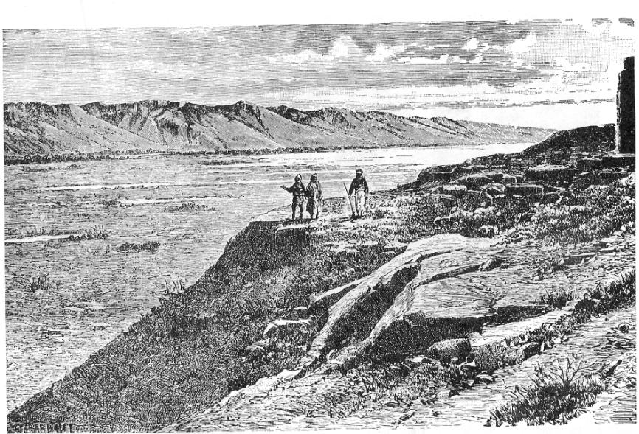
The desolated and arid Hula Valley in the nineteenth century (L. Lortet, 1880)

Twain elaborates on the notion of “your enemies which dwell therein shall be astonished (or desolated) at it” in various places in the chapter, including in his description of al-Majdal/Magdala just north of Tiberias:

Magdala is not a beautiful place. It is thoroughly Syrian, and that is to say that it is thoroughly ugly, and cramped, squalid, uncomfortable, and filthy… The streets of Magdala are any where from three to six feet wide, and reeking with uncleanliness… As we rode into Magdala not a soul was visible. But the ring of the horses’ hoofs roused the stupid population, and they all came trooping out – old men and old women, boys and girls, the blind, the crazy, and the crippled, all in ragged, soiled and scanty raiment, and all abject beggars by nature, instinct and education. How the vermin-tortured vagabonds did swarm! How they showed their scars and sores, and piteously pointed to their maimed and crooked limbs, and begged with their pleading eyes for charity... They hung to the horses’ tails, clung to their manes and the stirrups… “Howajji, bucksheesh! howajji, bucksheesh! howajji, bucksheesh! bucksheesh! bucksheesh!”

In Jaffa, before Twain boarded his ship and took his leave of the land of Israel, he summarized:

Of all the lands there are for dismal scenery, I think Palestine must be the prince. The hills are barren, they are dull of color, they are unpicturesque in shape. The valleys are unsightly deserts fringed with a feeble vegetation that has an expression about it of being sorrowful and despondent. The Dead Sea and the Sea of Galilee sleep in the midst of a vast stretch… wherein the eye rests upon no pleasant tint… It is a hopeless, dreary, heart-broken land… Palestine sits in sackcloth and ashes. Over it broods the spell of a curse that has withered its fields and fettered its energies… desolate and unlovely… Palestine is no more of this work-day world. It is sacred to poetry and tradition – it is dream-land.

Jericho

I will quote one more excerpt, a fascinating passage that is likely less familiar to readers. Perhaps in order to illustrate the stark contrasts that the land of Israel can reach, from the heavens to the abyss, it is worth examining one the most beautiful locations in the land of Israel, namely, Jericho.

At the end of the Second Temple period, Jericho was at the pinnacle of its glory. It was home to twelve priestly divisions (Ta’anit 27a), as well as the winter palaces of the Hasmonean and Herodian kings. Josephus writes in his book The Jewish War (IV, 8:3, 466-471):

[The advantage] of this water is great when it flows even in little quantities. Accordingly, it waters a larger space of ground than any other waters do, and passes along a plain of seventy furlongs [originally: stadia, i.e., about eight miles] long, and twenty broad; wherein it affords nourishment to those most excellent gardens that are thick set with trees. There are in it many sorts of palm trees that are watered by it, different from each other in taste and name; the better sort of them, when they are pressed, yield an excellent kind of honey, not much inferior in sweetness to other honey. This country withal produces honey from bees; it also bears that balsam which is the most precious of all the fruits in that place… cypress trees also, and those that bear myrobalanum; so that he who should pronounce this place to be divine would not be mistaken, wherein is such plenty of trees produced as are very rare, and of the most excellent sort. And indeed, if we speak of those other fruits, it will not be easy to light on any climate in the habitable earth that can well be compared to it, what is here sown comes up in such clusters; the cause of which seems to me to be the warmth of the air, and the fertility of the waters; the warmth calling forth the sprouts, and making them spread, and the moisture making every one of them take root firmly, and supplying that virtue which it stands in need of in summer time.

In short, Jericho is a paradise of sorts.

By contrast, it is interesting to read a very different description of Jericho, that of Edward Robinson – a well-known scholar of the land of Israel – from 1838:

We now returned through the village, which bears in Arabic the name of Erîha, or as it is more commonly pronounced Rîha, a degenerate shoot, both in name and character, of the ancient Jericho. Situated in the midst of this vast plain, it reminded me much of an Egyptian village. The plain is rich, and susceptible of easy tillage and abundant irrigation, with a climate to produce anything. Yet it lies almost desert; and the village is the most miserable and filthy that we saw in Palestine. The houses, or hovels, are merely four walls of stones taken from ancient ruins, and loosely thrown together, with flat roofs of cornstalks or brushwood spread over with gravel. They stand quite irregularly and with large intervals; and each has around it a yard enclosed by a hedge of the dry thorny boughs of the Nŭbk. In many of these yards are open sheds with similar roofs; the flocks and herds are brought into them at night, and render them filthy in the extreme… One single solitary palm now timidly rears its head, where once stood the renowned “City of Palm-trees.”

Thus, we see that the land of Israel has the ability both to ascend to the heights of blessing and to plummet to the depths of curse. This fact itself is a historical wonder. How fortunate we are to have merited living in a generation when the land is green and beautiful once more; may it stay this way forever.

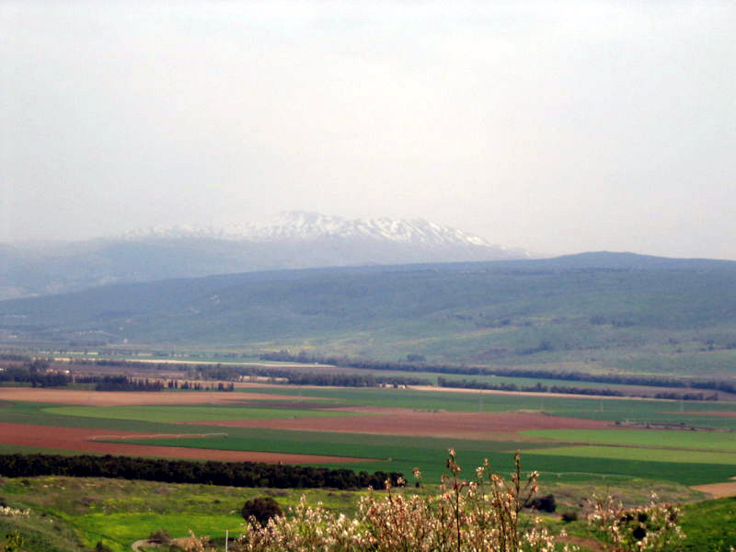
The fertile Hula Valley today

For further study:

E. Robinson and E. Smith, Biblical Researches in Palestine, Mount Sinai and Arabia Petraea: A Journal of Travels in the Year 1838, II, London 1841, 279-280.

M. Twain, The Innocents Abroad, Hartford 1869, 485, 503-505, 606-608.

Translated by Daniel Landman

This is known today as the Einan Springs or the Nahal Einan Reserve, a quiet, verdant spot at the foot of Keren Naftali in the Upper Galilee. Notably, a prehistoric settlement was revealed near these springs.

