YESHIVAT HAR ETZION
ISRAEL KOSCHITZKY VIRTUAL BEIT MIDRASH (VBM)
*********************************************************

GEOGRAPHY IN THE PARASHA

PARASHAT HA’AZINU

Mount Nebo: Did Moses Enter the Land of Israel?
By Prof. Yoel Elitzur

Moses’ Farewell Speech in Ha’azinu – Not in Vezot Haberakha

Following the lofty song that occupies most of Parashat Ha’azinu, Moses bids farewell to the people of Israel:

Moses came and recited all the words of this poem… And when Moses finished reciting all these words to all Israel, he said to them: Take to heart all the words with which I have warned you this day. Enjoin them upon your children, that they may observe faithfully all the terms of this Torah. For this is not a trifling thing for you: It is your very life; through it you shall long endure on the land that you are to possess upon crossing the Jordan. (Deuteronomy 32:44-47)

With that, Moses takes his leave of the nation of Israel. We can see that Parashat Vezot Haberakha, which follows this passage, is formulated very differently, from a stylistic perspective. It does not say “Moses called to the people of Israel and blessed them,” but rather, “This is the blessing with which Moses, the man of God, bade the Israelites farewell before he died” (33:1). In light of the general syntactic patterns in the Tanakh, this formulation seems to indicate that the event described in the verse occurred a while before. The Torah wanted to conclude with a blessing, but the actual relevant blessing had already happened before this point in time. This can be seen from the content as well. The ending of Parashat Ha’azinu is “That very day the Lord spoke to Moses: Ascend these heights of Abarim to Mount Nebo… You may view the land from a distance, but you shall not enter it – the land that I am giving to the Israelite people” (32:48-52). The natural continuation to this passage is clearly found later on, in chapter 34: “Moses went up from the steppes of Moab to Mount Nebo, to the top of Pisgah, opposite Jericho, and the Lord showed him the whole land: Gilead as far as Dan…” (34:1). As stated, the Torah wanted to conclude with a blessing, so it inserted the blessing chapter between God’s command to Moses to ascend to Mount Nebo and the story of the ascent itself. Thus, Moses’ actual final communication to the people of Israel before departing was the uplifting message at the end of chapter 32, which tied together the themes of the Torah, the national destiny of Israel and the land of Israel: “For this is not a trifling thing for you: It is your very life; through it you shall long endure on the land that you are to possess upon crossing the Jordan.”

On the other hand, the introduction of the blessings that were bestowed upon the tribes of Israel between the command to ascend to Mount Nebo and the ascent itself places a very strong emphasis on this ascent to the mountain. This emphasis removes it from the context of Moses’ personal life and places it out in the open, making it part of the intergenerational legacy of the nation of Israel. We will attempt here to understand the true nature of Mount Nebo and the significance of the view from its peak.

The Location of Mount Nebo

The Tanakh makes mention of Mount Nebo, as well as a city called Nebo next to the mountain. The location of Mount Nebo is known; an ancient tradition places it on a rocky spur about half a mile above sea level, overlooking the plains of Moab, at a site called Khirbet Siyagha and at a nearby site called Khirbet al-Mukhayyat. Many churches, both ancient and recent, have been built there. Remnants written in Samaritan script have been found at the site as well, seemingly indicating that even the Samaritans (during the Byzantine period or thereafter) identified this site as the place where Moses bid farewell to his people and looked out upon the land of Israel. The ancient name “Nebo” has been preserved there by the Arabs in the form Niba. West of the spur is a lower peak (2215 feet above sea level) from which a very steep slope descends in the direction of the plains of Moab (a descent of 1970 feet over about three miles). Since the mountain is situated slightly west of its neighboring mountain ranges, and dominates the Jordan Rift Valley, its peak makes for a very unique lookout point even for a modern visitor. The fact that Mount Nebo is located in this region is basically evident from the Tanakh: “the top of Pisgah (literally, ‘the summit’), opposite Jericho.” However, even the highest summit in this region (2630 feet above sea level) is lower than the mountain to its east, which lies between the first peak and Madaba. Furthermore, Ze’ev Erlich notes correctly that in Parashat Va’etchanan, God tells Moses to go up to the top of Pisgah and gaze in all directions, including east (we will discuss the precise meaning of this further below). But throughout the entirety of the mountain accepted as Mount Nebo there is no location with a view to the east. In contrast, the mountain range east of that mountain indeed boasts a view to the east, and thus it seems that this is the summit described in the Torah. It is impossible to see the Western (Mediterranean) Sea from any summit in this region. Erlich explains that the expressions “as far as Dan,” “as far as the Western Sea” and “as far as Zoar” may refer to the boundaries of the geographical regions that Moses viewed, and not necessarily to the maximal extent of his lookout itself. I will comment here further that in the opinion of my father, z”l, the name “Dan” mentioned in this context does not refer to the city of Dan (also known as Laish/Leshem) but to the region that contains all the sources of the Jordan. This region was designated for the tribe of Dan through a tradition from the time of Jacob, as alluded to in Moses’ blessing: “Dan is a lion’s whelp that leaps forth from Bashan” (Deuteronomy 34:22).

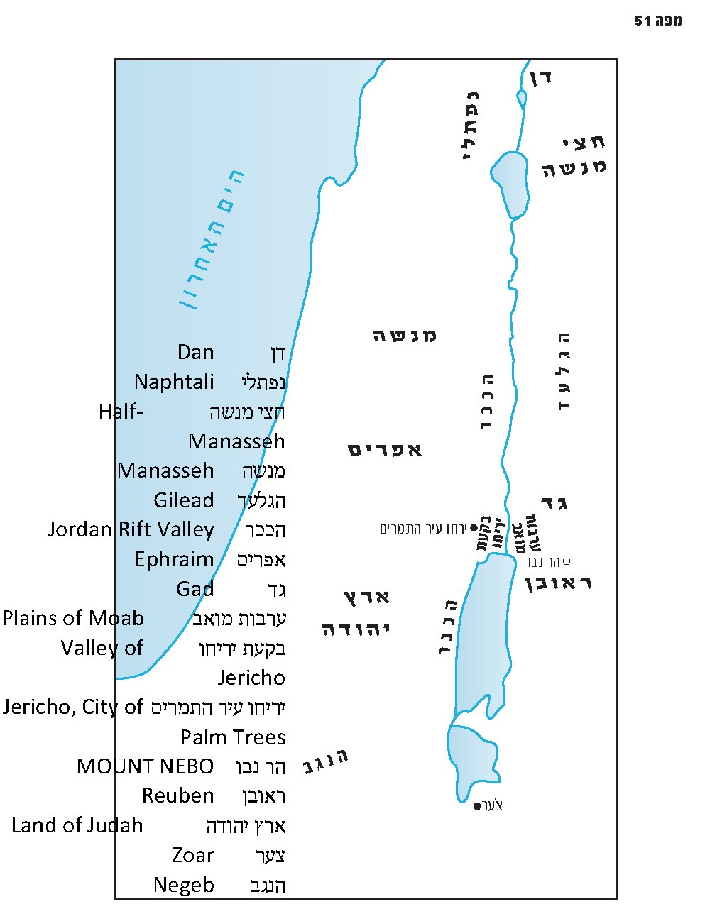

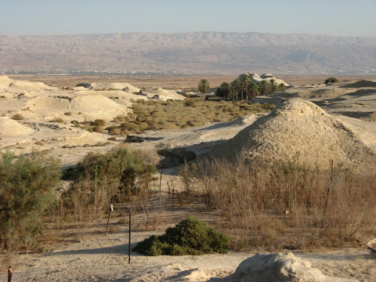
A view from Beth-hoglah near Jericho toward Mount Nebo (Courtesy of Erna Covos)

Did Moses Enter the Land of Israel?

Before we discuss the significance of Moses’ view from Mount Nebo, I would like to raise a fundamental question that may seem strange at first glance: Did Moses enter the land of Israel?

Obviously, based on the Torah’s account here and in other places, Moses certainly did not enter the land: “You may view the land from a distance, but you shall not enter it” (Deuteronomy 32:52). Moses begged and pleaded: “Let me, I pray, cross over and see the good land on the other side of the Jordan” (3:25), but his plea was not accepted: “But the Lord was wrathful with me on your account and would not listen to me” (3:26). Moses bemoaned his fate: “For I must die in this land; I shall not cross the Jordan. But you will cross and take possession of that good land” (4:22). The view from Mount Nebo served as a kind of consolation to Moses, recognizing the fact that he would not merit entering the land.

On the other hand, however, Moses’ burial place is located in Gadite territory, which is certainly part of the land of Israel. Moreover, we read in Parashat Vezot Haberakha that Moses praises the tribe of Gad: “He chose for himself the best, for there is the portion of the revered chieftain” (33:21). According to the accepted interpretation, this blessing praises the Gadites for rushing to take possession of this region, where “the revered chieftain” – Moses himself – would ultimately be buried. If so, Moses is indeed buried in the land of Israel, in the tribal territory of God’s chosen people.

So let us ask again: Did he enter the land of Israel or not?

The View from Atop Mount Nebo

Moses went up from the steppes of Moab to Mount Nebo, to the top of Pisgah, opposite Jericho, and the Lord showed him the whole land: Gilead as far as Dan; all Naphtali; the land of Ephraim and Manasseh; the whole land of Judah as far as the Western Sea; the Negeb; and the Plain – the Valley of Jericho, the city of palm trees – as far as Zoar. And the Lord said to him, “This is the land of which I swore to Abraham, Isaac and Jacob, ‘I will assign it to your offspring.’ I have let you see it with your own eyes, but you shall not cross there.” (Deuteronomy 34:1-4)

I would like to pose a small question here. “And the Lord showed him the whole land: Gilead as far as Dan” – why did God show Moses Gilead in particular? Gilead is located in the Transjordan, and Moses had already been there; in fact, if Moses desired, he could stroll through Gilead on his own two feet. So why did God need to show Gilead to Moses from the top of Mount Nebo?

The same question can be asked in relation to the parallel passage in Parashat Va’etchanan: “Go up to the top of Pisgah and gaze about, to the west, the north, the south and the east. Look at it well, for you shall not go across yonder Jordan” (4:27). It is understandable that Moses is asked to look out to the west, north and south, but can there be any possible reason for Moses to look out to the east?

The solution is that Moses truly did not enter the land of Israel. In reality, when Moses conquered the Transjordan, and when the Gadites and the Reubenites requested, “Do not move us across the Jordan” (Numbers 32:5), and when Moses replied angrily, “Are your brothers to go to war while you stay here?!” (32:6) – the Transjordan was not part of the land the nation of Israel was required to conquer at the time. At that point, the people of Israel’s sights were set on the land between the Jordan and the Mediterranean Sea, and not on the Transjordan.

On the other hand, the Transjordan was always included in the Promised Land: “From the river of Egypt to the great river, the river Euphrates” (Genesis 15:18); “From the Sea of Suph to the Sea of Philistia, and from the wilderness to the Euphrates” (Exodus 23:31) – but this definition of the land of Israel was only meant to be realized at a later stage. The guiding principle here is similar to that of the agreement between Moses and the Gadites and Reubenites: Once the Gadites and Reubenites participate in conquering the nuclear, primary land of Israel alongside the rest of the tribes of Israel, the sanctity of the land will spread to the Transjordan as well. As the verse states: “And this land shall be your holding under the Lord” (Numbers 32:22) – “your holding under the Lord” just like the territories of the remaining tribes.

The matter can be illustrated through an important halakhic example: the cities of refuge. Moses set aside three cities in the Transjordan and Joshua set aside three cities in the land of Canaan. Chazal stated in the Mishna:

Not until three cities were selected in the land of Israel did the [first] three cities beyond the Jordan receive fugitives, as ordained, ‘Six cities of refuge in all’ – [they did not function] until all six could simultaneously afford asylum. (Makkot 2:4)

In other words, when Moses set aside the three cities in the Transjordan, it was merely an act of hekhsher mitzva, preparation for the actual mitzva of setting aside cities of refuge. The commandment to set aside cities of refuge in the Transjordan only became relevant once that region became incorporated into the greater land of Israel, made up of the territory on both sides of the Jordan.

The same is true regarding the sanctity of the land as a whole. Only once the sanctity of the land began to apply in the Cisjordan, and the Gadites and Reubenites participated in conquering this region with the rest of the nation, was it possible for those tribes to return to the Transjordan and settle it. Only then could they fulfill the verse, “And this land shall be your holding under the Lord.” Note the words of the Psalmist:

Sihon, king of the Amorites, His steadfast love is eternal; Og, king of Bashan – His steadfast love is eternal; and gave their land as a heritage, His steadfast love is eternal; a heritage to His servant Israel, His steadfast love is eternal. (Psalms 136:19-22)

Thus, when Moses stands atop Mount Nebo and looks out upon the Chosen Land, God must show him Gilead as well. The Gilead that Moses already traveled through and experienced cannot compare to the Gilead of the future, the Gilead that will one day become a heritage to Israel. The Gilead that Moses knows is a mere preview, the faintest foretaste of the sanctified Gilead that will eventually come into existence as it is added to the land of Canaan and begins to share in its sanctity. Once it is connected to the land of Canaan, the Gilead becomes a different Gilead entirely. When Moses looks upon Gilead in one sweeping gaze, together with the whole Cisjordan, when he sees the future in his mind’s eye – the tribal territories into which the land will be divided (akin to Chazal’s midrashic entreaty to read the phrase yam ha-acharon – “the Western Sea” – as yom ha-acharon – “the end times”) – he is able to see Gilead in its true form.

At the end of the day, Moses truly did not enter the land of Israel, was not in the land of Israel and was deeply pained that he would not enter the land of Israel. As he stood atop Mount Nebo, Moses viewed the land of Israel from afar, knowing that he would not be able to enter. However, after Moses’ death, once Joshua and the people of Israel conquered the land and the Gadites and Reubenites went on to settle Gilead, it did not matter that Moses never reached the land of Israel – the land of Israel reached him, its sanctity pouring forth and subsuming Moses and his burial site. Indeed, Moses is now in the land of Israel.

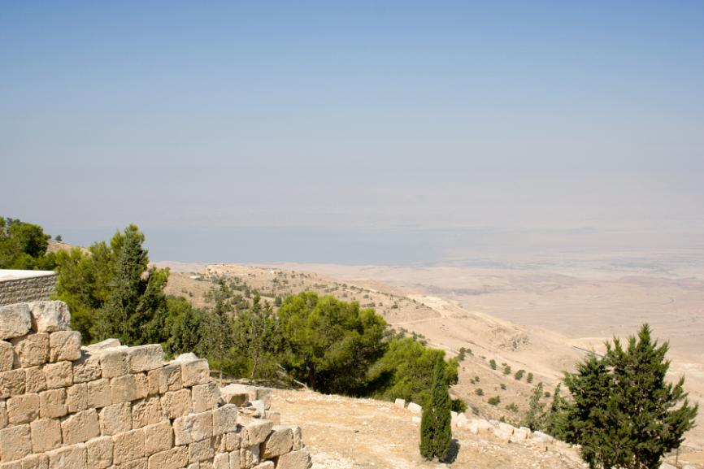
View from Mount Nebo (according to the common tradition) toward the plains of Moab and the Dead Sea (David Bjorgen/Wikimedia Commons)

For further study:

Yehuda Elitzur and Y. Keel, Daat Mikra Bible Atlas (trans. L. J. Schramm), Jerusalem 2011, 122-123.

Z. H. Erlich, “Nevo – Ha-ir Ve-hahar,” Mizrach Ha-Yarden Be-mabat Yehudi, Bnei Brak 1996, 193-213 [Hebrew].

M. Piccirillo, “Mount Nebo,” The New Encyclopedia of Archaeological Excavations in the Holy Land 3 (1993), 1110-1118.

M. Piccirillo and E. Alliata, Mount Nebo: New Archaeological Excavations 1967-1997, vols. 1-2, Jerusalem 1998.

Rabbi Yisrael Yehoshua Tronk of Kutna, Yeshu’ot Malko, Yoreh De’a 67 [Hebrew].

Translated by Daniel Landman

Thus explained Ibn Ezra at the beginning of Parashat Vayelekh.
The city of Nebo is also mentioned in the Mesha Stele as one of the Reubenite cities. King Mesha of Moab relates that he wiped out all 7,000 of its Israelite inhabitants.
This is a territorial name for the northern slope of the mountain, as I personally corroborated on a visit to the site.
As I mentioned in the above note, the Arabic name Niba refers to a territory, not a geographical point.
I heard a similar interpretation from Rabbi Yoel Bin-Nun, in his explanation of Numbers 13:21: “They went up and scouted the land, from the wilderness of Zin to Rehob, at Lebo-hamath.” They did not necessarily reach Lebo-hamath in practice; rather, it is more reasonable to interpret that this was the general border of the land that they scouted, in line with the set of borders recorded in Parashat Masei (Numbers 34).
See our discussions on Parashat Va’era and Parashat Matot.
See Map 51 below.

