YESHIVAT HAR ETZION
ISRAEL KOSCHITZKY VIRTUAL BEIT MIDRASH (VBM)
*********************************************************

GEOGRAPHY IN THE PARASHA

PARASHAT VEZOT HABERAKHA

Benjamin’s Portion
By Prof. Yoel Elitzur

The Borders of Benjamin’s Portion

“Of Benjamin he said: Beloved of the Lord, he rests securely beside Him; ever does He protect him, as he rests between His shoulders” (Deuteronomy 33:12). Before we address the inner content of this blessing, let us first review Benjamin’s portion in the land of Israel.

Benjamin’s portion is situated “between the Judites and the Josephites” (Joshua 18:11). It is described in detail in Joshua 18, and its southern and northern borderlines are described again in detail in the description of the borders of Benjamin’s tribal neighbors: the northern borderline of Judah (15:5-9) and the southern borderline of Ephraim (16:1-3). The descriptions in Joshua 15-16 fit well with the description in Joshua 18. The picture that emerges is that Benjamin’s portion is a narrow strip between Jerusalem to the south and Bethel to the north, and between the Jordan to the east and the line of mountain slopes to the west.

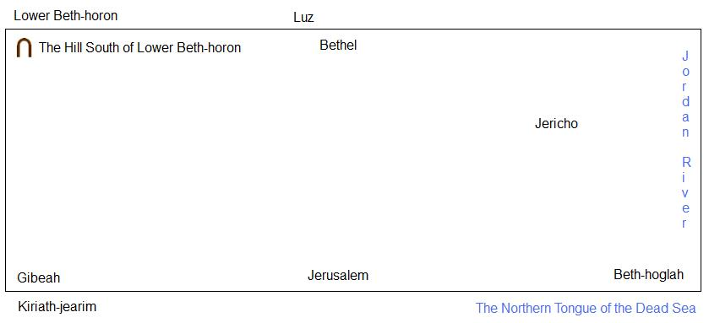
A diagram of Benjamin’s portion according to Joshua 18:12-20

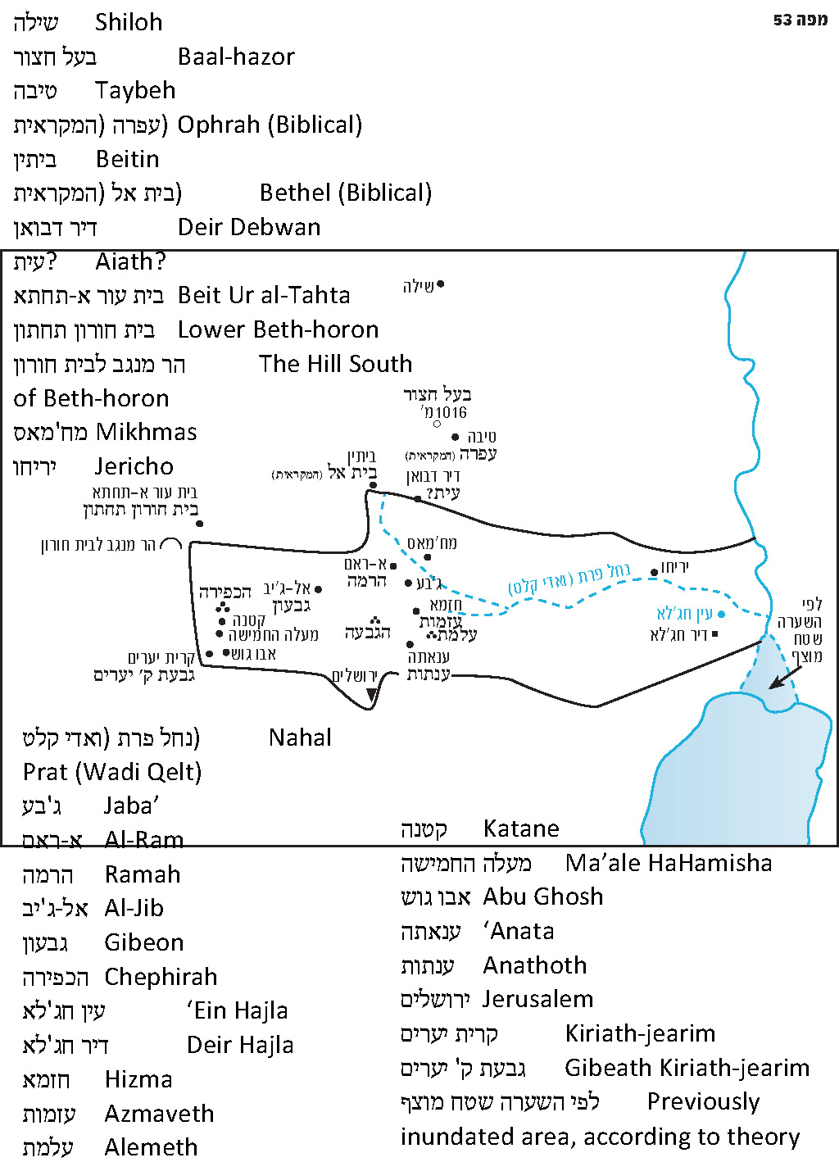

The northeast corner of the land of Benjamin is “the Jordan near Jericho”; the northwest corner is “the hill south of Lower Beth-horon”; the southwest corner is the edge of Kiriath-jearim (which was a city that belonged to the Judites); and the southeast corner is “the northern tongue of the Dead Sea, at the southern end of the Jordan” – in other words, the Jordan estuary at the Dead Sea.

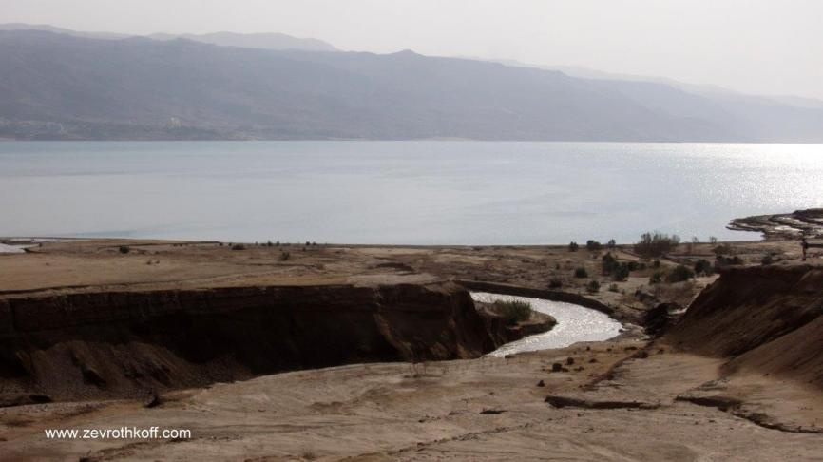
“The northern tongue of the Dead Sea, at the southern end of the Jordan” (Joshua 18:19) – the estuary of the Jordan (Courtesy of Dr. Zev Rothkoff)

The width of Benjamin’s portion at its center, from the village of Beitin (within which ancient Bethel has been identified) to Jerusalem, is about ten miles. Its eastern and western sections are narrower, generally about six miles wide or even less. The portion’s length is about 26 miles. I will make two comments here regarding the course of the borderline:

- In historical atlases and Biblical maps, the eastern side of Benjamin’s southern borderline is generally drawn with a curved line, creating an unusual protuberance. The line begins at the Jordan estuary and runs north, parallel to the Jordan River, and only turns west after a few miles. The reason for this is that the border must account for Beth-hogla, noted in Joshua 15:6 and 18:19 as the first border point after the “northern tongue of the Sea at the southern end of the Jordan” on the borderline between Judah and Benjamin. Beth-hogla’s name was preserved in ‘Ein Hajla and Deir Hajla, about five miles northwest of the Jordan estuary at the Dead Sea. This sharp deviation from the otherwise straight borderline seems unreasonable, but I believe the solution is tied to the question of the water level of the Dead Sea. In my joint research with Prof. Amos Frumkin, who investigated the changes in the water level of the Dead Sea over the course of the geological history of the land of Israel, we claimed that at the time of the land’s apportionment the water level of the Dead Sea was significantly higher than it is today – about 1250 feet below sea level. As a result, the Jordan estuary at the sea was located about 4.5 miles north of where it is today, near ‘Ein Hajla, such that the borderline was basically straight, without any unusual twists and turns.

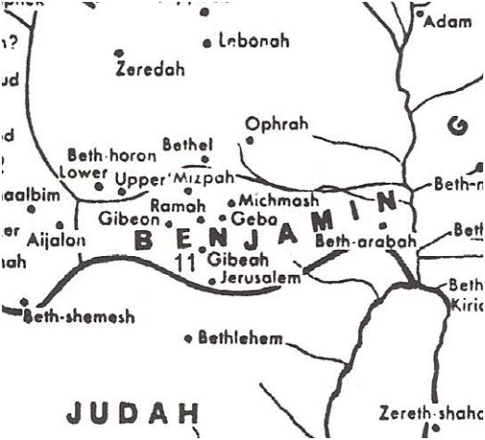
Map of Benjamin’s portion according to Yohanan Aharoni, The Land of the Bible (ed. A. F. Rainey), 1979. Note the curious curve in the southeast.

- Ophrah, which is enumerated in Joshua 18 in the list of Benjaminite cities and is identified with certainty with the summit of the village of Taybeh, is situated about four miles northeast of Beitin (Biblical Bethel) – in other words, outside of Benjamin’s portion. The towering Mount Hazor (also known as Mount Baal-hazor) near Taybeh seems to have been located outside Benjamin’s portion as well. However, the Tanakh calls it “Baal-hazor near Ephraim” (II Samuel 13:23), meaning apparently that it was a border point between Ephraim and Benjamin. In addition, the language of the verse describing Benjamin’s northern border in the area of Bethel seems strange as well: “From Jericho it ascended through the hill country toward Bethel. From Bethel it ran to Luz” (Joshua 16:1-2). The difficulty of this description is, quite simply, that Bethel is itself Luz (Genesis 28:19, 35:6, Judges 1:23). In light of these difficulties, my father, z”l, maintained that the northern border of Benjamin was not at Bethel itself, but 4.5 miles farther to the north, at Mount Hazor. This mountain rises 3,333 feet above sea level and is the summit of “the hill country of Bethel.” My father suggested that although the word har (mountain) is written only once in this verse, it should be understood as if it were written twice. Thus, the verse should be interpreted as follows: “From Jericho it ascended through the hill country to the hills of Bethel. From (the hills of) Bethel it ran to Luz” – meaning that the border ascended from Jericho to the hills of Bethel, and from there to the city of Bethel. In order to distinguish between the region known as “the hills of Bethel” and the city of Bethel, the verse chose to call the city by its ancient Canaanite name, “Luz.” Thus, it turns out that the northern border of Benjamin was actually located farther north, enough to include even Ophrah.

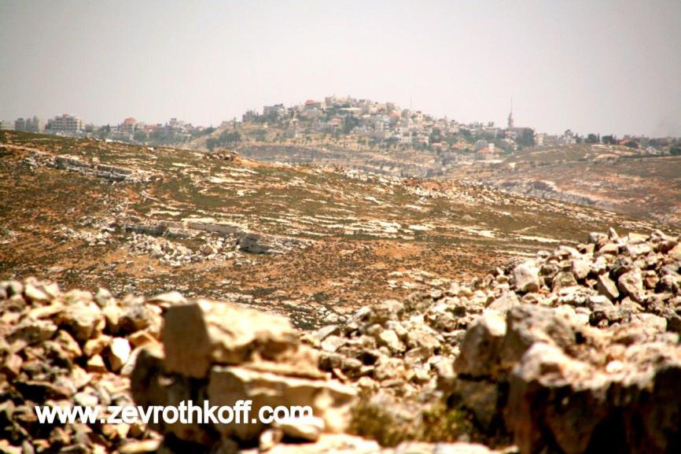
Taybeh – identified with ancient Ophrah, located four miles northeast of Bethel (Courtesy of Dr. Zev Rothkoff)

In my own research on the verse in Joshua, I begged forgiveness of my father, z”l, and preferred a different interpretation: that “Bethel” and “Luz” were two distinct, non-identical locations within the same vicinity. According to the story of Jacob’s dream at Bethel (Genesis 28), and in particular the verse, “He named that site Bethel; but previously the name of the city had been Luz,” it can be inferred that Luz was the city, while Bethel was the site. In my humble opinion, an analysis of the borderline and its topographical surroundings, with this approach in mind, supports an ancient tradition identifying the site of Jacob’s dream with a site called Burj Beitin. This site is located southeast of the village of Beitin, near modern-day Highway 60. As for the deviation of Ophrah from the portion’s borders and the subtle indication that there was some kind of de facto border at Baal-hazor, the matter seems to be tied to several other unusual details. The Tanakh states explicitly that some Ephraimite cities were located within the portion of Manasseh (Joshua 16:9, 17:9), and that some Manassite cities were located within the portions of Issachar and Asher to the north (17:11). One clue that some territory in the southern part of Ephraim was seized by Benjaminites can be found in the name Eretz Yemini – a strip of land within the hill country of Ephraim, north of Benjamin’s portion (I Samuel 9:4; see our discussion on Parashat Tazria). Similarly, the Ephraimite cities within Manasseh were called Eretz Efrayim (Judges 12:15). A kind of domino effect can be seen here: The Benjaminites apparently encroached on the portion of Ephraim to the north, while the Ephraimites, in turn, encroached on Manasseh, who, in turn, encroached on Issachar and Asher.

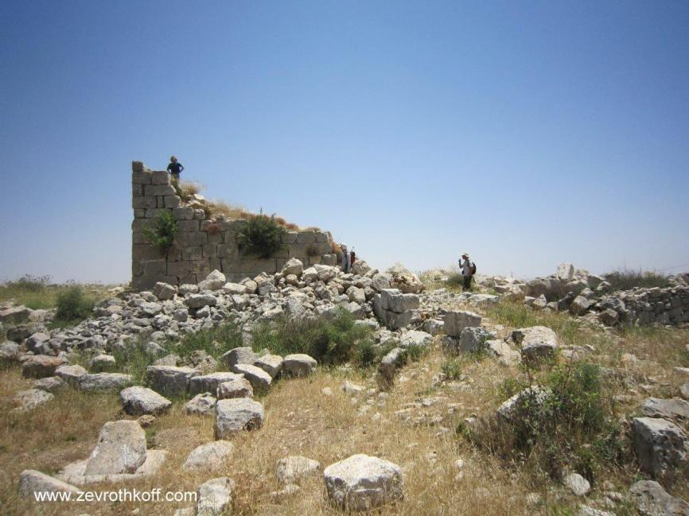
Burj Beitin – the traditional site of Jacob’s dream (Courtesy of Dr. Zev Rothkoff)

The Tribe of Benjamin in its Portion

When the people of Israel entered the land, Benjamin was an intermediate tribe with respect to its population, but its portion was among the smallest. To be more precise, its portion is exceedingly narrow. As stated above, it is a strip about 26 miles long from east to west, about ten miles wide at its widest point, and less than six miles wide on the east and west sides. This portion was made up of four regions: a. on the east, the Jericho oasis, the entirety of which is contained within Benjamin’s portion; b. to its west, an arid, desert area that is devoid of settlement; c. the central mountain ridge, the watershed region and the semi-desert ecotone region a few miles to its east; and d. the fertile, mostly flat region in the western part of the portion.

Where were the Benjaminites able to settle? In the area of Jericho there was a destroyed tell that had been included in Joshua’s curse over the city and was not rebuilt until the time of Hiel of Bethel. In the early Judges period, at a different site within the Jericho oasis, a new city called “the City of Palms” was apparently built, and was first settled by “the descendants of the Kenite, the father-in-law of Moses” (Judges 1:16). Then the city fell to King Eglon of Moab (3:13), and following Ehud’s triumph over Eglon the city return to the hands of the Benjaminites. However, it should be pointed out that even in the time of David, the Jericho region was considered a desolated place (II Samuel 10:5). The desert region west of Jericho was not suitable for habitation, and the fertile region to the west then belonged to the Gibeonites, the native Canaanites whose lives the people of Israel spared. In light of this reality, a situation was created in which the watershed and the semi-desert ecotone strip, which extended 2.5 miles east of the watershed, became the regions that were most crowded with settlements. Despite the poor agricultural conditions – rocky terrain, relatively minimal rain and only one significant spring (Ein Prat) – this was apparently the most crowded settlement bloc in the entire land of Israel. This situation continued throughout the Biblical period. In Isaiah 10:28-32, thirteen settlements were enumerated: Aiath (Ai), Migron, Michmas, Geba, Ramah, Gibeah of Saul, Bath-gallim, Laish, Anathoth, Madmenah, Gebim, Nob and Jerusalem. If other sources from the Tanakh are included, additional names can be appended to this list: Bethel, Mizpah, Beth-azmaveth, Alemeth, Zimri, Parah-Perath, Zela/Zelzah. All in all, this amounts to more than twenty settlements in a strip of land about ten miles long and 2.5 miles wide.

On the other hand, according to the account at the end of Judges, the Benjaminite cities were burned and most Benjaminites, along with their wives and children, were killed by their kinsmen at the Battle of Gibeah, leaving only six hundred men to form new families with the daughters of Jabesh-gilead and Shiloh. As both Josephus (Antiquities 5:132-174) and Seder Olam (ch. 12) interpreted, this incident took place in the early Judges period. The recovery process for the Benjaminites certainly extended well into the Judges period, and toward the end of the period it seems that the land of Benjamin was once again too small for the needs of the Benjaminites.

As stated, the most fertile section of the portion remained in the hands of the Gibeonites. Because of this, the Benjaminites became the party that suffered the most from the decision to spare the lives of the Gibeonites. In several places, the Tanakh indicates – either explicitly or implicitly – that the Benjaminites, and especially, it seems, the family of Saul’s father and of Saul himself, reneged on the oath to leave the Gibeonites unharmed. They raided the Gibeonites, killed many of them, banished many of them and settled in their place in the Gibeon region and in the cities surrounding it: Beeroth, Chephirah and Kiriath-jearim. Saul’s extended family was a family of settlers. They spread out over various places in the land of Benjamin, generally not remaining to settle in their ancestral homes. Saul’s great-grandfather earned the moniker “the father of Gibeon,” meaning that he was the founder of Israelite settlement in Gibeon. The sin of reneging on the oath to the Gibeonites was considered a grave crime, but as it condemned this behavior, the Tanakh also defended Saul, explaining that his attack on the Gibeonites was “in his zeal for the people of Israel and Judah” (II Samuel 21:2; also see 4:2-3, I Chronicles 8:29-40, 9:35-44).

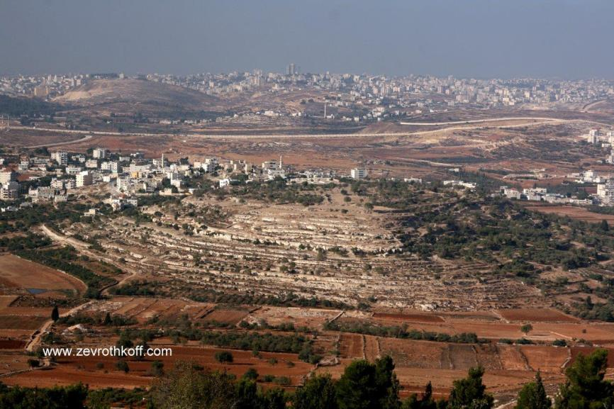
Al-Jib – ancient Gibeon (Courtesy of Dr. Zev Rothkoff)

“Beloved of the Lord, He Rests Securely Beside Him; Ever Does He Protect Him, As He Rests Between His Shoulders”

This pithy blessing highlights the fact that Benjamin is defined and characterized by the Shekhina – the Divine Presence. This is evidenced by Chazal’s statement: “The Shekhina rested [on Israel] only in the portion of Benjamin… all ‘protections’ shall be naught elsewhere but in Benjamin’s portion” (Zevachim 118b; Yerushalmi Megilla 1:11, 72c). The truth is that this Talmudic statement is based on the aggadic assumption that the border between Benjamin and Ephraim ran through Shiloh. This notion, however, does not fit the simple understanding of Biblical geography, according to which Shiloh is located in the heart of Ephraim’s portion. On the other hand, the statement certainly represents the most faithful expression that we possess of the spirit of Moses’ blessing to Benjamin. It is certainly true as well that Gilgal, Nob, Gibeon, Bethel, Kiriath-jearim and Jerusalem were indeed located in the land of Benjamin. Rabbi Yoel Bin-Nun listed eight facts that demonstrate, in his opinion, that Benjamin’s portion was indeed considered “the portion of the Shekhina,” not all of which are equally convincing. Here are all eight facts, in brief:

- The pact with the Gibeonites, who resided in the land of Benjamin, concludes: “That day Joshua made them hewers of wood and drawers of water – as they still are – for the community and for the altar of the Lord, in the place that He would choose” (Joshua 9:27).

- The Gibeonites’ harsh demand – “Let seven of his male issue be handed over to us, and we will impale them before the Lord in Gibeah of Saul, the chosen of the Lord” (II Samuel 21:6) – testifies to the sanctity of the land of Benjamin in the eyes of the Gibeonites.

- The bloody war following the incident of the concubine at Gibeah, which was accompanied by fasting and sacrifices, the Urim and Thummim and the High Priest leading the warriors, demonstrates that the incident was perceived not just as an abomination, but also as a desecration of the sanctity of the land.

- Despite the great importance of Shechem, Shiloh, Hebron and Beersheba, there was a disproportionate concentration of sites designated for divine worship specifically in Benjamin: in Gilgal, Bethel, Kiriath-jearim, Mizpah, Gibeath-elohim, Nob, Gibeon and finally Jerusalem.

- While implementing the census that David instructed him to conduct, Joab skipped over the tribes of Levi and Benjamin, and they are mentioned in this context in the same breath (I Chronicles 21:6), indicating that both tribes are considered the portion of the Shekhina.

- Saul, the Benjaminite king, was an anomalous ruler. He often more closely resembled a religious leader and a man of God: he was chosen with the help of the Urim and Thummim; he brought a burnt-offering at Gilgal; he imposed a cherem (religious ban) upon the nation; he taught the people the halakhot of blood and religious slaughter; he eliminated the practice of consulting ghosts and familiar spirits; and it might even be added – prophesied with the prophets (“Is Saul too among the prophets?” [I Samuel 10:11]).

- Our verse here, in Moses’ blessing, uses the unique terms chofef (“cover” or “protect”) and shakhen (“rests”).

- When the Ark of God was returned from the territory of the Philistines and proceeded to strike the men of Beth-shemesh, the latter sent messengers to the inhabitants of Kiriath-jearim, imploring them to take away the Ark (I Samuel 6:21-7:1). The Tanakh does not explain why the men of Kiriath-jearim were better suited to receive the Ark than the men of Beth-shemesh were, and what could possibly have motivated them to put their lives in danger by bringing the Ark into their midst after it had exacted such a heavy toll on both the Philistines and the Israelites. It was simply clear to all at the time that the place where the Ark of God belonged was the land of Benjamin, not Judah. The nation understood this, and sent messengers to the inhabitants of the Benjaminite point closest to Beth-shemesh to take the Ark back to their portion. Once the Ark was installed there, the nation finally merited repentance and salvation (7:2-11).

Rabbi Yoel Bin-Nun pointed out another interesting discovery of his: The tribes surrounding Benjamin’s portion were the tribal division leaders that surrounded the Mishkan in the wilderness – Judah, Dan, Ephraim and Reuben!

He Rests Between His Shoulders

It is also interesting to note where Benjamin’s blessing is found within the order of the tribal blessings. Benjamin is blessed together with Levi, between Judah and Joseph, in accordance with its geographical location. With this in mind, let us note the respective locations of the two Temples. The Temple of the patriarchs was located in Bethel: “This is none other than the house of God, and that is the gateway to heaven” (Genesis 28:17). The Temple for future generations and for all eternity is located in Jerusalem: “This is my resting-place for all time; here I will dwell, for I desire it” (Psalms 132:14). Both places are in Benjamin’s portion, but surprisingly, neither of them is situated in the heart of the portion; rather, both are situated along the portion’s borders, the first in the middle of the borderline with the Josephites and the second in the middle of the borderline with Judah. Furthermore, at each of these points, the borderline seems to waver somewhat, as if it were attempting to give the site two names – one holy Israelite name for the part of the site in Benjamin’s portion and one “secular” Canaanite name for the part of the site in the neighboring portion. In the case of Bethel, the borderline is described on two occasions from east to west. The first description is, “From Bethel it ran to Luz” (Joshua 16:2), and the second description is, “From there the boundary passed on to Luz, to the ‘shoulder’ (flank) of Luz to the south – that is, Bethel” (18:13). This means that the site of “Bethel” is located southeast of the city of “Luz,” with the border running between the two, Bethel in Benjamin and Luz in Ephraim. In the case of Jerusalem it is less explicit. The border runs through En-rogel and the Valley of Ben-hinnom, but the Tanakh stresses that the border abuts on Jerusalem itself, which is in Benjamin: “Along the southern ‘shoulder’ (flank) of the Jebusites – that is, Jerusalem” (15:8). It seems that the midrashic approach, which places the border within the Temple itself, at the foundation of the altar (Zevachim 53b and parallels) only reinforces what the Tanakh itself already states here. Note as well the unique and virtually identical structure of the two verses: “To the shoulder of Luz to the south – that is, Bethel” and “Along the shoulder of the Jebusites to the south – that is, Jerusalem.” It is difficult not to notice an intentional connection here to the expression from Moses’ blessing: “He rests between His shoulders.”

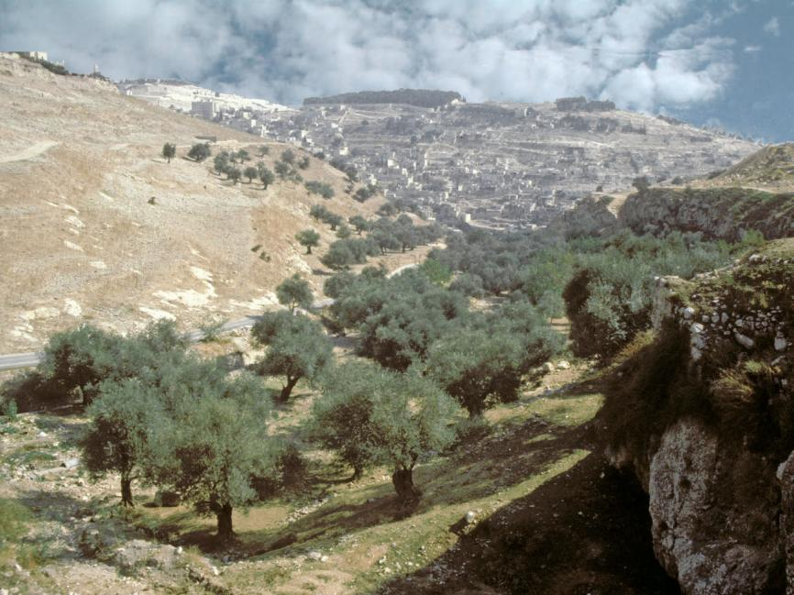
Valley of Ben-hinnom; the bare slope to the left is probably “the shoulder of the Jebusites to the south,” where the borderline between Benjamin and Judah passes (Z. Radovan)

The borderline of Benjamin contains a third example of this same phenomenon as well: Kiriath-jearim, in the southwest corner of Benjamin’s portion. Kiriath-jearim has a satellite city known as “Gibeah” or “Gibeath Kiriath(-jearim).” The Tanakh emphasizes that Kiriath-jearim itself is “a city of the Judites” (18:28), meaning that the borderline runs between the two sites. When the Ark was brought from Beth-shemesh to Kiriath-jearim, it was brought specifically to Gibeah, where Abinadab and his sons were appointed to safeguard it. Against this backdrop, we can now understand well what we mentioned earlier with regard to Lower Beth-horon. The Tanakh went out of its way to describe at great length the northwesternmost point in the land of Benjamin – “the hill south of Lower Beth-horon”; and again, “the hill on the south side of Beth-horon.” The purpose of this was seemingly to stress that Beth-horon was not one of the holy sites that the Benjaminite borderline split down the middle, but it was contained entirely within Ephraim.

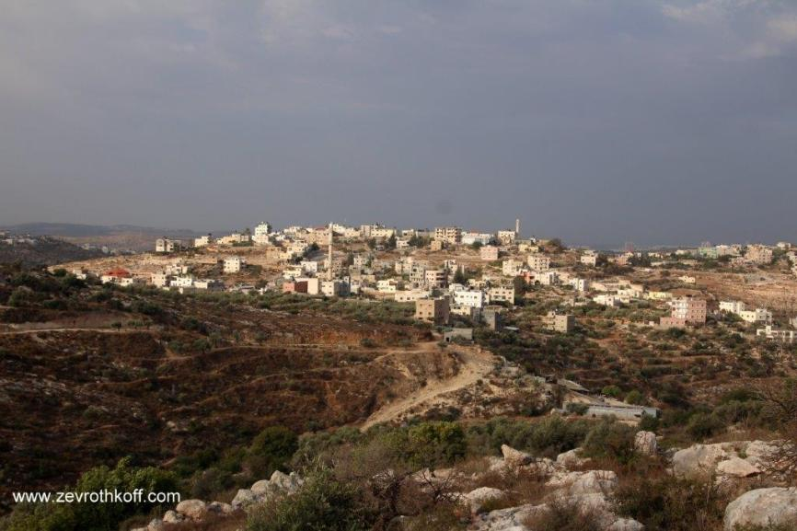
Lower Beth-horon (Courtesy of Dr. Zev Rothkoff)

What is the idea behind all of this? First, it appears that the role of Benjamin within the nation of Israel is connecting. In a theoretical, ideal world, Benjamin’s entire portion would consist of one long connecting line, with no width whatsoever. Since we exist in the real world, the portion does contain a minimal width, but the centers of Benjamin’s true essence are located on the borderlines with its two powerful neighbors, the two major powers of the nation of Israel: Judah and Joseph. Second, this connection is defined by holiness. The Shekhina and the sanctity of the location burst out from the place where the tribes of Israel connect to one another.

Benjamin the tribe is a reflection of Benjamin the person. Benjamin the person began his life as the child of Jacob and Rachel’s old age. Biologically, Benjamin was the full brother of Joseph, but over the course of the tumultuous events of his early life he was taken under wing by Judah: “I myself will be surety for him; you may hold me responsible” (Genesis 43:9). Judah’s absolute loyalty to Benjamin – “Therefore, please let your servant remain as a slave to my lord instead of the boy… For how can I go back to my father unless the boy is with me?” (44:33-34) – was what renewed and recreated the connection between Jacob’s sons and their brother Joseph.

Similarly, the tribe of Benjamin began its existence as part of “the house of Joseph.” The distinction between “Judah” and “Israel” was born long before the days of Rehoboam and Jeroboam; it existed from the beginning of the nation of Israel’s presence in the land of Israel (see Joshua 11:16; I Samuel 15:4; II Samuel 19:41-20:2, 24:9). The difference is that in all the early contexts, Benjamin is associated with “Israel”; in the time of Saul, the tribe of Benjamin even produced a king of “Israel.” But from the moment that the kingdom split following the death of Solomon, Benjamin transferred to the protection of the tribe of Judah.

It is incredibly appropriate that the Temple of the patriarchs was located at Benjamin’s original, natural “connection point” with the tribe of Joseph. By contrast, the eternal Temple is located at the acquired connection point with the tribe of Judah, strengthened by the bonds of loyalty and self-sacrifice.

The Model of a Tightly Stretched Tent

The national ideal is a vibrant life in which both of Israel’s major powers – Judah and Joseph – must develop the nation and themselves, and each must exert a strong pull in its respective direction. If this mutual pulling creates a true connection between the two powers, built upon holiness and shared divine worship, it will create, in effect, a tightly stretched tent, where Benjamin represents the sturdy central cord that connects the two sides. If “Benjamin” and all it represents loosens its grip on the two sides, this will create a disastrous schism between Judah and Israel, each disconnected from the Shekhina and from the other – “There was a continual war between Rehoboam and Jeroboam” (I Kings 14:30). And there is another possibility that is just as bleak: “Benjamin” may remain strong, but the centers of the nation’s life force will become extinguished. The tent’s cord will remain taut, but the tent itself will still collapse. This situation – where people maintain a lifestyle of ethereal holiness without any connection to reality – has a name: It is called galut, exile.

All these ideas are condensed into one short verse: “Of Benjamin he said: Beloved of the Lord, he rests securely beside Him; ever does He protect him, as he rests between His shoulders.”

For further study:

Y. Bin-Nun, “Nachalat Binyamin Nachalat Shekhina,” in Lifnei Efrayim U-Binyamin U-Menasheh, Jerusalem 1985, 25-46 [Hebrew].

S. Dar, et al., Eretz Binyamin: Leket Ma’amarim U-mekorot, Tel Aviv 1972 [Hebrew].

Yehudah Elitzur, “The Boundary Line Between Benjamin and Ephraim,” Studies in Bible and Exegesis 1 (1980), 7-14.

Yoel Elitzur, “Burj Beitin – Masoret U-mekorah,” Shomron U-Binyamin 2, Jerusalem 1991, 103-111 [Hebrew].

A. Frumkin and Yoel Elitzur, “The Rise and Fall of the Dead Sea,” Biblical Archaeology Review 27:6 (2001), 42-50.

A. Frumkin and Yoel Elitzur, “Historic Dead Sea Level Fluctuations Calibrated with Geological and Archaeological Evidence,” Quaternary Research 57, 2002, pp. 334-342.

Z. Kallai, Historical Geography of the Bible, Jerusalem 1986, 125-137, 398-404.

Translated by Daniel Landman

Map 53 (after the diagram)
Today, this site is home to the village of Kharbatha al-Misbah. There is no hill in the area that stands out in terms of its dimensions; the verse is conveying that Beth-horon itself is located in Ephraim rather than in Benjamin.
The term “tongue of the sea” in Biblical geographical terminology refers to an elongated body of water that juts into the land.
A Greek Orthodox monastery is located today in Deir Hajla, as well as an IDF army base and a stubborn settlers’ outpost.
According to the data provided in Parashat Pinchas, Benjamin ranked sixth in population out of the twelve tribes.
The number reaches fourteen if the word aniya preceding Anathoth, interpreted by most as an adjective meaning “poor,” describing the state of Anathoth, and by others (who read the word as anicha) as an instruction to Anathoth to “take up the cry,” is understood as an additional settlement called Anijah.
This can be inferred from the fact that Phinehas son of Eleazar son of Aaron led the warriors, and also from the summarizing words of the section: “Thereupon, the Israelites dispersed, each to his own tribe and clan; everyone departed for his own territory” (Judges 21:24).
Admittedly, as a result of unforeseen developments such as the decision of the Reubenites to settle in the Transjordan, the orientation of the tribal portions was flipped with respect to the wilderness orientation, yielding a sort of mirror image of the wilderness encampment scheme.

