YESHIVAT HAR ETZION
ISRAEL KOSCHITZKY VIRTUAL BEIT MIDRASH (VBM)
*********************************************************

GEOGRAPHY IN THE PARASHA

EREV PESACH

Gilgal
By Prof. Yoel Elitzur

The Starting Point for the Nation of Israel in the Land of Israel

In the haftara for the first day of Pesach, we read about Gilgal.

Every book in the Tanakh presents the reader with a different atmosphere. The book of Exodus transports the reader into the atmosphere of Egypt, allowing him to experience the plagues, the Egyptian gods, the fear and the excitement of the night when the Egyptian firstborn were struck down and the great revolution of the Exodus itself. The book of Kings brings the reader to an atmosphere of kings and prophets, hardships and complications, rebellions and assassinations, Judah and Israel and an endless struggle with Aram and Assyria.

The atmosphere of the book of Joshua is one of liberation, of open skies, sunshine, simple, sincere faith, new beginnings – as the nation of Israel enters the land of Israel. The landscape of Gilgal perhaps represents a perfect characterization of the atmosphere of the entire book of Joshua.

The people of Israel crossed the Jordan on the tenth of Nisan and encamped in Gilgal. There, we read that “At that time the Lord said to Joshua, ‘Make flint knives and proceed with a second circumcision of the Israelites’” (Joshua 5:2). And it was in Gilgal, in the steppes of Jericho, that they brought the Pesach offering: “The Israelites offered the Pesach offering in the steppes of Jericho. On the day after the Pesach offering, on that very day, they ate of the produce of the country, unleavened bread and parched grain” (5:10-11). It was here that the people of Israel became a nation living in its own homeland. It was here where the Mishkan and the Ark of the Covenant resided throughout the period of the conquest and allotment of the land, until they moved to Shiloh.

In Gilgal, the people of Israel set up the twelve stones that they had taken from the Jordan. Just as the night of Pesach is the time for “And you shall explain to your son” (Exodus 13:8), Gilgal is the place for “And you shall explain to your son”:

[Joshua] charged the Israelites as follows: “In time to come, when your children ask their fathers, ‘What is the meaning of these stones?’ tell your children: ‘Here the Israelites crossed the Jordan on dry land.’ For the Lord your God dried up the waters of the Jordan before you until we crossed. Thus all the peoples of the earth shall know how mighty is the hand of the Lord, and you shall fear the Lord your God always.” (Joshua 4:21-24)

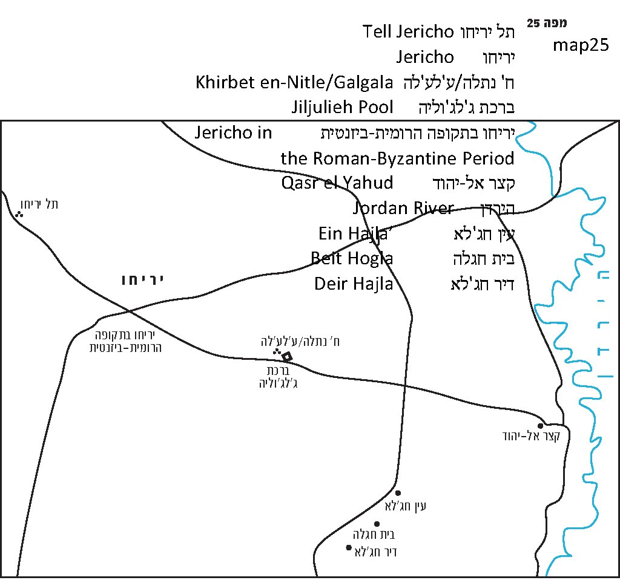

Where is Gilgal?

Based on the geographical context, it is clear that Gilgal is situated between the Jordan and Jericho. But the verse provides a more precise description of Gilgal’s location: “The people came up from the Jordan on the tenth day of the first month, and encamped at Gilgal on the edge of the eastern portion of Jericho” (Joshua 4:19). It is worth paying close attention to the formulation. The verse does not say “east of Jericho” but “on the edge of the eastern portion of Jericho (biktzeh mizrach Yericho).” In other words, “Jericho” refers here to the entire large territorial area that is watered by the springs of Jericho. Gilgal can be found on the eastern part of this territorial area. It seems that Gilgal is not the name of a settlement here (it is never mentioned in any list of cities) but of a region. We can learn from our chapter in Joshua that Gilgal refers to a large region that could accommodate the sizeable population of the people of Israel at the time – 600,000 men, not including children.

Traditions regarding the twelve stones of Gilgal have existed for many years. Josephus wrote (Antiquities 5:20) that the place where the nation encamped and set up the stones that the people had taken from the Jordan is located a distance of fifty stadia from the Jordan and ten stadia from Jericho.

We read in a baraita: “Rabbi Judah said: Abba Halafta, Rabbi Elazar ben Mathia and Hananiah ben Hakinai (sages of the Yavne generation) stood upon these stones and estimated that each was equal to about forty se’ah” (Sota 34a). Forty se’ah was not an imaginary measurement, nor is the story in the baraita of the sort that is prone to extreme exaggeration. The volume of a cubic stone that is slightly less than thirty inches long on each side is approximately forty se’ah. This means that the stones reported by the sages were large but not enormous, keeping in mind that these were natural stones.

This tradition, of which the Tanna’im were aware, was then transmitted to the early Christian pilgrims, who certainly attested to the same tradition. The first of these pilgrims was known as the “Pilgrim of Bordeaux” (333 CE, about two hundred years after the period of the three Tanna’im who “stood upon these stones”). The Pilgrim writes (in Latin) that the twelve stones can be seen in the vicinity of Jericho. Eusebius of Caesarea, a contemporary of the Pilgrim of Bordeaux, writes in his Onomasticon that Gilgal is pointed out in a deserted place two Roman miles east of Jericho, and that the people at the time considered it a holy place. Two hundred years later, the Madaba Map (sixth century CE, according to the accepted dating) shows an illustration of a church with a pitched tiled roof located between Jericho and the Jordan. Near the building, twelve stones can be seen, standing one on top of the other, and above the stones is the Greek inscription: ΓAΛΓAΛA TO KAI ΔWΔEKAΛIΘON (galgala to kai dodekalithon) – “Galgala, which is also [the place of] the twelve stones.”

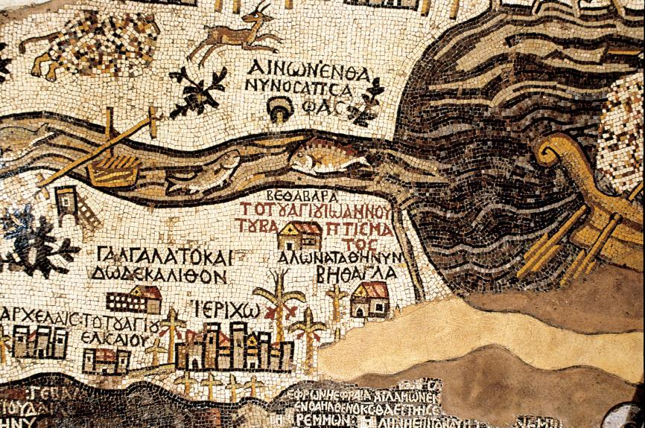
Gilgal in the Madaba Map: A tile-roofed church with twelve stones and the caption ΓΑΛΓΑΛΑΔWΔΕΚΑΛΙΘΟΝ – “Galgala, which is also the twelve stones” (Zev Radovan)

The information provided by the Christian sources allows us to identify with confidence the place that they describe. Two Roman miles is slightly less than two standard modern miles. And indeed, about 1.7 miles east of Byzantine Jericho (located in the area of the market of modern Jericho) between the old Roman road that led to the Jordan and the modern highway that runs parallel to it about a third of a mile to its south, we find an ancient site that is clearly the place that the sources describe. The Arabs call the place Khirbet en-Nitle, but interestingly, there are reliable testimonies from the nineteenth-twentieth centuries regarding the preservation of the name Gilgal in this region, in two different versions. The first version is ġalġala, another name for that same ruin, and the second version is jaljul or jiljulieh, another name for the ruin or for the area surrounding it, or according to the testimony of Claude Conder in the Palestine Exploration Fund (PEF) survey, for the name of a rectangular pool that was located southeast of the site. There have been several known cases of Arab preservation of an ancient name in two different versions. The reason for this may be that there were two different populations. In our case, we may speculate that there were Hebrew or Aramaic speakers on one side and Greek speakers on the other side. In late Greek, for about the past 1500 years, the letter gamma is pronounced as |ġ| (the voiced velar fricative), such that the word “Galgala” sounds like ġalġala. It was not difficult for the Arabs to accept a word with such a pronunciation, since the root ġalġal is known in Arabic, meaning to deepen, permeate or suffuse.

What Can We Find in Khirbet en-Nitle?

The most prominent feature here is the remnants of a Byzantine church. Particularly prominent in the area are fragments of a red tiled roof scattered throughout the area, which are apparently pieces of the roof that was illustrated on the Madaba Map. And what about the stones? Indeed, many stones – both large and small – can be found at the site. Some of these stones may have come from the traditional twelve stones that we have been seeking.

To our great sorrow, control of this invaluable site, along with Jericho itself, including Tell Jericho (Tell es-Sultan), Elisha Spring (‘Ein as-Sultan) and the ancient Shalom Al Yisrael Synagogue, was given over the Palestinian Authority, and Jews are allowed virtually no access to it. To find the site, one must first drive on the road bypassing Jericho to the north. Then, about a mile after passing the Beit Hogla outpost and the Mul Nevo army base, one crosses the old highway path that formerly ran from Jericho to the King Abdullah Bridge at the point about a mile east of the ruins of Gilgal. A helpful landmark for finding this point is a small rise on the left side of the highway containing several tall trees.

I have visited Khirbet en-Nitle, i.e., Gilgal, many times in the past. Not long ago I visited again and found that the Palestinian Authority had marked the site with a sign in Arabic and English: Shajarat an-Nitla (“the Tree of Nitla”). Aside from the archaeological remnants, the site is also quite beautiful. Its surroundings are open and verdant, and in the center stands a tall, spreading tamarisk tree (the Tree of Nitle). The foot of this tree is a perfect spot to rest, as well as to celebrate on Chol Ha-mo’ed. We did just this on several occasions in the past. During the month of Nisan, the springtime sun rising above this tree symbolizes the early days following the arrival of the nation of Israel in its land: “I fell in love with Israel when he was still a child” (Hosea 11:1).

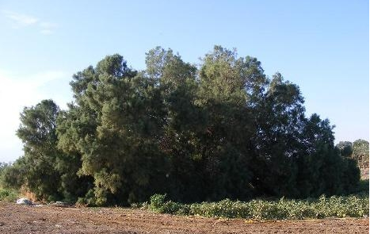
The large tamarisk in Gilgal (Donia Al-Watan)

For further study:

M. Avi-Yonah, The Madaba Mosaic Map: with Introduction and Commentary, Jerusalem 1954, 36-37.

J. H. Bernard, Theodosius (Palestine Pilgrims’ Text Society), London 1893, 7.

C. R. Conder and H. H. Kitchener, The Survey of Western Palestine, III, London 1883, 173, 191.

Yoel Elitzur, Ancient Place Names in the Holy Land, Jerusalem-Winona Lake 2004, 146, 359.

G. S. P. Freeman-Grenville, R. L. Chapman III and J. E. Taylor, The Onomasticon of Eusebius of Caesarea, Jerusalem 2003, 41.

O. Limor, Holy Land Travels: Christian Pilgrims in Late Antiquity, Jerusalem 1998, 35, 149, 175, 227 [Hebrew].

M. Piccirillo and E. Alliata, The Madaba Map Centenary, Jerusalem 1999, 52.

A. Stewart, The Pilgrimage of the Holy Paula by St. Jerome (Palestine Pilgrims’ Text Society), London 1896, 12.

J. Wilkinson, Egeria’s Travels to the Holy Land, Jerusalem 1981, 161.

Translated by Daniel Landman

See map 25
Josephus claimed that Joshua built a stone altar there and offered sacrifices on it, a tradition that is not supported in any other source.
Also see Tosefta Sota 8:3 and Yerushalmi Sota 7:5. Abba Halafta was R. Yosi's father. He was usually called Abba Halafta, meaning “my father Halafta,” by R. Yosi, while others called him Rabbi Halafta. Here however, according to the most reliable testimonies, it was R. Judah who referred to him using the title “Abba,” which should be interpreted as an honorific title in this case.
In the PEF survey and map it was called “Shejeret el Ithleh.” The Arabic word ‘athleh is the etymological parallel of the Hebrew ‘eshel, meaning “tamarisk.” Perhaps the current nitle was developed from this name.

