YESHIVAT HAR ETZION
ISRAEL KOSCHITZKY VIRTUAL BEIT MIDRASH (VBM)
*********************************************************

GEOGRAPHY IN THE PARASHA

SHABBAT CHOL HA-MO’ED PESACH

Aviv and Tel Aviv
By Prof. Yoel Elitzur

In honor of Chag Ha-aviv and Chodesh Ha-aviv, we will now discuss the word aviv and one geographical name that contains it: “Tel Aviv.”

Aviv

Spring is a wonderful time of year. But the Tanakh does not use the word aviv on its own to refer to the spring season, as we do in modern Hebrew, instead using only the phrase chodesh ha-aviv: “Observe chodesh ha-aviv and offer a passover sacrifice to the Lord your God, for it was in chodesh ha-aviv, at night, that the Lord your God freed you from Egypt” (Deuteronomy 16:1). Aviv is a very real agricultural term, meaning the grain that no longer consists of soft grass as it does in the winter, but it not yet yellow and dry as it is in the summer. As we read in Parashat Bo: “Now the flax and barley were ruined, for the barley was in the ear (aviv) and the flax was in bud” (Exodus 9:31). Chazal used this word to mean the same thing; thus we read in the Mishna: “If it has produced blades, he must turn the soil; if it is in the ear (aviv), he must beat them out; if it has grown into corn, it must be burned” (Kil’ayim 5:7). A similar word to aviv is ev, which is found twice in the Tanakh: “To see the budding of the vale (be-ibbei ha-nachal)” (Song of Songs 6:11); and “While still tender (be-ibbo), not yet plucked, they would wither before any other grass” (Job 8:12). This word has parallels in Akkadian and in Arabic. In Akkadian we find the word abbu, meaning swamp, and in archaic Arabic we find the word abbu, which refers to plants for grazing in swamps and meadows. Based on these parallels, Eliezer Ben-Yehuda raised the possibility that perhaps in Hebrew as well, the singular form of the words ibbei and ibbo was *av. If so, the change in the word’s first vowel would be similar to the words pat and tzad, which become pitto and tziddo, respectively, in their possessive forms.

We should comment that, in contrast to the way it appears at first glance, there is apparently no connection between the Hebrew *ev and the Aramaic ibba, which Onkelos and Jonathan frequently use to translate the word peri (“fruit”) when it appears in the Tanakh. This Aramaic word appears three times in Daniel 4 in the form inba, and it is apparently the cognate of the Akkadian word inbu (“fruit”). Akkadian also features the verb enēbu, meaning “to carry fruit.” Another seemingly similar Aramaic word that has a completely different etymological background is aba, meaning “forest” in the Aramaic of the Talmud Bavli. This word is parallel to the Arabic word ‘aba and the Syriac word ‘ava, both of which also mean “forest.” The Bavli’s Aramaic had a strong tendency to omit guttural letters, rendering the word as aba with an alef rather than an ayin.

Tel Aviv Today

The Tel Aviv-Yafo metropolis, which today boasts over 410,000 residents and close to 3.5 million people including the satellite cities in its greater metropolitan area, began as “Ahuzat Bayit,” founded in April 1909 on the sand dunes north of Yafo. A year after the establishment of Ahuzat Bayit, it was decided to name the new city Tel Aviv, which was the title of the Hebrew version of Theodor Herzl’s novel Altneuland. Herzl published Altneuland in German in Leipzig in 1902, at the age of 42. This was seven years after the verdict in the Dreyfus case that shaped Herzl’s identity as a Zionist, and two years before his untimely death. Altneuland made a great impression on the Jewish world, and in the very same year the book was translated into Yiddish by Isidore Elyashiv and into Hebrew by Nahum Sokolow. The inspiration for the name “Altneuland,” which means “Old-New-Land,” came to Herzl from a synagogue in Prague called the Altneuschul. According to tradition, this synagogue contained a building stone from Jerusalem that would one day be returned to its source. Nahum Sokolow, a journalist, author and public figure, was about the same age as Herzl, and was taken by Zionism fever. After Herzl’s death, Sokolow was appointed in his place as the secretary general of the World Zionist Congress and eventually was elected president of that body. He worked for many years on behalf of the Zionist movement, though, like many of his contemporaries, did so from outside the land of Israel.

The name “Tel Aviv” is explained as follows in Sokolow’s novel:

And Friedrich whispered: “Tel Aviv!”

“Indeed so! You aimed well. This was an everlasting ruin, a hill of ancient ruins, and now it is a hill of spring (tel aviv) and life. We established a new state on our old land.”

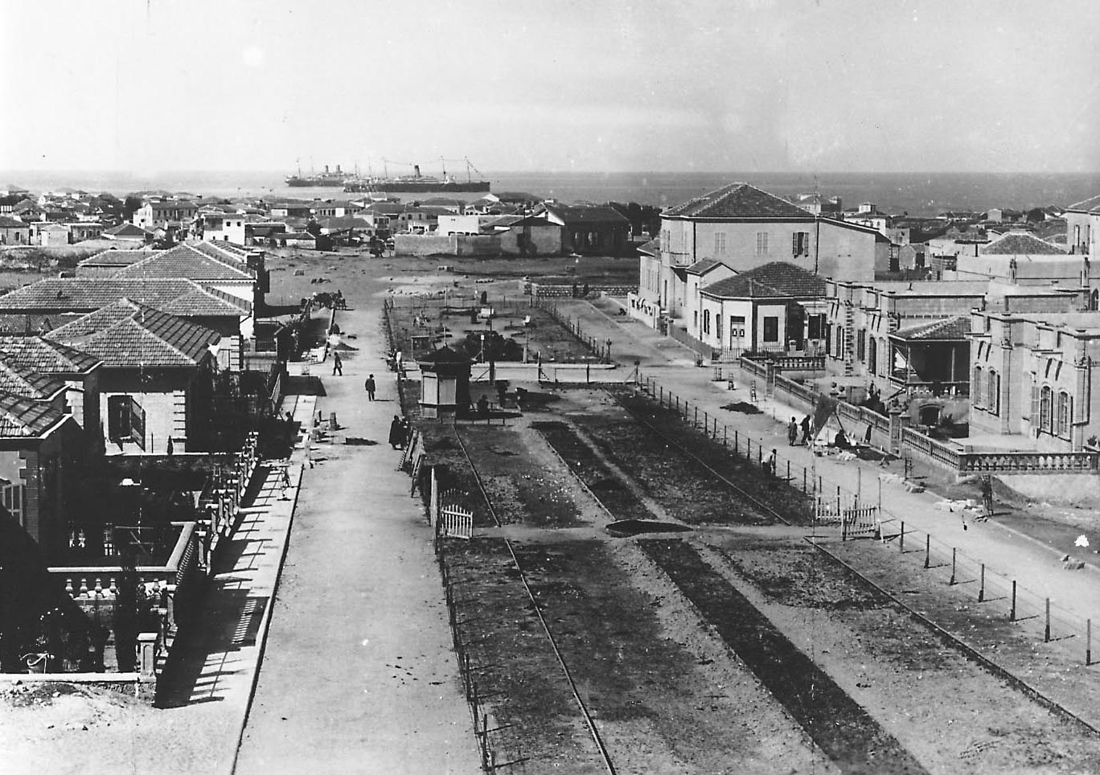
Tel Aviv in its early years (Z. Radovan)

Tel Aviv and Similar Names in the Tanakh

In Zev Vilnay’s Ariel encyclopedia of the land of Israel, there are twenty modern place names in the form Tel-X. These include: one city (Tel Aviv); seven existing Jewish settlements (Tel Yosef, Tel Yitzhak, Tel Litwinsky, Tel Mond, Tel Adashim, Tel Tzur and Tel Katzir); two abandoned Jewish settlements (Tel Hai and Tel Tzur in the Carmel region); one Bedouin settlement (Tel Sheva); six neighborhoods (Tel Or, Tel Arza, Tel Asher, Tel Binyamin, Tel Baruch and Tel Giborim); two neighborhoods that were swallowed up by their surrounding areas and whose names have been forgotten (Tel Hayim and Tel Yehuda); and one hospital (Tel HaShomer).

Despite this, in ancient times this kind of name was almost non-existent in the land of Israel. In post-biblical sources the only name of this type that is known is Tel Arza (Mishna Yevamot 16:7).

In the Tanakh we find three place names in the form Tel-X – Tel Abib (Ezekiel 3:15), Tel-melah and Tel-harsha (Ezra 2:59 and Nehemiah 7:61) – all three of which are located in Babylonia. Names of this type were apparently common in Mesopotamia at the time. In the list of place names mentioned in Assyrian sources collected by Finnish Assyriologist Simo Parpola there appear twenty-four names in the form Til-X, and in the list of names from Babylonian sources collected by Ran Zadok there appear twenty-one such names. The three names from the Tanakh mentioned above are not mentioned in Assyrian and Babylonian sources, but one of the twenty-four names from Assyrian sources is perhaps mentioned in the Tanakh in a slightly different version. The name in question is Til-Aššūr, mentioned in three royal inscriptions of Tiglath-Pileser III (744-727 BCE) and in three inscriptions of Esarhaddon (680-669 BCE). It has been suggested that this Assyrian name should be identified with Telassar, a place mentioned in the Rabshakeh’s speech opposite the walls of Jerusalem (II Kings 19:12, Isaiah 37:12). It has even been speculated that the Biblical version of the name is actually the original name, while the Assyrian sources adjusted it to the more common formula, Til-X.

Tel Abib: The City of Judean Exiles in Babylonia

The book of Ezekiel begins with the vision of the chariot that was revealed to the prophet Ezekiel “in the community of exiles by the Chebar Canal” (Ezekiel 1:1). After this revelation, Ezekiel travels to “the exile community that dwelt in Tel Abib by the Chebar Canal” (3:15), where he seems to have continued to dwell with the exiles. The Chebar Canal is mentioned in the form nâr Kabâru in Babylonian documents of that period, and in the Persian Period in the archives of the Murashu family of Nippur, which was located about 45 miles southeast of the city of Babylon (about 90 miles south of Baghdad). The Chebar Canal was a large artificial stream that ran from the Euphrates River north of Babylon and returned to flow back into the Euphrates about 70 miles farther south. The canal split into secondary canals and watered a large stretch of land east of the Euphrates. The Chebar Canal flowed through Nippur, which was located in the same region where the Judean exiles settled. In recent years, documents have been found in Babylonia that mention “the city of the people of Judea,” and in a shortened version, “the city of Judea.” This place may have been another city of Judean exiles, and possibly even Tel Abib itself.

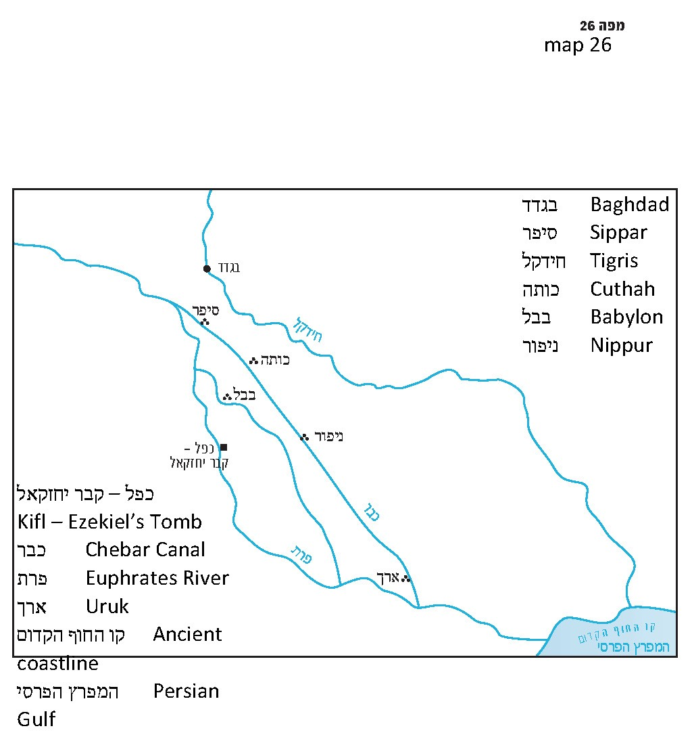

It is interesting to note that an ancient tradition identifies a site on the banks of the Euphrates River, west of the remains of Nippur, as the tomb of the prophet Ezekiel. The place is called Kifl and it contains an impressive fortified site, featuring two towers and about two hundred stores that used to be owned by Jews. The place is mentioned as early as in the Geonic literature. Two of the first and most famous Jewish travelers of the Middle Ages, Rabbi Benjamin of Tudela and Rabbi Petachiah of Regensburg, who visited the site between 1170 and 1180, described it in detail and with great admiration. Iraqi Jews would visit the site and fill it and its surrounding area with large crowds of people on the Jewish festivals. The place also was home to clay tiles on which the verses of the book of Ezekiel were engraved. Starting from 1937 until the decade following the establishment of the State of Israel, these tiles were dismantled. Some pieces reached Israel and were handed over to the president of Israel at the time, Yitzhak Ben-Zvi, and they can be viewed today at the Ben-Zvi Institute (Yad Ben-Zvi). Following the Gulf War, Jewish groups from Israel and from around the world returned to visit the site once more, and it became clear that anti-Semitic Arabs had damaged the Hebrew inscriptions at the site.

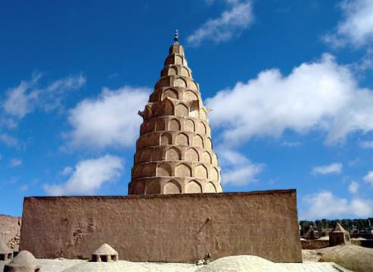
Ezekiel’s Tomb by the Euphrates River

The Linguistic Background of the Name of the Babylonian Tel Abib

The word aviv and the name Tel Abib do not carry any meaning in Akkadian, the language of Babylonia, but there is a famous and important expression in Akkadian that is similar in its form to aviv: abūbu, meaning “the deluge.” The expression is used in the same contexts in which the word mabbul is used in Hebrew, first and foremost as a name for the cosmic event of the destruction of the world in the early days of humanity, through a divinely ordained flood. Here and there, however, it is also a name for an exceptionally devastating rainstorm. Two unique linguistic expressions sometimes include the word abūbu. The first expression is lām abūbi, meaning “before the deluge,” used to refer to something that is primordially ancient. The second expression is til abūbi, meaning “a hill of ruins made by the flood,” or in other words, an everlasting ruin, a place that is eternally destroyed and desolate. The expression is generally mentioned in victory inscriptions that describe the conquest and destruction of cities and lands, and sometimes in the formulations of curses for those who would break a pact. Modern scholars have connected the biblical “Tel Abib” to this expression, maintaining that the exiles were resettled in a ruined tell called Til Abūbi. Some scholars suggested emending the text of the verse from “Tel Abib” to “Tel Abub,” while others posited that “Tel Abib” was a euphemism: The exiles changed the name of the site from one with negative connotations to a more pleasant-sounding Hebrew name. The difficulty with these theories is that in all the Babylonian and Assyrian literature there is not one mention of an actual place described as a “til abūbi,” nor is there any certainty that a place called Til Abūbi actually exists. The phrase is always used as literary imagery for cases of extreme destruction, similar to the Hebrew phrase tel olam (“an everlasting ruin”; see Deuteronomy 13:17). The Chicago Assyrian Dictionary cites eight sources that mention til abūbi. In seven of them, the full expression is kīma til abūbi, meaning, “like hills of ruins,” and in the eighth the expression is māssu ana til abūbi litēr, meaning, “may (Adad) turn his land into hills of ruins.”

It seems to me that we will be able to understand the matter once we delve into the world of Ezekiel, his contemporaries and his geographical setting. Tel Abib by the Chebar Canal in Babylonia was a city of Judean exiles who arrived in Babylonia during the exile of Jehoiachin. Ezekiel, who arrived in Babylonia with them, saw divine visions and was chosen as a prophet by the Chebar Canal, on the fifth day of the fourth month, during the fifth year of the exile of King Jehoiachin (Ezekiel 1:2) – six years before the destruction of Jerusalem (592 BCE). Immediately after the revelation by the Chebar Canal, it says:

A spirit seized me and carried me away. I went in bitterness, in the fury of my spirit, while the hand of the Lord was strong upon me. And I came to the exile community that dwelt in Tel Abib… and for seven days I sat there stunned among them” (3:14-15).

Ezekiel’s prophetic career continues for twenty years (compare to Ezekiel 40:1), and the next dated prophecy comes to him in his home in Tel Abib on the fifth of Elul, one year after the first revelation (8:1).

In the summer of 2005, my friends – and I alongside them – suffered the difficult experience of destruction, as well as a kind of exile: Israel’s dismantlement of the communities of Gush Katif. What we experienced was not nearly as grievous as what our ancestors experienced in the time of Ezekiel, but the last two weeks that I spent in Kfar Darom with its residents, and the tears on the day of the expulsion are things that one who experienced them remembers anew every day of his life. “Like a sparrow wandering from its nest is a man who wanders from his home” (Proverbs 27:8). Even today, when I happen to meet one of the evictees, our conversation is different from the conversation I might have with any past friend or acquaintance. Simple small talk like “How are you?” and “How’s it going?” takes on new, loaded significance.

When I read about Tel Abib by the Chebar Canal in the book of Ezekiel today, it is no longer simply “the city of Judean exiles” as it says in the commentaries or in encyclopedias. These were people who were torn by brute force from their lives and from their homes in Jerusalem or in Judea, shackled in chains and shipped off to a foreign, distant land so different in its landscape, language and climate from their own. Even if these people later managed to maintain reasonable, civil relationships with the Babylonian authorities, they can never be the same people they once were. Five years after the initial trauma, Tel Abib by the Chebar Canal is a settlement under construction. The settlement that they are building or that the authority is building for them is a settlement of uprooted people, devoid of the usual joy and delight of building. Today I understand that “I sat there stunned among them” has a dual meaning: It describes both Ezekiel and the people around him.

It is easy to understand how the people there lapsed into apathy and despair. It is also easy to understand the feelings that the false prophets – Ahab son of Kolaiah, Zedekiah son of Maaseiah and Semaiah the Nehelamite (Jeremiah 29:21-32) – sowed among the people, promising the nation that the awful nightmare was about to end, and that in a short time they would all joyfully return to Judea and Jerusalem. It seems that it was no coincidence that only after a year in Tel Abib does the Tanakh mention that the prophet lived in a house. Indeed, it is logical to presume that the settlement, during its construction, was made up of tents or temporary huts, and that it took some time until the first real houses appeared. Ezekiel and the elders of Judea who “were sitting before [him]” (Ezekiel 8:1, 14:1) were certainly among the people who agreed to take the reasonable and responsible albeit unexciting path, as Jeremiah encouraged them to do in his letter:

Thus said the Lord of Hosts, the God of Israel, to the whole community which I exiled from Jerusalem to Babylon: Build houses and live in them, plant gardens and eat their fruit. Take wives and beget sons and daughters…. Multiply there, do not decrease. And seek the welfare of the city to which I have exile you and pray to the Lord in its behalf; for in its prosperity you shall prosper. (Jeremiah 29:4-7)

This is not an easy task: to build without the delight of creation, to know that “It will be a long time” (29:28), to accept the decree of Babylonian exile that could be – and indeed was – not particularly harsh. The exile lacked the curses, destruction, bloodshed, famine and pestilence described in the Torah’s admonition, but it was still a full-fledged exile.

It may be that the Hebrew name that was adapted to the Babylonian setting – “Tel Abib” – was born of this prophetic approach. I will permit myself to speculate that at least from a linguistic and literary perspective, the rationale behind the Hebrew name “Tel Abib,” given by exiles from Jerusalem in the sixth century BCE, was not too far from the idea that inspired Nahum Sokolow in the early twentieth century CE. It seems to me that we may presume that they too considered the integration of tel, symbolizing the destruction, with aviv, symbolizing the new – albeit slow – growth. I believe that the Babylonian-Assyrian expression til abūbi is certainly the key to the background of name “Tel Abib” that the exiles gave to their settlement. However, this was not the true name of the place, but rather a literary concept. When they chose to give the name Tel Abib to the city of exiles that they built, it was as if they were defying the original Akkadian expression by presenting in its place a Hebrew expression that was so similar to it in linguistic structure and yet so different from it in its contextual meaning. The exiles were declaring to themselves and to others: We will not allow ourselves to become mired here out of apathy caused by the destruction of our former lives. Neither will we entertain unrealistic delusions of a sudden return to our homeland on the wings of eagles. We will develop ourselves slowly but surely, like the stalks of grain that are still green in the springtime, until the conditions are ripe for us to return home, to the land of Israel.

For further study:

E. Ben-Yehuda, A Complete Dictionary of Ancient and Modern Hebrew, 7 [Hebrew].

C. Cohen, “Tel Aviv,” in A. Maman, S. E. Fassberg and Y. Breuer (eds.), Sha’are Lashon 1, Jerusalem 2007, 30-32 [Hebrew].

C. Cohen, “The Lord Sat Enthroned Before the Flood (Ps. 29:10): A New Interpretation,” Leshonenu 53 (1990), 193-201 [Hebrew].

G. A. Cook, The Book of Ezekiel (ICC), Edinburgh 1967, 42-43.

I. J. Gelb, et al. (eds.), The Assyrian Dictionary, A/1, s.v. abūbu, Chicago 1964, 77-78.

S. A. Kaufman, The Akkadian Influences on Aramaic, Chicago 1974, 58-59.

Y. Kobayashi, “Tel Abib,” Anchor Bible Dictionary, 6, 344.

S. Parpola, Neo-Assyrian Toponyms, Neukirchen-Vluyn 1970, 352-356.

R. Zadok, Gepgraphical Names According to New-and Late-Babylonian Texts (RGTC 8), Wiesbaden 1985, 308-313.

R. Zadok, The Nippur Region during the Late Assyrian, Chaldaean and Achaemenian Periods, Chiefly according to Written Sources, IOS 8: 266-332.

R. Zadok, “Tel Abib”; “Telassar,” Encyclopaedia Biblica 8, 568 [Hebrew].

Wikipedia entries: “Altneuland”; “Nahum Sokolow”; “Ezekiel’s Tomb”; “Tel Aviv”

Translated by Daniel Landman

We also find this word in the Talmud Bavli in Chullin 67b.
For example: “Thus the proverb runs, ‘From the very forest itself comes the [handle of the] axe (aba) [that fells it]” (Sanhedrin 39b).
The Peshitta, the Syriac translation of the Bible, uses the word ‘ava (with an ayin) in its translation of the verse, “A man goes with his neighbor into a grove” (Deuteronomy 19:5).
Sokolow published the book as Tel Aviv: A Story by Theodor Herzl. Translated into Hebrew: N.S. Warsaw, The Russian Zionist Organization, 1902.
Sokolow died in London in 1936; his remains were brought to Israel in 1956 and re-interred next to Herzl’s tomb.
For more details and references, see our discussion on Parashat Kedoshim.
See Map 26
During the Middle Ages this occurred primarily on Sukkot and in the modern period on Shavu’ot.
Prof. Chaim Cohen of Ben-Gurion University in Beersheba suggested using this expression to interpret the verse, “The Lord sat enthroned at the Flood (la-mabul); the Lord sits enthroned, king forever” (Tehillim 29:10) to mean that God sits on His royal throne forever; “Your throne stands firm from of old; from eternity You have existed” (93:2).

