YESHIVAT HAR ETZION
ISRAEL KOSCHITZKY VIRTUAL BEIT MIDRASH (VBM)
*********************************************************

GEOGRAPHY IN THE PARASHA

SHEVI’I SHEL PESACH

The Sea of Suph
By Prof. Yoel Elitzur

We will now discuss the Sea of Suph, where an unprecedented and unequaled miracle took place, and whose banks first heard the jubilant sound of the Song at the Sea: “I will sing to the Lord, for He has triumphed gloriously” (Exodus 15:1).

The Red Sea

We all know that the Sea of Suph is the body of water we know today as “the Red Sea.” Do not believe the fictitious explanation for this name that one hears frequently from tour guides and others easily taken by false etymologies, that the source of the name “the Red Sea” is a misspelling of the English translation of Yam Suf – “Reed Sea.” The truth of the matter is that “the Red Sea” originated from the Greek Erythra Thalassa, which became the Latin Mare Rubrum and later the Aramaic Yama Sammoka (as appears in the Dead Sea Scrolls). The name then migrated to all the European languages. Herodotus mentions this name already in the middle of the fifth century BCE, and the translators who authored the Septuagint used the name in the middle of the third century BCE as the established translation for Yam Suf. In ancient sources, the name refers occasionally to the Persian Gulf or even to the Indian Ocean. The source of the name is not clear, though it may be that it derives from the mountains of red granite in its vicinity. We will suffice by saying that English and many other languages refer to the Sea of Suph as “the Red Sea.”

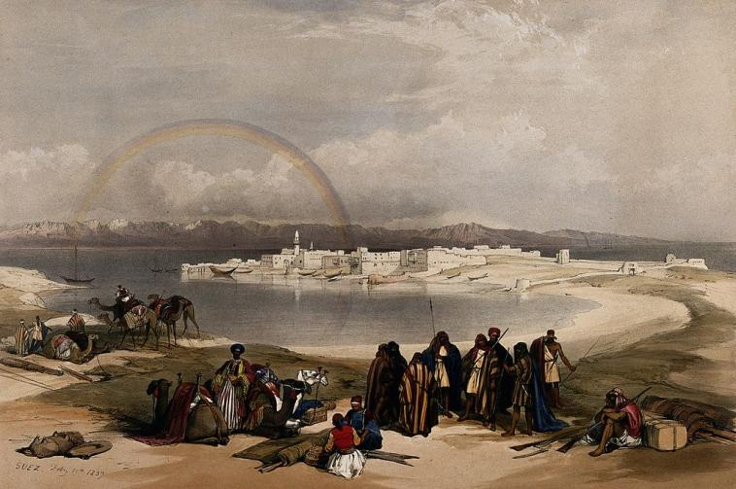
Colored lithograph of Suez and the Gulf of Suez, 1849 (Wellcome Images)

The Scholarly View Placing the Sea of Suph in a Northern Lake

In modern Hebrew as well, Yam Suf refers to the Red Sea, and specifically to its two gulfs on either coast of the Sinai Peninsula: the Gulf of Eilat and the Gulf of Suez (in Arabic Suways). However, if we look at encyclopedias, historical atlases or various modern commentators, we are in for a surprise. Most modern scholars identify the Sea of Suph – where the people of Israel crossed – as one of various bodies of water other than the Red Sea itself. Most label one of the two so-called Bitter Lakes, which are today combined in the Suez Canal as “the Sea of Suph,” while others chose Lake Manzala by to the Mediterranean Sea, near Port Said. Still others strayed even farther away from the Red Sea, preferring Lake Bardawil (Herodotus’ “Serbonian Bog”) within the Mediterranean Sea in northern Sinai.

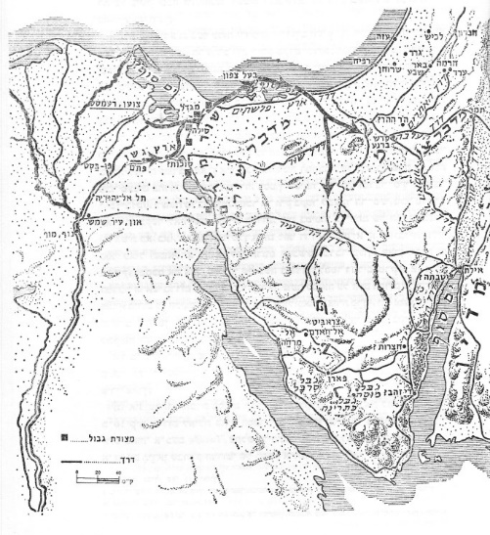
The route of the Exodus according to the first edition of Yohanan Aharoni’s The Land of Israel in Biblical Times (Jerusalem 1962 [Hebrew]). Here, the Sea of Suph is identified with both Lake Manzala and Lake Bardawil joined to the Mediterranean! In later editions other opinions were also represented. (Courtesy of Bialik Institute)

Are the Scholars Right?

If one follows the occurrences of the name “the Sea of Suph” in the Tanakh, it is easy to come to the conclusion that the Biblical Sea of Suph indeed refers to both gulfs of the Red Sea. Particularly interesting in this regard is Rashi’s commentary on Parashat Bo. Rashi, who lived more than 900 years ago, never visited the land of Israel and seemingly did not use maps either. The only materials at his disposal were the Tanakh and the literature of Chazal. The visual appearance of the Sea of Suph as we know it – a sea that is bifurcated into two long, narrow gulfs, one on the east and one on the west, reaching Egypt – is highly unusual and difficult to guess without prior knowledge of it. But Rashi, using only the texts available to him, seems to have guessed correctly: “I believe that the Sea of Suph was partly in the west, opposite the entire southern boundary, and also east of the land of Israel” (Rashi, Exodus 10:19). We will list a few of the sources that prove this (based on Rashi, with certain differences). The most prominent source, which demonstrates clearly that the entire Gulf of Suez is called “the Sea of Suph” is the story of the plague of locusts: “And when morning came, the east wind had brought the locusts. Locusts invaded all the land of Egypt and settled within all the territory of Egypt…” (Exodus 10:13-14). Ancient Egypt was a strip of land a few dozen miles wide concentrated along the entire length of the Nile River (the northern region was much wider because of the many branches of the Nile Delta). The Torah states that the locusts reached Egypt by way of an “east wind,” and they “settled within all the territory of Egypt.” After Moses pleaded with God on behalf of Pharaoh, the locusts left by way of a west wind: “The Lord caused a shift to a very strong west wind, which lifted the locusts and hurled them into the Sea of Suph; not a single locust remained in all the territory of Egypt” (10:19). The verse indicates that a west wind “thrust the locusts into the Sea of Suph, which was opposite it” (Rashi), demonstrating that just as Egypt was a kind of long strip running from south to north, the Sea of Suph was similarly a long strip running from south to north, east of Egypt. On the other hand, one can cite other verses that seem to indicate that the Sea of Suph is located southeast of the land of Israel: “I will set your borders from the Sea of Suph to the Sea of Philistia” (23:31); “They set out from Mount Hor by way of the Sea of Suph to skirt the land of Edom” (Numbers 21:4); “King Solomon also built a fleet of ships at Ezion-geber, which is near Eloth on the shore of the Sea of Suph in the land of Edom” (I Kings 9:26). The meaning seems clear: The Biblical Sea of Suph refers to the two gulfs of the Red Sea.

Why Did the Scholars Move the Sea of Suph North?

There are two answers to this question, one geographical-historical and one linguistic. The geographical-historical reason is the scholars’ desire to find a place that would provide a natural explanation for the miracle of the Splitting of the Sea (or “the creation myth of the Splitting of the Sea,” as Bible critics would say). We will not address the topic of miracles and nature in Jewish thought and throughout the Tanakh in this framework. We will merely note that, at least in our case, the desire to find a natural explanation for the Splitting of the Sea is justified; such an explanation is even implied in the Biblical text itself. The Torah speaks of a powerful east wind that blew for many long hours preceding the Splitting of the Sea, and hints at the fact that the water returned to its place only gradually, in stages. First, the ground became muddy and the wheels of the Egyptian chariots became stuck in it, causing them to become dislodged from their axles. At this stage, the Egyptians attempted to return toward Egypt, at which point the water returned and engulfed them and their chariots. Various scholars considered the marshy swamps near the northern lakes as an appropriate location for the drowning of the Egyptians, and some scholars believed that in those lakes there was likely to be greater differences in water level between high and low tides. Others explained alternatively that the strong wind created sandstorms that could transport whole dunes into the lakes. The most prominent example of such phenomena is Lake Bardawil, a shallow lake located within the Mediterranean Sea. On the northern boundary between the lake and the deep waters of the sea is a strip of land that appears during low tide and is covered by water during high tide.

The linguistic reason is the desire to understand the name “Sea of Suph,” in Hebrew and possibly in Egyptian as well. The Hebrew suf refers to the sedge, a freshwater plant that grows on the banks of the Nile. The Red Sea is a salty sea and thus no sedge can grow on its shores. By contrast, sedge are common on the shores of the Bitter Lakes, as well as in Egypt and in the Northern Sinai Peninsula, due to the high groundwater there.

Because of these two perspectives, scholars saw fit to move the Sea of Suph northward. From the etymological perspective, one may claim that the name indeed at first referred to the northern lakes, but its usage later spread to the salty sea south of the lakes as well, and the meaning of the name was forgotten. However, the burden of proof lies with one who would make such a claim. From the perspective of the Torah’s narrative, scholars have had the most difficulty grappling with the verse that states that “God did not lead them by way of the land of the Philistines, although it was nearer…. So God led the people roundabout, by way of the wilderness at the Sea of Suph” (Exodus 13:17-18). The Bitter Lakes, and even more so the lakes adjacent to and within the Mediterranean Sea, are “by way of the land of the Philistines,” the shortest route from Egypt to Canaan – not “by way of the wilderness.” The scholars attempted to resolve this problem in various ways, both exegetical and critical, and I will not review them here.

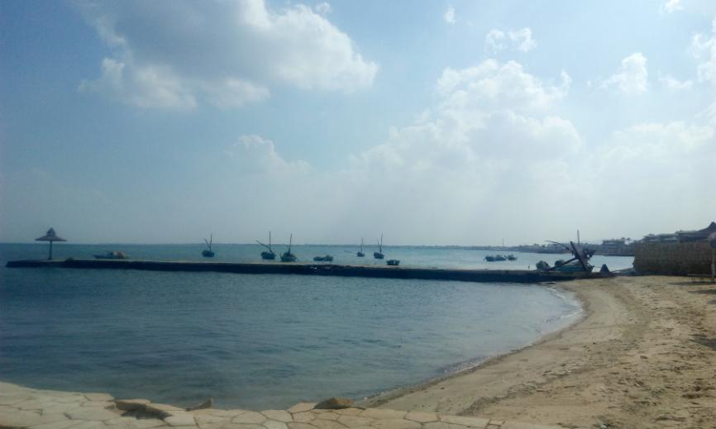
The Great Bitter Lake

In my opinion, this is a typical case of hard data against speculation. In every place where the information found in the Tanakh is clear, the Biblical Sea of Suph is the Red Sea. Etymological speculations and scientific reconstructions of miraculous events cannot simply brush away hard data. We may be able to explain the Splitting of the Sea or we may not; we may succeed in understanding the etymological background of the word suf or we may not (do we understand the names “Sinai,” “Zin,” “Alush,” “Amalek” and many others?). But the explicit facts that arise from the words of the Tanakh in other prominent places must form the basis for our conclusions.

Where Did the Splitting of the Sea Take Place?

In order to understand the geographical location of the Splitting of the Sea, it is worth mentioning the name Etham, “which is on the edge of the wilderness,” where Israel encamped before the Splitting of the Sea. From there the people traveled to Pi-hahiroth, Migdol and Baal-zephon, until they finally marched into the sea on dry ground. In the list of the marches of the people of Israel in Numbers 33, it says that after they crossed the sea “they made a three-days’ journey in the wilderness of Etham and encamped at Marah.” These combined pieces of information demonstrate that Etham was located on the edge of the Sea of Suph, on the border between “the wilderness” and “the land,” apparently in the place where the modern-day city of Suez is situated. This demonstrates that the Splitting of the Sea took place just south of Suez.

One attempt to explain the miracle scientifically in this location was made by a hydrologist named Moshe Dayan (no relation to the famous general). Dayan examined the data regarding the sea in the period preceding the construction of the Suez Canal, according to maps and diagrams that the canal’s excavators used in the mid-nineteenth century. He came to the conclusion that the area contained a raised terrace that could become exposed for a certain amount of time under extreme conditions of both low tide and strong winds, and then become inundated with large amounts of water immediately thereafter. One of the early preparations that the members of Ferdinand de Lesseps’ delegation undertook prior to excavating the Suez Canal was to inspect the tidal range (the difference between the high tide and the low tide) in the various bodies of water that the canal would connect. The tidal range in the Bitter Lakes was 0.66 meters; in the Mediterranean Sea it was 1.10 meters; but in the Gulf of Suez it was all of 3.24 meters!

In conclusion, whether or not we are convinced by the veracity of Moshe Dayan’s analysis, the Sea of Suph is indeed the Red Sea, and not any lake to its north or on the shores of the Mediterranean Sea. The people of Israel crossed the sea near the northern edge of the Gulf of Suez. Blessed is He who performed miracles for our ancestors in this place!

For further study:

Y. Aharoni, The Land of the Bible: A Historical Geography (translated and edited by A. F. Rainey), Pennsylvania 1979, 196-197.

U. Cassuto, A Commentary on the Book of Exodus, trans. I. Abrahams, Jerusalem 1974, 127.

C. Cohen, “Musagim Geografiyim Be-mivchan Ha-etimologiya Ve-haheksher (Mi-shi’urei Dr. Yoel Elitzur),” Maaliot (1995) 158-167 [Hebrew].

M. Dayan, “The Dividing of the Red Sea According to Natural Sciences,” Beit Mikra 73 (1978), 162-176 [Hebrew].

K. A. Kitchen, The Reliability of the Old Testament, Michigan-Cambridge 2003, 259, 261-263.

Translated by Daniel Landman

The former Israeli settlement of Nahal Yam was located on the shore of this lake, and its residents supported themselves by fishing there. It was evacuated in 1974 and then handed over to Egypt in 1980.
According to Cassuto, the locusts came from the direction of Sudan. He explains that the phrase ru’ach kadim throughout the Tanakh refers to a strong, dry wind and not necessarily an eastern wind.
In classical Egyptian, the word swt is equivalent to the Hebrew suf (the last letter may not be part of the root). In modern Egyptian the word is ṯwfy.
This would be similar to the name “the Red Sea,” which grew to include the Indian Ocean and the Persian Gulf in various sources, or “Africa,” which once referred to North Africa alone, and now refers to the entire continent.
See Exodus 8:21-23 to compare the Torah’s usage of these two terms.

