YESHIVAT HAR ETZION
ISRAEL KOSCHITZKY VIRTUAL BEIT MIDRASH (VBM)
*********************************************************

GEOGRAPHY IN THE PARASHA

SHAVU’OT

Sinai
By Prof. Yoel Elitzur

“On the third new moon after the Israelites had gone forth from the land of Egypt, on that very day, they entered the wilderness of Sinai…. Israel encamped there in front of the mountain” (Exodus 19:1). At Sinai we encamped as one man, with one heart. At Sinai, we heard the voice of God speaking from out of the fire. At Sinai, we made the golden calf – but also the Mishkan. At Sinai, we became a nation, with chieftains, flags, Levites and priests. Sinai is the setting for half of the book of Exodus, all of the book of Leviticus and a third of the book of Numbers. The nation of Israel stayed in Sinai for almost a year, a year in which it acquired its eternal, unchanging identity.

Where is Mount Sinai? The number of different views on this matter is almost equal to the number of scholars who tackled the question. In Menashe Har-el’s book The Sinai Journeys, which was first published in Hebrew in 1968, he listed twelve different views regarding the location of the mountain, and in the decades that have passed since the book’s publication even more suggestions have been proposed. Mount Sinai has been identified with almost every significant peak in the Sinai Peninsula. After the Sinai Peninsula was handed over to Egypt, one scholar even identified Mount Sinai with Mount Karkom in the western Negev, within the borders of the state of Israel – quite a convenience for Israeli visitors. Some identified Mount Sinai in Midian, east of the Gulf of Eilat, and some went so far as to identify it in the northern Transjordan or even in the depths of the Arabian Peninsula.

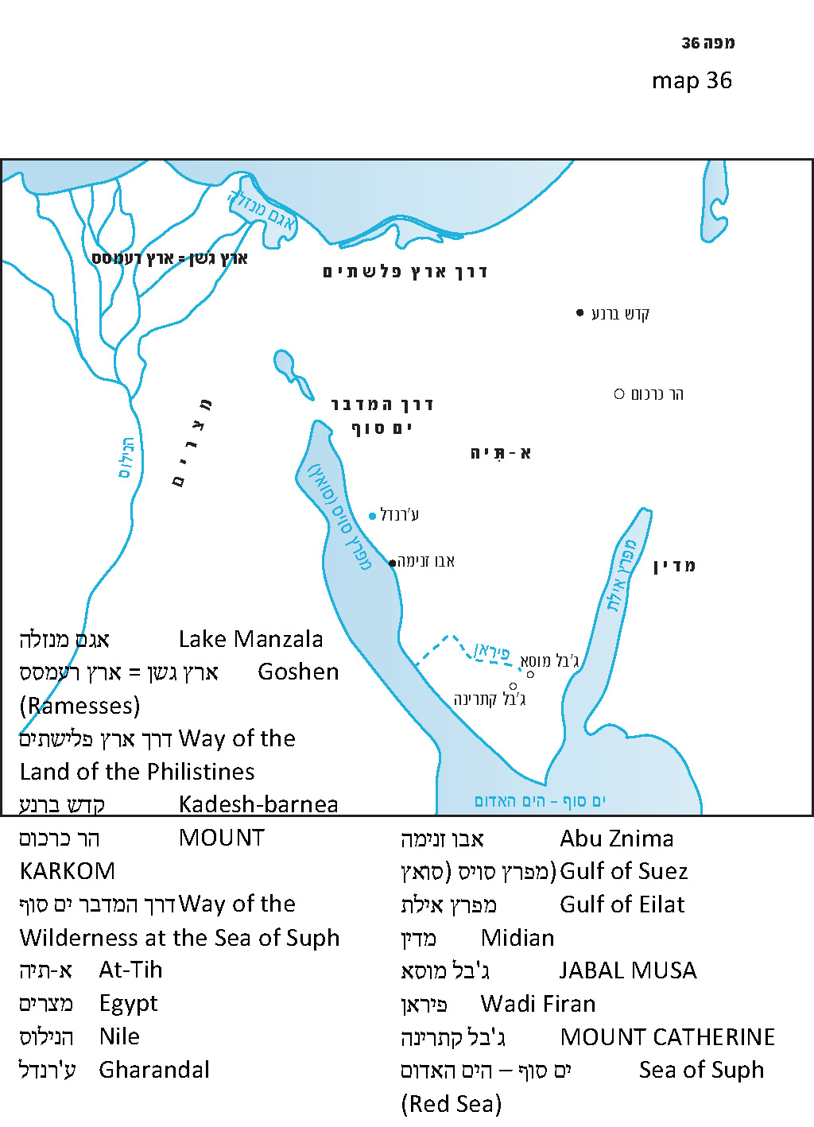

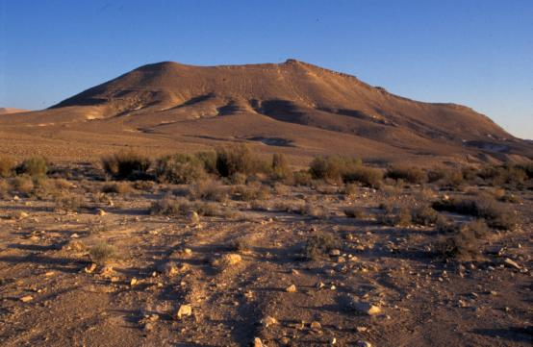
Mount Karkom, south of Makhtesh Ramon – “Mount Sinai” according to Prof. Emmanuel Anati (Zev Radovan)

Is There a Way to Determine Which View is the Right One?

In my opinion, there is.

What do we know from the Tanakh about the wilderness of Sinai and Mount Sinai? The meaning of the name Sinai is actually not clear to us, but the location’s other name – Horeb – indicates an arid region. The verses teach us that the region contains rocks and boulders, from which God – through the hand of Moses – drew water for Israel: “I will be standing there before you on the rock at Horeb. Strike the rock and water will issue from it” (Exodus 17:6). It seems that a verse in Deuteronomy describes the very same incident: “Who brought forth water for you from the flinty rock” (Deuteronomy 8:15). This outpouring of water was not a one-time event. The water continued to flow long after Moses struck the rock, and it was mentioned later in connection to the sin of the Golden Calf: “He strewed it upon the water” (Exodus 32:20); and in the account in Deuteronomy: “I threw its dust into the brook that comes down from the mountain” (9:21). At the foot of the mountain there must have been room for a large encampment. One of the rabbinic aggadot (Sota 5a; Midrash Tehillim 68) presents Mount Sinai as a hill that is not particularly tall. Indeed, it was because of its humility that it merited serving as the setting for the Giving of the Torah, instead of other towering peaks like Tabor and Hermon. However, it is far from certain if this aggada was speaking of an actual geographical identification; it is more likely that the details of the aggada remain in the realm of ideas and moral lessons.

Finding Sinai

The Biblical text provides a few clues as to the location of Sinai. The people of Israel reached the wilderness of Sinai a month and a half after leaving Egypt, taking a discontinuous path with several stops along the way. The Torah reports: “It is eleven days from Horeb to Kadesh-barnea by the Mount Seir route” (Deuteronomy 1:2), and the prophet Elijah walked forty days and forty nights from the wilderness of Beer-sheba “as far as the mountain of God at Horeb” (I Kings 19:8). However, the most basic piece of geographical information the Torah provides us regarding Sinai is its location between Midian and Egypt. Moses traveled there initially from Midian, when he led his flock far from his normal grazing area. Moses passed through this place again when he later returned from Midian to Egypt. On that occasion, God sent Aaron to meet him: “He went and met him at the mountain of God, and he kissed him” (4:27).

Sinai’s location between Midian (whose identity has been established as the eastern coast of the Gulf of Eilat, in our context the northern part of this region) and Egypt allows us to reject outright all the views that place it outside the Sinai Peninsula. Even within the Sinai Peninsula, there are vast regions in which Mt. Sinai could not possibly be located.

First of all, the reader should beware of being misled by the modern name “the Sinai Peninsula.” In Biblical terminology, Sinai was only one of several wildernesses in this huge space, and by no means the largest among them. From a geographical perspective, the Sinai Peninsula is made up, broadly speaking, of three major sections:

- The northern section close to the Mediterranean Sea is not very arid. It has relatively high groundwater levels, numerous dune fields and, here and there, settlements and the remnants of ancient settlements.

- The central section, known in Arabic as at-Tih, is an absolute desert, mostly flat and large in area – almost 7.5 million acres with virtually no signs of life.

- The southern section is a region whose center contains an exceptionally tall massif with lofty granite mountains reaching up to 8500 feet above sea level.

The northern section of the Sinai Peninsula is known in the Tanakh as the wilderness of Shur. It is mentioned in the book of Genesis in connection to the patriarchs and their settlement in the western Negeb; in the description of the settlement patterns of the Ishmaelites; and in Exodus as the wilderness that the people of Israel entered after they crossed the Sea of Suph.

The large, dry central section is known in the Tanakh as the wilderness of Paran. It was this wilderness that the people of Israel entered after leaving the wilderness of Sinai, and it was there that they wandered until reaching Kadesh-barnea, at the edge of the land of Canaan (Numbers 11-12). In the eastern section of the northern part of this wilderness, around Kadesh-barnea, was the wilderness of Zin.

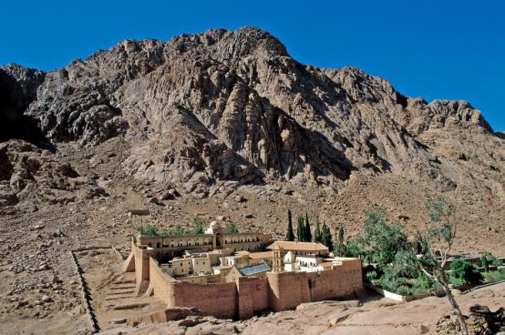
Mount Catherine, the highest mountain in the entire Sinai Peninsula, with the ancient monastery at its foot (Zev Radovan)

The remaining section, the tall, southern part of the peninsula, is apparently where the wilderness of Sinai and Mount Sinai can be found. From ancient times, the Christian tradition has identified Mount Sinai in Jabal Musa (lit. “Moses’ Mountain), one of the highest peaks in the Sinai Massif. A famous monastery was built not far from there, at the foot of Mount Catherine, the highest peak in the entire region. It is worth according a measure of respect to the Christian traditions of identification from the period of early Christianity. The traditions from this period are often based on Jewish traditions, and it is not inconceivable that the source of this tradition predates Christianity as well.

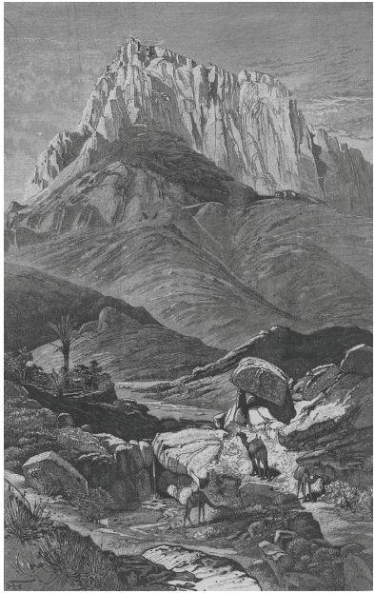
Jabal Musa, view from the south (C. W. Wilson, Picturesque Palestine, Sinai and Egypt, London 1881-1884)

An examination of various parts of the Torah can reaffirm this fundamental outlook, without necessarily committing to one particular peak or another. In Parashat Beshalach, the Torah emphasizes that “God did not lead them by way of the land of the Philistines… God led the people roundabout, by way of the wilderness at the Sea of Suph” (Exodus 13:17-18). The southern section of the peninsula is a wilderness that is flanked on its right and on its left by the two gulfs of the Sea of Suph.

Elim and “the Sea of Suph”

Moreover, my father and teacher, z”l, emphasized in this connection a verse that usually attracts little attention. In the list of the marches of the people of Israel in the wilderness in Numbers 33, the Torah enumerates the places where the people of Israel encamped after crossing through the sea: Marah, Elim, the Sea of Suph, the wilderness of Sin, Dophkah, Alush, Rephidim and the wilderness of Sinai. This list is parallel to the list in Exodus but adds several stations that were not mentioned in the latter. The surprise here is the Sea of Suph: “They set out from Elim and encamped by the Sea of Suph” (Numbers 33:10). Why would the people of Israel return to the Sea of Suph after having crossed the sea long ago? We are forced to conclude, therefore, that after Israel crossed the sea and emerged into the wilderness, they need to return to encamp by the Sea of Suph – not on the Egyptian side of the sea but on the Sinaitic side. We see from this that the direction of their movement was from the north to the south, parallel to the length of the Gulf of Suez, until they reached an area where the tall mountains draw so close to the sea that they had no choice but to return to traveling along the shoreline. We are familiar with these details from the reality on the ground.

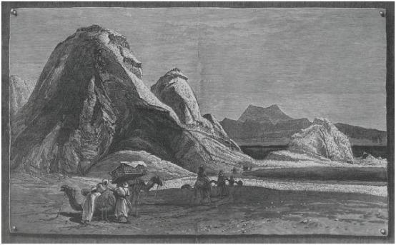
Ras Abu Znima; The mountains reach the sea and the caravan route passes through the seashore (Picturesque Palestine, Sinai and Egypt)

Even today, the road that runs north-south on the western side of the Sinai Peninsula must run along the shoreline at a point known today as Abu Znima. This point, located about 75 miles south of Suez and about 60 miles northwest of Mount Catherine, is presumably “the Sea of Suph” to which the verse refers. Elim, the point before the Sea of Suph, is, according to the verses, a large desert oasis containing “twelve springs and seventy palm trees.” This station, where the people of Israel encamped, also has an excellent identification. It is known today as Gharandal, and it contains very high groundwater levels. The surrounding area contains large palm groves growing above the high groundwater, which occasionally rises above ground. Residents of this region often draw water from the ground by digging small wells about seven feet deep. I remember this area well from the years when Israel controlled Sinai following the Six-Day War. During that period, it was common practice for all those passing through Gharandal to buy bottles of cola from the Bedouins who lived there.

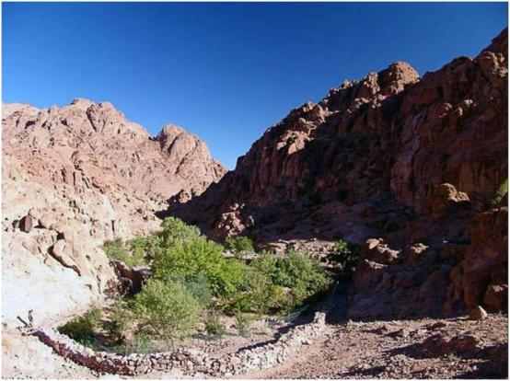
The oasis of Gharandal in the western part of the Sinai Peninsula; “Twelve springs and seventy palm trees”; most probably the Biblical Elim (www.efratnakash.com)

Sure enough, the accounts of early pilgrims describing the place highlight these same typical characteristics, identifying it with the Biblical Elim as well. Note the details in the following description (translated from the original Latin), from a twelfth-century copy of an early Christian source, generally accepted as having been originally written in the fourth century CE:

Then you reach Arandara, the Arandara which was called Helim. There is a stream there, and, though it dries up from time to time, there is water to be had from its bed or from near the bank. In that place there is plenty of grass and a great many palm trees, and all the way from Sur, where we crossed the Red Sea, there is no place as pleasant as this, or with such good plentiful water. The next staging-post from there is beside the sea.

The massif in southern Sinai also fits the Torah’s descriptions of “the flinty rock” and “the brook that comes down from the mountain.” A flowing stream is certainly a rarity in the desert, but such a stream exists on the Sinai Massif. There, in the vicinity of the Mount Sinai of the Christian tradition, we find Wadi Firan, which contains a constant flow of water. In all likelihood, it was against the backdrop of these ancient landscapes that we received the Torah.

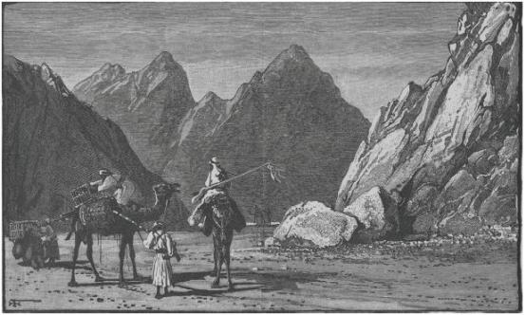
Wadi Firan and Jabal Sirbal: A combination of rocky flints, arid environment and flowing water (Picturesque Palestine, Sinai and Egypt)

For further study:

E. Anati et al., “Where is Mt. Sinai?” Biblical Archaeology Review 11 (1985).

Yehuda Elitzur and Y. Keel, Daat Mikra Bible Atlas (trans. L. J. Schramm), Jerusalem 2011, 96-97.

M. Har-el, The Sinai Journeys: The Route of the Exodus, San Diego (1983).

M. Har-el, “Sinai, Mount Sinai,” Encyclopaedia Biblica 5, col. 1020-1022 [Hebrew].

Z. Ilan, “Ha’im Efshar She-Har Sinai Hu Serabit el-Khadim?” Beit Mikra 24 (1979), 278-282 [Hebrew].

R. D. Kimchi, Sefer Ha-shorashim (ed. J. H. R. Biesenthal and F. Lebrecht), Berlin 1847, 135.
[http://www.daat.ac.il/daat/vl/radak/radak01.pdf]

A. Stewart, Antoninus Martyr (PPTS 2), London 1896, Paragraphs 37-40.

J. Wilkinson, Egeria’s Travels to the Holy Land, Jerusalem-Warminster 1981, 91-100, 208.

Translated by Daniel Landman

See Map 36.
“He drove the flock achar ha-midbar” (Exodus 3:1). According to Radak, Shadal, Cassuto and some modern translators, midbar here means “pasture” (cf. Aramaic DBR, “to guide”; Chazal’s dabbar, “leader”; and the use of midbar in Genesis 37:22, II Samuel 17:28, Micah 2:12 and Mishna Beitza 5:7). Other translations of achar ha-midbar have included: “to the far side of the desert”; “to the backside of the desert”; “to the west side of the wilderness”; “to the inner parts of the desert”; “to the edge of the desert”; and “to the farthest side of the desert.”
See our discussion on Parashat Beha’alotekha for a detailed examination of the various wildernesses. In this discussion we will only mention briefly what is necessary for the context here.
The Torah’s phrase einot mayim probably refers to artificial wells. Compare to: “An angel of the Lord found her by a spring of water (ein ha-mayim) in the wilderness… Therefore the well was called Beer-lahai-roi” (Genesis 16:7, 14); “He made the camels kneel down by the well outside the city… Here I stand by the spring of water (ein ha-mayim)” (24:11, 13).

