YESHIVAT HAR ETZION
ISRAEL KOSCHITZKY VIRTUAL BEIT MIDRASH (VBM)
*********************************************************

GEOGRAPHY IN THE PARASHA

EREV ROSH HA-SHANA

Shiloh
By Prof. Yoel Elitzur

Rosh Ha-shana and Shiloh

Let the year and its blessings begin! Some people think that the most appropriate place to celebrate Rosh Ha-shana and to reach lofty spiritual heights is Ukraine. I believe that the best place to celebrate Rosh Ha-shana and to reach lofty spiritual heights on that momentous holiday is… Shiloh. Allow me to explain.

The customary Torah reading and haftara on the two days of Rosh Ha-shana express the two exalted aspects of Rosh Ha-shana. According to Megilla 31a, on the first day of Rosh Ha-shana we read the section of the Torah beginning “The Lord took note of Sarah” (Genesis 21:1), while the haftara recounts the story of Hannah. The next day the Torah reading begins “God put Abraham to the test” (22:1), while the haftara begins, “Ephraim is a dear son to Me” (Jeremiah 31:20). On the first day of Rosh Ha-shana the emphasis is on kingship (malkhiyot), while on the second day of Rosh Ha-shana the emphasis is on remembrance (zikhronot). On the first day we read the story of Ishmael’s expulsion from Abraham’s household. Hagar and Ishmael wandered through the wilderness until God decreed that Ishmael would survive the ordeal “where he is,” i.e., by virtue of his current innocence. God then caused a well of water to present itself before the two wanderers, revitalizing them. The Midrash states:

Rabbi Yuda son of Rabbi Simon: The ministering angels jumped up to indict [Ishmael], saying before Him, “Master of the World! For a man who will someday kill your children with thirst, you will bring up a well?” He said to them, “Right now, is he righteous or wicked?” They said to Him, “Righteous.” He said to them, “I judge a person only [where he is] at that moment.” (Bereishit Rabba 53)

God’s attributes of justice and mercy are not the sole possessions of any particular nation; God judges His world and His creations without bias or prejudice. While it is true that Ishmael needed to be distanced from Isaac, he did not forfeit his right to live.

In the haftara of the first day of Rosh Ha-shana, we read:

The Lord deals death and gives life, casts down into Sheol and raises up. The Lord makes poor and makes rich; He casts down, He also lifts high. He raises the poor from the dust, lifts up the needy from the dunghill, setting them with nobles, granting them seats of honor. For the pillars of the earth are the Lord’s; He has set the world upon them. (I Samuel 2:6-8)

This passage exhibits God’s attribute of broad justice, fitting for a day whose theme is kingship.

On the second day, we focus on the concept of remembrance, on Israel’s merits, on the intimate and unique connection between God and His chosen people. We read about the binding of Isaac, about “on the mount of the Lord there is vision,” and about the oath that God made:

Because you have done this and have not withheld your son, your favored one, I will bestow My blessing upon you and make your descendants as numerous as the stars of heaven and the sands on the seashore. (Genesis 21:16-17)

In the haftara, we mention the merit of “Rachel weeping for her children.” God Himself comforts her: “Restrain your voice from weeping, your eyes from shedding tears” – and the wonderful ending – “Truly, Ephraim is a dear son to Me” (Jeremiah 31).

The location that is common to both haftarot is none other than Shiloh. At Shiloh, we encounter the direct confluence of peshat and reality as we see the same earth and the same scenery as those described in the haftara of the first day:

This man used to go up from his town every year to worship and to offer sacrifice to the Lord of Hosts at Shiloh…. The priest Eli was sitting on the seat near the doorpost of the temple of the Lord…. She prayed to the Lord, weeping all the while…. “Then go in peace, and may the God of Israel grant you what you have asked of Him” … “I am the woman who stood here beside you and prayed to the Lord. It was this boy I prayed for.” (I Samuel 1)

The personal, human story of Elkanah and Hannah, of Eli and Samuel, contains no sound and fury, but it does feature the themes of faith, prayer, justice and mercy. These themes fit well with the setting of the humble Mishkan, situated in a moderately hilly landscape that was terraced and well-planted.

In Shiloh, we can connect on a deep level to the haftara of the second day: “The people who escaped from the sword, found favor in the wilderness; Go to calm him, Israel.” We find ourselves in a place where a large settlement cascades down the slopes of the mountain toward the ancient tell where the Shekhina dwelled for centuries in the early years of the nation of Israel’s existence.

In Shiloh, we turn to the right and to the left and see numerous small Israeli settlements and outposts that revitalize the earth. We see countless traditional olive trees, fruit trees and vineyards that directly recall the vineyards that existed in Shiloh during the period of the Judges. All of these are planted and cultivated by people who remain faithful to the nation of Israel, faithful to the earth and faithful to the God of Israel.

In Shiloh, located in the heights of Ephraim, we can connect to the verse, “For the day is coming when watchmen shall proclaim on the heights of Ephraim: Come, let us go up to Zion, to the Lord our God!”

In Shiloh, we connect to the verse:

Truly, Ephraim is a dear son to Me, a child that is dandled! Whenever I have turned against him, My thoughts would dwell on him still. That is why My heart yearns for him; I will receive him back in love – declares the Lord.

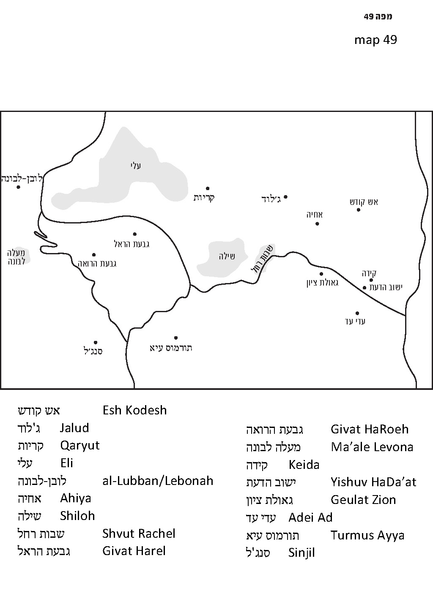

Where Was the Mishkan Located?

In Shiloh, most people are familiar with the tell that is today a well-maintained visitors’ site. The tell contains within it archaeological excavations that continue even today at a remarkable pace and scope. Visitors today can enjoy the scenic view from the top of a tower that was erected at the highest point of the tell, as well as a moving audiovisual presentation. Since the site was first excavated over eighty years ago by a Danish team, it has been excavated again several times over the last thirty years by Israeli teams, which discovered many interesting findings. The Arabic name of the tell was Seilun, a preservation of the original ancient Hebrew name. In a Greek inscription written on a mosaic floor found here in recent years, a name was mentioned that appears to have been an intermediate version between the original Hebrew name and the later Arabic name. The Arab villages adjacent to Shiloh also have ancient Hebrew names: Jalud (mentioned on a legal document from the time of Bar Kokhba as “Galoda of Akrabatta”); Qaryut (likely the place of origin of Judas Iscariot); and al-Lubban (Lebonah, mentioned in Judges 21:19).

At this juncture, it is worth dedicating a few words to the thing that everyone has been searching for in Shiloh: the location of the Mishkan. Archaeologists have not found remnants of the Mishkan. There are remnants in Shiloh that teach us indirectly about the Mishkan in Shiloh. There are prominent remnants of a Canaanite city that was surrounded by a fortified wall, above which were findings typical of the period of Israelite settlement, indicating that the Israelites had settled atop the ruins of the Canaanite city. They spread out beyond the walls of the city, and did not use the massive wall for the purpose of fortification, but instead used the wall and its stones to build houses. Among the various findings were large storage jars (“collar-rim jars”) typical of the period of Israelite settlement (Iron I).

Where was the Mishkan in Shiloh? We will attempt here to present a fascinating original theory that was first suggested by Charles Wilson in 1873. More than one hundred years later, without having seen or read Wilson’s theory, Rabbi Yoel Bin-Nun raised the same ideas and even developed them somewhat further. (Rabbi Bin-Nun appeared happy when I showed him that Wilson beat him to the punch in proposing this theory, but I imagine he was a bit disappointed deep down.) The essence of the idea is as follows. When you stand at Tel Shiloh, below you to the north is a kind of terrace that extends from the tell, but is situated outside the walls; below that is a wadi. The entrance to Tel Shiloh in earlier periods was certainly from the south. While the city gate has not yet been discovered, the topography dictates the assumption that this is where the gate was located, since the southern side of Tel Shiloh is the only side that does not feature steep slopes. Thus, it must be that the entrance gate to Shiloh was on the southern side.

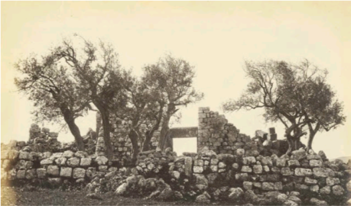
1866 photograph of Jama’a el-Arba’in – perhaps an ancient synagogue, located south of Tel Shiloh, today adjacent to the Tel Shiloh visitors’ center (The Palestine Exploration Fund)

Beyond the tell on the northern side, opposite the city gate, there is the terrace mentioned above that protrudes from the tell but is located outside the walls. The terrace is a part of the same mountain range, but distinct from it. Behind the terrace to the north is a deep wadi, followed by a taller mountain behind the wadi.

The interesting thing is that this terrace contains two natural rows of boulders one opposite the other. At some point in history, someone cut through the boulders artificially, creating a straight line pointing inward on the northern wall and a straight line on the opposing wall on the southern side. These two rows of boulders run precisely east-west and the distance between the rows is just less than eighty feet. These unique details bring to mind a Biblical association! Eighty feet is about fifty cubits, which is the width of the Mishkan’s enclosure according to the Torah. Recall that the enclosure of the Mishkan must be oriented such that the longer side runs from east to west, while the shorter side runs from north to south! Chazal addressed the fact that the Tanakh calls the Mishkan in Shiloh both a heikhal (temple) and an ohel (tent). This indicates that the Mishkan in Shiloh had a kind of intermediate status between the original Mishkan in the wilderness, which was made of strips of cloth and wooden planks, and the Temple in Jerusalem, which was a house of cedar and hewn stones. The Sages state: “There was no roof there, but there was a structure of stone beneath, and cloths above them. It was [considered] ‘the Resting Place.’” (Mishna Zevachim 12:6). A logical addition to complete this picture would be an enclosure with walls hewn out of stone, in place of the walls of the enclosure in the wilderness, which were made of linen hangings.

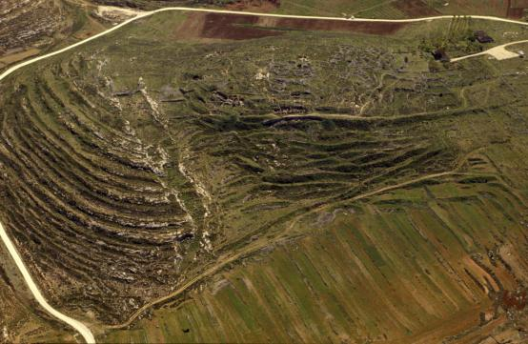
Tel Shiloh before the excavations of recent years, viewed from the west. On the left side, note the northern terrace with the two rocky ranges. (Zev Radovan)

Placing the location of the Mishkan in the northern terrace and outside the city walls would also explain the details of the story of the fiasco at Eben-ezer, recounted in I Samuel 4. We read:

A Benjaminite ran from the battlefield and reached Shiloh the same day…. The man entered the city to spread the news, and the whole city broke out in a cry. And when Eli heard the sound of the outcry and asked, “What is the meaning of this uproar?” the man rushed over to tell Eli. (I Samuel 4:12-14)

We see from here that the man first arrived in the city; the city then “broke out in a cry”; and only afterward did Eli hear “the sound of the outcry.” Where was Eli at the time? We learned in I Samuel 1: “The priest Eli was sitting on the seat near the doorpost of the temple of the Lord,” meaning that the Mishkan must have been located outside the city, on the side opposite the city’s gate.

Let us briefly add one more conceptual perspective. We know that the Torah prohibits planting sacred trees and erecting altars in the enclosure of the Temple: “You shall not plant an ashera – any kind of tree beside the altar of the Lord your God that you may make – or erect a stone pillar; for such the Lord your God detests” (Deuteronomy 16:21-22). Setting up trees and erecting stone pillars were deeply rooted worship rituals among the Canaanites, and were therefore prohibited by the Torah, even though at the time of the patriarchs these practices had not yet been prohibited. This prohibited pair – the tree and the pillar – are connected to the tall mountains as well, as it says:

You must destroy all the sites at which the nations you are to dispossess worshiped their gods, whether on lofty mountains and on hills or under any luxuriant tree. Tear down their altars, smash their pillars, put their ashera plants to the fire and cut down the images of their gods, obliterating their name from that site. (Deuteronomy 12:2-3)

It seems that just as the Torah is opposed to a tree, so is it opposed to the perception that the Temple must be situated at the highest possible point. This notion is illustrated well in Jerusalem. The Temple Mount is higher than its immediate vicinity but lower than the mountains in the surrounding area.

In Shiloh as well, we see a similar topographical picture to that of Jerusalem. This terrace, atop which stood the Mishkan according to the hypothesis of Wilson and Bin-Nun, is lower than the highest point of the city and lower than the mountain behind it as well. It is a perfect candidate for the location of God’s sanctuary.

If this is indeed so, anyone who merits the opportunity to be in Shiloh on Rosh Ha-shana can stand in awe of the place, breathing in the exalted air that is full of sanctity, of fear of Heaven and of a connection to the land of Israel.

For further study:

Y. Bin-Nun, “Mekomi Asher Be-Shilo,” in Z. Erlich (ed.), Shomron U-Binyamin, Ofrah 1987, pp. 102-106 [Hebrew].

C. R. Conder and H. H. Kitchener, The Survey of Western Palestine – Memoirs, II: Samaria, London 1882, pp. 367-368.

C. W. Wilson, Palestine Exploration Quarterly Statement 5, January 1873, 38.

Z. Yeivin, “Shiloh – Excavation on the Northern Plateau,” Judea and Samaria Research Studies: Proceedings of the 2nd Annual Meeting – 1992 (1993), pp. 95-110 [Hebrew].

Translated by Daniel Landman

See Map 49 below.

