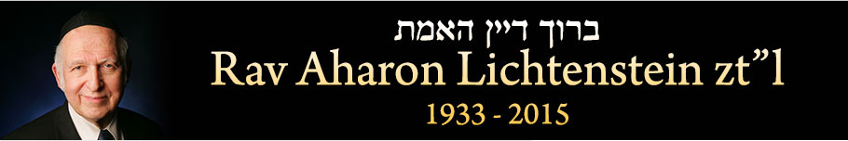
Rabbi Dr. Aharon Lichtenstein, a French-born and American-raised leader of Modern Orthodox Jewry, will receive the Israel Prize in Jewish religious literature this year. The 80-year-old scholar was born in Paris, but grew up in the United States, where he was ordained at Yeshiva University, studied under his father-in-law Rabbi Joseph Soloveitchik, and received his PhD in English literature from Harvard.

In 1971, he moved to Israel at the invitation of Holocaust survivor Rabbi Yehuda Amital to join him at the helm of Yeshivat Har Etzion, a religious Zionist yeshiva in the West Bank region of Gush Etzion. (The area had been inhabited by Jews until they were massacred in 1948, and was resettled after the Six Day War in 1967.)

As dean of the yeshiva, Lichtenstein has educated generations of Israeli and American Orthodox leaders in a humanistic tradition that seeks to combine religious learning and striving with the intellectual fruits of the secular world. His writings in Hebrew and English have become staples of the Modern Orthodox bookshelf, and under his leadership, Har Etzion has opened both an academic teacher’s college and a sister seminary at Migdal Oz run by his daughter Esti Rosenberg, which launched an advanced Talmud and Jewish law institute for women in 2013. Har Etzion’s Virtual Beit Midrash, one of the earliest efforts to teach Torah over the internet, now reaches thousands of subscribers.

- GLATT KOSHER HEDONISM [“By His Light”, page 16-18]
I mention this point particularly to an American audience. In recent years, one observes on the American scene a terribly disturbing phenomenon: the spread of hedonistic values, but with a kind of glatt-kosher packaging. There was a time when the problem of hedonism for religious Jews didn’t often arise, because even if you wanted to have the time of your life, there wasn’t very much that you could do. The country clubs were all barred to Jews, there weren’t many kosher restaurants, there were no kosher nightclubs, etc. In the last decade or two, a whole culture has developed geared towards frum Jews, where the message is enjoy, enjoy, enjoy, and everything has a hekhsher (kosher certification) and a super-hekhsher. The message is that whatever the gentiles have, we have too. They have trips to the Virgin Islands, we have trips to the Virgin Islands. Consequently, there has been a certain debasement of values, in which people have a concern for the minutiae of Halakha (which, of course, one should be concerned about), but with a complete lack of awareness of the extent to which the underlying message is so totally non-halakhic and anti-halakhic.
Don’t misunderstand me—I am not opposed to people enjoying themselves to some extent. I am not arguing for a totally ascetic approach to life; I don’t live that way myself, and what I don’t practice I certainly am not going to preach. In a sense, I don’t practice it because I don’t really think that it is demanded. (There certainly were gedolim [great rabbis] who did advocate it, but others disagreed.) The question is something else entirely. The question is not whether there is room in human life for a person to have a certain measure of pleasure. Rather, the question is what is his basic perspective? How much does he involve himself in this? Does he see himself as basically being born to enjoy or to work?...
To some extent, this feeling has permeated our world: a whole culture of enjoyment has begun to take hold. This is something which is recent, and with which anyone who is a ben-Torah, certainly, should in no way identify or associate. That whole culture advocates that man is born for pleasure, but unfortunately has to work if he wants to enjoy. In contrast, we have to know that “Adam le-amal yulad,” Man is born to do labor” (Iyyov 5:7).
- If You Remain Silent at This Time: Concern for the Jewish People [By His Light,168-182]
Well aware of her true destiny, Esther presents herself before Achashverosh. She renounces personal considerations in favor of communal ones. Only after she has passed the test of identification and concern is she capable of standing before Achashverosh, appearing before the people, leading the camp, initiating action, making demands and even deciding events.
The key to the question of where we find the transition from the retiring Esther of Chapter Two to the regal and commanding Esther of Chapter Nine is to be found in the Esther of Chapter Four. In the zero-hour of Chapter Four, the fateful showdown between Mordekhai and Esther decided the struggle between apathy and empathy, selfishness and selflessness.
As mentioned earlier, the Megilla recounts Esther’s development on two levels: one in terms of strength of character, initiative and courage, and the other in terms of moral awareness, of reassessing priorities. The two processes go hand in hand: when Esther finds the will to achieve an important end, she finds the ability to do so as well. This is the essence of Mordekhai’s message to her—if there is a will, there is a way. But first, you must truly will it.
Such was Esther’s redemption then. The same applies to us today.
We are all, to some degree, Esther. Each of us, for whatever reason, has doubts as to his or her abilities. We, too, are hesitant: “What, I’m going to achieve all that? I’m going to save Am Yisrael? I’m going to put a stop to assimilation? I’m just a youngster; I can achieve only a little: a little bit in my neighborhood, a little bit in a youth group, a little bit in the family. But to start a revolution? To determine the future of a nation? To avert an evil decree? Little me?”
Here comes the demand. I don’t want to use Mordekhai’s words, but I do want at least to pose the question. How much of our resignation is motivated by supposed “inability” and how much is a result of the fact that our concern simply doesn’t run deep enough?...
Today, too, everyone knows that Am Yisrael is in grave danger. There is danger of assimilation, danger of mixed marriages, danger of people losing their way, danger of being cut off from roots and values. Can it be that only you cannot see it?..
Herein lies the ultimate question. It is directed to each and every one of us. Let each person do as Esther did: stand before himself, stand before God, and once the situation is quite clear to him, ask himself, “Where do I stand, who am I, what comes first, what is vital and what is secondary?” This does not imply that what is secondary is necessarily unimportant: Esther’s plans of being queen and ruling over one hundred and twenty-seven provinces certainly represented serious career considerations. The question is not whether one’s personal plans are inherently improper. Rather, a person must ask himself not only whether what he is doing is good and worthy, but whether it is the best and most worthy thing that he could be doing. He has to keep asking himself: Is this really what the circumstances require? Is this the best that I can do at this time?
What significance does this knowledge have for me? To what extent does it cause me pain? To what extent do I identify with world Jewry, in fasting and prayer? To what extent is my spiritual world structured such that Kenesset Yisrael and its dangers are on one side and I, with my considerations and private plans, am on the other?
Like Esther, we will all have to ask ourselves the question when the time comes: We could have saved; did we? What will be our answer then? More importantly, what is our answer today?

- תלמוד בבלי מסכת חולין דף ס עמוד ב
רבי שמעון בן פזי רמי, כתיב: ויעש אלהים את שני המאורות הגדולים וכתיב: את המאור הגדול ואת המאור הקטן! אמרה ירח לפני הקדוש ברוך הוא: רבש"ע, אפשר לשני מלכים שישתמשו בכתר אחד? אמר לה: לכי ומעטי את עצמך! אמרה לפניו: רבש"ע, הואיל ואמרתי לפניך דבר הגון, אמעיט את עצמי? אמר לה: לכי ומשול ביום ובלילה, אמרה ליה: מאי רבותיה, דשרגא בטיהרא מאי אהני? אמר לה: זיל, לימנו בך ישראל ימים ושנים, אמרה ליה: יומא נמי, אי אפשר דלא מנו ביה תקופותא, דכתיב והיו לאותות ולמועדים ולימים ושנים, זיל, ליקרו צדיקי בשמיך: יעקב הקטן שמואל הקטן דוד... הקטן. חזייה דלא קא מיתבא דעתה, אמר הקדוש ברוך הוא: הביאו כפרה עלי שמיעטתי את הירח!

- THE AKEIDA [“By His Light”, page 122-124]
But regarding certain particular tzivuyyim (divine commands), surely we find instances in which obedient response to God’s normative demands stands in apparent opposition to what we conceive to be good and, if you will, to what we understand that God conceives to be good. Here, a problem arises: How do we relate to this?
When there is a conflict between the tzav and the moral order, what do we do about it? For us, the answer is perhaps practically difficult, but surely it is conceptually clear and unequivocal. This, after all, is what the akeida (sacrifice of Yitzchak—Bereishit 22) is all about. Kierkegaard emphasized that the akeida represents a conflict between Avraham’s moral sense and the divine command; as far as understanding the problem, he was unquestionably correct. On the one hand, Avraham is commanded to offer his son to God (which, at this point, he understands to mean “Slaughter him,” not “Offer him”). On the other hand, he knows that murder is forbidden. The message of the akeida is clear: God’s command takes precedence, in every respect, over our moral sensibility and our conscientious objections.
This is not to say that in such a context there is no room for moral sensibility. Surely, in relating to Halakha, including those areas which one may find morally difficult, there is some role for conscience, some role for the goodness in us, particularly in an interpretive capacity. Conscience does and legitimately can have a role in helping us to understand the content and substance of the tzav. In the Midrash, Chazal depict Avraham’s thoughts during his three-day journey to the akeida. He tried to understand God’s command: perhaps God meant something else. Surely, one can, and presumably should, walk the last mile in order to try in every way to avoid a conflict. But even when one has walked the last mile, at times the conflict may remain, and—as in the akeida—the decisive element is clear. It was only a tzav of God, or of the angel sent by God, which was able to countermand the command to sacrifice Yitzchak.
The task before us is multifaceted. As those who educate towards yirat Shamayim, we must communicate the message of the akeida—boldly, loudly and clearly. On the other hand, as those who do seek to ingrain moral sensitivity in ourselves and in our children, we need not dismiss the ambivalences, the difficulties and contradictions (at the initial level, surely). We need not wish away Avraham’s three days of spiritual groping. We need not dismiss the wrestling and grappling as being a reflection of poor yirat Shamayim, of spiritual shallowness, or of a lack of frumkeit. Inasmuch as goodness itself is an inherent component of frumkeit, the goodness which is at the root of the problems, struggles and tensions is itself part of yirat Shamayim—and a legitimate part. If the sense of moral goodness is legitimate, then the questing and the grappling are also legitimate.
- ON THE MURDER OF PRIME MINISTER YITZCHAK RABIN Z"L

http://etzion.org.il/vbm/english/archive/ral1-rab.htm
Aside from this, there is a special source of worry for those to whom the settlement of Yehuda and Shomron is important…The circumstances of his cold-blooded murder, though, are a source of great pain and distress for us. Last week I visited mori ve-rabi Harav Aharon Soloveitchik shlit"a, whose fierce opposition to the peace process is well-known. As soon as I walked in, he repeated over and over - "A badge of shame, a badge of shame." For two days, he hadn't slept, out of shame and humiliation. This shame, that our state, our people, should have fallen to such a level, should be felt by everyone - religious, secular, right and left. For to the extent that we feel any sense of unity within Am Yisrael, to the extent that we feel like a single body, then the entire body should feel shamed and pained no matter which limb is responsible for this tragedy. We should feel deep shame that this method of supposedly solving conflicts has become part of our culture.

But naturally, this shame should be felt by our camp, the National Religious camp, more than any other. Here was a man who grew up in the best of our institutions. A day before the murder, he could have been cited as a shining example of success and achievement, and a source of communal pride. Coming from a "deprived" background, he studied in a Yeshiva High School, attended a great Yeshivat Hesder, and was accepted to the most prestigious division of Bar-Ilan University. Today, we hide behind the phrases, "a wild weed," "from the outskirts of our society." But if a day before the murder we would have said proudly, "See what we have produced," we must say it now as well - "See what we have produced!" It is indefensible that one who is willing to take credit when the sun is shining should shrug off responsibility when it begins to rain. Let us face our responsibility not defensively, but as Chazal would see it…

- Tradition, “A Rabbinic Exchange on Baruch Goldstein’s Funeral”

Rav Aharon Lichtenstein
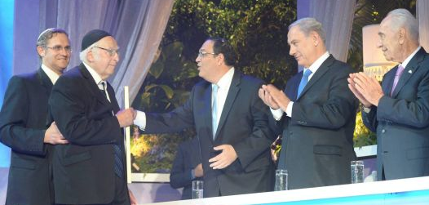
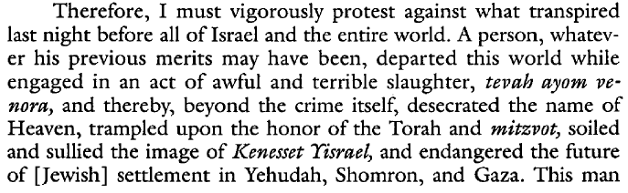
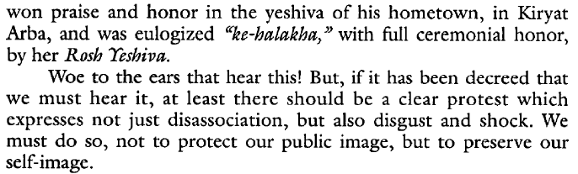
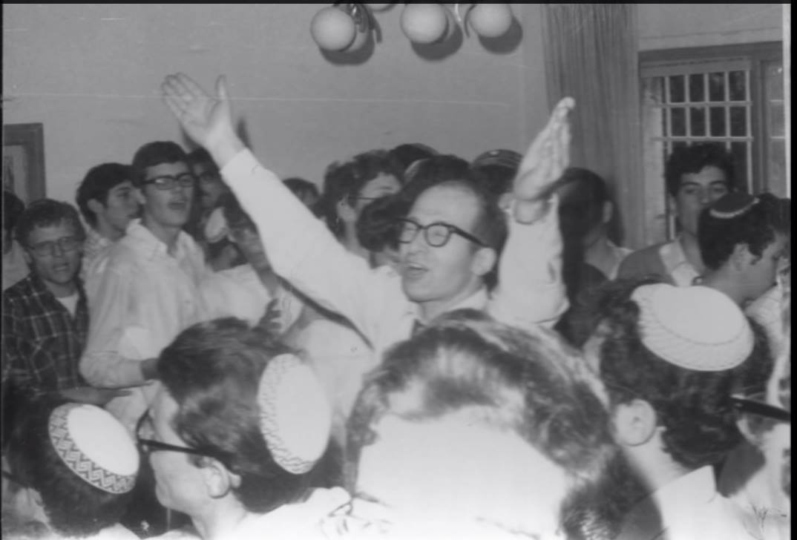

Rav Dov Lior
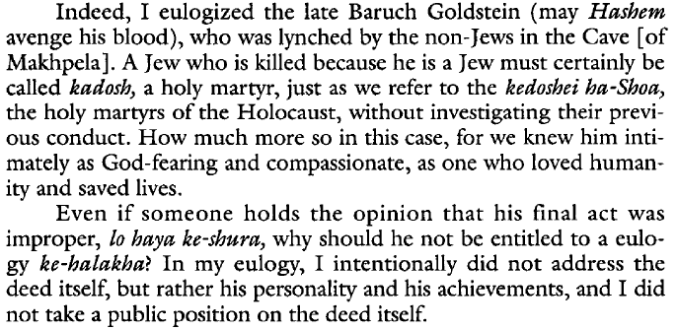
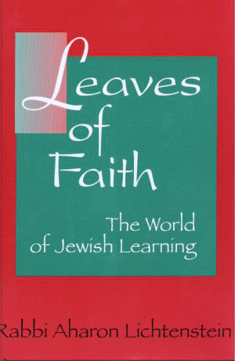

For Further reading
Lectures – “By His Light”
Essays – “Leaves of Faith”, “The Varieties of Jewish Experience”

VBM-Torah.org

