PARASHAT HASHAVUA
****************************
PARASHAT LEKH LEKHA
**************************************************************
*********************************************************
In memory of Eliyahu ben Shaul Halevi and Mazal z”l
*********************************************************

The Covenant Between the Parts and the Covenant of Circumcision

By Rav Yoel bin-Nun

God makes three promises to Avraham: the first along with the command, “Go forth…” (lekh-lekha – Bereishit 12:1), the second at Elon Moreh, and the third “to the east of Beit El.” He forges two covenants with him and swears one oath (at the akeida). The oath at the akeida is itself connected to the first promise, through the use of the same command – “lekh lekha” (22:2), which occurs only in these two instances in all of the Tanakh. Thus, the journey to the promised land (the first “lekh lekha”) is bound up with the journey to the place of the Divine Presence, the site of the Temple (the second “lekh lekha”).

The structure of this entire system of promises, covenants, and oath can be presented as follows:

Promise with “Go forth from your land… to the land” (12:1-3)
Promise at Elon Moreh (12:7) | Promise on the east of Beit El (13:14-17)
Covenant between the parts (chapter 15) | Covenant of circumcision (chapter 17)
Oath following “… and go forth to the land of Moriah” (akeida) (chapter 22)

Let us take a closer look at the two covenants and note the differences between them:

Covenant between the parts (15) | Covenant of circumcision (17)
Mention is made of “the land” | Mention is made of “the land of Cana’an”
God’s Name – Tetragrammaton (and Avraham’s use also of “Ado-nay,” indicating God’s kingship) | God’s Name – El Sha-dai and Elokim (Tetragrammaton appears once at the beginning of the unit, in the narrative, but not later on in the dialogue)
Avraham prepares the parts and God forges the covenant. Avraham is in a deep sleep; the covenant is experienced as a vision. | Avraham is awake and active; he forges the covenant.
Essence of the covenant is the land.  The purpose and destiny is historical and national. | Essence of the covenant is the family of the forefathers.  The purpose and destiny is religious and natural (“to be God unto you, and to your seed after you”)
Avraham is promised conquest of the full expanse of the land (“to take possession of it”) | No mention of conquest. The Land of Cana’an is merely a place of residence (and the forefathers are strangers and residents in it)
To be realized in the distant future, in the fourth generation (the generation that will come out of Egypt) | Covenant is established immediately. The Land of Cana’an is promised as an everlasting possession, and circumcision is the sign of the covenant for all generations.

There is no mistaking the profound and essential difference between the two covenants. We have here two different approaches, two perspectives, and two different sets of implications for Am Yisrael, Eretz Yisrael, and all of Jewish history.

The first approach, that of the Covenant of Circumcision, is a religious, natural, and family-oriented covenant. Its rests on the foundation of the Creation, nature, the unique entity that is family, and the nature of Eretz Yisrael – on both the revealed and concealed levels. The covenant is established already in Avraham’s lifetime; it is anchored in the family tradition of Avraham’s household, and expressed in circumcision as its sign for all generations.

This covenant has nothing to do with changing times or circumstances. Its validity and force is exactly the same whether the “holy land” - the eternal possession of Avraham’s seed – is occupied and ruled by Cana’anim or Emorim, Egyptians or Pelishtim, Arameans or Amonites, Assyrians, Babylonians, Persians, Greeks, Romans (whether pagan or Christian), Muslims, Turks, or Arabs. No matter who comes along, the “holy land” remains what it is and retains its unique status. Just as the revealed nature of the land – its mountains and streams, deserts and valleys, rocks and climate – remain fundamentally the same, so its concealed nature – its unique sanctity – remains, no matter what.

Thus, whoever joins the covenant of circumcision as a family covenant belongs to the seed of Avraham, to the nature of the land, and, to a certain extent, to its holiness. Jews living in the “holy land” or traveling to the land in order to “dwell under the wings of the Divine Presence,” to draw in the spiritual inspiration that exists only in this place, never drew any connection (and still draw no connection) between this quality and the identity or character of the rulers of the land – which, from this perspective, is a matter of altogether secondary importance. The covenant to which they commit themselves through their dwelling in the land, their prayers, their observance of mitzvot, and their consciousness of and meditation upon the sanctity of the land, has religious but not historical (or political) significance. The “holy land,” both in the period of its settlement by the forefathers and their children and later, under foreign rule, remains our “eternal possession” – a family inheritance. No foreigner has any part or portion in its unique sanctity or in the perpetuation of the covenant; these pertain only to those who belong to the covenant of circumcision.

This sanctity finds profound expression in the realm of burial places in the land – the purchase of Ma’arat Ha-Makhpela as a burial place for the family of the forefathers, as well as Yosef’s oath to Yaakov that he would not bury him in Egypt, but rather “in my grave which I dug for myself in the land of Cana’an; there shall you bury me” (Bereishit 50:5). The sanctity of the land as revealed in the family burial plots of the forefathers and their children who are buried there is the foundation upon which R. Ashtori Ha-Farchi, a disciple of the Rosh, based the idea of the land’s inherent sanctity, the root of Am Yisrael’s dwelling in it, beyond the sanctity related to the commandments dependent upon the land (Kaftor Va-Ferach, chapter 10). He relied on this foundation when he settled in Beit Shean (ibid., end of Introduction), even though that area is exempt from the sanctity of the commandments.

This is the general direction adopted by R. Yehuda ha-Levi in his Sefer Ha-Kuzari. Nowhere does he make any mention of sovereignty or political control of the land as a central principle (see ma’amar 2:14, 44). In his profound and inspiring words about “the land possessing the quality of prophecy,” the “land of God,” he emphasizes the nature of prophecy as a natural, spiritual phenomenon that exists in Eretz Yisrael, connected to the natural, spiritual quality that is unique to Am Yisrael, which can be realized only in the land – and specifically when all of Am Yisrael, as a great populace, dwell in it and the Temple is built, for then the Divine Presence rests there and the inherent quality of God’s people is revealed openly and wholly in God’s land. Nowhere is there a word about political sovereignty; there is only the principle that when all of Israel dwell in the land, then the Divine Presence can be revealed through the Temple.
R. Yehuda Ha-Levi’s approach is not one of political sovereignty in the historical sense, but rather the natural, spiritual essence that is realized through the resting of God’s presence. This point is manifest clearly in the fact that he draws no essential distinction between the period of the forefathers in the land and the period of the First Temple.

The kabbalistic and chassidic teachings offer a similar perspective; they present the inherent, hidden holiness as the true and inner essence of this world in general and of the holy land in particular. The commandments, according to this view, are simply manifestations of an inner rhythm and constancy, channels of spiritual nourishment for the individual and collective soul, while transgressions create severance and disease of the soul – just like sins against the body, whose physical results are treated by doctors.

According to this view, the Torah is given to Am Yisrael as a revelation of the secret essence implanted in the universe, the world, the holy nation, and the holy land from the time of Creation. Not only can no scholar reveal any “chiddush” in the Torah, because any “new” insight is simply the discovery of something that always existed but was previously concealed, but even the Exodus from Egypt and the giving of the Torah did not represent any “chiddush,” since the Torah and Am Yisrael were blissfully ensconced in the heavenly treasure-house long before Adam appeared.

This view leaves almost no room for revolution and change, nor for crisis and disappointment. Everything exists as it always has, in accordance with the order of Creation. “All is known in advance,” as the mishna in Avot (3:15) teaches; “permission is given” only to integrate within this preset order.

The second approach – that revealed in the Covenant of the Parts – is based on upset and transformation, and its essence is “chiddush.” This approach is the banner raised by the visionaries and activists of social movements and spiritual disciplines, the leaders of nations and states, the legislators of social law and morality, those who create history and are borne aloft upon its waves. This is the “chiddush” that Avraham introduced into the world. Prior to the appearance of revolutionaries such as Avraham and Moshe, there was nothing of value in the world; indeed, this period is referred to as the “two thousand [years] of void.” The cosmic, natural religious consciousness was immersed in idolatry; the monotheistic message of the forefathers was as yet unknown, and so there was no movement towards its realization.
Eretz Yisrael, from the perspective of the Covenant Between the Parts, is the locus and center of a moral, spiritual, historical revolution. From this perspective, Jewish sovereignty in the land is quite unlike the rule of the other nations, because Am Yisrael is destined to build in this land a moral society that pursues “the way of God, to perform justice and righteousness” (Bereishit 18:19), further to God’s choosing of Avraham and his descendants.

It is this perspective that is at the center of the Rambam’s worldview, which emphasizes (Hilkhot Avoda Zara 1:2-3) the religio-intellectual, historical, and moral revolution wrought by Avraham, the “the pillar of the world”:

When this mighty one was weaned, he began to wonder, though he was a child; he thought day and night… And he started to stand up and call out to all the world, telling them that there is one God of the entire world, and that it is proper to serve Him… as it is written (Bereishit 21:32), “And he called there in the name of the Lord God of the world.”

If we compare the approach of R. Yehuda h=Ha-Levi with that of the Rambam, we see that it is specifically the Rambam who defines the concept of “Eretz Yisrael” in terms of political sovereignty, in the historical and tangible sense:

Wherever mention is made of Eretz Yisrael, the reference is to the lands conquered by the king of Israel or by a prophet with the consent of the majority of the Jewish People… (Hilkhot Terumot 1:2)

In principle, this is also the Ramban’s approach in his gloss to the Rambam’s Sefer Ha-Mitzvot.

Borders of “The Land of Cana’an” and Borders of “The Land”

In the historical sense, Eretz Yisrael has no geographical borders, nor is it conceivable that it could have any more specific than the space between the Nile and the Euphrates:

Every place where the sole of your foot shall tread shall be yours; from the wilderness to the Lebanon, from the river – the Euphrates River – to the uttermost sea shall be your border. (Devarim 11:24)

Seemingly, the borders of the Divine promise in the Torah are “from the river of Egypt to the great river, the Euphrates River” (Bereishit 15:18). Many interpret this verse as a geographical specification of fixed borders, just as the borders set forth in Parashat Mas’ei (Bamidbar 34), describing the borders of “the land of Cana’an” between the Jordan and the sea, are essentially geographical borders. Indeed, the Ramban adopts this interpretation in many places.

However, the difference between the two sets of borders goes far beyond the matter of geographical scope. We must go back to the plain meaning of the biblical verses and the wonderfully accurate language of the Rambam. The Rambam defines the borders of Eretz Yisrael in accordance with historical realization – i.e., the borders settled by those who came to the land following the Exodus from Egypt (the “first sanctity”) or those who returned following the Babylonian exile (the “second sanctity”) – but first there must be conquest of the land of Canaan, which is the sacred nucleus (Hilkhot Terumot 1:2-3).

What this means is that the expansive borders of the promise define the space within which Bnei Yisrael will realize their sovereignty through “mass conquest” (and in accordance with the conditions pertaining to that term), while the actual borders are determined in keeping with the conquest itself: “Every place where the sole of your foot shall tread.” In other words, the borders extend to whichever places the sovereign flag of Israel reaches, “with the consent of the majority of the Jewish nation” (as the Rambam expresses it).

Therefore the “land of Cana’an” (meaning, the primal nucleus of unique sanctity) has clear, fixed geographical borders, while the borders of “the land” are not geographical, but rather a matter of actual historical realization (through sovereignty or settlement, perhaps both), within the space defined by the “borders of the promise” between the Nile and the Euphrates – each generation in accordance with what God chooses to give it.

The historical perspective is bound up with God’s revelation in history in general and Jewish history in particular, and hence it is necessarily dependent on changing circumstances. For this reason, Avraham cannot be ruler of the land, because his descendants have not yet matured to the point of becoming “the nation of the God of Avraham” (which will happen only at the time of the Exodus) and because “the sin of the Emorites is not yet complete” (Bereishit 15:16). Therefore, Avraham experiences the Covenant Between the Parts as a vision, while he is asleep. This covenant is not to be realized for another four hundred years – and even then, as explained, it will happen in accordance with historical conditions and within the framework of an historical process:

I will not drive them out from before you in one year, lest the land become desolate, and the wild beasts multiply against you. Little by little I will drive them out from before you, until you are increased and inherit the land. And I will set your bounds from the Red Sea to the Sea of the Pelishtim and from the desert to the river… (23:29-31)

The map below shows the relationship between the borders of the Divine promise and the borders set down in Parashat Mas’ei:

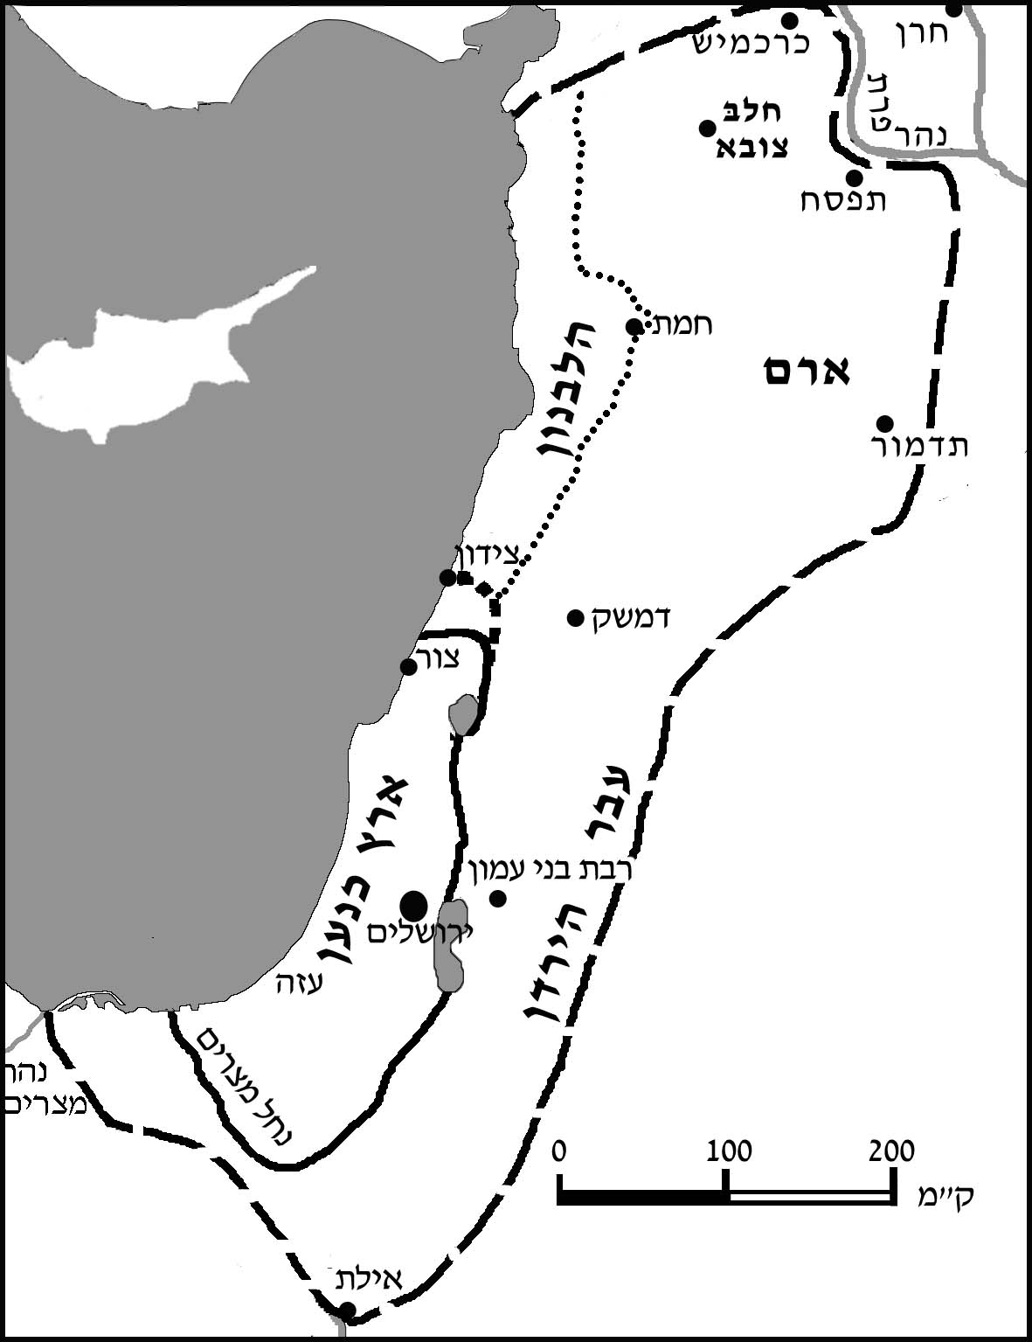

The borders of the kingdom of David and Shelomo (the outer broken line) include the kingdom of Chiram and the kingdom of the Phoenicians in Lebanon, who forged an alliance with David and Shelomo. This is the closest historical situation to the borders of the promise concerning “the land.” The “land of Cana’an” sometimes includes Lebanon (Bamidbar 34) and sometimes not, but in terms of historical realization, both in the inheritances given to the tribes (the innermost solid line) and throughout the First and Second Temple Periods, Lebanon remained outside. The theoretical border of the tribal inheritances in the regions of Tzur (Tyre) and Tzidon (Sidon) are a matter of fierce controversy (see Yehoshua 13, 19; Shoftim 1). The dotted line on the map shows the option of the northern border including Tzidon Rabba (Shmuel II 24:6-7).

“The land” as a whole was always divided, geographically and historically, into four parts: Ever Ha-Yarden (the eastern bank of the Jordan) and Aram, to the east of the Syria-African fault line, and Cana’an and Lebanon, to its west. The nuclear “Eretz Yisrael” – the land of Cana’an to the west of the Jordan and to the south of Tzidon – is the smallest but most important part.

The commandments pertaining to the land, according to the halakhic-historical approach, are a function of the “first sanctity” in the days of Yehoshua (the first conquest of the land by those who left Egypt), the “second sanctity” in the days of Ezra (by those who returned from Babylonian exile), and the “third sanctity” (by the exiles gathered in from all four corners of the earth). What is most important for the purposes of the mitzvot is not the cosmic sanctity of Eretz Yisrael since the creation of the world, but rather the moral, social significance (“the way of the Lord, to perform justice and righteousness”), and the historio-politico-national significance, and these are at the forefront of Jewish history from the Exodus from Egypt, the giving of the Torah, and up until the final redemption, with the fulfillment of the prophecy of Yermiyahu:

Therefore behold, days are coming, says the Lord, when it shall no more be said, “As the Lord lives, Who brought up Bnei Yisrael out of the land of Egypt,” but rather, “As the Lord lives, Who brought up Bnei Yisrael from the land of the north, and from all the lands into which He had driven them, and I will bring them back into their land that I gave to their fathers. (Yermiyahu 16:14-15)

The redemption from “the land of the north” must have the same significance as the Exodus from Egypt in the historio-national sense as well as the moral, social sense, comprising an all-encompassing revolution.

These two fundamental perspectives are embodied in these two very different covenants – the Covenant of Circumcision and the Covenant Between the Parts. These different aspects are manifest in the Name of God (“Elokim” or “El Sha-dai,” as opposed to the Tetragrammaton), the definition of the land, the nature of the covenant, its content, and its meaning. It is specifically for this reason that the two covenants are consolidated into a single covenant at the time of the Exodus, when the Pesach sacrifice, offered by all of Bnei Yisrael, is dependent and conditional upon circumcision.

Translated by Kaeren Fish

Visit our website: http://www.vbm-torah.org

Much of the theory of biblical criticism as to separate sources in Sefer Bereishit arises from this distinction (along with the seeming repetition of the story of Creation and the story of the Flood). Close attention to the analysis presented here (and elsewhere) will reveal the fundamental difference between the biblical criticism approach, which separates the accounts, and the approach we propose, which interprets the two covenants as two different aspects or perspectives that meet and combine within a single Torah, insofar as these two covenants become one at the time of the Exodus. In this regard, our approach is also fundamentally different from that of R. Breuer z”l. Obviously, close analysis and comparison of these different views requires extensive discussion that lies beyond the scope of our present study.
According to R. Meir and Rabbi (Chullin 6b; Yerushalmi, Demai, ch. 2, 22c. The Rambam likewise writes in his Hilkhot Melakhim (5:11) that for anyone who is buried in Eretz Yisrael, his burial place is considered an “altar of atonement.” The Chatam Sofer (Yoreh De’ah 233) and R. Kook (Shabbat Ha-Aretz [Jerusalem 5753], pp. 115-119) use this as their basis for the practical ruling that the inherent sanctity of the land goes beyond the sanctity of the commandments that are performed upon or in connection with it.
See Sefer Ha-Kuzari 1:109; 2:9-24; 3:1; 4: end of 3, 11, 17; end of the book.
There are two common misconceptions concerning R. Yehuda Ha-Levi’s concept of Eretz Yisrael. First, he starts off – both chronologically and conceptually – talking about the unique nature of Am Yisrael; only afterwards, and in conjunction, does he go on to say, “and also the land has a part in this quality” (Sefer Ha-Kuzari 2:12). Second, what R. Yehuda Ha-Levi emphasizes is not conquest or Jewish sovereign rule, but rather the sanctity of the Divine Presence and the unique quality of prophecy. It is the Rambam, rather than R. Yehuda Ha-Levi, who is the great proponent of “Eretz Yisrael” as a sovereign Jewish entity, and Ramban adopts a similar view. My thanks to R. Zalman Koren, who pointed this out to me.
In the omissions from Positive Commandments, commandment 4. In the dispute in Sefer Ha-Mitzvot, the Ramban is thus much closer to the Rambam than he is to the Sefer Ha-Kuzari, which is more closely aligned with the world of the kabbalists. However, more generally, we might point to a fundamental difference: the Rambam has a clear world-view that is altogether historical and political, while in the Ramban we find both perspectives side by side. He speaks of Eretz Yisrael as the holy land, and of all the mitzvot as being bound up with its unchanging unique quality (as, for instance, in his commentary on Vayikra 18:25 and in many other places), recalling R. Yehuda Ha-Levi. On the other hand, in his gloss on Sefer Ha-Mitzvot, Eretz Yisrael is a sovereign political entity that is conquered and settled as a matter of historical realization – echoing the view of the Rambam. For this reason, the Ramban should be viewed as merging the different approaches – in harmony with his general guiding principle. All contemporary “unifiers” – and especially R. Kook and his disciples – thus follow the Ramban. From this analysis, it is clear that there is no disagreement between the Rambam and Ramban as to the commandment to conquer Eretz Yisrael at the hand of a king or a prophet with the consent of the nation; this mitzva exists throughout the generations, as is evidenced clearly in the Rambam’s Hilkhot Melakhim (chapter 5). Their dispute concerns only the question of whether the mitzva that applies for all generations is “conquest of the land” or the mitzva of the “war against the seven nations.” See Sefer Ha-Mitzvot, mitzva 187, where the Rambam states clearly that this mitzva applies for all generations, even during those periods when, for whatever reason, it cannot be fulfilled. This is in complete contrast to the Megillat Ester’s argument with the Ramban. Clearly, then, the Ramban disagrees with the Rambam when he says, “Do not become muddled and say that this commandment concerns the war against the seven nations…” See the response of R. Yehoshua Mi-Kutna in his Yeshu’ot Malko, siman 66.
Likewise, in three places in Sefer Devarim (7:22; 11:22-24; 19:8-9); see also the Rambam, Hilkhot Melakhim 11:2.
The “third sanctity” of Eretz Yisrael, for the purposes of the commandments related to the land, must be dependent both on conquest, such as that characterizing the sanctity of the First Temple, and settlement, characterizing the sanctity of the Second Temple. This is established by R. Hillel of Shklov and other disciples of the Vilna Gaon, in his name (Kol h=Ha-Tor 1:15; also pay close attention to Aderet Eliyahu on Devarim 1:8; 11:31). It is therefore extremely odd that in our times, the borders of the land are still conceived and cited according to the borders of the returnees from the Babylonian exile – which are long obsolete – such that areas of Israel that have been conquered and settled in modern times are said to be exempt from terumot and ma’asrot and the laws of shemitta. Such areas include the Beit Shean valley, the Acre region, the Golan, Ashkelon, the Katif region, and the Arava. All of these areas are “Eretz Yisrael” for all intents and purposes when they are under our sovereignty and Jews are living there, cultivating the land and extracting its fruits. R. Y. Rosenthal decries this situation in his introduction to Otzar h=Ha-Terumot, and to my view he is correct. Even if we say that recognizing the sanctity of these areas for the purposes of the mitzvot requires an actual declaration, as Ridbaz maintains (commentary on Rambam’s Hilkhot Terumot 1:5), then we must make such a declaration. Careful attention should be paid to Ridbaz’s explanation as to why there was no such declaration in his time, what they knew, and what their concerns were. R. Zevin raised this question about the conquests of the IDF, which should seemingly have established the sanctity of the land in practice in the same way as the “first sanctity,” or at least in the same way as the “second sanctity,” although he was careful not to set this down as a definitive conclusion (Ha-Tzofeh, 28 Tevet 5708, shortly before the establishment of the State; Warhaftig, et al (eds.), Techumin 10 [Alon Shvut, 5749], pp. 15-25). To my mind, the conquests of the IDF represent a return to the first sanctity – even in places where the “second sanctity” had previously been maintained, in accordance with Yaavetz (Mor U-Ketzi’a, siman 306). From the language of the Rambam, it is similarly clear that the “third sanctity” is like the first; pay close attention to his Hilkhot Terumot 1:26. Thus, R. Zevin’s first argument against the declaration of sanctity in our times falls away (i.e., how can we introduce a sanctity that is not mentioned in the Torah; Techumin, ibid. p. 24).
See further in my book Pirkei Ha-Avot Be-Sefer Bereishit, pp. 48-54 (and the article “Ha-Aretz Ve-Eretz Cana’an Ba-Torah” on my website).

